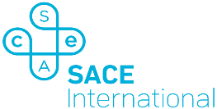

About the SACE International Program
The SACE is the official senior secondary qualification of the Government of South Australia. It is typically delivered in a students’ final two years of schooling. All Australian universities and major global universities accept the qualification. The SACE gives students the skills and knowledge to achieve success in university and in life.

