MUSIC STUDIES SAMPLE EXAMINATION ANSWERS

Q1a | Option 4
Q1b | Option 2
Q1c | Option 4 (major 3rd then minor 6th)
Q1d | Option 1 (simple duple)
Q2
Q3ai | Perfect 4th
Q3aii | 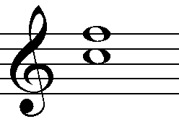
Q3bi | Minor 3rd
Q3bii | 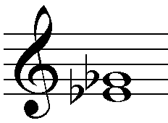
Q4a | Option 3 (melodic minor)
Q4b | Option 2 (harmonic minor)
Q5a
Q5b | Interrupted cadence (V-vi)
Q6 | Option 2
Q7 | Possible correct answer  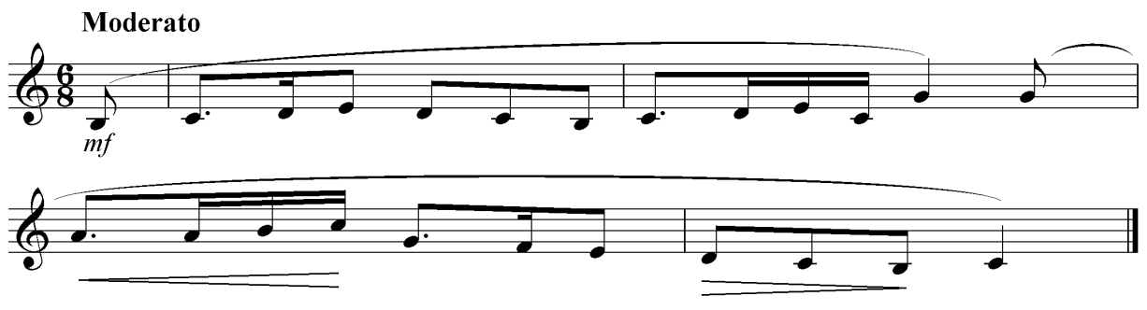
Q8a | Ternary form: A: bars 1-8 / B: bars 9-14 / modified A: bars 15-20
Q8bi | Pause or fermata - a pause longer than the value of the note
Q8bii | Crescendo and diminuendo - gradually getting louder then softer
Q8biii | Tenuto – held
Q8biv | Acciaccatura- a grace note that is also known as a ‘crushed’ note
Q8bv | Legato – smooth and connected
Q8c | Bars 9-10; 11-12 – one tone below
Q8d | Tonic key is G Major – modulates to A minor at bar 9 (using the dominant 7th chord) – then to the dominant key of D Major, at bar 13 – back to the tonic key of G Major at bar 15
Q8e | Any three of the following:  - Regular phrase length  - Expressive, graduated dynamics  - Consonant harmony with an emphasis on the tonic-dominant relationship  - Homophonic texture  - Alberti bass featured (broken chord pattern based on triadic harmony)  - Features use of the V7 chord (dominant seventh) – e.g. in bars 9,11,13,and 15  - Scored for a pianoforte (a keyboard instrument capable of an expressive range of dynamics, first mass-produced during the Classical period)
Q9a | Time signature – Cut Time 2/2 simple duple, with 4-bar repeated phrases (looped phrases) (N.B. also accept 4/4 simple quadruple and adjust tempo response accordingly)  Tempo – Andante/walking speed; approximately 80 minim beats per minute (for 2/2 time signature)  Rhythmic patterns – Two short repeated rhythm phrases followed by an extended third phrase, use of accents on some syncopated chords with the following rhythm pattern:  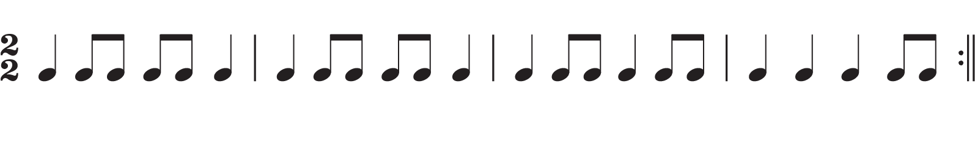
Q9b | Minor tonality (G natural minor Aeolian mode)  Subdominant minor to tonic minor chords
Q9c | Improvisatory Reggae style, based upon looping technology and FX processing
Q9d | The texture gradually thickens through record layering. Commences with a two-chord ostinato on the off-beat, followed by rhythm guitar, vocal drums, then the bass line. The texture thins with some instruments silenced and voice harmonies layered, followed by an improvised saxophone solo. All instruments then return to join the improvised saxophone solo.
Q10 | Option 4
Q11a | The original rhythm 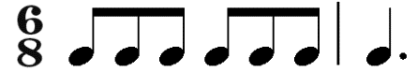 is changed into a syncopated rhythm in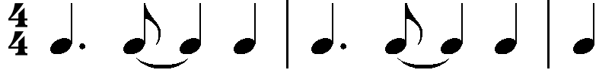. The pitch of the notes is the same as the original, but as the underlying harmony is different, the melody starts on the 5th of the A minor chord rather than the 3rd of the C major chord. Triplets are juxtaposed by quaver and crotchet rhythms throughout (e.g. quavers in bar 13 in the alto, tenor and baritone saxophones, with triplets in bar 14 of the soprano saxophone)
Q11b | The original key of C major is changed to the relative minor of A minor. The C-G7-C progression becomes Am-Em –Dm in the arrangement.
Q11c | The soprano saxophone plays a countermelody of a descending scale in triplets in bar 14-15. This reinforces the text in the nursery rhyme: “the mouse ran down” The soprano saxophone then plays the melody in bars 16 and 17.  The alto sax plays the melody in bars 13 and 14, and then fills in the harmony in bars 15 to 17, with a pedal note in bars 14, 16 and 17.
Q11d | The claves and congas, with syncopated repeating rhythms, set up the latin feel of the arrangement. Using an ostinato in the bass line from bars 1-12 adds further to the latin feel, and the use of syncopation in the melodic line reinforces the latin rhythms.
Q11e | The climax point is in bars 13 and 14, where the dynamics are loudest, the pitch is highest and the cadence is imperfect, with a pedal note on the dominant that sets up tension prior to the delayed resolution of the cadence in bar 18.
Q12 | Possible correct answer  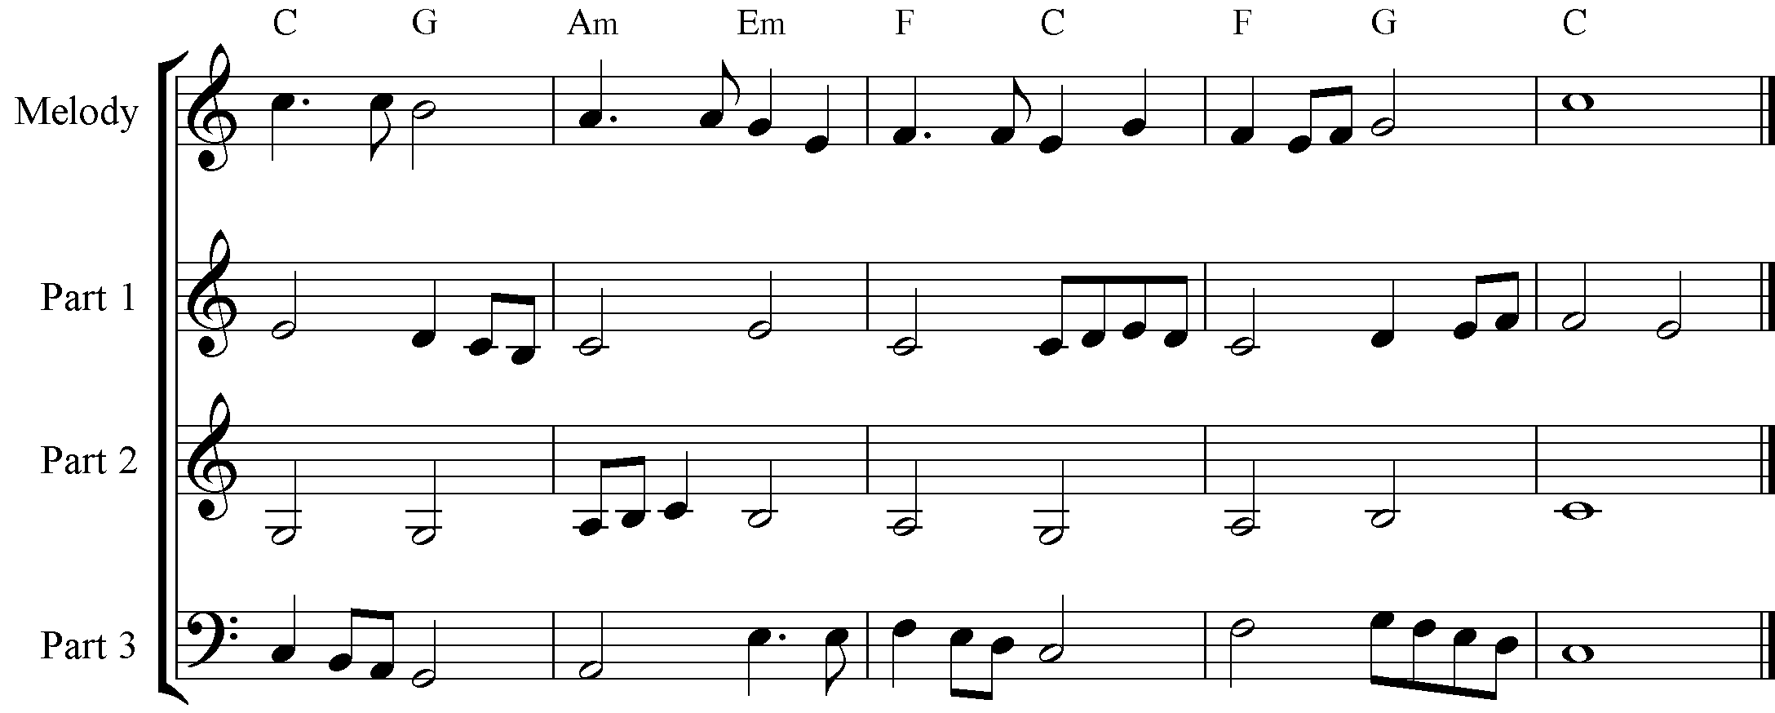
Q13

Q14a | Possible correct answer  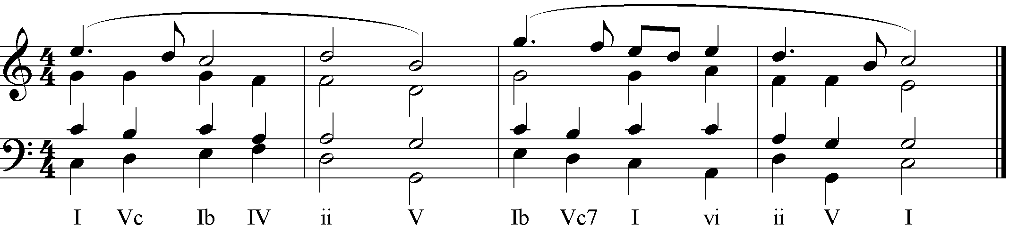
Q14b | Possible correct answer  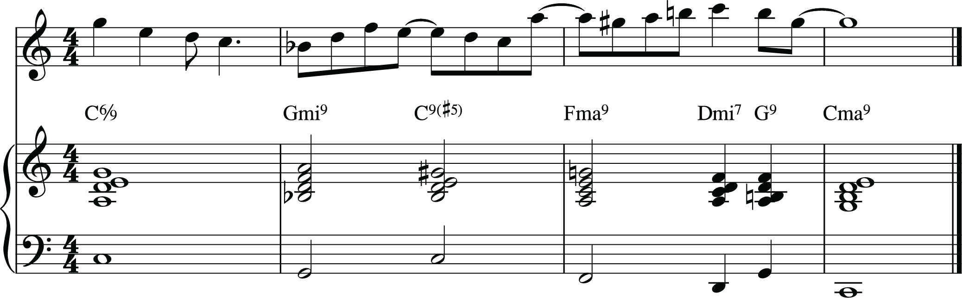
Q15a | Siciliana – 6/8 time – compound duple – 2 beats per bar, each beat 3 quavers  Numero uno – 3/4 time – simple triple – 3 beats per bar, each beat 2 quavers
Q15b | Siciliana – in binary form (hybrid binary) with a 3 bar coda – section A from bars 1-8; section B from bars 9-24 and the coda from bars 25-27. Section A is revisited in bars 17-20.  Numero uno – in ternary form (A section from bars 1-16; B section from bars 17-32 and the A1 section from bars 33- 44, with an 8 bar coda (bars 45-52) that uses some rhythmic material from both the A and B sections.
Q15c | Siciliana is in A minor, and chiefly uses the melodic minor form to build the melody. There is a modulation to the dominant key (E minor) in bars 9-16 and brief modulations to the subdominant major (D major) in bar 21 and to the sub-dominant minor (D minor) in bar 22. There is a return to the tonic key at bar 23.  Numero uno is in A major. The B section explores the unrelated keys of F major and its tonic minor, F minor, before returning to A major at bar 33. There is a brief modulation to F# minor (the relative minor of the tonic key) in bar 40. The coda is chromatic and ends in F major.
Q15d | Both pieces are essentially homophonic in texture, with the melodic line shifting between parts, particularly the Siciliana. Numero uno also has some countermelody in Parts 1 and 4 (b 35-44 for example) suggesting a touch of polyphony in these sections.  Siciliana uses a similar texture throughout with phrases of either 4 or 8 bars. The only exception is a small change in texture in bars 5 to 8, with the melody in the left hand.  Numero uno begins with a duet between the clarinet and bassoon, with the clarinet playing the melody. The french horn joins to add colour towards the end of the first repeated section. From bar 17 there is a duet between the flute and oboe, with the flute playing the melody. The other instruments join one by one towards the end of the A section. The B section begins with the oboe, then the clarinet joins, followed by the flute and finally the bassoon.

