Stage 1 Physics - Parachute Investigation Design

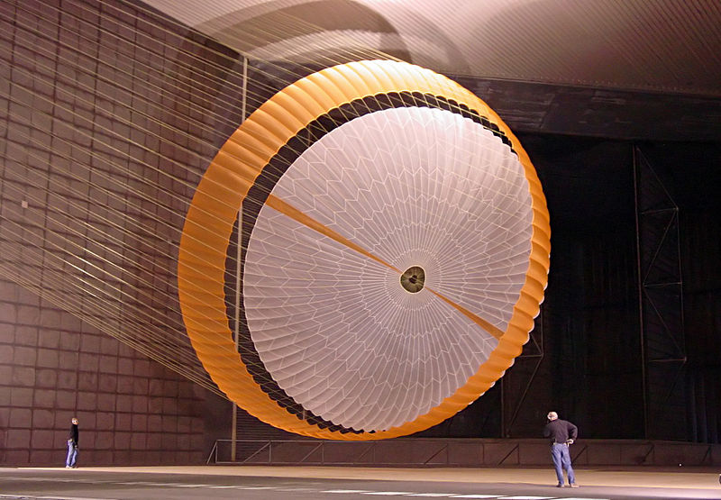  By NASA - http://photojournal.jpl.nasa.gov/catalog/PIA10208, Public Domain, https://commons.wikimedia.org/w/index.php?curid=15477610  (Courtesy NASA/JPL-Caltech) | 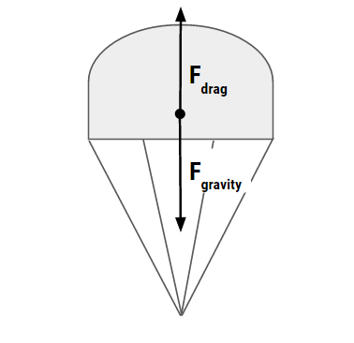

Video
Watch the video of the design process of the Mars Rover’s parachute. Type: bit.do/marsparachute into the address bar of your browser.

Background
Spacecraft designed for re-entry on a planet that has an atmosphere such as Mars can deploy a parachute to slow the craft’s rate of descent. The spacecraft falls at constant speed when the magnitude of the upward acting drag force (caused by “air” resistance) equals the magnitude of the downward acting force of gravity. The parachute is designed to minimise the speed on impact.

To minimise the force on impact you need to minimise the speed before impact. When the parachute is falling at constant (terminal) speed:
, so {with “s” constant}
As the relationship between and drop time is inversely proportional, you can minimise by maximising the drop time.

Useful Terms
Payload: The carrying capacity of a parachute. Payload is measured in kg.
Drop time: The total time between parachute deployment and touchdown.
Suspension lines: These lines attach the parachute to the payload.
Canopy :The expanding, umbrella-like part of a parachute.
Vent :A hole in the apex to vent some air out of the canopy to reduce the oscillation.

BEFORE CONDUCTING THE EXPERIMENT
IAE1
RISK ASSESSMENT | Before conducting a test drop, you will write a comprehensive risk assessment and hand it in to your teacher.
INVESTIGATION DESIGN | After the test drop, you will deconstruct the question: What will affect drop time? Then design a detailed investigation to test the effect of one factor (variable) on drop time. Keep a record of your thinking during the deconstruction and annotate your design to justify the decisions you make about various aspects of the design, e.g. how and why to control variable, number of samples etc. Hand the deconstruction and design in to your teacher on ____________.

THE REPORT DUE AFTER THE EXPERIMENT  IAE2 - IAE3 - IAE4 - KA1 - KA4 |  | Done?
INTRODUCTION | Physics background, hypothesis, variables | □
METHOD | Step-by-step of the method you actually used | □
RESULTS | Present the data collected in a single Data Table of results. | □
 | Students will represent their data using a Line Graph for continuous data, or a Bar Graph for discontinuous data. | □
 | Describe the trends and relationships as shown by your data. | □
DISCUSSION  Interpretation  Analysis  Evaluation | Interpret your results with reference to science concepts. | □
 | Evaluate your data by discussing the precision (scatter) of your data, and by commenting on reliability. | □
 | Describe the sources of possible systematic and random exp. errors in order of greatest impact. | □
 | Evaluate your procedure. | □
CONCLUSION | Write a statement in relation to your original aim and hypothesis (supports, refutes or inconclusive). This includes justification. | □
 | Describe any relationship between the independent and dependent variables established. | □

The report should be a maximum of 1000 words if written, or a maximum of 10 minutes for an oral presentation, or the equivalent in multimodal form.
Evidence outlining the deconstruction and design process should be attached to the report. This evidence should outline the deconstruction process, the method chosen as most appropriate, and a justification of the plan of action, to a maximum of 4 sides of an A4 page. Suggested formats for the summary sheet include flow charts, concept maps, tables, or notes.
Only the following sections of the report are included in the word count:

- Introduction
- analysis of results
• evaluation of method/procedure
• conclusion.

Stage 1 Physics Rocket Science: Parachute Investigation
 |  | A | B | C | D | E
The deconstruction and investigation design done before the experiment including a risk assessment prepared prior to the practical. | IAE1 | Critically deconstructs a problem and designs a logical, coherent, and detailed physics investigation. | Logically deconstructs a problem and designs a well-considered and clear physics investigation. | Deconstructs a problem and designs a considered and generally clear physics investigation.. | Prepares a basic deconstruction of a problem and an outline of a physics investigation. | Attempts a simple deconstruction of a problem and a procedure for a physics investigation. | I
Results: Present the data collected in a table of results.  A line graph with a line or curve of best fit OR a column graph. Max-min bars will show the precision of your measurements.  Describe the trends and relationships as shown by your data. | IAE2 | Obtains, records, and represents data, using  appropriate conventions and formats accurately  and highly effectively. | Obtains, records, and represents data, using appropriate conventions  and formats mostly accurately and effectively. | Obtains, records, and represents data, using generally appropriate conventions and formats with some errors but generally accurately and effectively. | Obtains, records, and represents data, using conventions and formats inconsistently, with occasional accuracy and effectiveness. | Attempts to record and represent some descriptive data, with limited accuracy or effectiveness. | I
Discussion: Analyse and evaluate precision of your data and a description of sources of errors. Conclusion includes a clear and concise statement based on the data; supports or refutes the hypothesis. Any relationships established. | IAE3 | Systematically analyses and interprets data and evidence to formulate logical conclusions with detailed justification. | Logically analyses and interprets data and evidence to formulate suitable conclusions with reasonable justification. | Undertakes some analysis and interpretation of data and evidence to formulate generally appropriate conclusions with some justification. | Describes data and undertakes some basic interpretation to formulate a basic conclusion. | Attempts to describe results and/or interpret data to formulate a basic conclusion. | I
Discussion: Evaluate your procedure and describe and justify three improvements you could make to the experiment design. | IAE4 | Critically and logically evaluates procedures and  their effects on data. | Logically evaluates procedures and their effects  on data. | Evaluates procedures and some of their effects on data. | Attempts to evaluate procedures or suggest an effect on data. | Acknowledges that procedures affect data. | I
Demonstration of physics understanding throughout the report, particularly the introduction and the interpretation of results. | KA1 | Demonstrates deep and broad knowledge and understanding of a range of physics concepts. | Demonstrates some depth and breadth of knowledge and understanding of a range of physics concepts. | Demonstrates knowledge and understanding of a general range of physics concepts. | Demonstrates some basic knowledge and partial understanding of physics concepts. | Demonstrates limited recognition and awareness of physics concepts. | I
Spelling, grammar, sentence and paragraph structure.  Appropriate use of physics terminology  Method summarised  Neat and clear presentation in an appropriate format. | KA4 | Communicates knowledge and understanding of physics coherently with highly effective use of appropriate terms, conventions, and representations. | Communicates knowledge and understanding of physics mostly coherently with effective use of appropriate terms, conventions, and representations. | Communicates knowledge and understanding of physics generally effectively, using some appropriate terms, conventions, and representations. | Communicates basic physics information, using some appropriate terms, conventions, and/or representations. | Attempts to communicate information about physics. | I

