Stage 1 English Subjects Implementation

Workshop Booklet

2015

Ref: A450590, July 2015
© SACE Board of South Australia

CONTENTS
Integration of Australian Curriculum English Implementation Power Point Presentation 1
Stage 1 English 11
Learning and Assessment Plan – Example 1 11
Learning and Assessment Plan – Example 2 12
Learning and Assessment Plan – Example 3 13
Stage 1 English Performance Standards 14
Task 1 - Assessment Type 1: Responding to Texts 15
Task 2 - Assessment Type 3: Intertextual Study 16
Stage 1 English as an Additional Language 17
Learning and Assessment Plan – Example 1 17
Learning and Assessment Plan – Example 2 18
Stage 1 English as an Additional Language Performance Standards 20
Task 1 - Assessment Type 1: Responding to Texts (literary texts) 21
Task 2 - Assessment Type 1: Responding to Texts 22
Task 3 - Assessment Type 1: Responding to Texts (literary texts) 23
Task 4 - Assessment Type 2: Interactive Study 24
Task 5 - Assessment Type 3: Language Activity 25
Task 6 - Assessment Type 3: Language Activity 26
Stage 1 Essential English 27
Learning and Assessment Plan – Example 1 27
Learning and Assessment Plan – Example 2 28
Learning and Assessment Plan – Example 3 29
Learning and Assessment Plan – Example 4 30
Learning and Assessment Plan – Example 5 31
Stage 1 Essential English Performance Standards 32
Task 1 - Assessment Type 1: Responding to Texts 33
Learning and Assessment Plan form 34

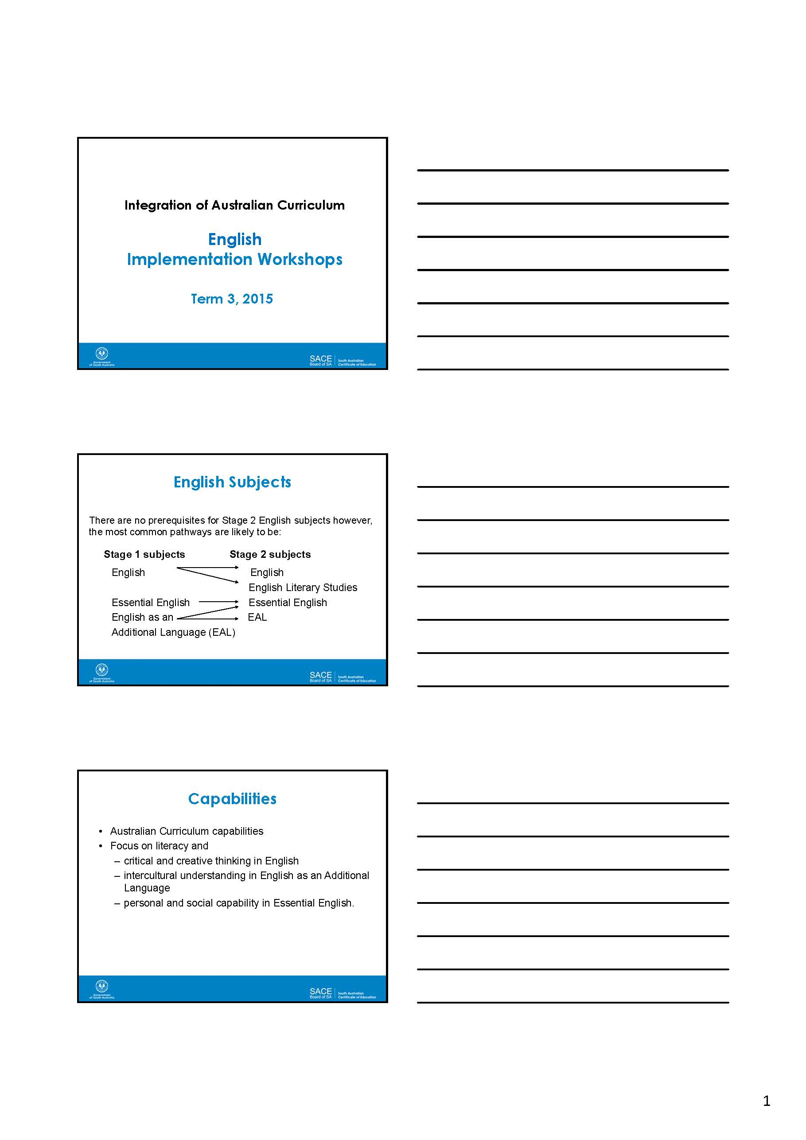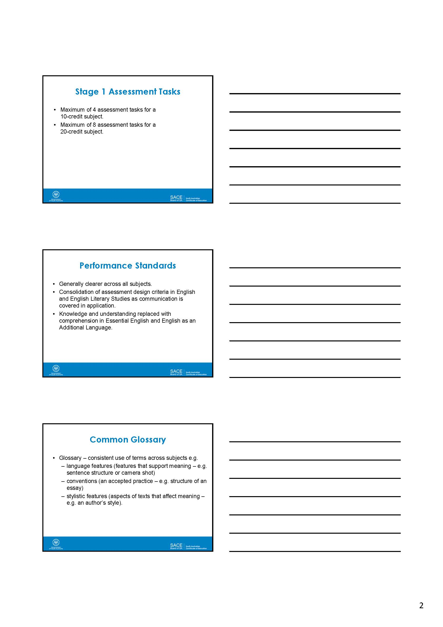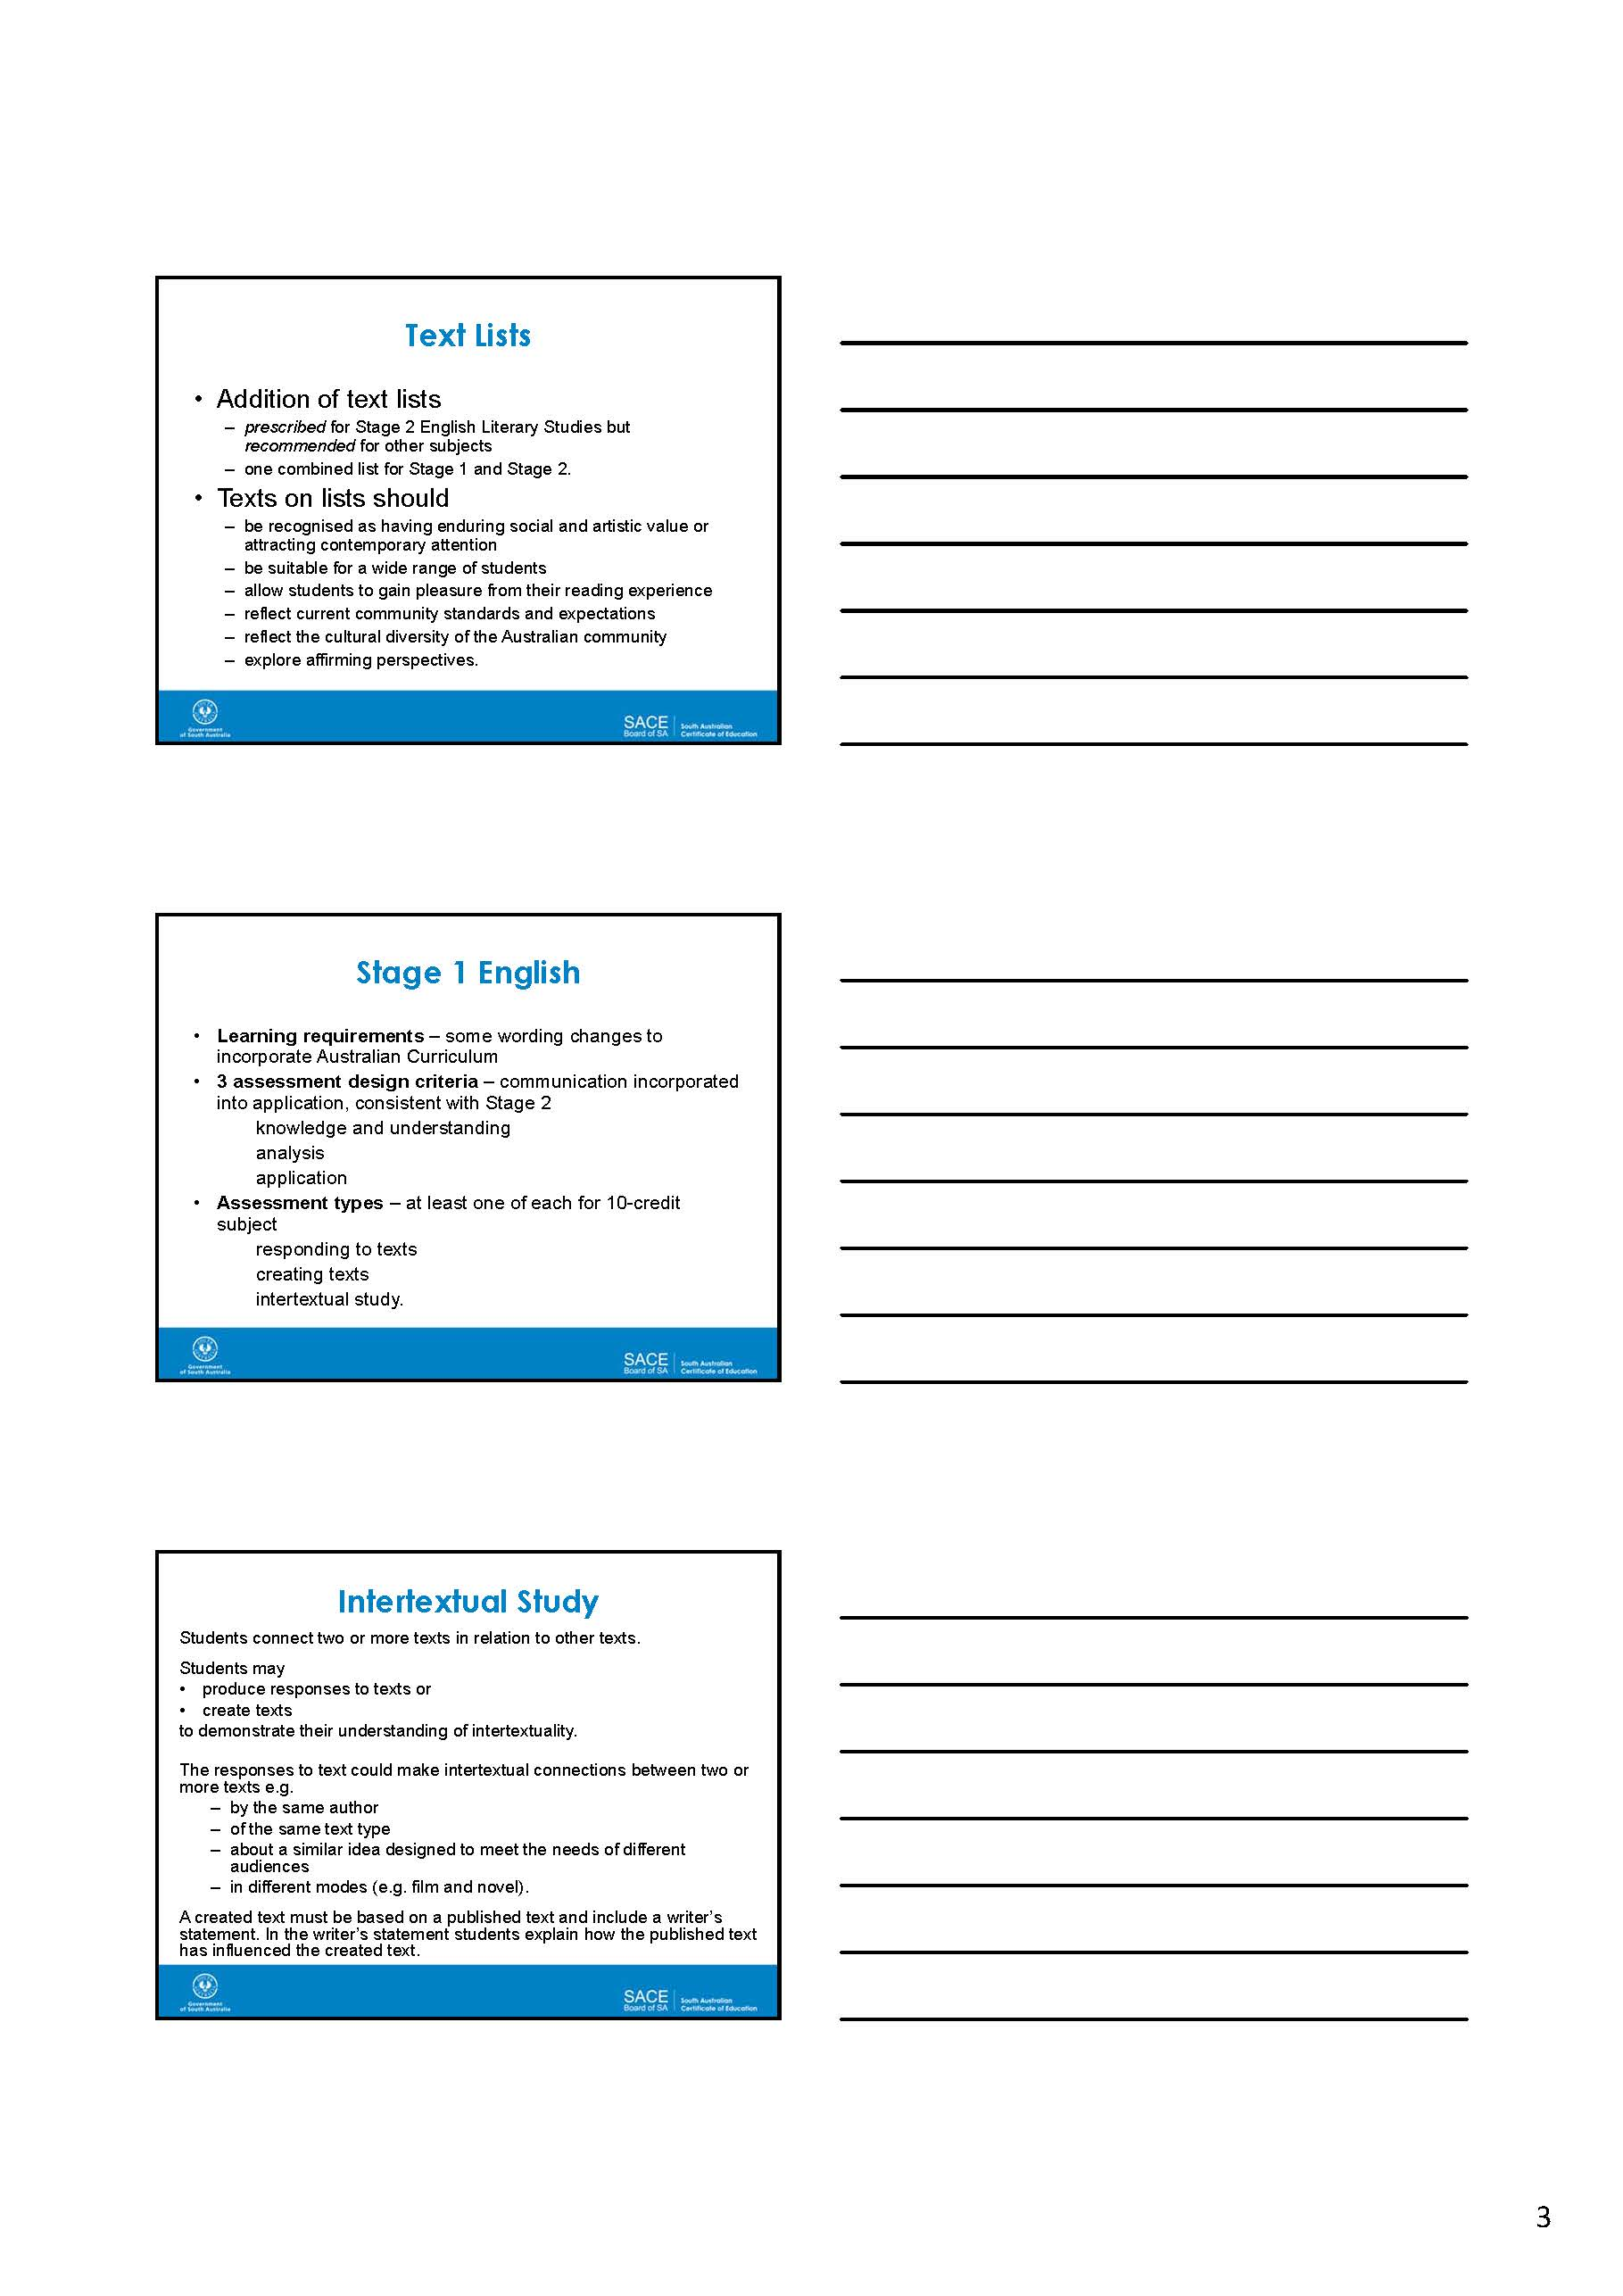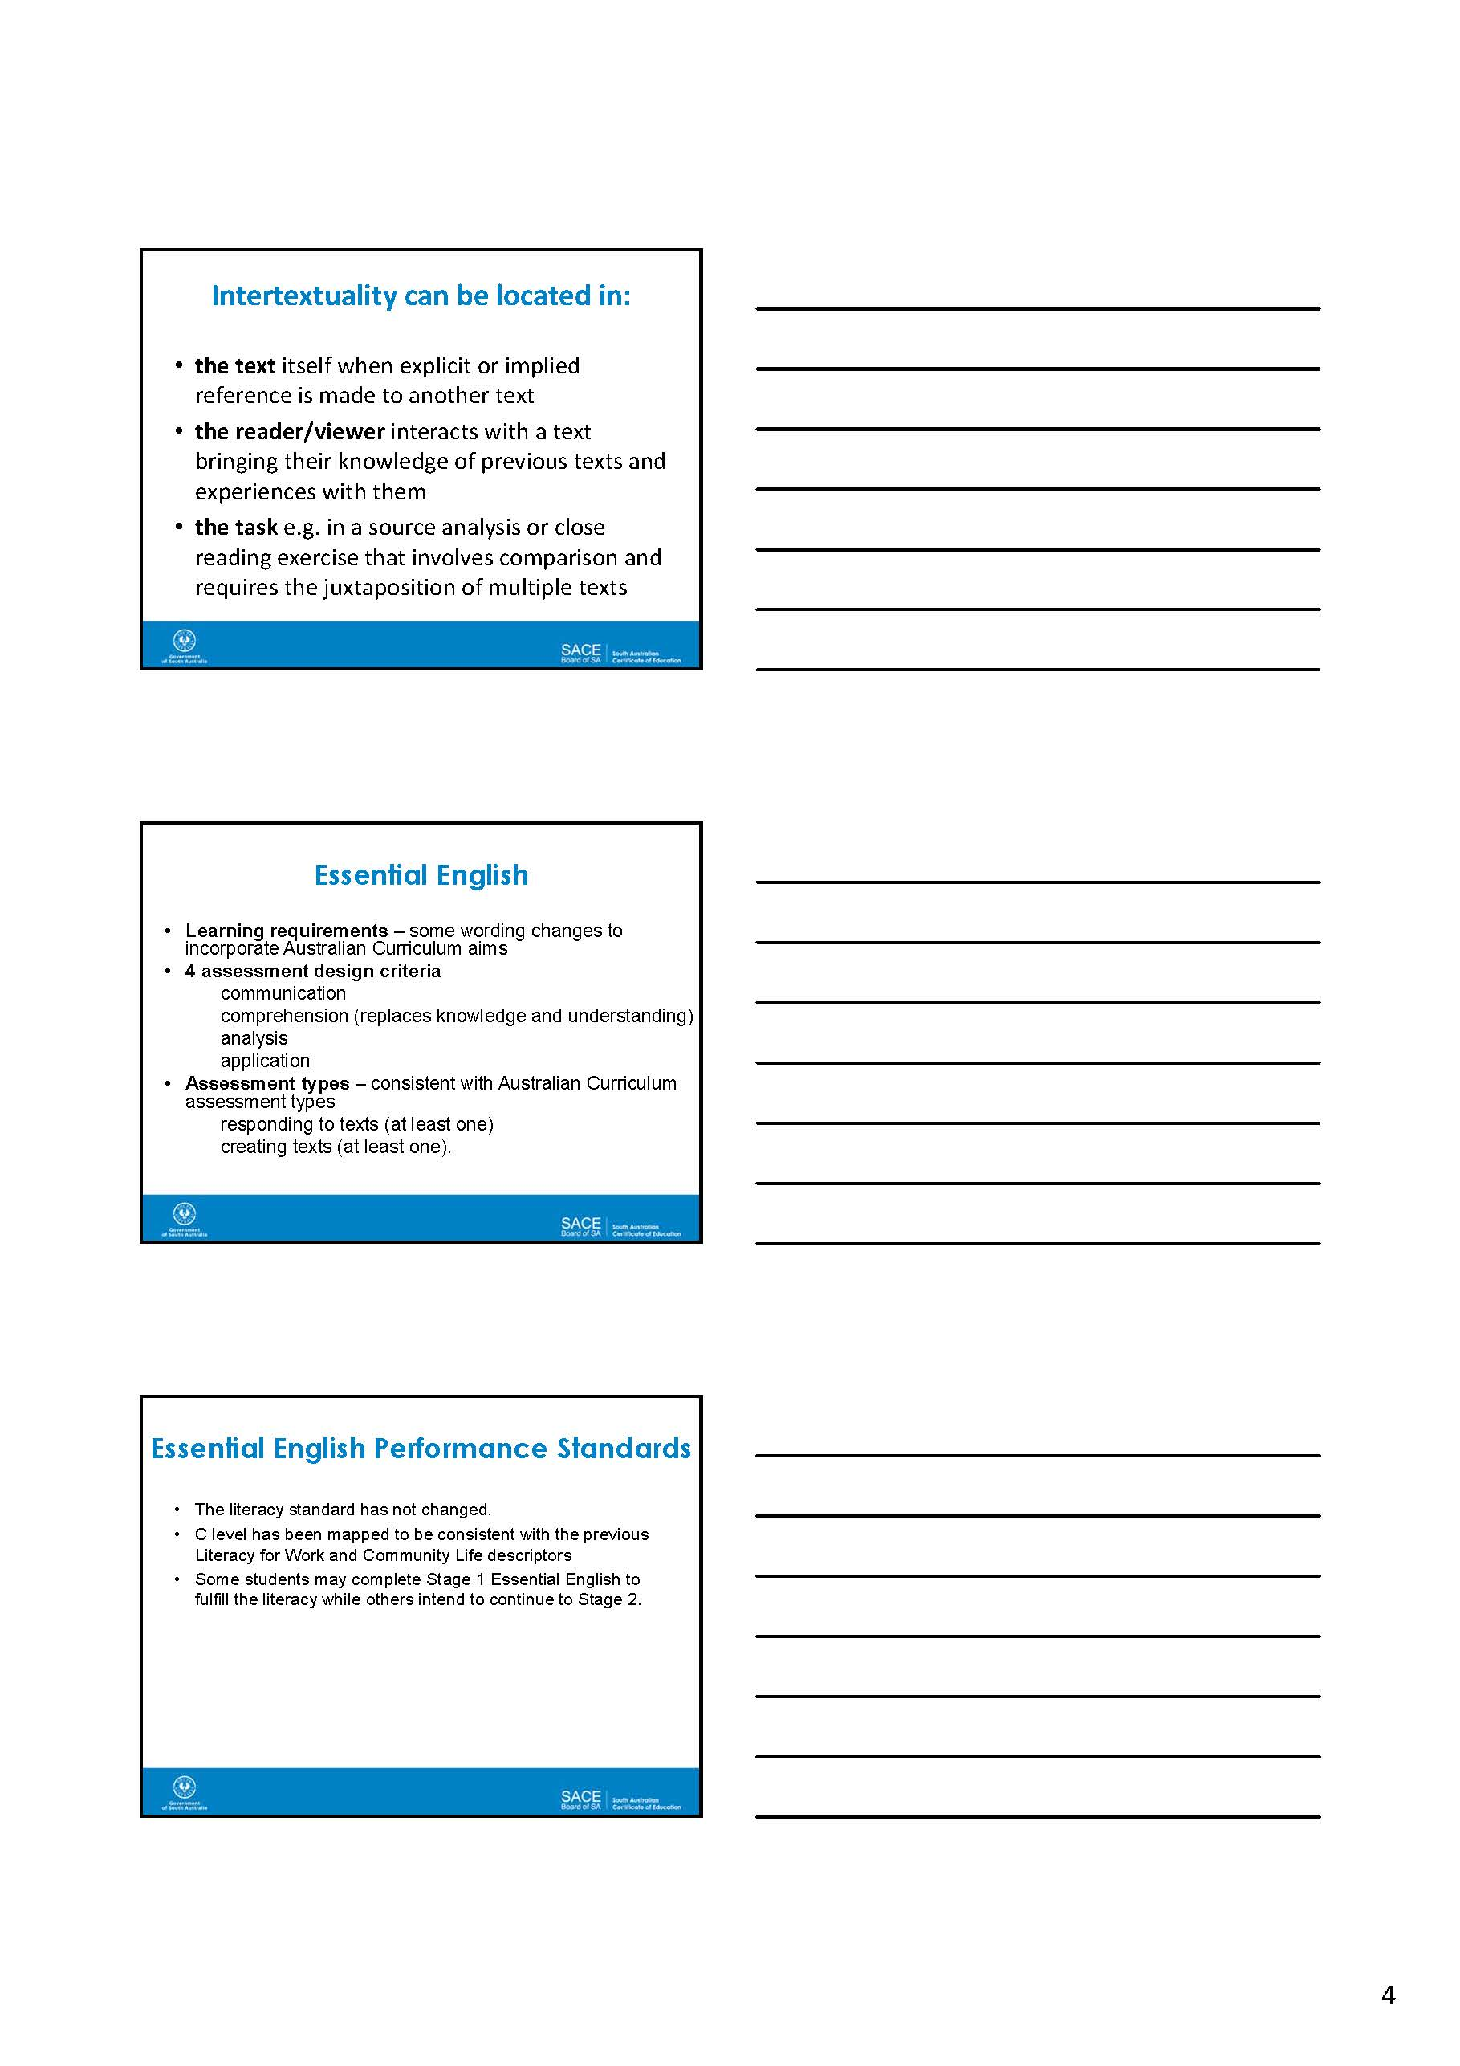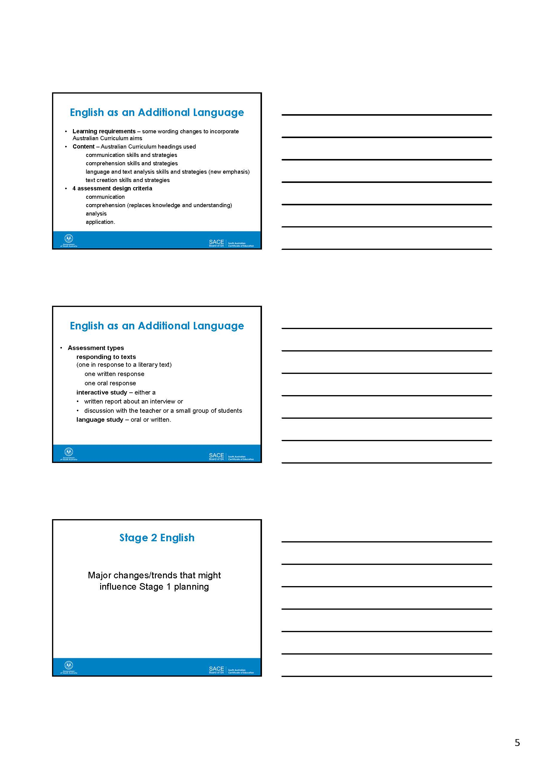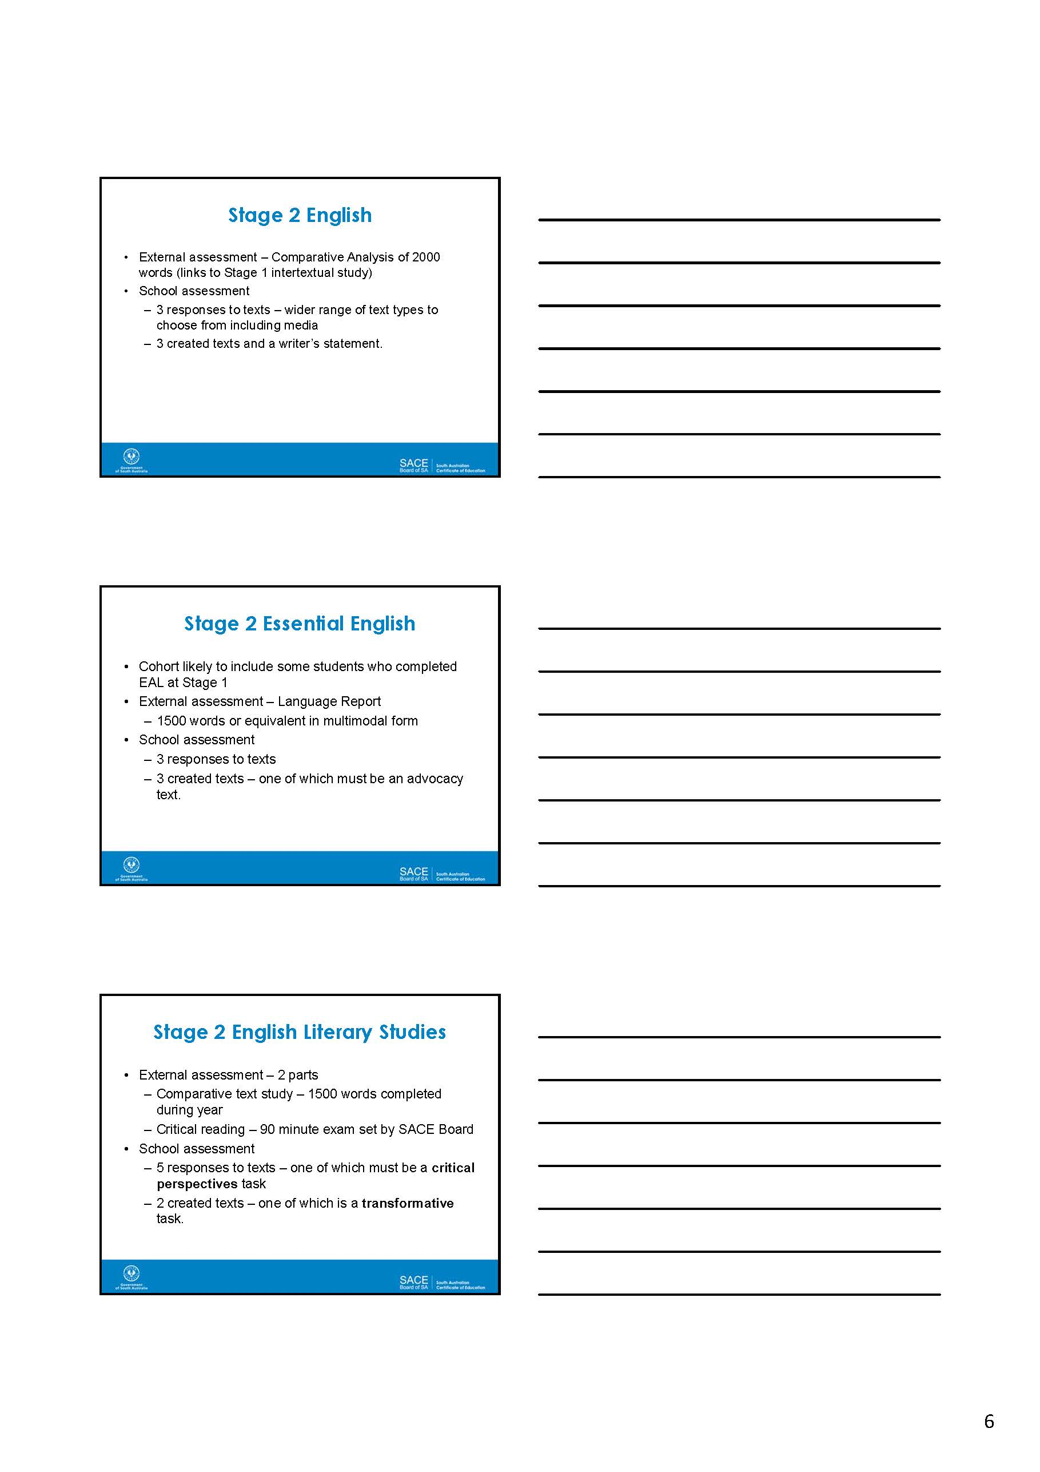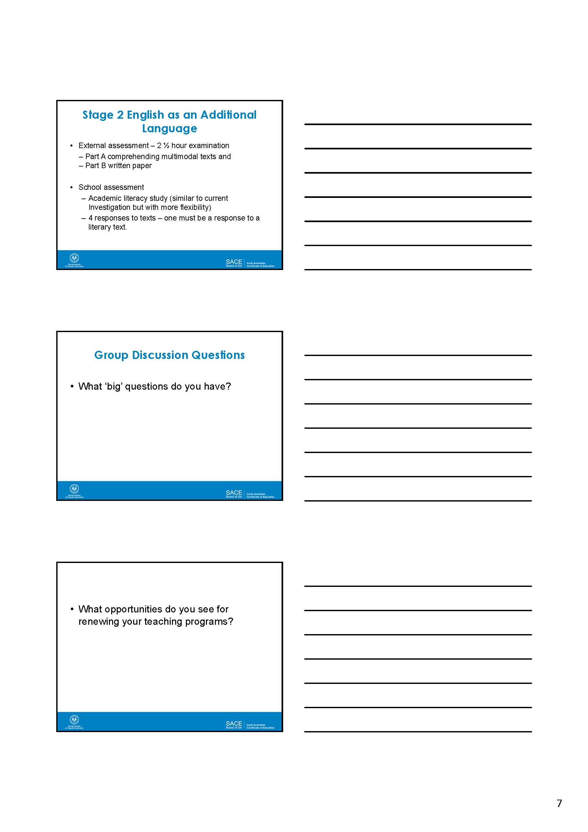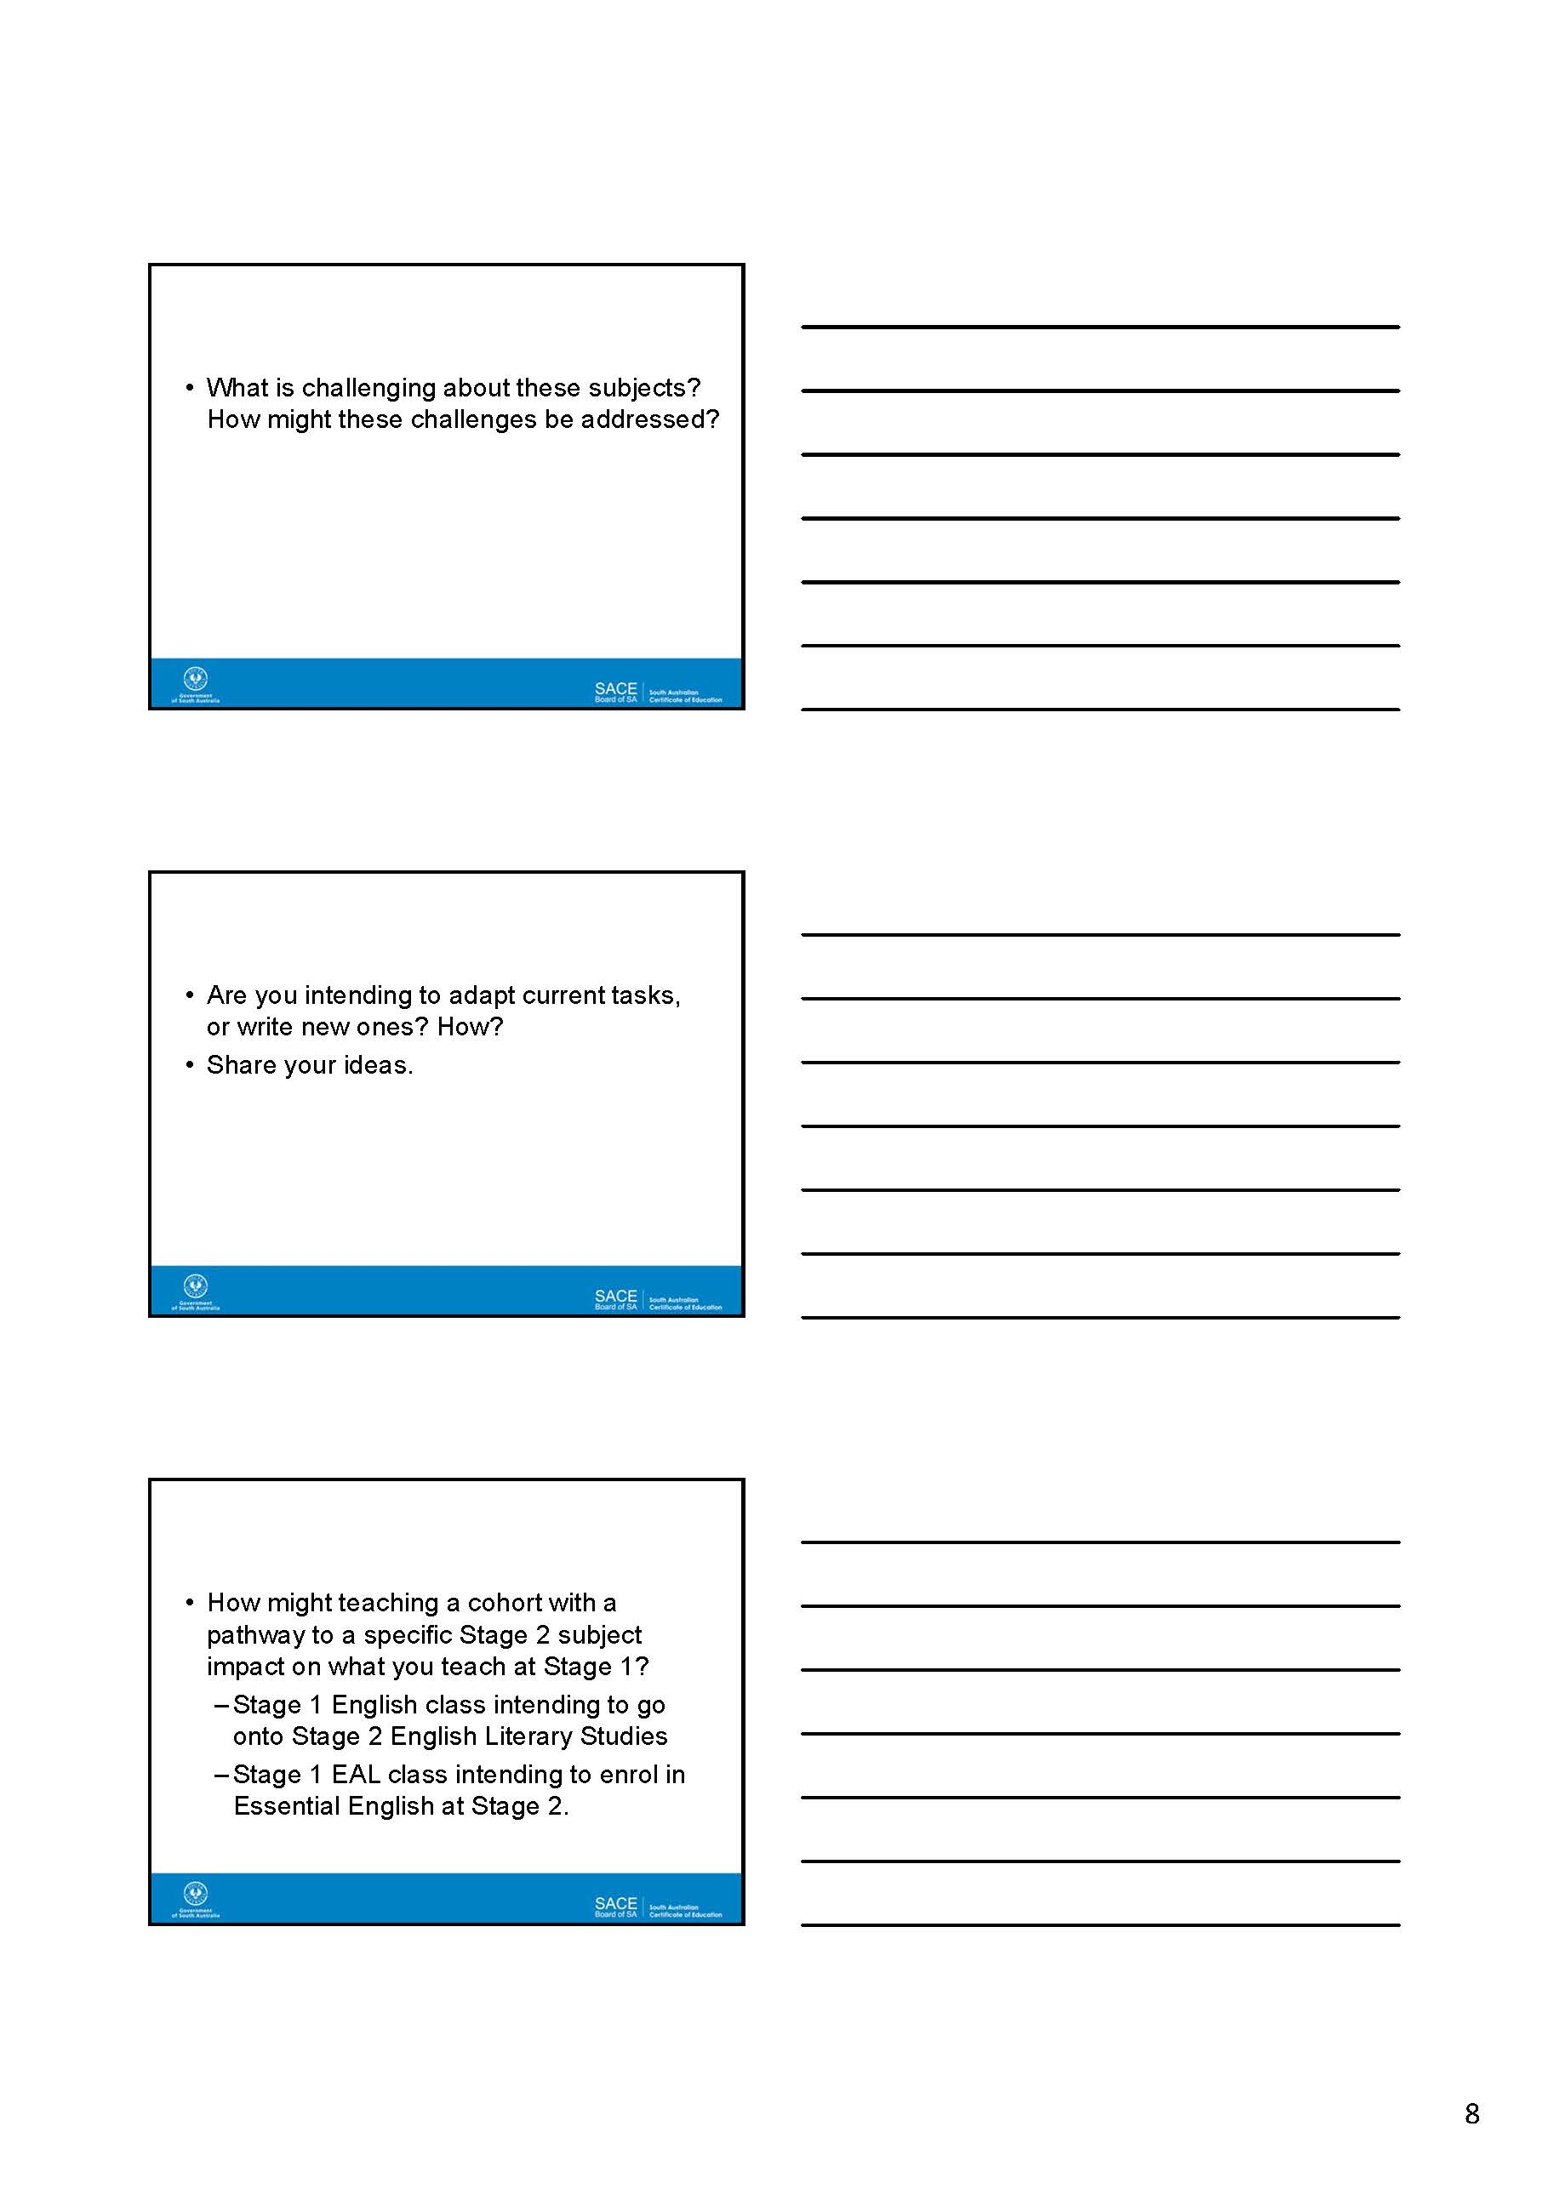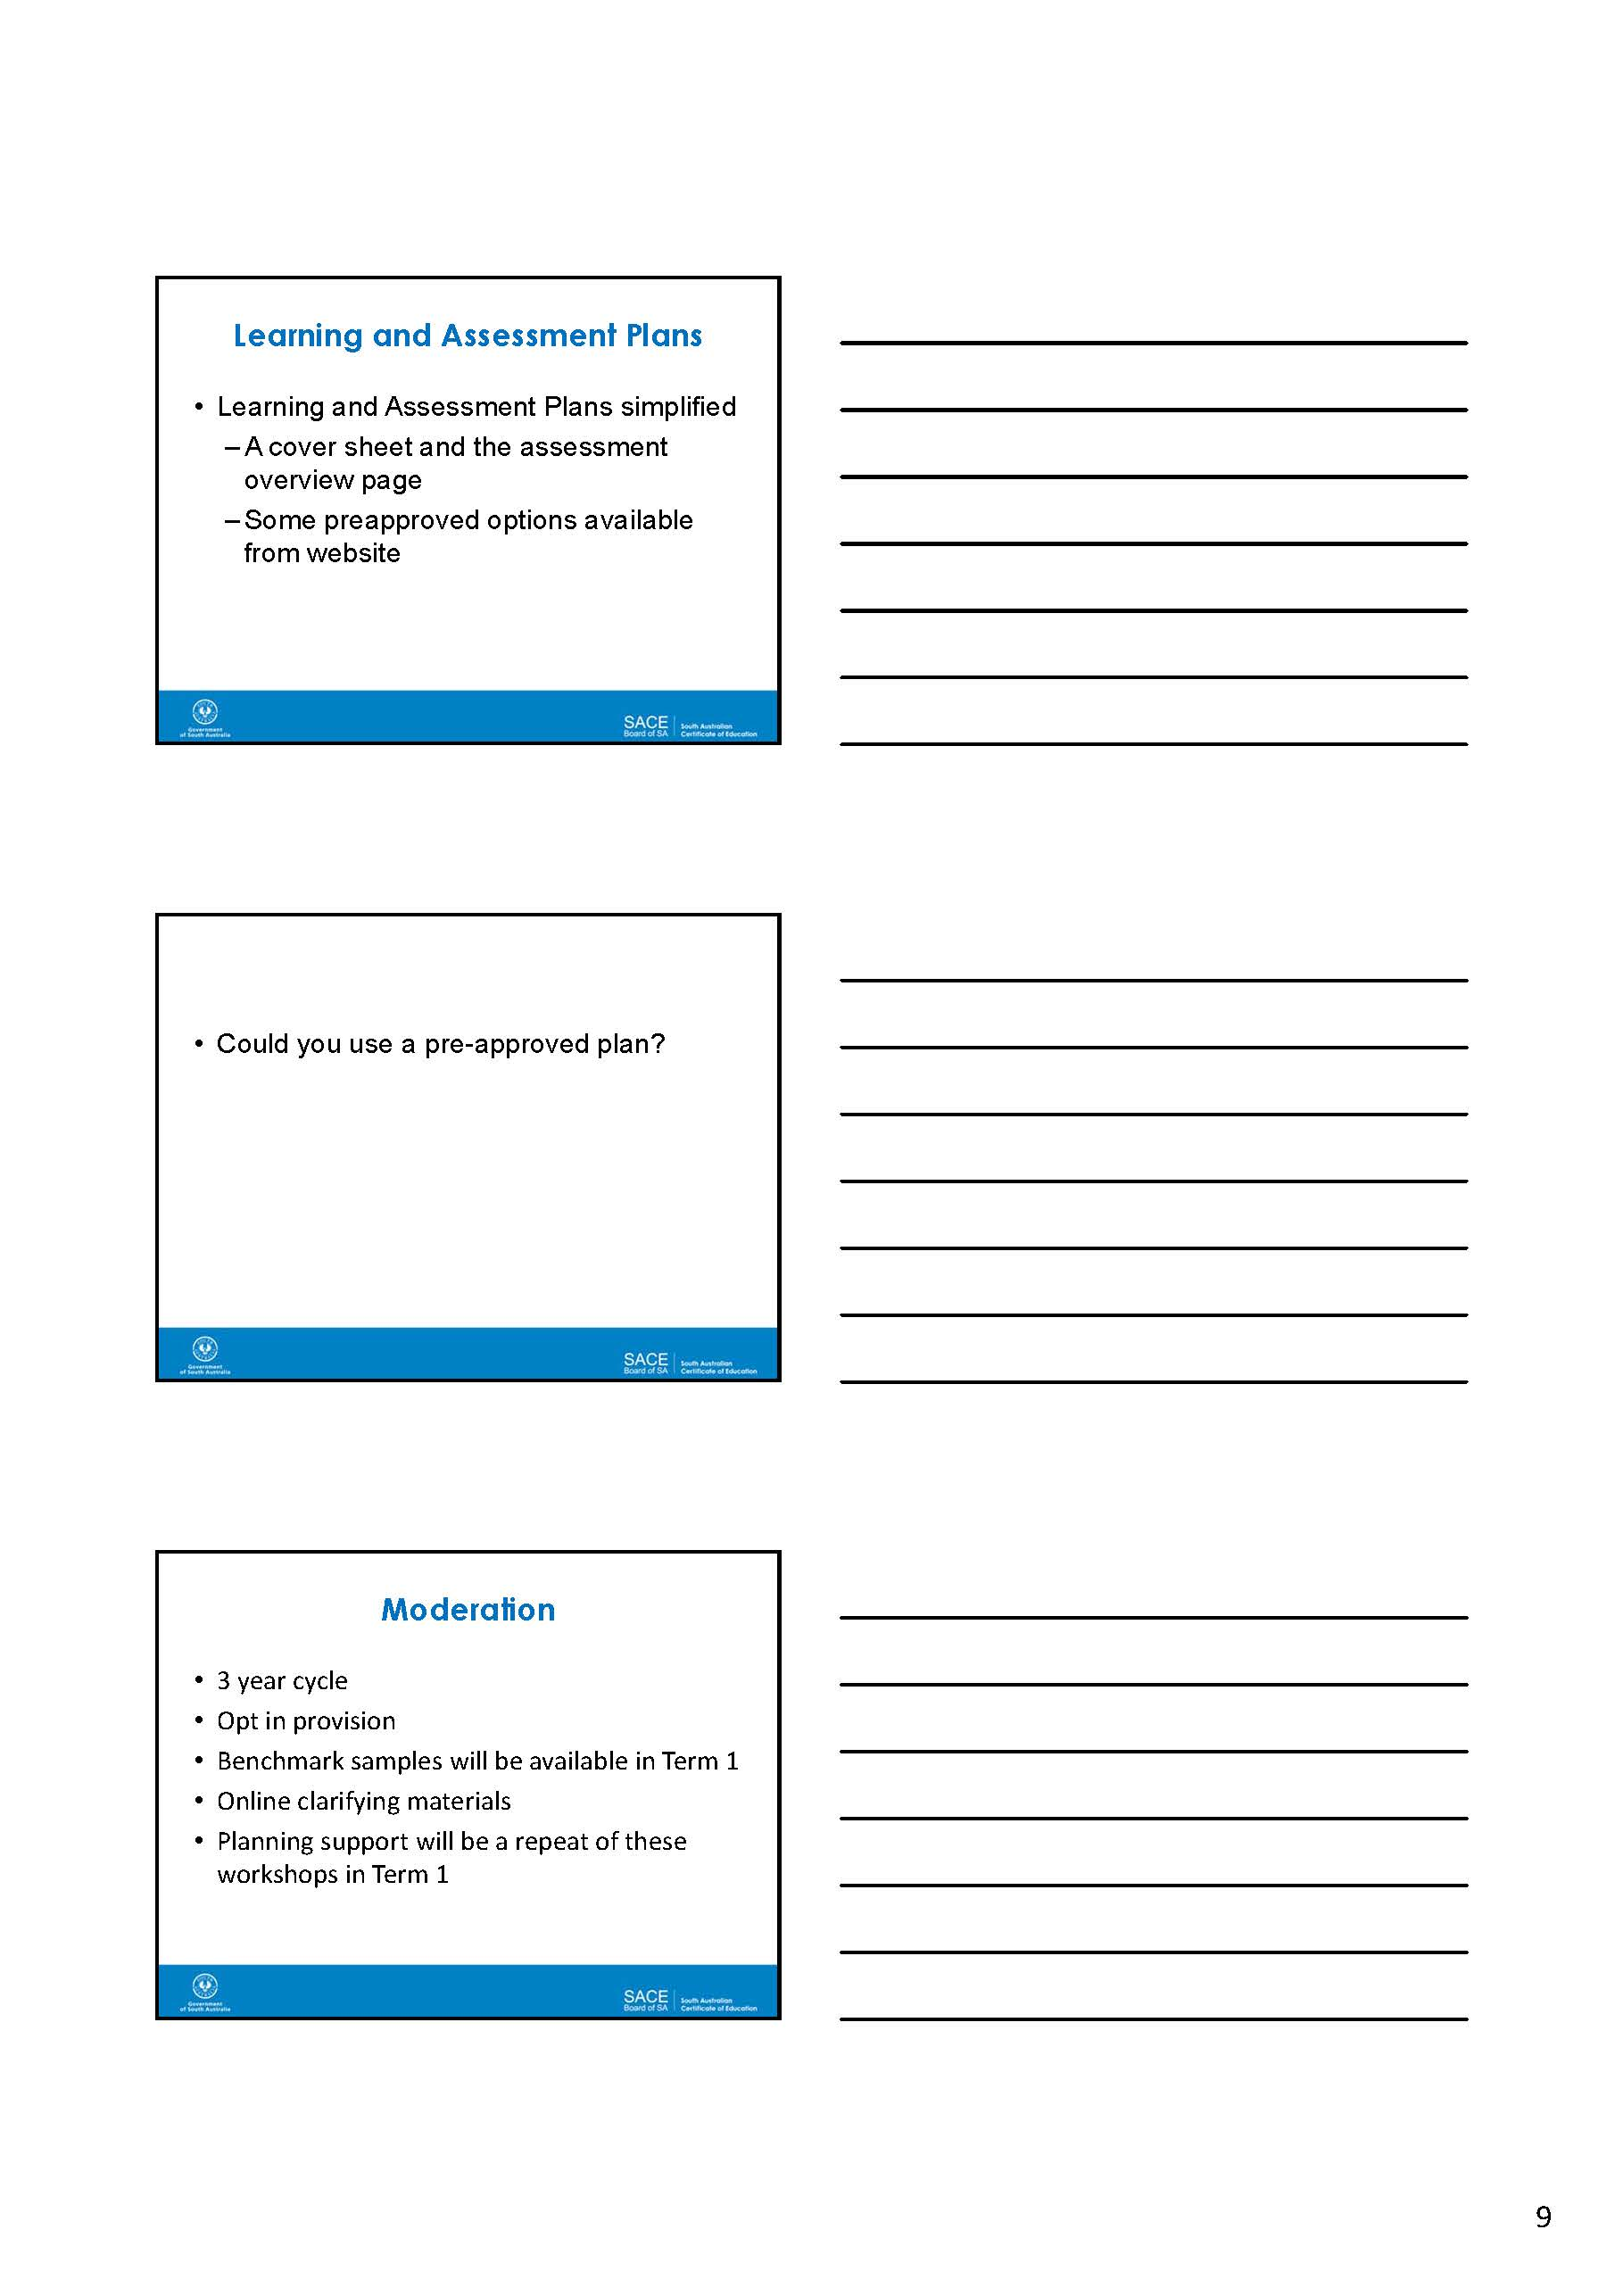

Stage 1 English (10 credits)
Learning and Assessment Plan Example 1
ASSESSMENT OVERVIEW

Complete the table below to show details of the planned tasks. Use numbers to show where students will have the opportunity to provide evidence for each of the specific features for all assessment design criteria.

Assessment Type and Weighting | Details of assessment | Assessment Design Criteria |  |  | Assessment conditions  (e.g. task type, word length, time allocated, supervision)
 |  | K & U | An | Ap
Responding to texts  Weighting 50% | Compare the stylistic features and conventions in one of Tim Winton’s short stories from the The Turning with the film version of the same story. Discuss the similarities and differences and how effective the short film is in representing the written version. | 2 | 2,3 | 1,3 | Written text up to a maximum of 800 words.
 | How do the purpose, context and audience of one example of an online blog influence the language and stylistic features? Present your analysis in an oral presentation, supported by a PowerPoint. | 3 | 1 | 1,3 | Oral task up to a maximum of 5 minutes.
Creating texts  Weighting 25% | Create one or more entries for an online blog in a style similar to one of the following Australian bloggers.  - Pip Lincolne - ‘Meet me at Mikes : Good stuff for nice people’ http://meetmeatmikes.com/52-hellos/  - Karen Cheng writes about fashion and life http://www.karencheng.com.au/  - Peter G writes souvlaki for the soul http://souvlakiforthesoul.com/  - Bill Tikos http://www.thecoolhunter.com.au  - Mick’s AFL footy blog http://www.yumstudio.com.au/footy/ | 3 | 2,3 | 2 | Written text should be a maximum of 800 words; an oral should be a maximum of 5 minutes; a text in multimodal form should be of equivalent length.
Intertextual Study  Weighting 25% | Zusak uses literary allusion throughout the text, The Messenger, by referring to  - films such as Cool Hand Luke, Ben Hur, Stir Crazy  - authors such as James Joyce (Ulysses), Shakespeare, Charles Dickens, and Emily Bronte (Wuthering Heights )  - songs about challenge by Bob Dylan (The Hurricane, Oxford Town, etc.), The Beatles (Eight Days a Week), Bon Jovi  - poetry by Sylvia Plath, etc.  - How is your understanding of the ideas in the novel, The Messenger, enhanced by some of the literary allusions within the text? | 1 | 3 | 1,3 | Written, oral, and/or multimodal.  A written response should be a maximum of 1000 words; an oral response should be a maximum of 6 minutes; a response in multimodal form should be of equivalent length.

Up to four assessments. Please refer to the English Subject Outline.

Stage 1 English (10 credits)
Learning and Assessment Plan Example 2
ASSESSMENT OVERVIEW

Complete the table below to show details of the planned tasks. Use numbers to show where students will have the opportunity to provide evidence for each of the specific features for all assessment design criteria.
Assessment Type and Weighting | Details of assessment | Assessment Design Criteria |  |  | Assessment conditions  (e.g. task type, word length, time allocated, supervision)
 |  | K & U | An | Ap
Responding to texts  Weighting 50% | Students attend a live drama performance from the Festival of Arts, the Fringe Festival, the State Theatre Company program, a school drama performance or any other appropriate play.  Students write a review appropriate for publication in one of the following:  - www.artsHub.com.au, a popular Australian theatre review site  - www.australianstage.com.au  - www.aussietheatre.com.au  - The Advertiser  - AdelaideNow.com.au | 2,3 | 1,2 | 1,3 | Written review up to a maximum of 800 words.
 | Students view the film Freedom Writers or another film with a similar theme. They produce a written or oral response, selecting from a range of formal analytical, creative, or evaluative options. They consider one of the following themes in their response:  - believing in yourself  - setting yourself goals  - following your dreams  - rising above adversity. | 1 |  | 2,3 | Written or oral text response in an appropriate form as negotiated.  Up to a maximum of 800 words if written or 5 minutes for an oral presentation.
Creating texts  Weighting 25% | Students choose a charity organisation, undertake some research and draft a persuasive argument whereby they discuss why their chosen charity should receive a $500,000 donation.  Students present the orals to their class, using PowerPoint to support the presentation. | 2,3 |  | 1,2 | A persuasive oral presentation, accompanied by a PowerPoint.  Up to a maximum of 5 minutes.  The PowerPoint includes a short advertisement for the chosen charity to be used as an internet advertisement.
Intertextual Study  Weighting 25% | Students select and read a novel for independent study. Following this, students select a further text such as a novel, magazine or newspaper article that is connected in some way to the first text in terms of ideas and perspectives, characterisation, setting, plot lines etc.  Students write an essay discussing the connection and/or the similarities and differences between the two texts. Students refer to examples and direct quotations from both texts to support their ideas. | 1 | 1,2,3 | 3 | Essay in written form up to a maximum of 1000 words.

Up to four assessments. Please refer to the English Subject Outline.

Learning and Assessment Plan Example 3
Stage 1 English (10 credits)
ASSESSMENT OVERVIEW

Complete the table below to show details of the planned tasks. Use numbers to show where students will have the opportunity to provide evidence for each of the specific features for all assessment design criteria.

Assessment Type and Weighting | Name and details of assessment | Assessment Design Criteria |  |  | Assessment conditions  (e.g. task type, word length, time allocated, supervision)
 |  | K&U | AN | APP
Assessment Type 1  Responding to Texts  Weighting 25 % | How has Wilde used language, stylistic techniques and conventions (e.g. irony, satire, witty repartee, inversion, contrived situations, incongruity, deception, parody, paradoxes, epigrams) to develop two or three themes in The Importance of Being Earnest (e.g. courtship and marriage, class struggle, gender representations, morality and etiquette, death, food) to present his critique of Victorian society. | 1,2,3 | 1,2 | 1,2,3 | A written response of a maximum of 800 words.
Assessment Type 2  Creating Texts  Weighting 40% | Based on the voice of Polly Espy in Max Shulman’s short story Love Is a Fallacy, write a letter to Peter Burch explaining why you have decided to go steady with him and not Dobie Gills. | 2 |  | 1,2 | A written response of a maximum of 800 words which includes a writer’s statement outlining the features of your new text compared to the original.
 | After reading Paul Keating’s famous Redfern speech, prepare a speech concerning a social issue about which you feel deeply. You will need to consider the context, purpose and audience for your speech. | 3 |  | 1,2 | An oral presentation of a maximum of 5 minutes.
Assessment Type 3  Intertextual Study  Weighting 35% | The central character in Max Shulman’s short story Love is a Fallacy and Don Tillman in Graeme Simsion’s The Rosie Project are both on a mission to find a wife. Compare and contrast the voices of these central characters and analyse the language, stylistic techniques and conventions used by the author to create these voices. | 1,2 | 2,3 | 1,2,3 | A written response of a maximum of 1,000 words.

Up to four assessments. Please refer to the English Subject Outline.

Stage 1 English Performance Standards

 | Knowledge and Understanding | Analysis | Application
A | Detailed knowledge and understanding of ideas and perspectives explored in a diverse range of texts.  Extensive knowledge and understanding of the variety of conventions, language, and stylistic features authors use to make meaning.  Comprehensive knowledge and understanding of ways in which texts are created for a range of purposes and audiences. | Perceptive evaluation of the complex relationship between purpose, context, and audience and how they shape meaning.  Insightful analysis of how language and stylistic features, and conventions combine to influence readers in various text types.  Analysis of complex intertextual connections between different texts. | Fluent and precise writing and speaking.  Sophisticated use of appropriate language features and conventions for a range of audiences and purposes.  Detailed and appropriate use of evidence from texts to support conclusions, with textual references integrated into responses.
B | Knowledge and understanding of ideas and perspectives explored in a range of texts.  Knowledge and understanding of a range of conventions, language and stylistic features authors use to make meaning.  Knowledge and understanding of ways in which texts are created for a range of purposes and audiences. | Effective analysis of the relationship between purpose, context, and audience and how they shape meaning.  Analysis of how language and stylistic features, and conventions influence readers in various text types.  Analysis of intertextual connections between different texts. | Mostly fluent and precise writing and speaking.  Use of accurate language features and conventions for a range of audiences and purposes.  Accurate use of evidence from texts to support conclusions, with textual references incorporated fluently in responses.
C | Knowledge and understanding of ideas and some perspectives explored in a range of texts.  Knowledge and understanding of some conventions, language and stylistic features authors use to make meaning.  Knowledge and understanding of ways in which texts are created for familiar purposes and audiences. | Description, with some analysis of purpose, context, and audience and how they shape meaning.  Description, with some analysis, of how language and stylistic features, and conventions influence readers in some text types.  Description, with some analysis of intertextual connections between different texts. | Generally fluent and accurate writing and speaking.  Use of language features and conventions appropriate for familiar audiences and purposes.  Use of evidence from texts to support conclusions, with some textual references incorporated in responses.
D | Reference to simple ideas explored in texts.  Knowledge and understanding of a narrow range of language features and conventions authors use to make meaning.  Knowledge and understanding of a restricted range of ways in which texts are created for limited purposes and audiences. | Identification of the purpose, context, and audience of texts.  Reference to some ways in which conventions and language features influence readers in some text types.  Recognition of similarities and or differences between texts. | Some control and fluency of expression.  Use of some language features and conventions appropriate for audience and purpose.  Limited use of evidence from texts to support conclusions with limited textual references to support responses.
E | Identification of an idea in a text.  Recognition of a restricted range of language features used by authors.  Acknowledgment of one or more ways in which texts are created for a purpose or an audience. | Reference to the purpose and audience of a text.  Recognition of a way in which language features influence readers in a text type.  Recognition of a connection between texts. | Emerging development of control of expression.  Emerging use of some language features appropriate to audience and/or purpose.

Task 1 - Assessment Type 1: Responding to Texts

English Stage 1
Assessment Type 1: Responding to texts
Introduction to Critical Perspectives/Literary theories

Literary theories were developed as a means to understand the various ways people read texts. The proponents of each theory believe their theory is the theory, but most of us interpret texts according to the “rules” of several different theories at a time. All literary theories are lenses through which we can see texts. There is nothing to say that one is better than another or that you should read according to any of them, but it is sometimes fun to “decide” to read a text with one in mind because you often end up with a whole new perspective on your reading. https://apps.carleton.edu/people/appleman/talksworkshops/workshop_handouts/critical_theories/

- Select a text that is familiar to everyone in the class or group such as:
- a shared text that has been read by everyone e.g. the set novel, a film, play or poem
- a popular text such as a film like Star Wars, Shrek or The Great Gatsby
- a traditional text such as a fairy story (e.g. Three Little Pigs) or a nursery rhyme.
Everyone in the class should agree to analyse the same text so the differences between readings are clear.
- In pairs read the definition of one of the following literary theories that you will be given:
  - Gender criticism
  - Historical and cultural criticism
  - Psychological or psychoanalytical criticism
  - Sociological (e.g. Marxist) criticism
  - Archetypal criticism
  - Reader-response criticism
  - Deconstructionist criticism
- Discuss the questions provided which guide you to read the text through a specific lens or perspective.
- Prepare and present an oral to the class in which you
  - explain the critical perspective or theory you have been given
  - present an analysis of the chosen story using the critical perspective
An oral response to texts should be a maximum of 5 minutes.
In this task you should:
- demonstrate knowledge and understanding of the ideas and perspectives explored in the text (KU1)
- analyse the relationship between the purpose, context and audience and how they shape meaning (An1)
- use of appropriate language in the oral presentation (Ap2)
- use of evidence from the text to support the conclusions (Ap3)
Task 1 - Assessment Type 3: Intertextual Study

Stage 1 English
Assessment Type 3: Intertextual Study
After reading the novel Jasper Jones, by Craig Silvey, and viewing the 1962 film, To Kill a Mockingbird, directed by Robert Mulligan, answer one of the following questions. Your answer should be a maximum of 1000 words; an oral of a maximum of 6 minutes or the equivalent in multimodal form.
- Jasper Jones has been called an Australian To Kill a Mockingbird by some critics. How has your understanding of the novel Jasper Jones, by Craig Silvey, been enhanced by watching the 1962 film, To Kill a Mockingbird, directed by Robert Mulligan?
- Silvey uses intertextual references throughout the text, Jasper Jones, by referring to novels such as The Sound and the Fury, Catcher in the Rye, Huckleberry Finn, To Kill a Mockingbird, radio broadcasts of cricket and comic book characters such as Spiderman and Batman. How is your understanding of the ideas in the novel, Jasper Jones, enhanced by the intertextual references?
- Jasper Jones is “unashamedly a book about books.” http://www.readings.com.au/interview/craig-silvey
Discuss how does Silvey uses characterisation and literary illusions to develop this theme?
- Listen to this discussion from the ABC Book Club http://splash.abc.net.au/en_US/media/-/m/1454052/contact-us
Many texts make connections to other texts but is this novel too close a retelling of the classic American novel 'To Kill a Mockingbird'?
- Create your own short story that develops one of the themes in Jasper Jones or To Kill a Mockingbird. It may be fictional or based on your experiences. In an accompanying writer’s statement explain how the text you have created has been influenced by your knowledge of one or both of the studied texts. Themes from Jasper Jones and To Kill a Mockingbird that could be developed through a short story are:
  - Morality and ethics (right and wrong)
  - Social inequality
  - Racism
  - Small town life
  - Youth transition to adulthood
  - Fear
  - Family
- Choose a minor character from Jasper Jones and create a short story in which they are the main character. Write the piece in the style of Silvey. In an accompanying writer’s statement explain how the elements of your story (e.g. plot, characters and/or language) have been influenced by your knowledge of Jasper Jones.
In this study you should:
- Demonstrate knowledge and understanding of the ideas and perspectives in one or both of Jasper Jones, by Craig Silvey, and the film To Kill a Mockingbird, directed by Robert Mulligan (KU1)
- In a writer’s statement analyse intertextual connections between the two studied texts or connections between your writing and one of the studied texts (An3)
- Write or speak with precision, fluency and coherence (Ap1)
- Use evidence from texts to support conclusions and incorporate textual references (Ap3)

Stage 1 English as an Additional Language (10 credits)
Learning and Assessment Plan Example 1
ASSESSMENT OVERVIEW

Complete the table below to show details of the planned tasks. Use numbers to show where students will have the opportunity to provide evidence for each of the specific features for all assessment design criteria.

Assessment Type and Weighting | Details of assessment | Assessment Design Criteria |  |  |  | Assessment conditions  (e.g. task type, word length, time allocated, supervision)
 |  | C | Cp | An | Ap
Assessment Type 1: Responding to Texts  Weighting 50% | Students choose one of Shaun Tan’s picture books, e.g. The Rabbits (about colonisation), The Lost Thing (about a creature lost in a strange city), or Tales from Outer Suburbia. Retell or transform the picture book into a written story, using an appropriate narrative structure that does not rely on visual images to make the meaning clear. | 1,2 | 1,2 |  | 1 | A written response to texts should be a maximum of 600 words.
 | Students watch the documentary When I was 11, by Genevieve Bailey, who travelled through 15 countries to explore the lives of 11-year-olds in different environments.  Students make a small sign appropriate for the website www.wheniwaseleven.com/ and use this as a basis for an oral presentation in which they discuss what they were like at 11, what they were doing and how their life has changed. They also explain which 11 year old from the series they feel the most connection with. | 1 | 1 | 1 | 2 | The oral response should be a maximum of 5 minutes
Assessment Type 2: Interactive Study  Weighting 25% | Students read and listen to a range of texts about the value of music in our lives and/or in our culture (or another appropriate topic).  They present an oral to a small group of class members explaining the role music plays in their life or culture. Students should:  - present and explain their perspective  - make reference to the texts studied (which may include music)  - be prepared to lead a brief discussion or ask questions of the audience  - answer questions from the teacher or class mates to demonstrate the spontaneous use of language  - use presentation aides such as short video clips, a digital slideshow, music, photos, images to support your presentation. | 1 | 1 | 1 | 2 | The student’s contribution to the presentation, explanation, and discussion should be a maximum of 5 minutes.
Assessment Type 3: Language Study  Weighting 25% | Select two television, magazine or internet advertisements from http://theinspirationroom.com/daily/australian-stereotypes or other sources.  Analyse how and why language (both the written words and visual images) is used to create gender or race stereotypes in the two or three selected examples.  Present the findings in the form of two or three annotated advertisements (for television advertisements still shots are appropriate) with an additional commentary that summarises your understanding of stereotypes, how they are constructed and the audience they target. |  | 1,2 | 2 | 1,2 | A written response to texts should be a maximum of 600 words.

Learning and Assessment Plan Example 2
Stage 1 English as an Additional Language (10 credits)
ASSESSMENT OVERVIEW
Complete the table below to show details of the planned tasks. Use numbers to show where students will have the opportunity to provide evidence for each of the specific features for all assessment design criteria.
Assessment Type and Weighting | Details of assessment | Assessment Design Criteria |  |  |  | Assessment conditions  (e.g. task type, word length, time allocated, supervision)
 |  | C | Cp | An | Ap
Responding to texts  Weighting 50% | Students listen to one of the following speeches or another suitable speech:  Dave Isay’s: Everyone around you has a story the world needs to hear https://www.ted.com/talks/dave_isay_everyone_around_you_has_a_story_the_world_needs_to_hear  Chris Lonsdale: How to learn any language in six months  https://www.youtube.com/watch?v=d0yGdNEWdn0  Julian Treasure: How to speak so that people want to listen  https://www.youtube.com/watch?v=eIho2S0ZahI  Students produce a written summary of the information, ideas and opinions expressed in the talk. | 1,2 | 1 |  | 1 | A written response to texts should be a maximum of 600 words
 | Students present a live oral presentation to the class or a small group or they create a digital presentation, including an oral recording, about a short story. In the presentation or recording they explain the ideas and the personal, social and/or cultural perspectives in the short story.  The short story may be chosen by the teacher or student and should be appropriate to the interests and abilities of the students such as:  The Lottery by Shirley Jackson,  Only 10 by Alan Baillie,  The Scythe by Ray Bradbury or  Big World by Tm Winton. | 1 | 1 | 1 | 2 | An oral presentation to the class or a small group or a digital presentation, including an oral recording. Up to a maximum of 5 minutes.  The digital recording may use any appropriate software such as Storykit, Photo Story or Shutterfly.
Interactive Study  Weighting 25% | Students conduct an oral interview with one or more people about their experience of learning a foreign language. The interview must be conducted in English.  Students present the results of their interview in a written report including the  - key findings of the interview  - reflection on the communication skills and strategies used in planning and conducting the interview. | 2 | 1,2 |  | 1 | A written report of up to a maximum of 600 words
Language Study  Weighting 25% | Compare the print version of a newspaper with the online version on the same day. How are they similar and different? What are the advantages and disadvantages of each mode of delivery? | 1 | 1,2 | 1,2 |  | An oral presentation accompanied by a PowerPoint or other digital media to a maximum of 5 minutes or a written essay to a maximum of 600 words

Stage 1 English as an Additional Language Performance Standards

 | Communication | Comprehension | Analysis | Application
A | Consistently clear and coherent writing and speaking, using a diverse and sophisticated vocabulary.  Thorough and consistent demonstration of grammatical control and complexity. | Insightful comprehension and interpretation of complex information, ideas, and opinions in texts.  Thorough and effective understanding of the purpose, structure, and language features of texts. | Thorough analysis of personal, social, and cultural perspectives in texts.  Consistently clear analysis of ways in which texts are created for specific purposes and audiences. | Consistent use of complex language features and conventions for different audiences and purposes.  Discerning selection and use of relevant evidence and examples from a range of sources to support a point of view.
B | Mostly clear and coherent writing and speaking, using a varied vocabulary.  Effective and usually accurate grammatical control and complexity. | Detailed comprehension and interpretation of some complex information, ideas, and opinions in texts.  Well-considered understanding of the purpose, structure, and language features of texts. | Effective analysis of personal, social, and cultural perspectives in texts.  Well-considered analysis of ways in which texts are created for specific purposes and audiences. | Effective use of language features and conventions for different audiences and purposes.  Considered selection and use of evidence and examples from a range of sources to support a point of view.
C | Generally clear and coherent writing and speaking with an appropriate vocabulary.  Appropriate grammatical control; some errors, but these do not impede meaning. | Appropriate comprehension and interpretation of information, ideas, and opinions in texts.  Appropriate understanding of the purpose, structure, and language features of some texts. | Some analysis of personal, social, and cultural perspectives in texts.  Analysis with some description of ways in which texts are created for purposes and audiences. | Appropriate use of language features and conventions for different audiences and purposes.  Selection of evidence and examples from a range of sources to support a point of view.
D | Occasionally clear and coherent writing and speaking, with a restricted vocabulary.  Partial grammatical control; some errors impede meaning. | Comprehension of aspects of information, ideas, and/or opinions in texts.  Some recognition and awareness of the purpose, structure, and/or language features of texts. | Recognition of personal, social, and/or cultural perspectives in texts.  Identification of ways in which texts are created for specific purposes and audiences. | Some use of language features and conventions.  Selection of some evidence and examples from a narrow range of sources.
E | Limited clarity and coherence in writing and speaking with a limited vocabulary.  Limited grammatical control; errors impede meaning. | Limited comprehension of information or ideas in a text.  Limited recognition and awareness of the purpose, structure, and language features of a text. | Limited recognition of personal, social, and/or cultural perspectives in texts.  Identification a purpose or audience for a text. | Attempted use of language features and conventions.  Selection of some evidence from a source.

Task 1 - Assessment Type 1: Responding to Texts (literary texts)

Stage 1 English as an Additional Language
Assessment Type 1: Responding to Texts (literary texts)

Shaun Tan is an Australian artist and writer, well known for his illustrated books that deal with social, political and historical subjects through surreal imagery. His books are enjoyed by readers of all ages and have been widely translated. He won an Academy Award for The Lost Thing, a 2011 animated film adaptation of his picture book. For his career contribution to literature Tan won the Astrid Lindgren Memorial Award from the Swedish Arts Council, the biggest prize in children's literature.

Choose one of the following graphic novels/picture books by Shaun Tan.
- The Arrival (about migration)
- The Rabbits (about colonisation)
- The Lost Thing (about a creature lost in a strange city)
- Tales from Outer Suburbia.

Activity
- Read your selected novel or text from above.
- Retell or transform the graphic novel/picture book or a section of the book into a written story. Use an appropriate narrative structure that does not rely on visual images to make the meaning clear.
Your written response should be a maximum of 600 words.
In this task you should:
- demonstrate comprehension and interpretation of the information, ideas and opinions in the text you have chosen (Cp1)
- include ideas gained from the visual images (showing your visual literacy) as well ideas expressed by the words in the text (if it has any)
- make it clear what is happening in the story
- incorporate the main idea or opinion that is being presented into the story (e.g. the feeling of being alone or displaced in a foreign place)
- use language features and conventions appropriate to narrative writing (Ap1)
- include a description of the setting of the story (where it takes place)
- develop the characters
- order the story or extract from the story so there is a clear beginning, middle and end
- produce clear and coherent writing, using appropriate vocabulary (C1)
- write in clear paragraphs
- use interesting and diverse words
- demonstrate grammatical control and complexity (C2)
- use a variety of different sentence structures to keep the writing interesting.

Task 2 - Assessment Type 1: Responding to Texts (literary texts)

Stage 1 English as an Additional Language
Assessment Type 1: Responding to Texts

Dave Isay opened the first StoryCorps booth in New York’s Grand Central Terminal in 2003 with the intention of creating a quiet place where a person could honour someone who mattered to them by interviewing them and listening to their story. Since then, StoryCorps has evolved into the single largest collection of human voices ever recorded. Isay aims to grow this digital archive of the collective wisdom of humanity.
Dave Isay’s Ted talk can be located at https://www.ted.com/talks/dave_isay_everyone_around_you_has_a_story_the_world_needs_to_hear
What you need to do:
- Listen to the whole talk once to gain a general impression.
- Listen to the talk again, write down words that are new to you, and then look up in a dictionary.
- Listen a third time, taking notes about the information, ideas and opinions expressed.
Your task is to produce a written summary of the information, ideas and opinions expressed in the talk.
A written response to texts should be a maximum of 600 words
In this task you should:
- demonstrate comprehension and interpretation of the information, ideas and opinions in the talk (Cp1)
- use language features and conventions appropriate to a summary (Ap1)
- write concisely to include the essential information or ideas from the talk
- avoid putting your own opinions into the summary as it should be objective
- present information in the same order as it appears in the talk
- paraphrase information, using your own words rather than copying phrases from the source text
- use quotation marks if you quote directly
- produce clear and coherent writing, using appropriate vocabulary (C1)
- write in clear paragraphs with topic sentences
- use interesting and diverse words
- demonstrate grammatical control and complexity (C2)
- use a variety of different sentences structures to keep the writing interesting.
(This activity links with Assessment Type 2: Interactive Study, the interview. When you complete your interview for Assessment Type 2 you could choose to share your interview with the world and upload the interview to https://storycorps.me/ . In this way you could assist Isay in his goal to create an archive of the wisdom of humanity.)

Task 3 - Assessment Type 1
English as an Additional Language: Stage 1
Assessment Type 1: Responding to Texts (short stories – literary texts)

Activity
- Choose one short story from any of these collections.
Adichie, C The Thing Around Your Neck

Baillie, A A Taste of Cockroach
Ellis, D Lunch with Lenin and Other Stories or Children of War
Harris,C Fortune Cookie

MacLeod, A, Island: Collected Stories
Nam, L The Boat
Tan, S Tales from Outer Suburbia

- Read the selected short story.
- Produce an oral presentation about the story to present to the class in a live presentation or record to show to the class in the form of a digital presentation such as a video or a photo story.
- The oral should include the following:

Performance standard | How to show evidence in your work
Comprehension and interpretation of the information, ideas and opinions in the short story (Cp1) | Explain what the story is about. (e.g. the plot)  Explain the main ideas. (e.g. is it about revenge, death, racism, love etc.)
Analyse the personal, social and cultural perspectives in the short story (An1) | Explain the author’s opinion about these ideas. How do you know?  - For example, in a short story about war it might be clear that the author is against war or in a short story about love the author’s opinion might be that there is no such thing as true love.  Can you tell if the author is from a particular social or cultural group? How? Does this influence the ideas in the story?  - For example, is the author writing from the perspective of a woman, a refugee, an African, a journalist, a husband etc and does this influence what they are writing?
Selection of evidence and examples (Ap2) | Explain what makes you think this is the author’s opinion? Provide evidence from the short story such as a quote or an event from the short story to illustrate this
Use clear and coherent spoken expression (C1) | Rehearse your speech before you present or record it.
An oral or multimodal presentation should be up to 5 minutes in length.
Task 4 - Assessment Type 2
English as an Additional Language: Stage 1
Assessment Type 2: Interactive Study

Interview - with someone with experience of an aspect of life (learning English)

Activity

- Select an interviewee. This should be someone who has studied English as an additional language. The aim is to interview them about their experience of learning English. Make sure they are available and are willing to be interviewed.
- Prepare your interview questions. About six open ended questions should provide plenty of scope for the interview. The types of questions you could ask might include:
  - Why did you choose to learn to speak English?
  - What was the most challenging part of learning English? Why?
  - How has learning English been important or useful in your life?
  - How does the grammar and vocabulary of English compare with your first language?
- Conduct and record the interview in English.
- Produce a written report in which you
  - demonstrate comprehension and interpretation of the information, ideas and opinions from the interview (Cp1)

  - reflect on the communication skills and strategies used in planning and conducting the interview
    - show your understanding of the purpose, structure and language features of the interview by explaining: (Cp2)
      - why you conducted the interview and what you hope to gain from it (the purpose)
      - the structure of the interview such as how you worded the questions to make them open-ended
      - the oral language features such as how you began and ended the interview, the level of formality of the language, how you kept the interview going using body language or extra questions

  - show grammatical control and complexity in the writing of your report (C1)
    - proof read carefully to make sure there are no grammatical errors
    - use different sentence structures to make your writing interesting to read

  - use appropriate language features and conventions (Ap1)
    - the conventions of a report include sub-headings
    - language in a report should be formal

Your written response should be a maximum of 600 words.

Task 5 - Assessment Type 1
English as an Additional Language: Stage 1
Assessment Type 3: Language Activity

Select a newspaper that has both a print version and an online version in English such as:
China Daily print version and http://www.chinadaily.com.cn/
Shanghai Daily print version and http://www.shanghaidaily.com/
Global Times e-paper and http://www.globaltimes.cn/
The Australian and http://www.theaustralian.com.au/
The Guardian weekly and http://www.theguardian.com/

Task:
You need to compare the print version of the newspaper with the online version on the same day.
Focus on some of the following points:
- the audience for this newspaper (who would read this)
- the purpose of a newspaper (e.g. to inform, to sell)
- the layout (e.g. of the front page of the print newspaper and home page of the online edition)
- the content and major stories in each
- analyse the opinions expressed about people, places and events in the news
- the headlines and visual images used to attract readers (e.g. are the visual images designed to appeal to emotions)
- the way in which you read them – page by page or linking to pages
- the language used to promote a point of view
- the similarities and differences between one or more articles from the printed paper with the online article
- letters to the editor compared with online article comments (if they are available)
- the advantages and disadvantages of the two types of news texts.

Presentation of your task can be:
- an oral presentation accompanied by a PowerPoint or other digital media (maximum of 5 minutes)
- a written essay (a maximum of 600 words).

In this task you should:
- use clear and coherent written or spoken expression (C1)
- demonstrate comprehension and interpretation of the information, ideas and opinions in the print and online newspapers (Cp1)
- demonstrate that you understand the purpose, structure and language features in texts (An1)
- analyse the personal, social and cultural perspectives in newspapers analyse the ways newspapers are created for specific purposes and audiences. (An2)
Task 6 - Assessment Type 3
English as an Additional Language: Stage 1
Assessment Type 3: Language Activity

Task:
- Record and transcribe a brief (e.g. 1-2 minutes) conversation between yourself and another person conducted in English. You might record a longer discussion and just choose the one or two minutes that you find most interesting to transcribe. Alternatively an extract from a Australian television or radio talk show could be used for the same purpose.
- Annotate and colour-code words in the transcript to identify and explain their origins. Use a dictionary or other resources to help you do this.
- Identify the proportion of words that are Anglo-Saxon, French, Latin, Asian, Aboriginal or Torres Strait Islander in origin, as well as those that show American influences or those that are uniquely Australian.
- Identify which words you have incorporated into the discussion from your first language.
- Write a summary and analysis of your findings to accompany your annotated transcript. Explain how your findings support or refute the idea that Australia is a multicultural nation.
The maximum word count is 600 words (not including the transcript).
In this task you should:
- write clearly and coherently (C1)
- show an understanding of the language features of texts such as conversations (Cp2)
- analyse the personal, social and cultural perspectives in spoken conversations (An1)
- select evidence and examples form the transcript to support a point of view (Ap2)
Some preparatory activities can be found at: http://splash.abc.net.au/res/teacher_res/18-chillax.html

Learning and Assessment Plan Example 1
Stage 1 Essential English (10 credits)
ASSESSMENT OVERVIEW

Complete the table below to show details of the planned tasks. Use numbers to show where students will have the opportunity to provide evidence for each of the specific features for all assessment design criteria.

Assessment Type | Details of assessment | Assessment Design Criteria |  |  |  | Assessment conditions as appropriate (e.g. task type, word length, time allocated, supervision)
 |  | C | Cp | An | Ap
Responding to Texts  Weighting 50% | Responding to Texts 1  Students select two examples of advertising – these may be sourced from television, internet, newspaper or magazine. They summarise the ways that the creators of the selected adverts communicate ideas, information and perspectives to the reader. Students will be guided to develop an understanding of the purpose, structure and language features of the adverts. |  | 1,2 | 1,2 |  | Students produce two separate commentaries on two adverts. There should be a combined total of a maximum of 500 words if written or 5 minutes if oral. Students have the option of presenting the commentaries in multimodal form of equivalent length.
 | Responding to Texts 2  Students are presented with a range of workplace texts including a safety document, a short training film explaining a work process, a report (on a workplace accident) and a document summarising the duties to be performed in a workplace role. Students select at least one of the texts and respond showing a comprehension of the information and ideas within the text or texts. |  | 1 |  | 1 | Students present a written or oral report on two workplace documents. The report may also contain visual elements to support conclusions. There should be a combined total of a maximum of 500 words if written or 5 minutes if oral.
Creating Texts  Weighting 50% | Creating Texts 1  Students select an issue or concern within a workplace, social/sporting or community context. They produce a text which advocates for a change or improvement to do with this issue or concern. Students identify the concern within the context and select an appropriate form of advocacy. | 1,2 |  |  | 1,2 | Students create an advocacy text in an appropriate form including, but not limited to, a webpage, magazine feature, PowerPoint presentation or speech. The text should be a maximum of 500 words if written or 5 minutes if oral or equivalent length in multimodal form.
 | Creating Texts 2  Students create a personal reflective piece of writing or oral which demonstrates the student’s passion, point of view, emotions, feelings, ideas or own history related to a particular topic, person or event in their life. Students negotiate the topic and create the texts to meet the needs and expectations of the audience using appropriate textual conventions to make meaning. | 1,2 |  |  | 1,2 | Students create a written or oral reflective piece. The piece may also contain visual elements to support conclusions. There should be a combined total of a maximum of 500 words if written or 5 minutes if oral or the equivalent in multimodal form.

Four assessments; at least one assessment should be an oral or multimodal and at least one should be in written form. Please refer to the Essential English Subject Outline.

Learning and Assessment Plan Example 2

Stage 1 Essential English (10 Credits)
ASSESSMENT OVERVIEW
Complete the table below to demonstrate how the set of assessments addresses all of the learning requirements and assessment design criteria.

Assessment Type  Weighting (%) | Details of Assessment | C | Cp | An | Ap | Assessment conditions as appropriate  (e.g. task type, word length, time allocated, supervision)
Responding  to Texts  Weighting:  40% | Reading Analysis  Students examine three posters all dealing with the same topic but with different images, language and structure. Students will be guided to develop an understanding of the purpose, structure and language features of the texts and then complete a brief analysis of how they meet the needs of the target audience. | C1 | Cp1  Cp2 | An1  An2 |  | Maximum of 500 words or the equivalent in multimodal form.
 | Film Analysis  Students are given a choice of films to watch such as The Black Balloon or Red Dog. Students give an oral presentation analysing how the director has used film techniques to present one of the themes of the film. |  | Cp1 | An1  An2 |  | Extended response to be in either oral or multimodal form, with a five minute time limit.
Creating Texts  Weighting  60% | Narrative  Students work through a process to select a topic for a piece of narrative writing. They complete a series of activities to develop an understanding of the structures and features of narrative texts. Their final piece of writing is proof-read and edited to reflect accurate spelling, grammar, punctuation and paragraphing. If students chose to, they may have an oral reading of their story graded instead of the written version. | C1  C2 |  |  | Ap1 | Final piece of work up to 500 words or five minutes in length if an oral reading.
 | Informative and Persuasive Text  Students create a newsletter for a specific audience. The newsletter must contain two or more text types such as one or more articles, a review, a set of instructions (e.g. a recipe, how to get to a venue, fitness instruction etc.) or an advertisement. Students draft and edit their piece of work before presenting it using Publisher. | C1  C2 |  |  | Ap1 | Maximum of 500 words or the equivalent in multimodal form
Four assessments; at least one assessment should be an oral or multimodal and at least one should be in written form. Please refer to the Essential English Subject Outline.
Kindly provided by Cherie Przedworski from the Youth Education Centre
Learning and Assessment Plan Example 3
Stage 1 Essential English (10 Credits)
ASSESSMENT OVERVIEW

Complete the table below to show details of the planned tasks. Use numbers to show where students will have the opportunity to provide evidence for each of the specific features for all assessment design criteria.
Assessment Type and Weighting | Details of assessment | Assessment Design Criteria |  |  |  | Assessment conditions  (e.g. task type, word length, time allocated, supervision)
 |  | C | Cp | An | Ap
Assessment 1: Responding to Texts  Weighting 50% | Film analysis  Students view a film such as The Sapphires, Looking for Alibrandi, The Book Thief, The Shawshank Redemption or another film appropriate to the needs and interests of the class.  Students present a written or oral response in which they  - identify and analyse one of the main ideas (themes) in the film  - explain the director’s opinion (perspective) about these ideas (e.g. in a film about war it might be clear that the director is against war)  - provide evidence from the film such as quotes or events to support the analysis. | 1, 2 | 1 | 1 |  | A written response up to a maximum of 500 words. An oral response should be a maximum of 5 minutes; a response in multimodal form should be of equivalent length.
 | How do magazines target their audience?  Students present a written or oral response in which they identify and analyse  - the purpose of a specific magazine cover  - the target audience of the magazine  - the structure and conventions of the cover (e.g. tag line, visual images),  - the language features including the images and words (e.g. rhetorical questions, symbolism) used to appeal to the specific audience.  The genre of magazine is to be negotiated with the teacher. | 1, 2 | 2 | 2 |  | A written response up to a maximum of 500 words. An oral response should be a maximum of 5 minutes; a response in multimodal form should be of equivalent length.
Assessment Type 2: Creating Texts  Weighting 50% | Creating a magazine cover  Based on the knowledge gained from analysing a magazine cover students create a cover for an invented magazine that targets a specific audience. The cover should include original images and photography. Students explain the design choices they made to meet the needs of the audience by annotating the cover or including a writer’s statement. | 1, 2 |  |  | 1 | A created magazine cover with annotations or a writer’s statement explaining the choices made in the creation of the cover. Written response up to a maximum of 500 words.
 | Narrative writing  Students select one topic from a selection of topics given by the teacher to compose a narrative. Students use the appropriate textual conventions when writing their narrative. | 1, 2 |  |  | 1 | A written response up to a maximum of 500 words.
Four assessments; at least one assessment should be an oral or multimodal and at least one should be in written form. Please refer to the Essential English Subject Outline.
Learning and Assessment Plan Example 4
Stage 1 Essential English (10 Credits)
ASSESSMENT OVERVIEW
Complete the table below to show details of the planned tasks. Use numbers to show where students will have the opportunity to provide evidence for each of the specific features for all assessment design criteria.

Assessment Type and Weighting | Details of assessment | Assessment Design Criteria |  |  |  | Assessment conditions  (e.g. task type, word length, time allocated, supervision)
 |  | C | Cp | An | Ap
Responding to Texts  Weighting 75% | The movie Transformers: Age of Extinction is controversial because of the amount of product placement (55 brands) used in the movie (or any other movie that uses product placement e.g. The Lego Movie, Iron Man 2).  Students watch the movie and examine the way product placement is used to advertise brands. In an oral presentation they analyse two or three specific examples of product placement in the film by explaining the purpose, placement and effectiveness of this on the audience. |  | 1, 2 | 1, 2 |  | An oral response should be a maximum of 5 minutes; a response in multimodal form should be of equivalent length.
 | Students read a series of texts (e.g. programs, newspaper articles, reviews, travel brochures, advertisements) on a current event in Adelaide (e.g. Clipsal 500, Fringe, Ozasia). Students respond by writing a formal email to the editor of the Advertiser arguing for or against the event. | 1, 2 | 1, 2 |  | 1 | A written response up to a maximum of 500 words.
 | Students watch an episode of the sitcom Fresh off the boat. In a written response students:  - define the term ‘stereotype’  - discuss how characters in the sitcom are stereotyped  - identify any characters who are not stereotyped or break with the traditional stereotypes. |  | 1, 2 | 1, 2 |  | A written response up to a maximum of 500 words.
Creating Texts  Weighting 25% | Students examine a range of daily activities such as travelling on public transport, shopping or banking. They create an instructional vodcast (a video that can be broadcast over the Internet) for an audience of recent migrants, international students or tourists from another country. | 1 |  |  | 1 | A vodcast up to a maximum of 5 minutes in length.

Four assessments; at least one assessment should be an oral or multimodal and at least one should be in written form. Please refer to the Essential English Subject Outline.
Tasks kindly provided by Steve Waugh from Glenunga International High School

Stage 1 Essential English (10 credits)
Learning and Assessment Plan Example 5
ASSESSMENT OVERVIEW
Complete the table below to show details of the planned tasks. Use numbers to show where students will have the opportunity to provide evidence for each of the specific features for all assessment design criteria.

Assessment Type and Weighting | Name and details of assessment | Assessment Design Criteria |  |  |  | Assessment conditions  (e.g. task type, word length, time allocated, supervision)
 |  | C | Cp | An | Ap
Responding  To Texts  Weighting 50% | Select two characters from the novel, Home by M Robinson. Discuss the choices they have made in response to their personal experiences, ideas, values and beliefs and discuss to what extent you can empathise with these characters’ choices. | 1, 2 | 1 | 1 |  | A written piece of 500 words max. It can be written in the form of a report, using headings.
 | Choose a film provided by the teacher. (The Sapphires, The Kite Runner, Slumdog Millionaire). Analyse the film techniques and their impact on the audience to convey the film’s message. | 1, 2 | 2 |  | 1 | Either a written or oral multimodal presentation to discuss the film techniques used. There should be a combined total of a maximum of 500 words if written or 3 minutes if oral or the equivalent in multimodal form.
Creating  Texts  Weighting  50% | After reading examples, choose people and events from your life to write a memoir. Use the correct features of this style including a reflective writing style, write in the first person and use correct tense. | 1, 2 | 1 |  | 1 | A written or oral reflective piece. It may contain visual elements to support conclusions. There should be a combined total of a maximum of 500 words if written or 3 minutes if oral or the equivalent in multimodal form.
 | Present a photo-story about an issue of local importance to you. Select appropriate images, music, soundtrack and text which highlight the importance of the issue to you. Your photo-story should be accompanied by a short introduction explaining the production of your photo-story and the choice you made in the production. | 1, 2 | 2 | 2 |  | A photo-story, accompanied by a short introduction explaining the production of the photo-story and the choice made in the production. There should be a combined total of a maximum of 500 words or the equivalent in multimodal form.

Up to four assessments. Please refer to the Essential English subject outline.

Kindly provided by DECD.

Stage 1 Essential English Performance Standards

 | Communication | Comprehension | Analysis | Application
A | Consistently clear and coherent writing and speaking, using appropriate vocabulary.  Thorough demonstration of grammatical control. | Detailed comprehension and interpretation of complex information, ideas, and perspectives in a range of texts.  Thorough understanding of the purpose, structure, and language features of texts. | Thorough analysis of ways in which creators of a range of texts convey information, ideas, and perspectives.  Identification and clear analysis of ways language features are used to create meaning in a range of texts. | Creation of complex texts for different purposes using appropriate textual conventions.
B | Mostly clear and coherent writing and speaking, using a varied vocabulary.  Effective and usually accurate grammatical control. | Detailed comprehension and interpretation of some complex information, ideas, and perspectives in texts.  Appropriate understanding of the purpose, structure, and language features of texts. | Analysis of ways in which creators a range of texts convey information, ideas, and perspectives.  Identification and analysis of ways in which language features are used to create meaning in a range of texts. | Creation of effective texts for different purposes using appropriate textual conventions,
C | Generally clear writing and speaking, using a mostly appropriate vocabulary.  Appropriate grammatical control; some errors, but these do not impede meaning. | Comprehension of some information and, ideas in texts.  Recognition and understanding of the purpose, structure, and language features of some texts. | Identification, with some basic analysis, of ways in which creators of a narrow range of texts convey simple information and ideas.  Identification, with some basic analysis, of ways in which language features are used to create meaning in a narrow range of texts. | Creation of texts for some purposes using appropriate textual conventions
D | Occasionally clear writing and speaking, with a restricted vocabulary.  Partial grammatical control; some errors impede meaning. | Identification of information, and ideas in texts  Some recognition and awareness of the purpose, structure, and/or language features of some texts. | Reference to one or more ways in which creators of a narrow range of texts convey simple information and ideas.  Reference to some ways in which language features are used to create meaning in a narrow range of texts. | Creation of texts for a narrow range of purposes using some textual conventions
E | Limited clarity in writing and speaking, with a limited vocabulary.  Limited grammatical control; errors impede meaning. | Identification of some information or ideas in a text.  Limited recognition and awareness of the purpose, structure, and language features of a text. | Recognition of the way in which a creator of a text conveys a simple piece of information or idea.  Reference to a way in which language features are used to create meaning in a simple text. | Creation of a partial text for a purpose attempting to use appropriate textual conventions,

Task 1 - Assessment Type 1
Essential English
Task 1: Reading Analysis
Aim: Analyse the differences between three different texts – one aimed at children, one aimed at workers and one from an Indigenous perspective.

Task:
- Examine the three posters provided
- For each poster answer the following questions:
  - What is the purpose of the text?
  - Who is the target audience of this text? How do you know this?
  - What type of text are these posters?
  - Examine the language features used to persuade the audience to wash their hands? Give an example for each feature.
  - Why do you think the author created the text this specific way? What else could the author have done to meet this objective?
  - What is your personal opinion of the text? What is good? What could be improved on?

Assessment Conditions:
- Maximum of 500 words or the equivalent in multimodal form
ASSESSMENT DESIGN CRITERIA
Communication
C1 Clarity and coherence of written and spoken expression, using appropriate vocabulary.
C2 Demonstration of grammatical control.
Comprehension
Cp1 Comprehension of information, ideas, and perspectives in texts.
Cp2 Understanding of the purpose, structure, and language features in texts.
Analysis
An1 Analysis of ways in which creators of texts convey information, ideas, and perspectives.
An2 Identification and analysis of ways in which language features are used to create meaning in texts.
Application
Ap1 Creation of texts for different purposes using appropriate textual conventions, in real or imagined contexts.

Text 1
http://evaq8.co.uk/How-To-Wash-Your-Hands-Poster-laminated-59cm-X-42cm.html

Text 2
http://www.kamsc.org.au/resources/resourceposters.html

Text 3
http://www.wash-hands.com/the_campaign/sammy_soap_the_clean_team_education_pack

Kindly provided by Cherie Przedworski from the Youth Education Centre
LEARNING AND ASSESSMENT PLAN
Stage 1 English

School |  |  | Contact Teacher
Other schools using this plan

SACE  School Code |  |  |  | Year |  | Enrolment Code |  |  |  |  |  | Program Variant Code (A–W)
 |  |  |  |  |  | Stage | Subject Code |  |  | No. of Credits (10 or 20)
 |  |  |  |  |  | 1

Recommended by principal or nominee (signature) |  | Date______________

Approved |  | Not approved

Accession Number |  |  |  |  |  |  |  |  | Expiry date | _________________________

Addendum

Please only use this section for any changes made after the learning and assessment plan has been approved.

Changes made to the learning and assessment plan
Describe any changes made to the learning and assessment plan to support students to be successful in meeting the requirements of the subject. In your description, please explain:
- what changes have been made to the plan
- the rationale for making the changes
- whether these changes have been made for all students, or individuals within the student group.

Principal endorsement of changes
The changes made to the learning and assessment plan support student achievement of the performance standards and retain alignment with the subject outline.

Signature of principal or nominee |  | Date

Stage 1 English (10 credits)
ASSESSMENT OVERVIEW
Complete the table below to show details of the planned tasks. Use numbers to show where students will have the opportunity to provide evidence for each of the specific features for all assessment design criteria.

Assessment Type and Weighting | Details of assessment | Assessment Design Criteria |  |  | Assessment conditions  (e.g. task type, word length, time allocated, supervision)
 |  | K & U | An | Ap
Responding to texts

Weighting %
Creating texts

Weighting
%
Intertextual Study

Weighting
%

Up to four assessments. Please refer to the English Subject Outline.

