Stage 2 Specialist Mathematics
Assessment Type 2: Folio
Bezier Curves Investigation
Purpose
To demonstrate your ability to:
- accurately apply mathematical concepts and relationships to explore a mathematical model
- communicate your results and solutions in report format.
A completed investigation should include:
- an introduction that outlines the problem to be explored, including its significance, its features, and the context
- the method required to find a solution, in terms of the mathematical model or strategy to be used
- the appropriate application of the mathematical model or strategy, including
- the generation or collection of relevant data and/or information, with details of the process of collection
- mathematical calculations and results, and appropriate representations
- the analysis and interpretation of results
- reference to the limitations of the original problem where appropriate
- a statement of the results and conclusions in the context of the original problem
- appendices and a bibliography as appropriate.
Performance Standards for Stage 2 Specialist Mathematics
 | Mathematical Knowledge and Skills and Their Application | Mathematical Modelling and  Problem-solving | Communication of Mathematical Information
A | Comprehensive knowledge of content and understanding of concepts and relationships.  Appropriate selection and use of mathematical algorithms and techniques (implemented electronically where appropriate) to find efficient solutions to complex questions.  Highly effective and accurate application of knowledge and skills to answer questions set in applied and theoretical contexts, especially proof. | Development and effective application of mathematical models.  Complete, concise, and accurate solutions to mathematical problems set in applied and theoretical contexts.  Concise interpretation of the mathematical results in the context of the problem.  In-depth understanding of the reasonableness and possible limitations of the interpreted results, and recognition of assumptions made.  Development and testing of valid conjectures, with proof. | Highly effective communication of mathematical ideas and reasoning to develop logical arguments, especially proof in applied and theoretical contexts.  Proficient and accurate use of appropriate notation, representations, and terminology.
B | Some depth of knowledge of content and understanding of concepts and relationships.  Use of mathematical algorithms and techniques (implemented electronically where appropriate) to find some correct solutions to complex questions.  Accurate application of knowledge and skills to answer questions set in applied and theoretical contexts, including proof. | Attempted development and appropriate application of mathematical models.  Mostly accurate and complete solutions to mathematical problems set in applied and theoretical contexts.  Complete interpretation of the mathematical results in the context of the problem.  Some depth of understanding of the reasonableness and possible limitations of the interpreted results, and recognition of assumptions made.  Development and testing of reasonable conjectures, with substantial attempt at proof. | Effective communication of mathematical ideas and reasoning to develop mostly logical arguments, including proof in applied and theoretical contexts.  Mostly accurate use of appropriate notation, representations, and terminology.
C | Generally competent knowledge of content and understanding of concepts and relationships.  Use of mathematical algorithms and techniques (implemented electronically where appropriate) to find mostly correct solutions to routine questions.  Generally accurate application of knowledge and skills to answer questions set in applied and theoretical contexts, including some attempts at proof. | Appropriate application of mathematical models.  Some accurate and generally complete solutions to mathematical problems set in applied and theoretical contexts.  Generally appropriate interpretation of the mathematical results in the context of the problem.  Some understanding of the reasonableness and possible limitations of the interpreted results, and some recognition of assumptions made.  Development and testing of reasonable conjectures, with some attempt at proof. | Appropriate communication of mathematical ideas and reasoning to develop some logical arguments, including some attempt at proof in applied and/or theoretical contexts.  Use of generally appropriate notation, representations, and terminology, with some inaccuracies.
D | Basic knowledge of content and some understanding of concepts and relationships.  Some use of mathematical algorithms and techniques (implemented electronically where appropriate) to find some correct solutions to routine questions.  Sometimes accurate application of knowledge and skills to answer questions set in applied or theoretical contexts. | Application of a mathematical model, with partial effectiveness.  Partly accurate and generally incomplete solutions to mathematical problems set in applied or theoretical contexts.  Attempted interpretation of the mathematical results in the context of the problem.  Some awareness of the reasonableness and possible limitations of the interpreted results.  Attempted development or testing of a reasonable conjecture. | Some appropriate communication of mathematical ideas and reasoning.  Some attempt to use appropriate notation, representations, and terminology, with occasional accuracy.
E | Limited knowledge of content.  Attempted use of mathematical algorithms and techniques (implemented electronically where appropriate) to find limited correct solutions to routine questions.  Attempted application of knowledge and skills to answer questions set in applied or theoretical contexts, with limited effectiveness. | Attempted application of a basic mathematical model.  Limited accuracy in solutions to one or more mathematical problems set in applied or theoretical contexts.  Limited attempt at interpretation of the mathematical results in the context of the problem.  Limited awareness of the reasonableness and possible limitations of the results.  Limited attempt to develop or test a conjecture. | Attempted communication of emerging mathematical ideas and reasoning.  Limited attempt to use appropriate notation, representations, or terminology, and with limited accuracy.

Introduction
A Bézier curve is a parametric curve used in computer graphics. Bézier curves are used to model smooth curves in, for example, animation.
Bézier curves were widely publicised in 1962 by the French engineer Pierre Bézier who used them to design car bodies. The curves were first developed in 1959 by Paul de Casteljau.
In the following investigation you will, individually, develop the algebra of Bézier curves and use them to design an object using Bezier Curves.
Task 1

Linear Bézier curves
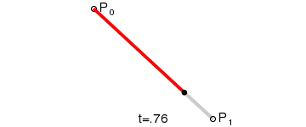
Given points P₀ and P₁, a linear Bézier curve is a straight line between those two points. The curve is given by B(t) where B(t) represents the moving point between two points P₀ and P₁, and $0≤t≤1$.
$$\begin{aligned}B\left(t\right)=P_{0}+t\left(P_{1}−P_{0}\right) \\ =\left(1−t\right)P_{0}+{\text{tP}}_{1}\end{aligned}$$

Quadratic Bézier curves
A quadratic Bézier curve is the path traced by the function B(t), given points P₀, P₁, and P₂. It departs from P₀ in the direction of P₁, then bends to arrive at P₂ in the direction from P₁.
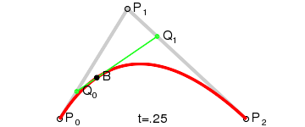
Consider the diagram below.

Using the diagram and a similar approach for Q₀ and Q₁ as detailed above in the linear model show that

Cubic Bézier curves
Four points P₀, P₁, P₂ and P₃ in the plane or in three-dimensional space define a cubic Bézier curve. The curve starts at P₀ going toward P₁ and arrives at P₃ coming from the direction of P₂. Usually, it will not pass through P₁ or P₂; these points are only there to provide directional information. The distance between P₀ and P₁ determines "how long" the curve moves into direction P₂ before turning towards P₃.
Using the diagram below show that the Bezier curve is defined as:

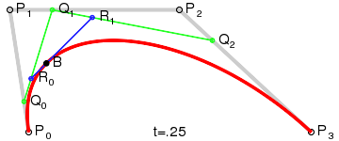

Make a conjecture
Make a conjecture about the Bezier curve, B(t), that would be generated if 5 points P₀ ,…, P₄ are used.
Prove your conjecture supplying a diagram to assist your formulation of the equation for B(t).
Task 2
Using appropriate software develop a shape, logo or design using Bezier curves. Be imaginative. Design a detailed logo or consider an animation character (or part of one).
Your resulting task must have:
- at least 4 Bezier curves, and some of these are to be of higher order than a cubic
- the mathematical development of at least 4 parametric equations describing these curves or some of the curves
- discussion of any difficulties you had with your design, and therefore limitations of the model developed.

Example

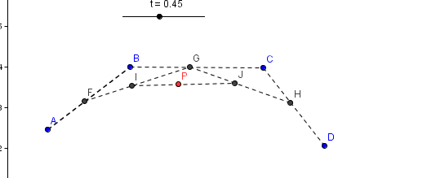

This is a sample set of instructions for the diagram above.

