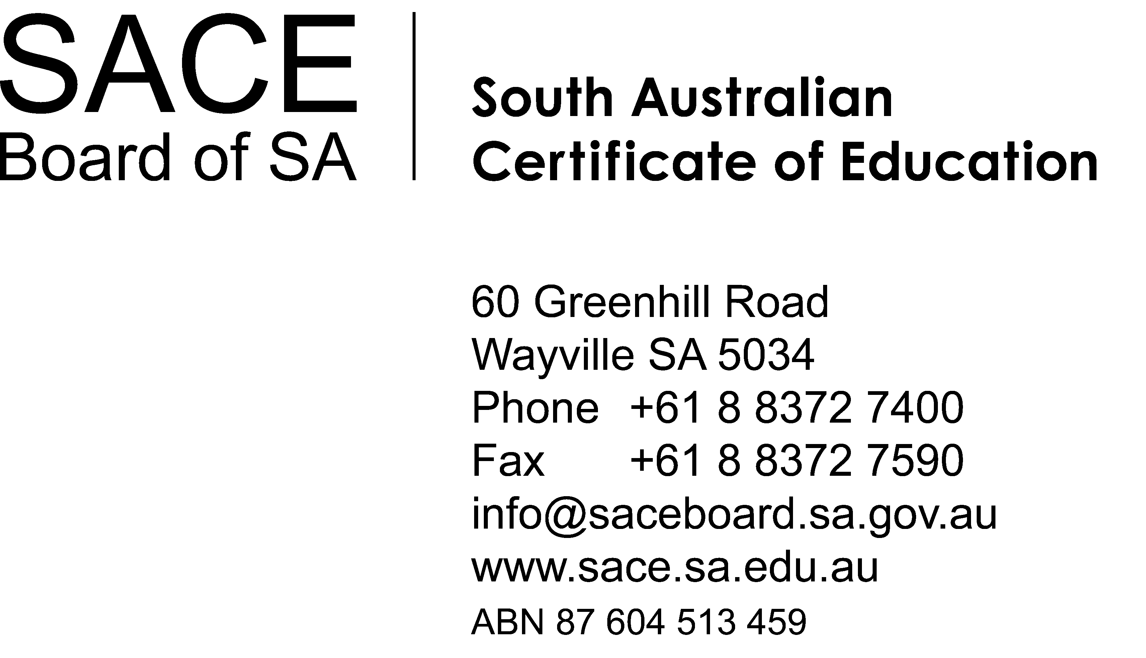

Minutes
Meeting: | IEU – SACE Board Collaborative Working Group | Date: | 2 June 2014
Location: | Conference Room, SACE Board of South Australia | Time: | 1.00 – 2.00pm

No. | Item
1 | Welcome and apologies  Attendees:  Neil McGoran (Chair), Chief Executive, SACE Board of South Australia  Glen Seidel, Secretary, Independent Education Union  Louise Firrell, Assistant Secretary, Independent Education Union  Cathy Schultz, A/Executive Manager, School Assessment Services  Andrew Green, Manager, Communications, SACE Board of South Australia  Hassan Mekawy, Manager, Professional Learning & Networks, SACE Board of South Australia  Alanna Langley, Executive Support Officer, SACE Board of South Australia  Apologies:  Jan Raymond, Executive Manager, School Assessment Services, SACE Board of South Australia  Susan Lohmeyer, Executive Coordinator, SACE Board of South Australia
2 | Confirmation of agenda  The agenda was confirmed without change.
3 | Confirmation of Minutes of meeting held 24 March 2014  The minutes of the meeting held Monday 24 March were confirmed without change.
4 | Discussion items:  4.1 Senior Secondary Australian Curriculum – progress report (verbal report)  The chair informed the group that a letter had been sent to all SACE Principals and Coordinators on Monday 2 June 2014 advising that the SACE Board has received funding approval to begin work on integrating the senior secondary Australian Curriculum into 15 SACE subjects.  This work will focus on how the Australian Curriculum content will be integrated using the relevant Units 1, 2, 3, and 4 of the Australian Curriculum.  Integration will occur in two phases:  Phase 1: Four English and four mathematics subjects (for teaching at Stage 1 in 2016, and Stage 2 in 2017)  Phase 2: Four science and two history subjects, and geography (for teaching at Stage 1in 2017, and Stage 2 in 2018).  Subjects that have the integrated Australian Curriculum content will retain their current structure and will continue to be identified as SACE subjects. The assessment requirements in these subjects will continue to be school assessed at Stage 1, and align with the 70:30 ratio of school and external assessment at Stage 2.  The Australian Curriculum general capabilities will be integrated progressively in all SACE subjects – those with Australian Curriculum content and those with existing SACE content.  The SACE Board will consult widely with teachers, schools, and other subject experts during integration of the curriculum, and will keep schools informed of progress. Consultation will commence early in 2015 with approval from the SACE Board planned for July 2015. Once approved, the SACE Board will provide workshops for teachers.  The IEU reported that teachers in regional areas have experienced difficulties in accessing SACE forums and workshops. The Manager, Professional Learning and Networks advised that the SACE Board does accommodate teachers in regional areas across South Australia, and that video conferencing is available for certain meetings.  ACTION: Hassan Mekawy to provide Clarifying Forum attendee data at the next meeting of the IEU – SACE Board Collaborative Working Group.  4.2 Institute of Educational Assessors – progress report  The Manager, Professional Learning and Networks provided a progress report on the Institute of Educational Assessors.  The Institute of Educational Assessors was proposed as one of the outcomes of the SACE First Year Evaluation. In its response to the Evaluation, the SACE Board identified “strengthening expertise in standards-based assessment” as a key focus area and priority.  The SACE Board has therefore determined to work in partnership with the school sectors, subject associations and the universities to progressively establish an Institute of Educational Assessors to focus on the development and accreditation of the professional expertise of teachers in assessment.  The primary purpose of the Institute will be to provide professional learning and services to meet the needs of professional teachers and educators seeking to strengthen their knowledge of, and practice in, assessment. The Institute will deliver training, professional development and certification in assessment and assessment practice, and will undertake research related to assessment and pedagogy. It is envisaged that the Institute will operate commercially; that is, fees will be charged for services provided, with revenue used to cover costs and ensure the Institute’s sustainability.  The SACE Board has met with representatives from Flinders University, University of South Australia and University of Adelaide collectively to consider an agreed recognition arrangement between the Institute and the universities. At this meeting there was an in-principal agreement from all three universities to support the recognition of the Certified Educational Assessor modules toward one quarter of a Graduate Certificate or one eighth of a Master’s degree (or equivalent).  Crown Law has advised that the Institute can operate as a ‘committee’ of the SACE Board, rather than as its own entity. This means that the Board will retain control and responsibility of the Institute.  By the end of the 2015 / 2016 Financial Year, it is expected that the Institute will be sustainable without the Government Funding and as such, with these additional funds  the Institute will be able to explore future growth possibilities.  4.3 Online Results Sheets project – outcomes of trial  The Chair advised that Online Results Sheets for the Research Project successfully opened on Monday 2 June 2014. Teachers can now enter their school assessment results in Schools Online, and Principals’ Delegates can review and submit these results sheets online.  A number of enhancements have been made to the system as a result of the successful trial held in March. 60 schools from a mix of sectors, locations, sizes, and technological profiles participated in the trial and provided valuable feedback.  By the end of 2014, Online Results Sheets will be used for every stage 2 subject. Schools will submit end-of-year Stage 2 school assessment results via Schools Online instead of using paper forms.  Further paper forms will be converted to online submission in 2015.  4.4 Research Project Student Expo  The Manager, Communications informed the group about the SACE Research Project Student Expo. The two-day event will be held on 13 & 14 August 2014, at the Royal Adelaide Showgrounds.  The expo is designed to inspire and inform students who are preparing to commence their Research Project in 2015. The event will provide support to those students who are considering their research question, and wanting to know more about how to research it. At least 4000 students are expected to attend the expo.  A range of organisations and experts, including the 3 universities, the State Library, Data SA, Australian Bureau of Statistics, SA Water and the Australian Research Centre will also be at the event to offer ideas and advice on potential research topics and questions.  Past and present students who have achieved excellence in the Research Project will be at the expo to offer hints on how to undertake the Research Project, overcome challenges, and meet the subject requirements.  All reading material provided to students at the expo (flyers, brochures, etc.) will be made available on the SACE website.
5 | Any other business
6 | Next Meeting  1 September 2014, 1.30 – 2.30pm, SACE Board of South Australia
7 | Close  The meeting closed at 1:58pm
Date of Distribution
19 June 2014

