Stage 2 Physical Education
Assessment Type 2: Improvement Analysis
City to Bay fun run
Task Description:
In this task you will prepare for and participate in the City to Bay fun run. The City to Bay fun run provides the opportunity for participants to be involved through a 12km, 6km or 3km fun run/walk event, or a 21.1km half marathon. To inform your preparation for the fun run you:
- identify your goal for the City to Bay fun run (e.g. what distance do you wish to participate in and will you walk or run?)
- identify one or more aspects of your ability to participate/perform in this fun run for improvement.
Your identified aspect(s) for improvement:
- may focus on physiological, biomechanical, and/or psychological areas
- may be related to one or more movement concepts and/or movement strategies.

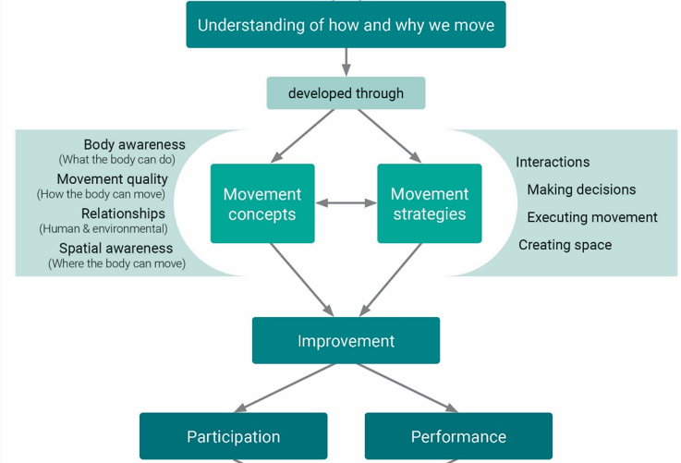

You design and implement strategies to improve the identified aspect(s) of your participation and/or performance for the fun run, and by collecting a range of evidence you monitor and evaluate the outcomes of your implemented strategies.
Step 1:
To identify the aspect(s) of the selected physical activity that you wish to focus on for improvement, collect data/measurements and seek feedback to assist you to evaluate your current proficiency in the identified aspect(s). The data may include a video record of your performance at the beginning of this task, and at several other stages during your improvement journey.
Select data/measurements that will allow you to monitor your performance over time, and to evaluate your performance improvement.
- You may choose to focus on your overall participation/performance (holistic view)
- You may choose to focus on a single aspect of your participation/performance.
Note: you should find or design measurement tools to monitor and support improvement for whichever of these options you select.
Step 2:
Devise and implement strategies to improve your ability to participate/perform in the identified aspect(s) over time and evaluate the effectiveness of your strategies. The evidence you collect at different stages of the improvement journey will:
- support you in monitoring your participation/performance improvement
- provide you with evidence to support your evaluation of your improvement
- assist in planning and implementing possible modifications to your strategies for improvement based on your ongoing evaluation of their effectiveness.
Step 3:
After participating in the City to Bay fun run, use the evidence you collected to evaluate the outcome of your participation/performance improvement journey. You should reflect on how you applied feedback and implemented strategies to improve your performance. Consideration of how you would continue to develop your ability to participate or perform in activities similar to the City to Bay fun run or to extend yourself into a similar or other direction are an important part of your final reflections in this assessment.

The Response:
Students produce their improvement analysis response as they undertake their individual journey of improvement. Their response format should suit the format of the evidence that they collect, and may include presentation of different forms of evidence (video, oral, written).
The improvement analysis response should be a maximum of 24 minutes for oral or multimodal presentations, or a maximum of 4000 words.
The response should include:
- analysis and evaluation of evidence relating to the aspect of physical activity identified for improvement
- research on and implementation of strategies for improvement
- evaluation of and modification to the implemented strategies
- an evaluation of the improvement of the identified aspect of physical activity
- reflection on, and evaluation of, the overall success of the strategies implemented for improvement
- recommendations for future directions.

Performance standards for Physical Education
Stage 2
- | Application | Analysis and Evaluation
A | Insightful and highly effective contextual application of knowledge and understanding to movement concepts and strategies.  Highly effective and focused application of collaborative skills in physical activity contexts.  Highly strategic application of evidence to inform the implementation of strategies for participation and/or performance improvement.  Highly effective use of accurate subject-specific terminology. | Critical analysis and perceptive evaluation of evidence relating to physical activity.  Insightful reflection on and evaluation of participation and/or performance improvement.  Perceptive evaluation of implemented strategies.
B | Considered and mostly effective contextual application of knowledge and understanding to movement concepts and strategies.  Mostly effective application of collaborative skills in physical activity contexts.  Strategic application of evidence to inform the implementation of strategies for participation and/or performance improvement.  Mostly effective use of accurate subject-specific terminology. | Thoughtful analysis and evaluation of evidence relating to physical activity.  Considered reflection on and evaluation of participation and/or performance improvement with some insights.  Thoughtful evaluation of implemented strategies.
C | Contextual application of knowledge and understanding to movement concepts and strategies.  Generally effective application of collaborative skills in physical activity contexts.  Competent application of evidence to inform the implementation of strategies for participation and/or performance improvement.  Generally effective use of subject-specific terminology. | Competent analysis, with some evaluation, of evidence relating to physical activity.  Competent reflection on, with some evaluation, of participation and/or performance improvement.  Description, with some evaluation, of implemented strategies.
D | Some application of knowledge and understanding to movement concepts and strategies.  Some application of collaborative skills in physical activity contexts.  Some application of evidence to inform the implementation of strategies for participation and/or performance improvement.  Some use of subject-specific terminology. | Basic analysis and description of evidence relating to physical activity.  Basic reflection on and description of participation and/or performance improvement.  Description of implemented strategies.
E | Attempted application of knowledge and understanding to movement concepts and strategies.  Attempted application of collaborative skills in physical activity contexts.  Attempted application of evidence to inform the implementation of strategies for participation and/or performance improvement.  Attempted use of subject-specific terminology. | Attempted description of evidence relating to physical activity.  Attempted reflection on and description of participation and/or performance improvement.  Attempted description of implemented strategies.

