DO WE NEED BIG SCIENCE?
Stage 2 Physics – Assessment Type 1: Investigations Folio
Science as a Human Endeavour Task

Some of the tools needed to investigate cutting edge physics are large projects that require large teams of scientists and millions (or billions) of dollars - this is often termed “Big Science”.

Your task is to explain the physics behind your chosen topic related to the Stage 2 Physics course and focus on an aspect (or several aspects) of Science as a Human Endeavour in the development, influences, collaboration/communication or application of the project.

This table contains some examples of “Big Science”, however there are many more examples and please feel free to find a project that interests you that is not in the list:

The Square Kilometre Array | Australian Synchrotron
OPAL (Open-Pool Australian Lightwater reactor) | Bragg Institute
The Relativistic Heavy Ion Collider | Large Hadron Collider
Laser Interferometer Gravitational-Wave Observatory | Hubble Telescope
National Ignition Facility (High powered LASER) | Juno (Jupiter Orbiter)
ITER (International Thermonuclear Experimental Reactor) | Advanced Light Source
Super-Kamiokande Neutrino Detector | The Earthscope

It is important that you consider the physics of the project as well as the interaction between physics and society - how society shapes physics and how physics in turn shapes society. Please read the subject outline but this graphic gives you an overview of the main aspects of Science as a Human Endeavour.

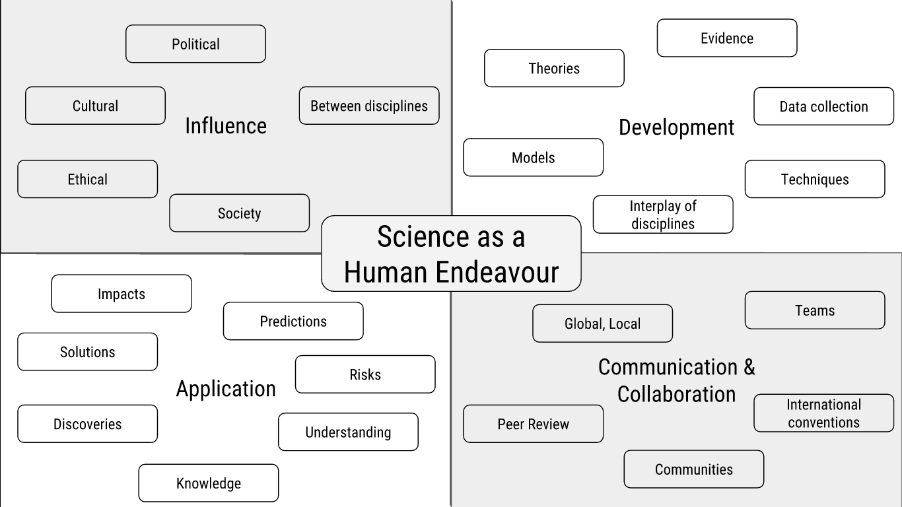

Based on your investigation, you will prepare a scientific report, which must include the use of scientific terminology and:
- an introduction to identify the focus of the investigation and the key concept(s) of science as a human endeavour that it links to
- relevant physics concepts or background
- an explanation of how the focus of the investigation illustrates the interaction between science and society, including a discussion of the purpose, potential impact, or application of the focus of the investigation, e.g. further development, effect on quality of life, environmental implications, economic impact, intrinsic interest
- a conclusion summarising the connection between the big science project and your selected SHE concepts
- citations and reference list or bibliography.
The scientific report should be a maximum of 1500 words* if written, or a maximum of 10 minutes for an oral presentation, or the equivalent in multimodal form.

*The word-count includes headings, direct quotations, and footnotes that are used as explanatory notes. The word-count does not include the title/question page or the reference list or bibliography (including footnotes or in-text references that are used to list author, date, and page numbers).

Student Name: Draft word count: Draft Due Date:

Big Science - Science as a Human Endeavour
Draft Feedback

Criteria | Evidence of  Exceeding the Standard | What  Meeting the Standard Looks Like | Evidence of  Requiring Improvement
KA1 Demonstrates deep and broad knowledge and understanding of a range of physics concepts. |  | The physics covers a range of physics potentially from different areas of the subject outline. You show deep understanding of concepts related to the big science project.
KA3 Critically explores and understands in depth the interaction between science and society. |  | The report communicates how the project has been shaped by society or how society has been shaped by the project. At least one key concepts of SHE is discussed with explicit links to the evidence.
KA4 Communicates knowledge and understanding of physics coherently, with highly effective use of appropriate terms, conventions, and representations. |  | The physics is relevant with clear links between the big science project and physics within the subject outline. The physics is clearly explained, well expressed and supported with diagrams, formulas, graphs or tables.

Due Date: Word Count: Student Name:

Big Science - Science as a Human Endeavour Task Rubric

 | A | B | C | D | E
KA1 | Demonstrates deep and broad knowledge and understanding of a range of physics concepts. | Demonstrates some depth and breadth of knowledge and understanding of a range of physics concepts. | Demonstrates knowledge and understanding of a general range of physics concepts. | Demonstrates some basic knowledge and partial understanding of physics concepts. | Demonstrates limited recognition and awareness of physics concepts. |  | I
KA3 | Critically explores and understands in depth the interaction between science and society. | Logically explores and understands in some depth the interaction between science and society. | Explores and understands aspects of the interaction between science and society. | Partially explores and recognises aspects of the interaction between science and society. | Attempts to explore and identify an aspect of the interaction between science and society. |  | I
KA4 | Communicates knowledge and understanding of physics coherently with highly effective use of appropriate terms, conventions, and representations. | Communicates knowledge and understanding of physics mostly coherently with effective use of appropriate terms, conventions, and representations. | Communicates knowledge and understanding of physics generally effectively, using some appropriate terms, conventions, and representations. | Communicates basic physics information, using some appropriate terms, conventions, and/or representations. | Attempts to communicate information about physics. |  | I
Comment: |  |  |  |  |  | Grade:

