Name:
Stage 1 Physics Skills and Applications Task - Rocket Science Test - 50 marks
For the formulae refer to the equation sheet

- The closest galaxy is 2.5 million light years away.
  - Define the term light year.

(2 marks)
  - Calculate the distance travelled by light in one hour.

(2 marks)
- Circle the vector quantities:
mass speed displacement time weight
(1 mark)
- What is the speed of a rocket that travels 9000 metres in 12.00 seconds?

(2 marks)
- A car accelerates at a rate of 4 ms⁻² from rest in 6 seconds. Determine:
  - The final speed of the car.

(2 marks)
  - The distance the car travelled to achieve the final speed.

(3 marks)

- Below is the graph of a two stage rocket.
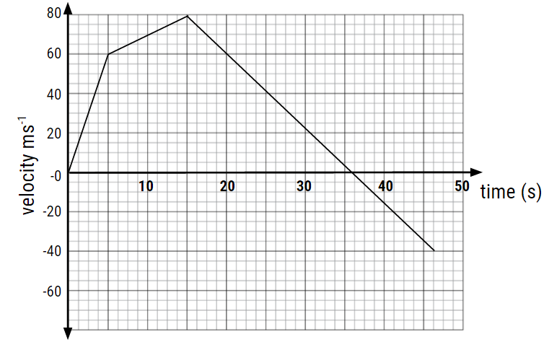
  - What is the time of burn for the second rocket stage?

(1 mark)
  - At what time after lift-off does the rocket reach apogee?

(1 mark)
  - At what height does the second rocket stage fire?

(2 marks)

  - What is the acceleration of the rocket after both stages have completed their burns and the rocket is in freefall?

(3 marks)

- The diagram below shows the landing and traverse map of the rover Spirit on the surface of Mars. The rover landed on the centre of spot ① on Sol 0, travelled in a near straight line to the centre of ②, a journey that took 64 sols (one sol = 1 Martian day = 24h 39m 35). Then Spirit turned and travelled to the centre of point ③.
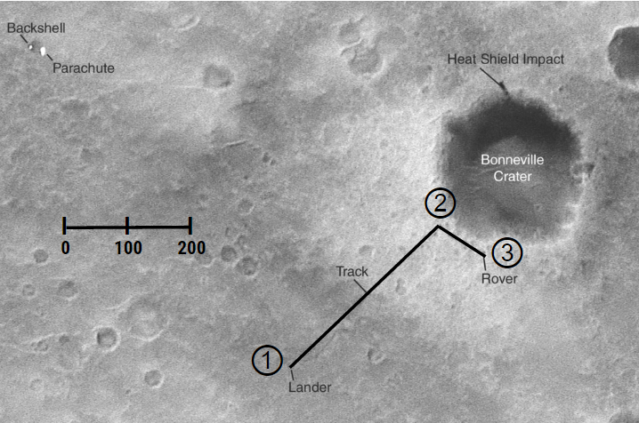
https://upload.wikimedia.org/wikipedia/commons/thumb/e/eb/Spirit_tracks.png/300px-Spirit_tracks.png
Using your ruler: and the scale indicated:
  - Determine the distance travelled by the rover from to ① to ③.

(1 mark)

  - Determine the displacement of the rover from to ① to ③.

(1 mark)
- If the Mars rover travels at a top speed of 0.038 ms⁻¹ how long does it take to travel 1.0 metre?

(2 marks)
The original mission plan was for the rover to last 90 sols, but instead lasted an impressive 2208 sols and traversed a total distance of 7,730.50 meters, Determine the average speed (in metres per sols) during the entire mission. (2 marks)

- A 100kg astronaut (including the spacesuit) becomes untethered during a space-walk and drifts to a distance of 10 metres from his spaceship. To get back to the ship, he throws a 1.5 kg hammer away with an acceleration of 10.0ms⁻².
  - How do the laws of physics help the situation for this astronaut?

(2 marks)
  - Calculate the force that acts on the hammer.

(2 marks)
  - Determine the acceleration imparted to the astronaut.

- marks)
9. Below is a picture of Neil Armstrong. He is 91kg and his suit is 34kg.
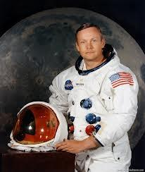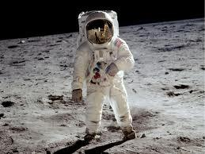
http://www.nasa.gov/images/content/464436main_S69-31741_full.jpg https://upload.wikimedia.org/wikipedia/commons/1/12/Buzz_Aldrin_Apollo_Spacesuit.jpg
Photos courtesy NASA/JPL-Caltech

  - Calculate the magnitude of the total weight of Neil Armstrong in his space suit on Earth. Include correct units in your answer.

(2 marks)
  - The same astronaut now stands at rest on the surface of the Moon. His weight is 201N vertically downward. Calculate the magnitude of the acceleration due to gravity on the Moon. Include correct units in your answer.

- marks)
- The rocket motors were turned off after 3 minutes and the rocket coasted in space. Some time later another burn was necessary to produce a course correction. This burn lasted for 3 seconds and produced 88 000 N of force. The mass of the rocket was 44 000 kg.
  - Explain the term coasted in terms of velocity and acceleration.

(2 marks)
  - What is the acceleration of the spacecraft during the 3 second burn?

- marks)
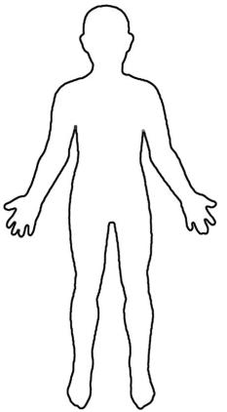
- During lift off of a rocket, accelerations are extreme. When the human body has forces exerted on it greater than 6 – 8 g, blackout can occur. Explain in terms of inertia how blackout can occur. Use the diagram to assist your explanation.

- marks)
- Describe the forces on a rocket, using free-body diagrams to assist you in your explanation of forces on a rocket and hence its motion as it
- sits on the launch pad
- accelerates through the atmosphere
- orbits the Earth
(8 marks - 6 marks content, 2 marks communication)

Performance Standards for Physics
 | Investigation, Analysis and Evaluation | Knowledge and Application
A | Critically deconstructs a problem and designs a logical, coherent, and detailed physics investigation.  Obtains, records, and represents data, using appropriate conventions and formats accurately and highly effectively.  Systematically analyses and interprets data and evidence to formulate logical conclusions with detailed justification.  Critically and logically evaluates procedures and their effect on data. | Demonstrates deep and broad knowledge and understanding of a range of physics concepts.  Applies physics concepts highly effectively in new and familiar contexts.  Critically explores and understands in depth the interaction between science and society.  Communicates knowledge and understanding of physics coherently, with highly effective use of appropriate terms, conventions, and representations.
B | Logically deconstructs a problem and designs a well-considered and clear physics investigation.  Obtains, records, and displays data, using appropriate conventions and formats mostly accurately and effectively.  Logically analyses and interprets data and evidence to formulate suitable conclusions with reasonable justification.  Logically evaluates procedures and their effect on data. | Demonstrates some depth and breadth of knowledge and understanding of a range of physics concepts.  Applies physics concepts mostly effectively in new and familiar contexts.  Logically explores and understands in some depth the interaction between science and society.  Communicates knowledge and understanding of physics mostly coherently, with effective use of appropriate terms, conventions, and representations.
C | Deconstructs a problem and designs a considered and generally clear physics investigation.  Obtains, records, and displays data, using generally appropriate conventions and formats with some errors but generally accurately and effectively.  Undertakes some analysis and interpretation of data and evidence to formulate generally appropriate conclusions with some justification.  Evaluates procedures and some of their effect on data. | Demonstrates knowledge and understanding of a general range of physics concepts.  Applies physics concepts generally effectively in new or familiar contexts.  Explores and understands aspects of the interaction between science and society.  Communicates knowledge and understanding of physics generally effectively, using some appropriate terms, conventions, and representations.
D | Prepares a basic deconstruction of a problem and an outline of a physics investigation.  Obtains, records, and displays data, using conventions and formats inconsistently, with occasional accuracy and effectiveness.  Describes data and undertakes some basic interpretation to formulate a basic conclusion.  Attempts to evaluate procedures or suggest an effect on data. | Demonstrates some basic knowledge and partial understanding of physics concepts.  Applies some physics concepts in familiar contexts.  Partially explores and recognises aspects of the interaction between science and society.  Communicates basic physics information, using some appropriate terms, conventions, and/or representations.
E | Attempts a simple deconstruction of a problem and a procedure for a physics investigation.  Attempts to record and display some descriptive data, with limited accuracy or effectiveness.  Attempts to describe results and/or interpret data to formulate a basic conclusion.  Acknowledges that procedures affect data. | Demonstrates limited recognition and awareness of physics concepts.  Attempts to apply physics concepts in familiar contexts.  Attempts to explore and identify an aspect of the interaction between science and society.  Attempts to communicate information about physics.

