Stage 2 Language and Culture

External Assessment Cover Sheet
Assessment Type 4: Investigation

SACE Registration Number:

Issue: How has the raising of Dinka culture changed since their migration to Western countries?
word count ___

This investigation is assessed using the following specific features:

Knowledge and Understanding |  | Analysis and Reflection | Ideas and Expression
KU1* |  | AR2 | IE2
KU2* |  | AR3 | IE3
KU3*

*Teachers must include at least one of KU1, KU2, or KU3. Please tick as appropriate.

How has the raising of children in the Dinka culture changed since their migration to Western countries?
The topic allows for establishing knowledge and understanding in different contexts
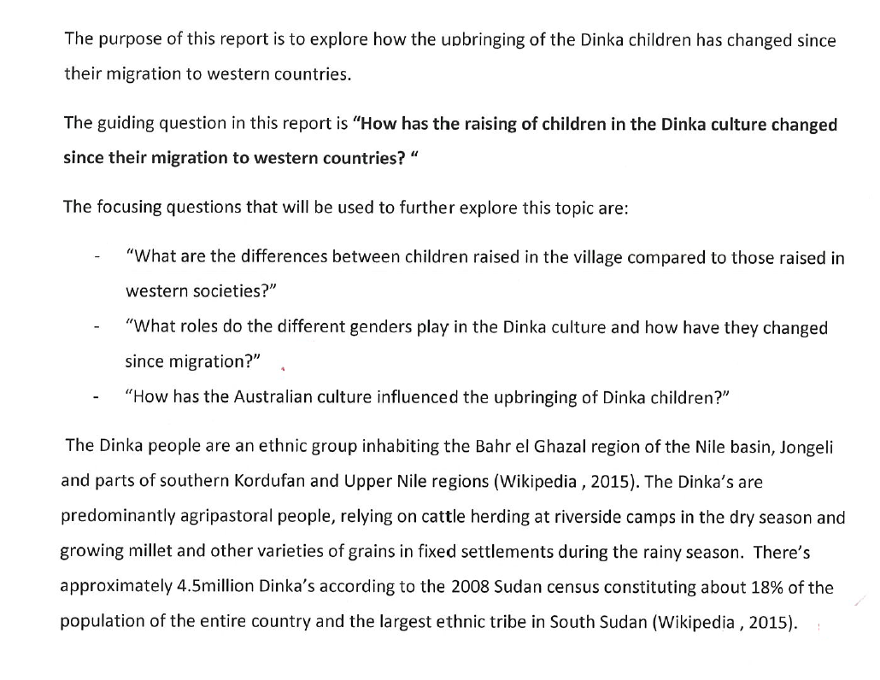

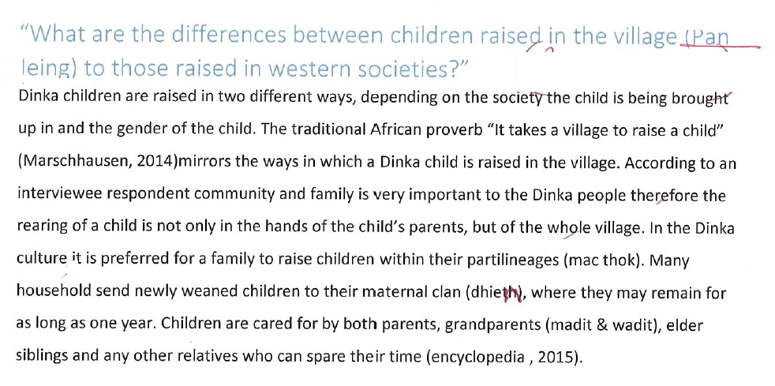

Knowledge and understanding of culture

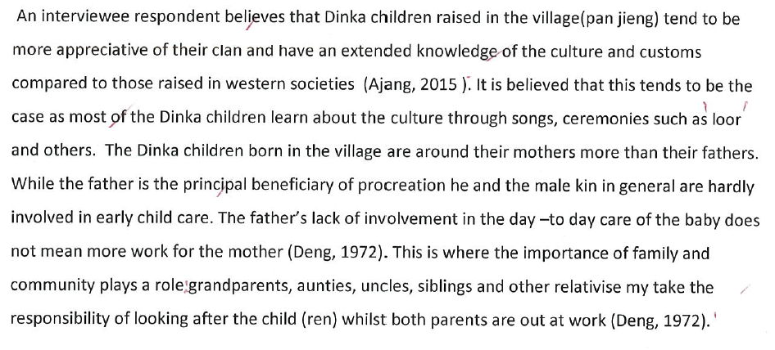
Use of primary sources

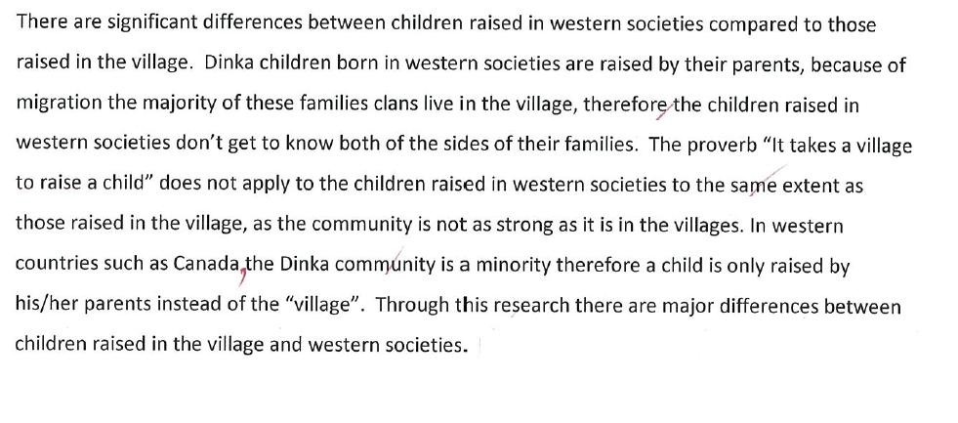
Well considered knowledge and understanding of culture in different contexts. (KU1)

No evidence of knowledge and understanding of language in different contexts (KU1)

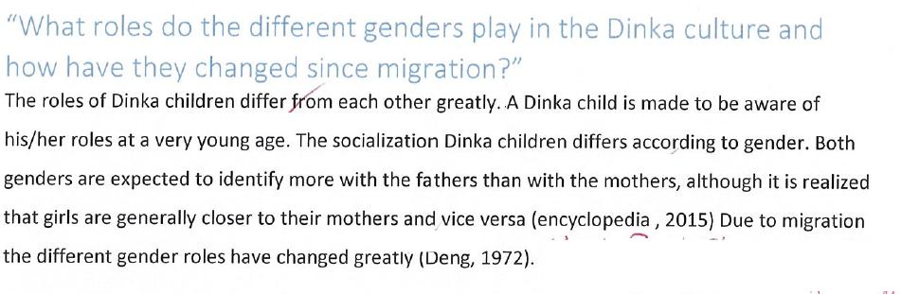

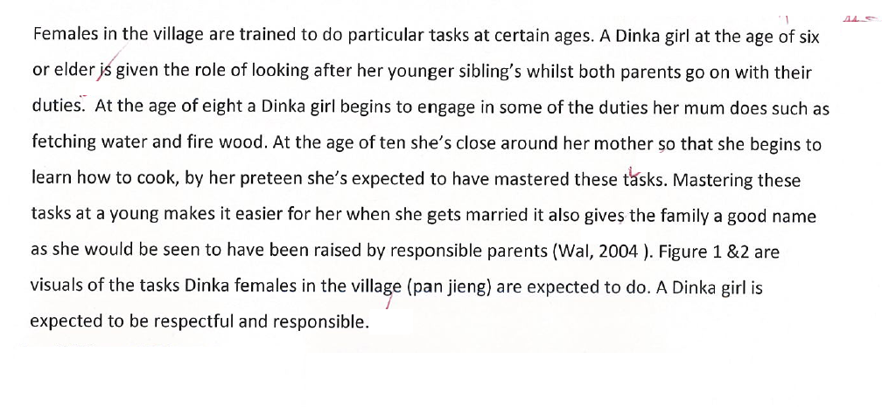
A range of complex linguistic structures and features are used with a high degree of accuracy to convey meaning (IE1)

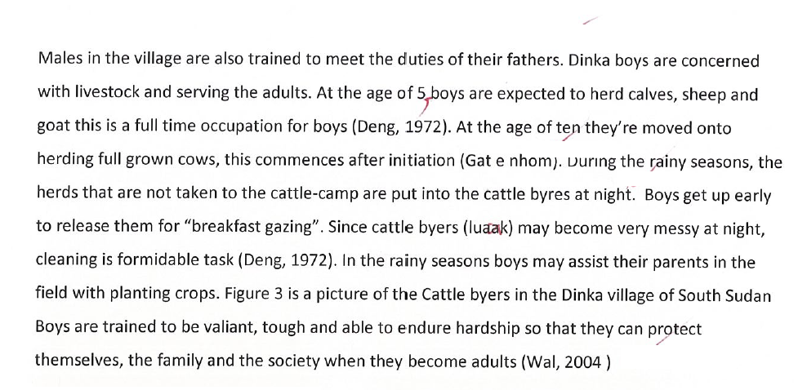

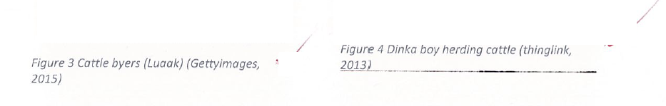

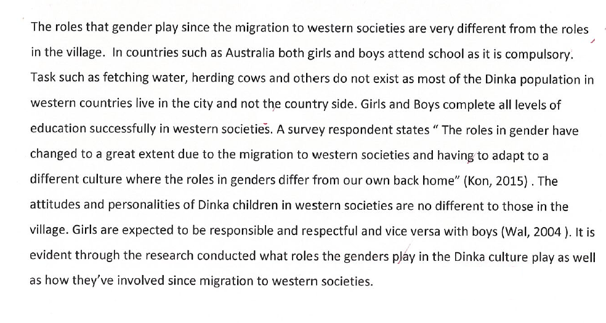
A range of complex linguistic structures and features are used with a high degree of accuracy to convey meaning (IE1)
Simple ideas are expressed and opinions are supported with reference to different sources and perspectives (IE2)

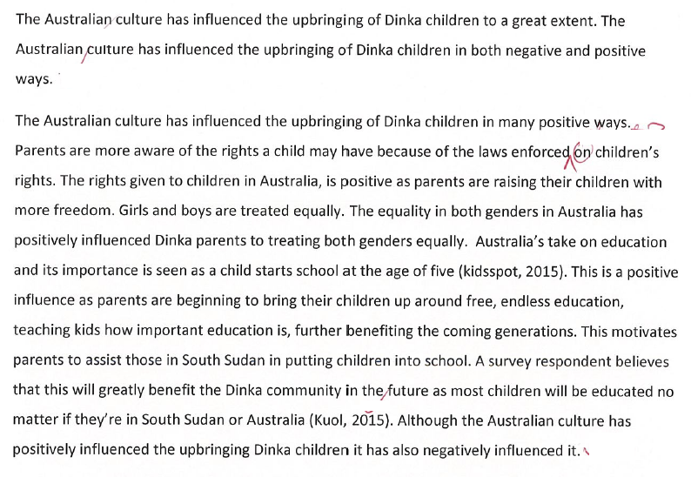
To what extent has the Australia culture influenced the upbringing of Dinka children”

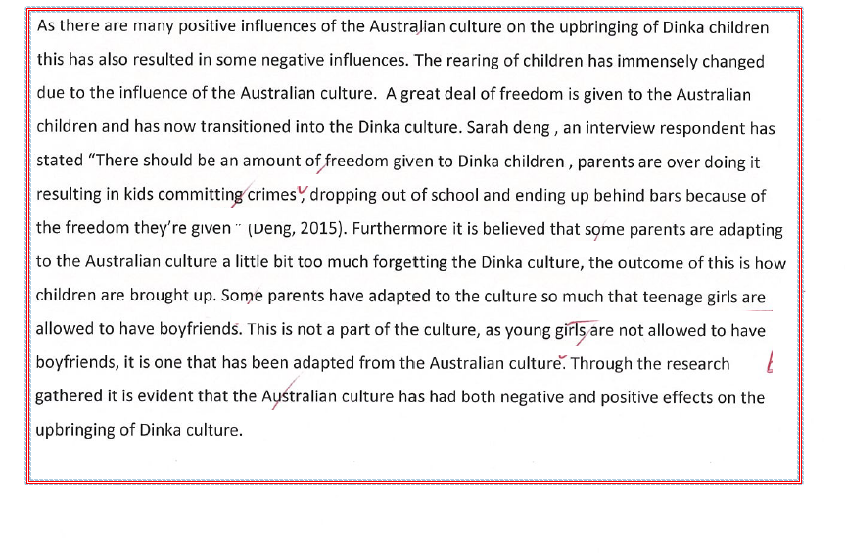
Some reflection on how language and cultural background relate to an individual’s sense of personal identity in the Australian context (AR2)

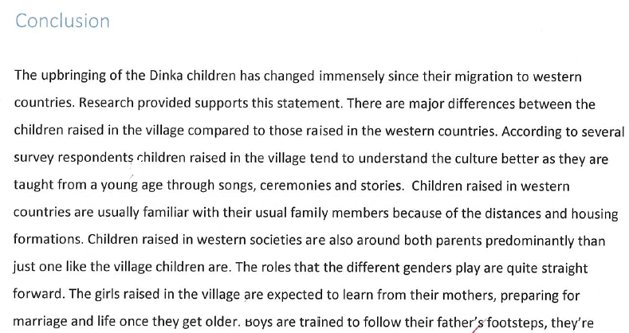
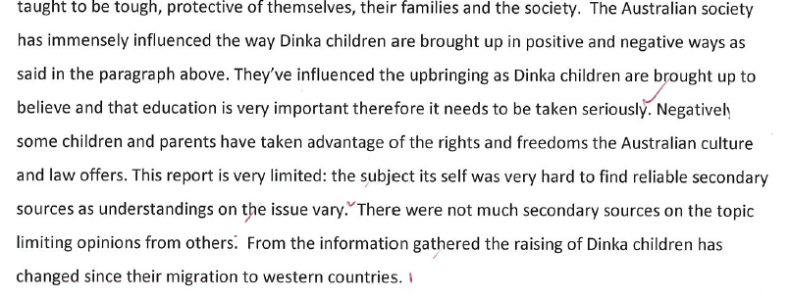
Evidence of secondary sources used

Additional Comments
Overall Grade: B
There is breadth and some depth in the treatment of the topic with a clear and effective presentation and discussion on the findings. Some complex ideas are expressed and supported. The report is structured in a coherent way as most conventions of the text type have been observed. There is evidence of well- considered knowledge and understanding of the culture in different contexts. There was no evidence of how the people move between languages and cultures and how the language is sustained in an Australian context.

Performance Standards for Stage 2 Language and Culture

 | Knowledge and Understanding | Analysis and Reflection | Ideas and Expression
A | Language and Culture in Different Contexts  Insightful knowledge and understanding of language and culture in different contexts.  Language as a System  Clear and thorough knowledge and understanding of the target language as a system.  Language Origins, Development, and/or Change  Clear and well-informed understanding of, for example:  the origins/heritage of the target language, the historical development of the target language, and the dynamic nature of the target language  the relationship with, and influences of, other regional languages, local dialect(s), and regional variation  global influences on the target language, word-borrowing, and the use of global English in familiar contexts. | Analysis  The functions of particular linguistic and cultural features in the text identified and explained with clarity and insight.  Detailed explanation of how some stylistic features are used for effect/impact in the text (e.g. register, tone, textual features/organisation).  Perceptive analysis of communication across cultural boundaries and the meaning of words/phrases in particular contexts, including explanation of some subtleties of translation.  Reflection  In-depth analysis of and reflection on how cultures, values, beliefs, practices, and ideas are represented or expressed in texts.  Insightful reflection on own values, beliefs, ideas, and practices in relation to those represented in texts.  Critical reflection on how language and cultural background relate to an individual’s sense of personal identity in the Australian context.  Interpretation  Concepts and perspectives represented in texts identified and explained with clarity and insight.  Interpretations of meaning supported by detailed and appropriate use of evidence from texts. | Accuracy, Appropriateness, Range, and Clarity of Expression  A range of complex linguistic structures and features used with a high degree of accuracy to convey meaning and create desired impact.  Very effective, fluent, and precise communication.  Language selected and register are consistently appropriate to the particular cultural and social context.  Standard target language pronunciation used. Some accent/dialect may be evident, but this does not impede meaning. Intonation and stress used effectively to enhance meaning.  Depth of Treatment  Depth and breadth in the treatment of the topic/research.  Detailed, clear, and very effective presentation and discussion of insights, findings, and conclusions based on research.  Complex ideas elaborated in detail, and opinions supported by evidence from a range of sources and perspectives.  Coherence in Structure and Sequence  Information and ideas organised logically and coherently, using a range of cohesive devices.  Conventions of the text type are observed.
B | Language and Culture in Different Contexts  Well-considered knowledge and understanding of language and culture in different contexts.  Language as a System  Clear knowledge and understanding of the target language as a system.  Language Origins, Development, and/or Change  Mostly clear and informed understanding of, for example:  the origins/heritage of the target language, the historical development of the target language, and the dynamic nature of the target language  the relationship with and influences of other regional languages, local dialect(s), and regional variation  global influences on the target language, word-borrowing, and the use of global English in familiar contexts. | Analysis  The functions of particular linguistic and cultural features in the text identified and explained with some clarity.  Description of how some stylistic features are used for effect/impact in the text (e.g. register, tone, and textual features/organisation).  Well-considered analysis of communication across cultural boundaries and the meaning of words/phrases in particular contexts, including explanation of one or more subtleties of translation.  Reflection  Well-informed analysis of and reflection on how cultures, values, beliefs, practices, and ideas are represented or expressed in texts.  Well-considered reflection on own values, beliefs, ideas, and practices in relation to those represented in texts.  Some critical reflection on how language and cultural background relate to an individual’s sense of personal identity in the Australian context.  Interpretation  Key concepts and perspectives represented in texts identified and explained with some clarity.  Interpretations of meaning supported by some appropriate examples from the text. | Accuracy, Appropriateness, Range, and Clarity of Expression  A range of linguistic structures and features used mostly accurately to convey meaning.  Effective and mostly clear communication.  Language selected and register mostly appropriate to the particular cultural and social context.  Generally accurate pronunciation. Some accent/dialect may be evident, but this does not generally impede meaning.  Depth of Treatment  Breadth and some depth in the treatment of the topic/research.  Clear and effective presentation and discussion of insights, findings, and conclusions.  Some complex ideas expressed, and opinions/points of view supported, with reference to a range of sources and perspectives.  Coherence in Structure and Sequence  Mostly coherent organisation of information and ideas, using some cohesive devices.  Most conventions of the text type observed.
C | Language and Culture in Different Contexts  Considered knowledge and understanding of language and culture in different contexts.  Language as a System  Competent knowledge and understanding of the target language as a system.  Language Origins, Development, and/or Change  Generally informed understanding of, for example:  the origins/heritage of the target language, the historical development of the target language, and the dynamic nature of the target language  the relationship with and influences of other regional languages, local dialect(s), and regional variation  global influences on the target language, word-borrowing, and the use of global English in familiar contexts. | Analysis  Particular linguistic and cultural features in texts identified and described.  Some stylistic features (e.g. idiom) recognised and described.  Considered analysis of communication across cultural boundaries and the meaning of words/phrases in particular contexts, including recognition of one or more subtleties of translation.  Reflection  Informed analysis of, and some reflection on, cultures, values, beliefs, practices, and ideas represented or expressed in texts.  Some reflection on own values, beliefs, ideas, and practices in relation to those represented or expressed in texts.  Some reflection on how language and cultural background relate to an individual’s sense of personal identity in the Australian context.  Interpretation  Main points and ideas in texts and supporting details identified, with some explanation.  Interpretations of meaning supported with isolated examples from the text. | Accuracy, Appropriateness, Range, and Clarity of Expression  A range of linguistic structures and features used with variable accuracy to convey meaning, often with reliance on rehearsed patterns.  Generally competent communication.  Language selected and register show awareness of and are generally appropriate to the particular cultural and social context.  Pronunciation is understandable. Accent/dialect may influence pronunciation, but does not interfere with meaning.  Depth of Treatment  Some variety in the treatment of the topic/research.  Competent presentation and discussion of insights, findings, and conclusions.  Simple ideas expressed, and opinions/points of view supported, with reference to different sources and perspectives.  Coherence in Structure and Sequence  Generally coherent organisation of information and ideas, often relying on one or two cohesive devices.  Responses generally conform to familiar conventions of the text type.
D | Language and Culture in Different Contexts  Basic knowledge and some understanding of language and culture in different contexts.  Language as a System  Basic knowledge and some understanding of the target language as a system.  Language Origins, Development, and/or Change  Some awareness of, for example:  the origins/heritage of the target language, the historical development of the target language, or the dynamic nature of the target language  the relationship with and influences of other regional languages, local dialect(s), or regional variation  global influences on the target language, word-borrowing, or the use of global English in familiar contexts. | Analysis  One or more basic linguistic and/or cultural features identified.  One or more stylistic features are identified.  Awareness and some description of communication across cultural boundaries, and of the meaning of words/phrases in particular contexts.  Reflection  Some aspects of cultural practices represented or expressed in texts identified.  Elements of learning experiences recounted to demonstrate partial understanding of the relationship between own values, beliefs, ideas, and practices and those represented or expressed in texts.  Some description of how language and cultural background relate to an individual’s sense of personal identity in the Australian context.  Interpretation  Some main points in texts identified, with some personal observations.  Specific information in texts transcribed rather than interpreted, often with minimal justification and elaboration. | Accuracy, Appropriateness, Range, and Clarity of Expression  Some basic meaning conveyed with frequent errors and reliance on formulaic expressions.  Some communication, using basic vocabulary and sentence structures.  Language and register occasionally appropriate to context.  Pronunciation may impede meaning.  Depth of Treatment  Some basic treatment of information or ideas.  Presentation of some basic findings.  Superficial and often repetitive ideas expressed, with reference to one or more sources.  Coherence in Structure and Sequence  Responses tend to be loosely connected sentences on a given topic.  Inconsistent use of limited conventions of the text type.
E | Language and Culture in Different Contexts  Identification of one or more examples of language and culture in different contexts.  Language as a System  Identification of a limited range of examples of the target language as a system.  Language Origins, Development, and/or Change  Emerging awareness of, for example:  the origins/heritage of the target language, the historical development of the target language, or the dynamic nature of the target language  the relationship with and influences of other regional languages, local dialect(s), or regional variation  global influences on the target language, word-borrowing, or the use of global English in familiar contexts. | Analysis  Attempted identification of one or more formulaic linguistic or cultural features.  One or more stylistic features are identified.  Emerging awareness of communication across cultural boundaries.  Reflection  Attempted identification of one or more familiar aspects of cultural practices represented or expressed in a text.  One or more elements of language learning experiences recounted.  Attempted description of how language and cultural background relate to an individual’s sense of personal identity in the Australian context.  Interpretation  Isolated items of information identified.  Literal translations of words/phrases provided. | Accuracy, Appropriateness, Range, and Clarity of Expression  Single words and set formulaic expressions used to convey basic information, with frequent errors that impede meaning.  Attempted communication, using a limited range of basic vocabulary and sentence structures.  Limited appropriateness of register to context.  Pronunciation impedes meaning.  Depth of Treatment  Attempted treatment of simple information.  Attempted description of information from one source.  Coherence in Structure and Sequence  Responses are disjointed.  Attempted use of one or more conventions of the text type.

