Stage 2 Health
Assessment Type 1: Group Investigation and Presentation
Student Response 2
Purpose:
To identify and evaluate the effectiveness of a health promoting strategy in maintaining and/or improving the wellbeing of adolescents, plan and implement a health promoting strategy or social action to a sub-population at the High School community.
Description of Assessment:
This assessment consists of two parts, a group investigation and presentation, and an individual discussion.

Part 1: Group Investigation and Presentation
- As a group, select a contemporary health issue associated with a topic of study, and then investigate the impact of the issue on the health and well-being of adolescents.

Possible health concerns that can generate health issues include:
- stress management
- fitness
- cyber safety
- use of drugs
- body image.

- Gather relevant information from a variety of primary and secondary sources such as observations, interviews, surveys, information from health agencies, print and/or electronic sources. Relevant community agencies and/or health professionals are also a helpful source of information.

- As a group, evaluate the effectiveness of an appropriate health-promoting strategy in maintaining or improving the health and well-being of adolescents, relevant to your selected issue.

- As a group, plan, research, and present your Idea for a health-promoting activity or social action to an audience. The presentation will be recorded.

- Present your findings to your target audience, relating the impact of the health issue, your findings, and the health-promoting strategies developed. Evaluate the Influence of existing health promoting activities and the role at the community agencies that you accessed.

Part 2: Individual Discussion
Individually present evidence of a discussion related to the group investigation and presentation. This must include:
- evidence of your participation and collaboration in the group planning and presentation (e.g. a verification feedback sheet, a video, audio tapes, or photographs)
- a personal reflection describing your preparation
- an evaluation of the researched information
- an evaluation of the factors that contributed to the effectiveness of the group exercise
- an evaluation of working in the group
- an evaluation of the health-promoting activity or recommended social action.
Assessment Conditions
The activity may take a variety of forms, such as workshops, debate, mime, or display, and can include print and multi-media technologies. The audience may be teacher and/or the class, or another group.
The individual discussion is presented in written, oral or multimodal form.
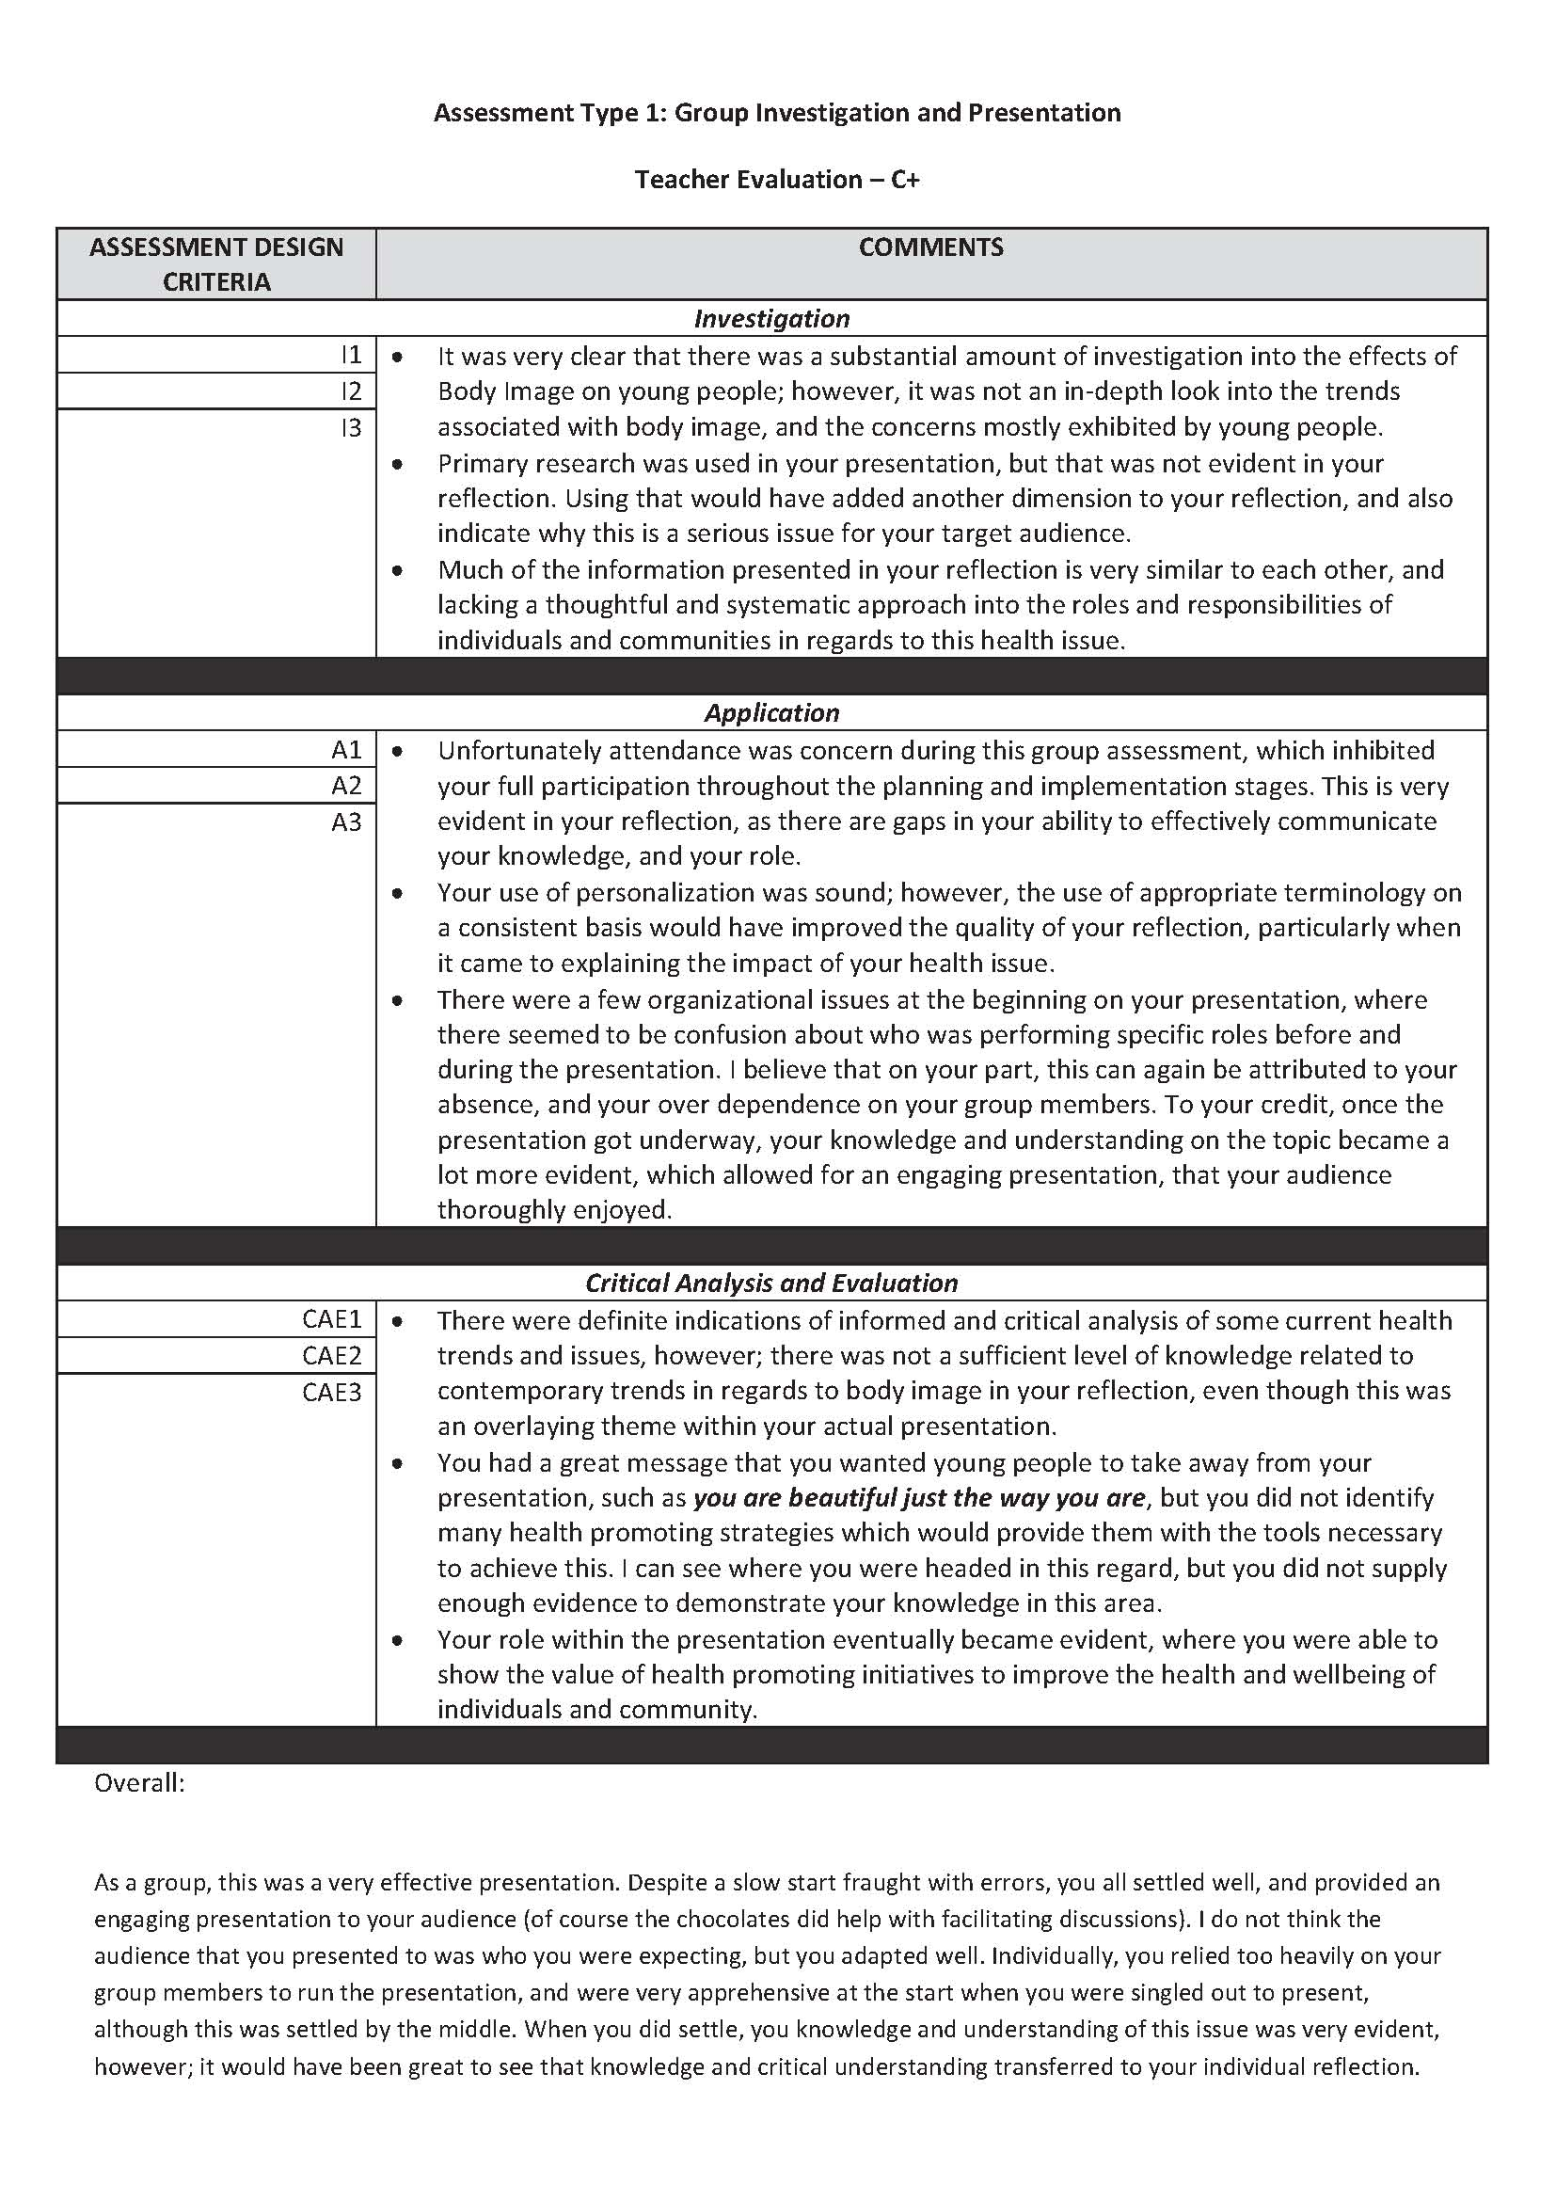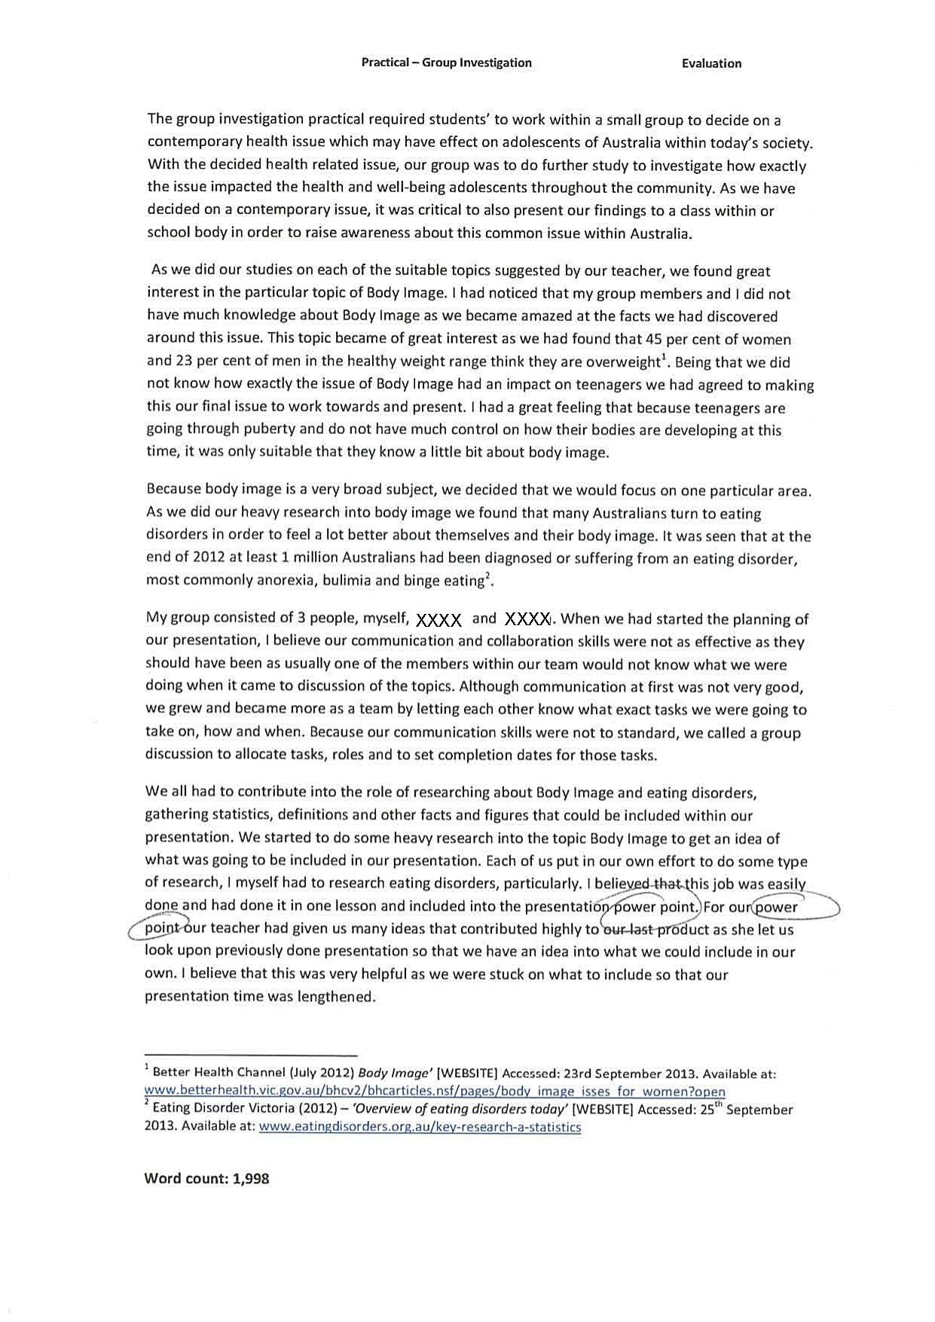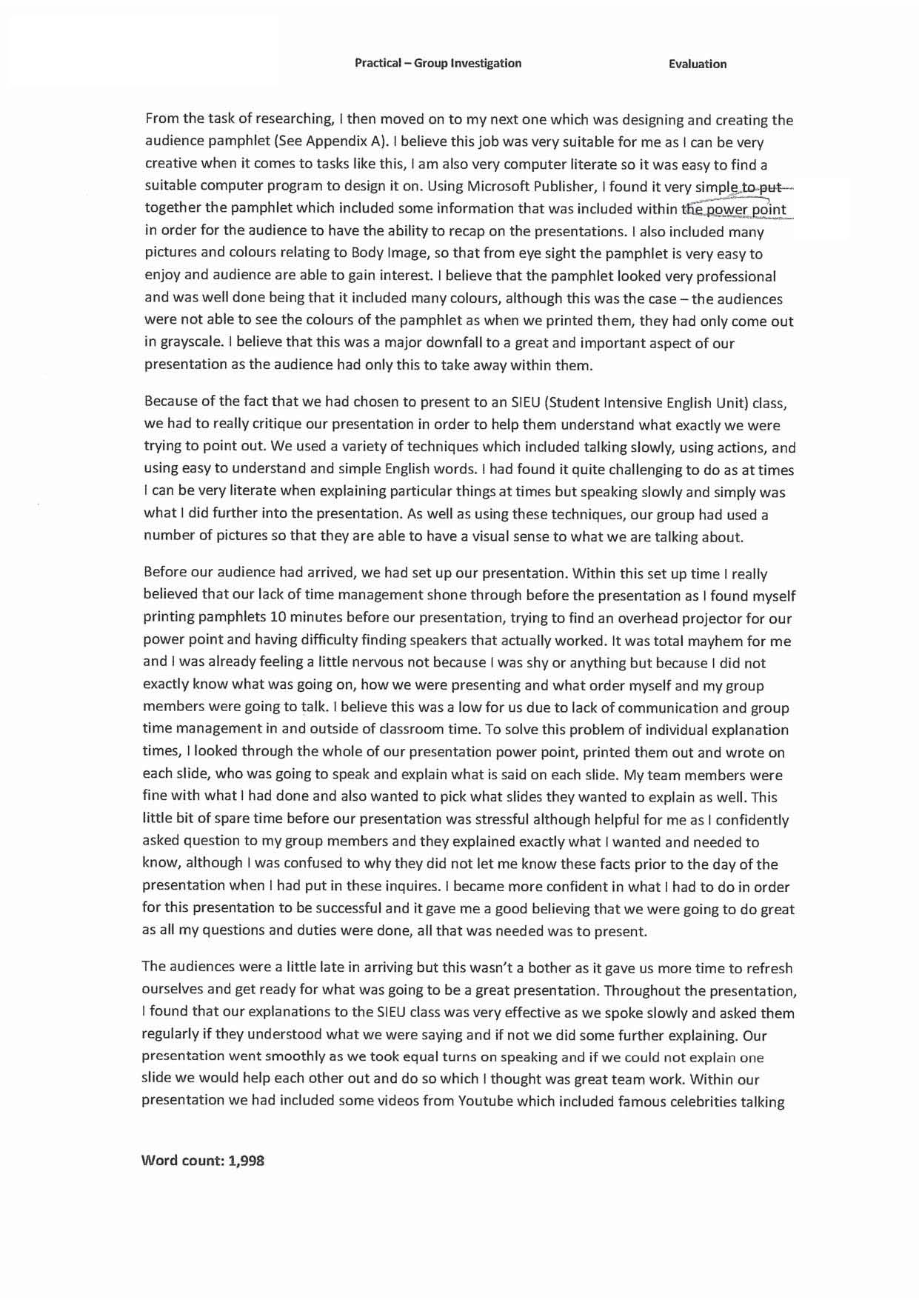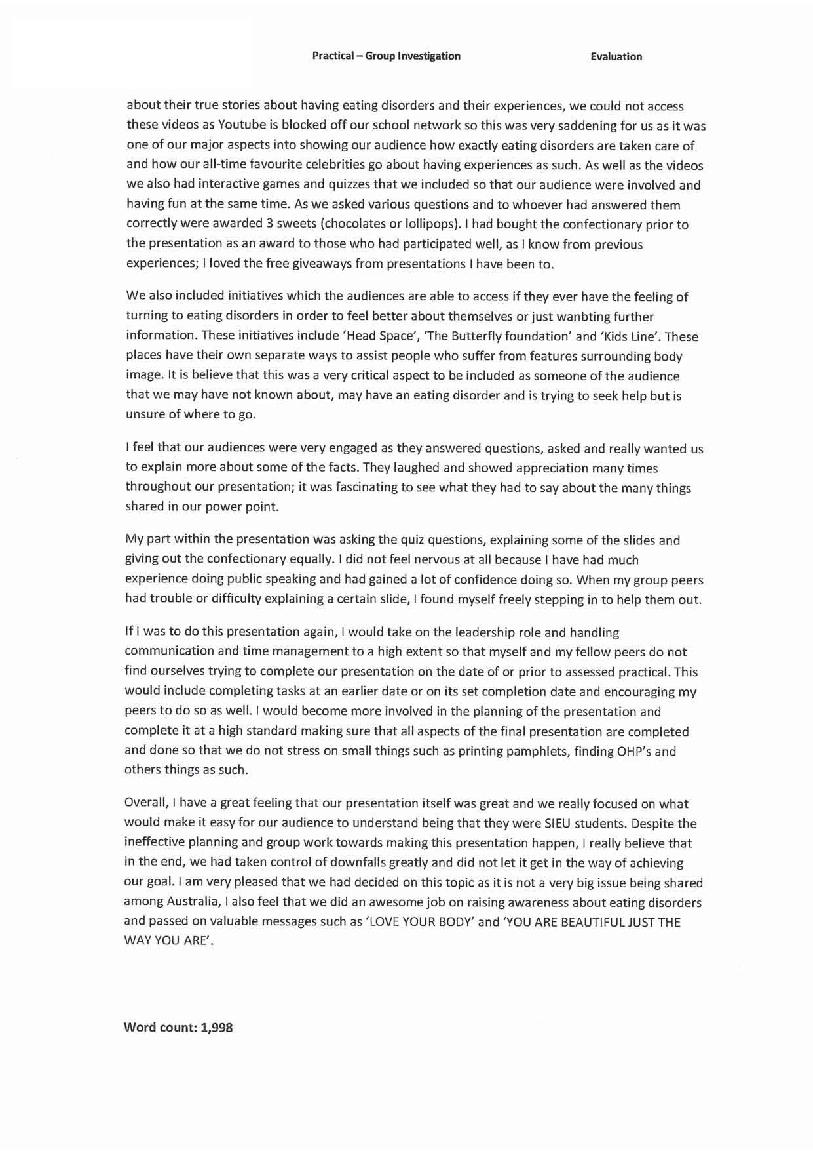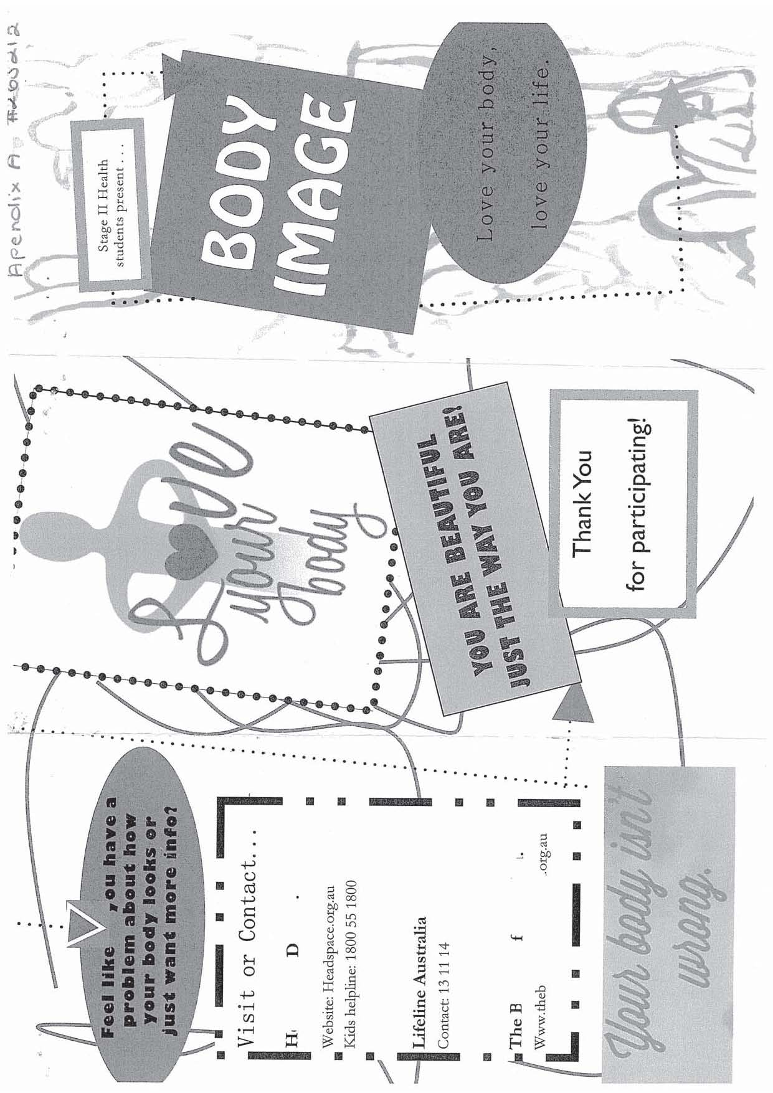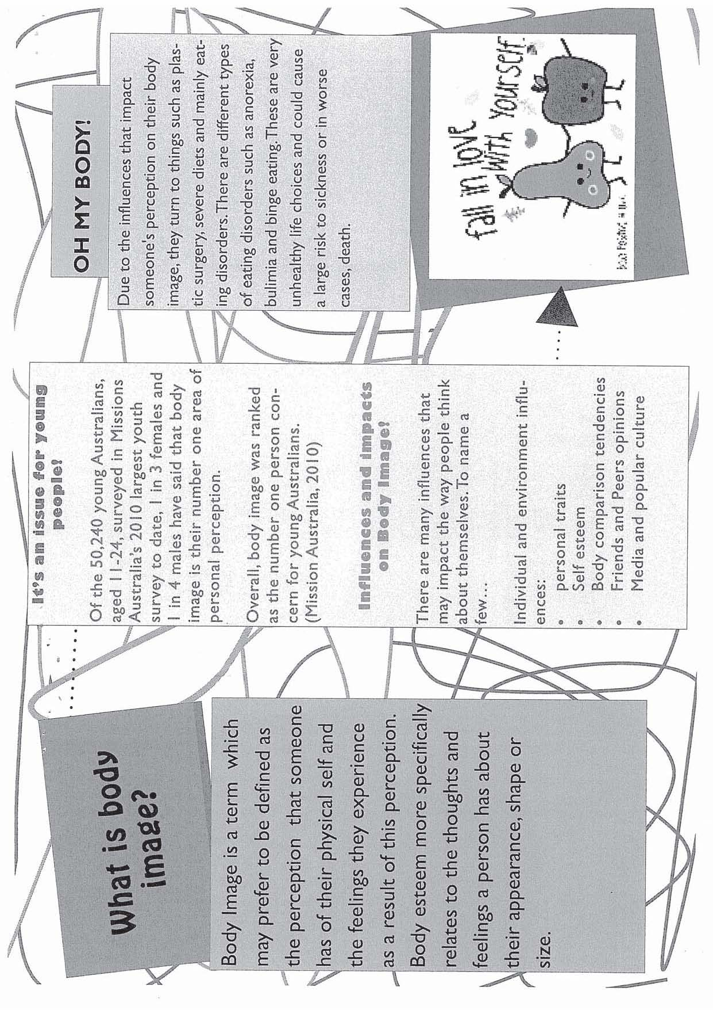
Evidence is provided by teacher’s comments to support assessment decisions for presentation.
Application 2
Some application of health literacy skills is evident in the explanation of how researched information affected the group decision to research and report on Body Image. Some personalisation of the topic can be seen in the comments on the reasons why the topic was selected. The use of appropriate terminology is inconsistent throughout.
Critical Analysis and Evaluation 1
Some thoughtful analysis of current health trends and issues evident in the discussion of the statistics.

Investigation 2
Research skills are indicated in inclusion of the researched facts. The presentation is generally organised with some information referenced.
Investigation 1
Some depth of investigation into the current issues around Body Image is evident in the inclusion of facts in the first paragraphs and in the pamphlet. Teacher comments indicate a substantial amount of investigation has taken place.
Application 3
Discussion of personal involvement in the preparation for the Presentation indicates competencies in working with others. Some productive involvement although limited evidence of this as only a brochure was produced. Teacher’s comments provide further detail.
Application 1
Competent evaluation of group skills indicates some use of practical problem solving skills to support the Presentation.
Critical Analysis & Evaluation 2
Some considered analysis of health promoting strategies is shown through the limited success of the pamphlet. Perhaps should have identified more strategies to achieve the goal.
Application 2
Some application of health literacy skills is evident in their application to the production of the power-point and the pamphlet.
Investigation 3
Competent critique of the role of communities in addressing health and well-being issues is implicit in reference to these initiatives.
Critical Analysis & Evaluation 3
Overall the evaluation of individual roles in the group presentation is thoughtful but with limited analysis of personal and social actions. The importance of engaging the audience is recognised in the promotion of improved health outcomes. Reflection is made about how personal involvement could improve the outcome.
Critical Analysis & Evaluation 2
The importance of education in promoting health strategies is recognised in the use of these slogans, in reference to helplines and in engaging the audience.
Investigation 3
Recognition of the role of communities and governments is evident in the inclusion of the contact list.
Critical Analysis & Evaluation 1
Pamphlet contains evidence of some thoughtful analysis of health issues in the points raised in the section on Influences and impacts on Body Image.
Additional Comments

This investigation is a C+ grade.

The final grade is based on evidence from the teacher’s assessment comments on the Presentation, the Reflection and the pamphlet.

Performance Standards for Stage 2 Health
 | Investigation | Understanding | Application | Critical Analysis and Evaluation
A | In-depth and critical investigation into and critique of current health trends and issues.  Productive and discerning approach to accessing, organising, and using information about health.  Sustained and cohesive investigation into and critique of the roles and responsibilities of individuals, communities, and governments in addressing health and well-being issues and priorities. | In-depth, coherent, and critical understanding of a variety of influences on personal and community health and well-being.  In-depth and critical understanding of health and related social justice issues. | Sustained and effective application of participation, interpersonal, practical, and group skills to an area related to health.  Consistent application of well-developed health literacy skills to relevant tasks.  Highly productive involvement in personal and social actions to promote improved health outcomes for individuals and communities. | Astute and critical analysis of a variety of current health trends and issues.  Discerning and comprehensive analysis of health-promoting strategies and the role of education in promoting and enhancing health outcomes.  Insightful evaluation of personal and social actions to promote improved health outcomes for individuals and communities.
B | Some depth of investigation into and critique of current health trends and issues.  Systematic and considered approach to accessing, organising, and using information about health.  Thoughtful and systematic investigation into and critique of the roles and responsibilities of individuals, communities, and governments in addressing health and well-being issues and priorities. | Thoughtful, and some critical, understanding of a variety of influences on personal and community health and well-being.  Some depth of understanding of health and related social justice issues. | Effective application of participation, interpersonal, practical, and group skills to an area related to health.  Mostly consistent application of health literacy skills to relevant tasks.  Productive involvement in personal and social actions to improve health outcomes for individuals and communities. | Thoughtful and critical analysis of a variety of current health trends and issues.  Clear and convincing analysis of health-promoting strategies and the role of education in promoting and enhancing health outcomes.  Thoughtful evaluation of personal and social actions to promote improved health outcomes for individuals and communities.
C | Some investigation into and critique of current health trends and issues.  Generally organised approach to accessing, organising, and using information about health.  Competent investigation into and critique of the roles and responsibilities of individuals, communities, and governments in addressing health and well-being issues and priorities. | Some thoughtful understanding of influences on personal and community health and well-being.  Some informed understanding of health and related social justice issues. | Competent application of participation, interpersonal, practical, and group skills to an area related to health.  Some application of health literacy skills to relevant tasks.  Competent involvement in personal and social actions to promote improved health outcomes for individuals and communities. | Some informed and critical analysis of some current health trends and issues.  Some considered analysis of health-promoting strategies and the role of education in promoting and enhancing health outcomes.  Some considered evaluation of personal and social actions to promote improved health outcomes for individuals and communities.
D | Identification of current health trends and issues.  Some attempt to access, organise, and use information about health.  Partial investigation into and description of the roles and responsibilities of individuals, communities, and governments in addressing health and well-being issues and priorities. | Some awareness of influences on personal and community health and well-being.  Basic description of health issues. | Some application of participation, interpersonal, practical, and group skills to an area related to health.  Attempted application of basic health literacy skills to tasks.  Some attempt to participate in personal and social actions to promote improved health outcomes for individuals or communities. | Some description of current health trends and issues.  Some explanation of a health-promoting strategy and the role of education in promoting or enhancing health outcomes.  Recounts of personal and social actions to promote improved health outcomes for individuals and communities.
E | Attempt to recognise one or more current health trends and/or issues.  Isolated attempts to access and use information about health.  Limited and fragmented investigation into and attempted description of the roles and responsibilities of individuals, communities, or governments in addressing health and well-being issues and priorities. | Emerging awareness of an influence on personal or community health and well-being.  Emerging awareness of health issues. | Attempted application of participation, interpersonal, practical, or group skills to an area related to health.  Attempted application of a basic health literacy skill to a task.  Limited attempt to participate in personal or social actions to promote improved health outcomes for individuals or communities. | Brief description of current health trends or issues.  Superficial description of a health-promoting strategy or the role of education in promoting or enhancing health outcomes.  Attempted recount of a personal or social action to promote health.

add

