STAGE 2 NUTRITION

Investigations Folio: Core Topic 1: Energy Content of Macronutrients
Burning food practical
Introduction:
In the body Macronutrients in food are able to be broken down by enzymes. As the bods between macronutrients are broken, energy is released for the body to use. This energy released is calculated inn units called kilojoules (kJ). This process of releasing energy can also be done by burning pieces of food. Different macronutrients produce different amounts of energy per gram. Carbohydrates produce 16kJ/g, proteins produce 17kJ/g and fats produce 37kJ/g. Foods that have a higher kilojoule content will burn for longer and therefore produce more heat.

Aim:
The aim of this practical was to investigate the energy content of a variety of food samples by burning the pieces of food. The energy released could then be compared to the nutrition panels of each food sample to see if they match.

Hypothesis:
The cheese and bacon balls will produce more energy than the multi-coloured and microwave popcorn due to its high fat and carbohydrate content.

Variables:
Independent: The food samples of microwave popcorn, multi-coloured popcorn and the cheese and bacon balls.
Dependent: The energy in kilojoules released by each food sample
Constant: The volume of water in the calorimeter in each burning of food samples.

Apparatus:
See appendix I

Safety Aspects:
See appendix II

Method:
See appendix III

Results:
The results of the mean energy per 100g that was obtained from the class, our group and the nutritional panelling can be summarised in Table 1. These results can be compared in figure1.2. For raw data see appendix IV.

Table 1: Results obtained from class, group and nutrition panel

 | Microwave Popcorn | Multi-coloured Popcorn | Cheese and Bacon Balls
Personal Results | 652.79kJ | 458.61kJ | 831.07kJ
Class Mean | 607.1575kJ | 586.81625kJ | 742.89kJ
Nutrition Panel | 1520kJ | 1740kJ | 2310kJ

Figure 1.2: Mean energy content of food samples
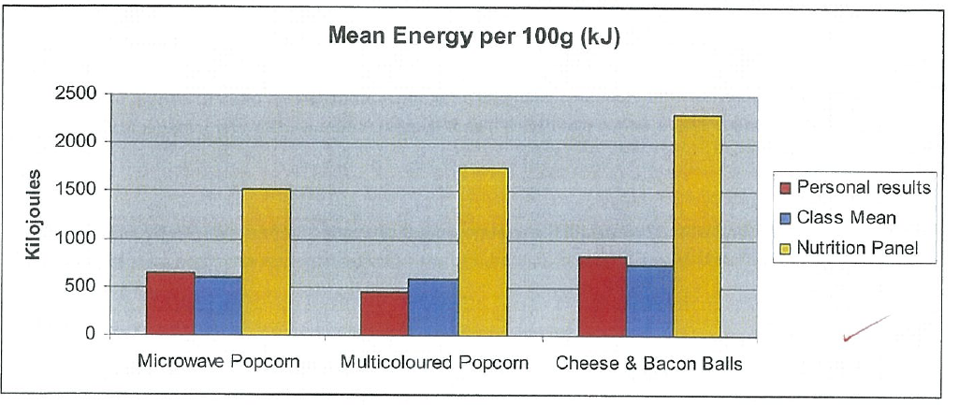
Investigation
Obtains, records, and displays findings of investigations using appropriate conventions and formats accurately and highly effectively.

Discussion:
From the practical investigation of food samples the results showed that all three food samples released at least some form of energy through heat. The energy released from these foods was due to their nutritional content including carbohydrates, lipids and protein. The amount of energy produced by each macronutrient is carbohydrates at 16kJ/g, lipids at 37kJ/g and proteins at 17kJ/g. From the graph, (figure 1.2) according to the mean class data, the cheese and bacon balls released the highest amount of energy followed by the microwave popcorn and then the multi-coloured popcorn. From the nutritional paneling (see appendix V) the cheese and bacon balls have a slightly higher fat total than the other food samples and contained a reasonable amount of protein. As lipids produce the highest amounts of kJ/g, the cheese and bacon balls were able to burn for longer and release more heat as shown in the class mean results. The microwave popcorn was relatively low in fat however it contained a high amount of protein and a reasonable amount of carbohydrates. In comparison, the multi-coloured popcorn had a very high carbohydrate (including sugar) content but a low fat and protein content. From the nutritional panel, the multi-couloured popcorn would be assumed to burn for a longer period of time and produce more heat however from the class mean and our group results it was found that the microwave popcorn produced more heat. This could have been due to random errors across our group and the rest of the class.
Knowledge and Understanding
communicate knowledge and understanding of nutrition in different contexts coherently and effectively.

As the range in data was quite large across the class, this indicated that the class means results were not very reliable. Compared to the nutritional paneling of the food samples, the mean energy content of our group and class data was much lower than the energy content indicated on the nutritional panelling. This is particularly due to the fact that when each food sample was burnt there were still remnants remaining on the mounted needle, even once the burning had been completed. The nutritional paneling is based on the body’s digestion ability to break down the macronutrients with the use of enzymes. When the body digests food, all macro nutrients are able to be completely broken down and hence the class and our group’s mean energy results were much lower than the nutritional panel.
Knowledge and Understanding
communicate knowledge and understanding of nutrition in different contexts coherently and effectively.

Throughout this practical there were much strength that enabled a smooth running practical. This included having background knowledge on the energy content in foods and an understanding of the digestion of macronutrients. Prior to completing the summative practical the assessment criteria were given, enabling the familiarisation with the method. A practice run was done to so that experience using the equipment could be gained. By working in small groups this enabled greater organisation especially in the set up and pack up time. This took much less time so that more time could be spent completing the practical. Having more time to complete the practical was another strength as this allowed any errors made in the process of burning of the food samples to be redone and corrected.
Application
Demonstrates constructive and focused individual and collaborative work skills. Self-evaluation.

Weaknesses included in the practical were that two pieces of food had to be burnt. As the sample on the bottom of the mounted needle was then not able to be 2cm away from the calorimeter, this allowed the heat energy to escape and not be accounted for. The accuracy of the energy content was also altered as the total mass of the food was not able to be completely burnt

Random errors included in this practical include that the food mounted on the needle each time was not consistently mounted in the same way or on the same angle due to the food samples different shapes. The volume of water placed in the calorimeter may not have been 50ml each time, which may have caused a food sample to have to heat a larger body of water. When placing the thermometer in the water sufficient time may not have been allowed for the temperature to cool or rose completely. When stirring the water, the thermometer may have also touched the bottom or side of the calorimeter, altering the accuracy of the results. The distance of the food to the calorimeter may not have been precisely 2cm each time causing some energy from the food samples to escape. As matches were used to light the food samples, the time taken to light each food sample was not the same. As some food samples required the match to be held there for a longer period of time, the heat from the match may have heated the calorimeter instead of the energy of the food sample causing inaccurate results. If the charcoal on the bottom of the calorimeter was not cleaned properly between each burning of foods, then the build-up of this charcoal may have acted as an insulator between the flame and the water.
Analysis and Evaluation
Evaluates procedures but with some errors.

Systematic errors include that the thermometer was faulty and may have given the wrong reading altering the results. Crumbs of the popcorn or cheese and bacon balls may have been left on the mounted needle and contaminated other food samples that were burnt, possibly altering the results. As the food sample was not able to be burnt completely this caused inaccuracy in the results produced.
Analysis and Evaluation
Evaluates procedures and suggests some appropriate improvements.
Improvements for this practical include burning more samples of each food product as to find temperature changes that are more concordant, increasing the accuracy of results. A ruler or other form of measurement could be used to ensure that the distance between the mounted food sample and calorimeter is consistently 2cm. To prevent the build-up of soot on the bottom of the calorimeter that potentially insulates the water; a new calorimeter could be used for each burning of the food samples. A food sample that is more consistent in shape, weight and energy content and that burns for longer that the popcorn and cheese balls could be used. All these improvements would play a role in increasing the reliability and accuracy of the practical.
Analysis and Evaluation
Systematically analyses data to formulate logical and highly relevant. Conclusion.

Conclusion:
In this practical the hypothesis was supported as our group’s data and the class’s mean data showed that the cheese and bacon balls produced the greatest amount of energy as it had a higher fat content that the two popcorn food samples. The microwave popcorn was found to produce more energy than the multi-coloured popcorn due to its high protein and carbohydrate content. As all the food was not burnt completely, the energy content results obtained from the practical were not able to be compared to the nutritional panel.
Investigation
Identifies aspects of safety other than those specified in the method displaying well-organised safe procedures.

Peer Review:
My group and I worked well together for this practical. We all followed the rules in the laboratory and were careful when handling the matches to reduce the risk of burning ourselves or one another. We all made sure to wear a safety apron and have our safety goggles on at all times.
Application
Demonstrates initiative in applying constructive and focused individual and collaborative work skills. Self-evaluation and teacher observation.

We divided the tasks up evenly so that one of us was in charge of measuring the initial and final weight and were also taking photographs. The other group member was responsible for changing the water and cleaning the bottom of the calorimeter and I was in charge of recording and working out the results. We worked together to ensure a quick set up so that more time could be spent burning the food samples. We all took turns burning the food samples and stirring the thermometer. We worked as a team so that our set up and packing up process was efficient.

Appendices

Appendix I: Apparatus

- Retort stand with 2 clamps
- Thermometer
- Cardboard
- Cork with needle
- Electronic scales
- 100ml measuring cylinder
- Calorimeter
- 6 pieces of microwave popcorn
- 6 pieces of multi-coloured popcorn
- 6 cheese and bacon balls
- Matches

Appendix II: Safety Aspects

Safety aspects of this practical include wearing safety glasses and an apron. This avoids any spillages or substances getting into eyes or on clothing. Hair should be tied back and any loose items such as ties or jewelry should be removed or tucked away to avoid it coming into contact with flames or any other harmful substances. Conduct in the lab includes no running and maintaining a clean bench area.
Investigation
Photographs, together with teacher observations and student review, provide evidence of safe manipulation of apparatus.

The use of fire in this practical could potentially cause burns. If a burn occurs the supervising teacher should be notified and the following steps should be taken. If burns occur, run the wound under cold water for 20 minutes and remove any constrictions such as clothing, jewelry from the burnt area. If clothing is stuck to the burn do not pull it. Minor burns should be treated with dressings and if needed a pain killer. The burnt area should be checked regularly. If a major burn occurs, seek medical attention and do not apply anything other than cold water to the burn until it has been assessed by a medical professional.

Appendix III: Method

1. Safety attire was obtained and put on.
2. Apparatus was collected and set up as shown in figure 1.1

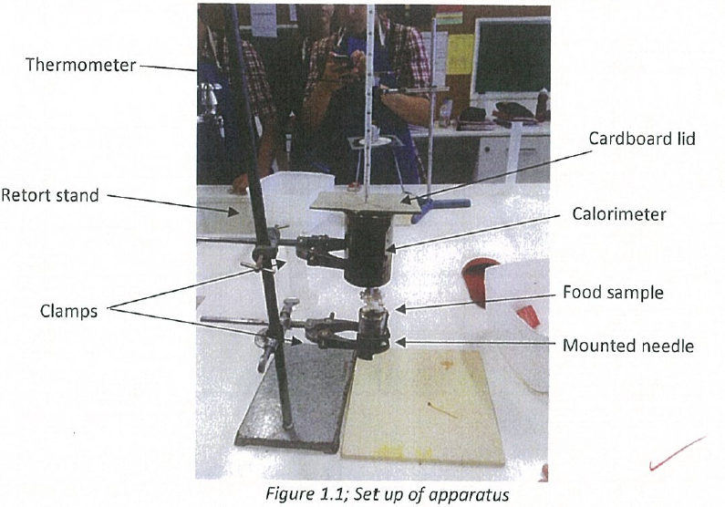
Knowledge and Understanding
Uses photographs together with text, tables, and graphs to communicate knowledge and understanding of nutrition coherently and highly effectively.

3. Two pieces of a food sample were placed on the mounted needle. The weight of the food on the mounted needle was measure and then recorded.
4. Using the measuring cylinder 50ml of water was poured into the calorimeter.
5. The mounted need was placed in the clamp so that the food sample was approximately 2cm from the bottom of the calorimeter.
6. The thermometer was placed though the cardboard lid into the calorimeter ensuring the thermometer did not touch the sides. The initial temperature of the water was recorded.
7. The food sample was then lit directly under the calorimeter using matches. As the food sample burnt the thermometer was used to stir the water taking care not to touch the sides.
8. After the last of the food samples had stopped burning and the temperature of the water stopped rising, the final temperature of the water was recorded.
9. The mass of the mounted need and food residue was weighed and recorded using the electric scales.
10. The water in calorimeter was carefully emptied into the sink using hot hands as the temperature of the water could get quite hot.
11. Steps 1 – 10 were repeated for three samples of each different food. A new 50ml portion of cold water was placed in the calorimeter for each testing of food sample.

Appendix IV: Raw Data
Food Combusted | Microwave Popcorn |  |  | Multi-coloured Popcorn |  |  | Cheese/Bacon Balls
Trial | 1 | 2 | 3 | 1 | 2 | 3 | 1 | 2 | 3
Mass of food, alfoil & mounted needle (initial) (g) | 10.40 | 10.78 | 10.78 | 10.65 | 10.57 | 10.67 | 11.06 | 11.15 | 11.35
Mass of food, alfoil & mounted needle (final) (g) | 10.18 | 10.51 | 10.50 | 10.20 | 10.23 | 10.22 | 10.39 | 10.59 | 10.74
Mass of Food combusted (g) | 0.22 | 0.27 | 0.28 | 0.46 | 0.34 | 0.45 | 0.67 | 0.56 | 0.48
Mass of water (g) [ml] | 50 | 50 | 50 | 50 | 50 | 50 | 50 | 50 | 50
Initial water temperature (°C) | 24 | 26 | 24 | 24 | 25 | 25 | 25 | 24 | 24
Final water temperature (°C) | 31 | 34 | 33 | 34 | 33 | 34 | 48 | 47 | 45
Temperature Change (°C) | 7 | 8 | 9 | 10 | 8 | 9 | 23 | 23 | 21
Investigation
Obtains, records, and displays findings of investigations using appropriate conventions and formats accurately and highly effectively. Confirmed by teacher observation.

Appendix V: Nutrition Panel of food samples
 | All nutrient values are per 100g edible portion (EP)
Food Item | Energy (kJ) | Protein (g) | Fat total (g) | Fat saturated (g) | Carbohydrate (g) | Sugars (g) | Sodium (mg)
Microwave Popcorn | 1520 | 12.1 | 5.4 | 1.1 | 55.0 | 0.5 | 7.0
Multi-coloured Popcorn | 1740 | 4.5 | 4.1 | 0.9 | 89.1 | 58.7 | 19.0
Additional comments
- Teacher observation during the implementation of the investigation, together with the student’s own review, enables assessment of safety and manipulation of apparatus (Investigation) and collaboration (Application).
- Evidence from this investigation contributes to an overall assessment for the Investigations Folio of a student’s use of appropriate nutrition terms and conventions (Application) and the communication of knowledge and understanding of nutrition in different contexts, using different formats (Knowledge and Understanding).
Performance Standards for Stage 2 Nutrition
 | Investigation | Analysis and Evaluation | Application | Knowledge and Understanding
A | Designs logical, coherent, and detailed nutrition investigations.  Critically and logically selects and consistently and appropriately acknowledges information about nutrition and issues in nutrition from a range of sources.  Manipulates apparatus, equipment, and technological tools carefully and highly effectively to implement well-organised safe and ethical investigation procedures.  Obtains, records, and displays findings of investigations using appropriate conventions and formats accurately and highly effectively. | Critically and systematically analyses data and their connections with concepts, to formulate logical and perceptive conclusions and make relevant predictions.  Logically evaluates procedures and suggests a range of appropriate improvements. | Applies nutrition concepts and evidence from investigations to suggest solutions to complex problems and to promote good health in new and familiar contexts.  Uses appropriate nutrition terms and conventions highly effectively.  Demonstrates initiative in applying constructive and focused individual and collaborative work skills. | Consistently demonstrates a deep and broad knowledge and understanding of a range of nutrition concepts.  Uses knowledge of nutrition perceptively and logically to understand and explain issues related to diet, lifestyle, culture, and health.  Uses a variety of formats to communicate knowledge and understanding of nutrition in different contexts coherently and highly effectively.
B | Designs well-considered and clear nutrition investigations.  Logically selects and appropriately acknowledges information about nutrition and issues in nutrition from different sources.  Manipulates apparatus, equipment, and technological tools carefully and mostly effectively to implement organised safe and ethical investigation procedures.  Obtains, records, and displays findings of investigations using appropriate conventions and formats mostly accurately and effectively. | Analyses data and their connections with concepts, to formulate generally appropriate conclusions and make simple predictions, with some relevance.  Evaluates procedures and suggests some appropriate improvements. | Applies nutrition concepts and evidence from investigations to suggest solutions to problems and to promote good health in new and familiar contexts.  Uses appropriate nutrition terms and conventions effectively.  Applies mostly constructive and focused individual and collaborative work skills. | Demonstrates some depth and breadth of knowledge and understanding of a range of nutrition concepts.  Uses knowledge of nutrition logically to understand and explain issues related to diet, lifestyle, culture, and health.  Uses a variety of formats to communicate knowledge and understanding of nutrition in different contexts coherently and effectively.
C | Designs considered and generally clear nutrition investigations.  Selects with some focus, and mostly appropriately acknowledges, information about nutrition and issues in nutrition.  Manipulates apparatus, equipment, and technological tools generally carefully and effectively to implement safe and ethical investigation procedures.  Obtains, records, and displays findings of investigations using generally appropriate conventions and formats with some errors but generally accurately and effectively. | Analyses data and their connections with concepts, to formulate generally appropriate conclusions and make simple predictions, with some relevance.  Evaluates some procedures in nutrition and suggests some improvements that are generally appropriate. | Applies nutrition concepts and evidence from investigations to suggest some solutions to basic problems and to promote good health in new or familiar contexts.  Uses generally appropriate nutrition terms and conventions with some general effectiveness.  Applies generally constructive individual and collaborative work skills. | Demonstrates knowledge and understanding of a general range of nutrition concepts.  Uses knowledge of nutrition with some logic to understand and explain one or more issues related to diet, lifestyle, culture, and health.  Uses different formats to communicate knowledge and understanding of nutrition in different contexts with some general effectiveness.
D | Prepares the outline of a nutrition investigation.  Selects and may partly acknowledge one or more sources of information about nutrition or an issue in nutrition.  Uses apparatus, equipment, and technological tools with inconsistent care and effectiveness and attempts to implement safe and ethical investigation procedures.  Obtains, records, and displays findings of investigations using conventions and formats inconsistently, with occasional accuracy and effectiveness. | Describes basic connections between some data and concepts, and attempts to formulate a conclusion and make a simple prediction that may be relevant  For some procedures, identifies improvements that may be made. | Applies some evidence to describe some basic problems and identify one or more simple solutions, or to promote good health, in familiar contexts.  Attempts to use some nutrition terms and conventions that may be appropriate.  Attempts individual work inconsistently, and contributes superficially to aspects of collaborative work. | Demonstrates some basic knowledge and partial understanding of nutrition concepts.  Identifies and explains some nutrition information that is relevant to one or more issues related to diet, lifestyle, culture, and health.  Communicates basic information about nutrition to others, using one or more formats.
E | Identifies a simple procedure for a nutrition investigation.  Identifies a source of information about nutrition or an issue in nutrition.  Attempts to use apparatus, equipment, and technological tools with limited effectiveness or attention to safe or ethical investigation procedures.  Attempts to record and display some descriptive information about an investigation, with limited accuracy or effectiveness. | Attempts to connect data with concepts, formulate a conclusion, and make a prediction.  Acknowledges the need for improvements in one or more procedures. | Identifies a basic problem and attempts to identify a solution or promote good health in a familiar context.  Uses some nutrition terms or conventions.  Shows emerging skills in individual and collaborative work. | Demonstrates some limited recognition and awareness of nutrition concepts.  Shows an emerging understanding of an issue related to diet, lifestyle, culture, and health.  Attempts to communicate information about nutrition.

