Stage 1 Physics

SUMMATIVE SKILLS AND APPLICATIONS TASK
Medical Physics Test (60 marks)
(50 minutes + 5 mins reading time, under direct supervision)
- Mystery elements named after famous Australian doctors are shown below:
$${}_{15}^{30}{Wo}$$  Woodium  (Fiona Wood) | $${}_{14}^{32}{Ch}$$  Changium  (Victor Chang) | $${}_{14}^{30}{Tm}$$  Teoium  (Charlie Teo) | $${}_{88}^{224}{Ho}$$  Hollowsium  (Fred Hollows)

- How many protons are there in the nucleus of Hollowsium?  (1 mark) | - What is the mass number of Teoium?  (1 mark)
- Which two elements are isotopes of each other?  (1 mark) | - Which element has the greatest number of particles in the nucleus?  (1 mark)

e. Changium is radioactive and undergoes beta minus decay to form a new element - Marshallium. Complete the nuclear equation and write the atomic and mass number of Marshallium (Ma) in the boxes.

${}_{14}^{32}{Ch}$

(2 marks)
f. Hollowsium is also radioactive, emitting alpha particles. Write a balanced nuclear equation Hollowsium’s decay

${}_{88}^{224}{Ho}$ ${}_{2}^{4}α$ +
(2 marks)

g. You have two boxes to safely store your samples of Changium and Hollowsium – a cardboard box and a lead box. Write which sample you would put in each box (by writing the name of the sample next to the appropriate box the box). Explain the reason for your choice.

Cardboard box: _______________________ Lead box: __________________________

(4 marks)

- The following table gives the half-life of four different radioactive isotopes.

Radioactive Isotope | Radiation Emitted | Half Life
Cobalt-60 | $$γ$$ | 5.27 years
Technetium-99m | $$γ$$ | 6 hours
Strontium-90 | $$β$$ | 28.8 years
Fluorine-18 | $β$⁺ | 110 minutes

a. Explain two reasons why Technetium is the most suitable isotope to be used for medical imaging compared to the other isotopes in the list.

(4 marks)
b. Describe one disadvantage in using a radioisotope that has a half-life of 6 hours.

(2 marks)

- In this PET scan a radioactive chemical has been used in a male patient in his 30s who had previous medical history of tongue cancer two years previously. The image was taken 64 minutes after fludeoxyglucose (18F) in the amount of 3.7 MBq/kg was administered.

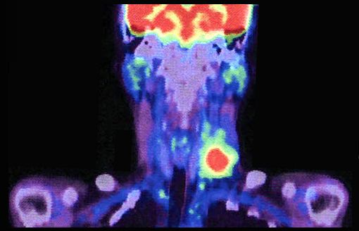
Image by Akira Kouchiyama - Wikimedia, CC-3.0-BY-SA https://commons.wikimedia.org/wiki/File:PET-CT_scanning_of_lymph_node_metastases_in_cancer_2.jpg

  - Describe how the decay of 18F can be detected in the patient.

(2 marks)
  - ¹⁸F is created inside a cyclotron from ¹⁸0. Describe this process and include a nuclear equation.

(4 marks)

  - The half-life of 18F is 120 minutes. If there are originally N_{o} nuclei, determine the number of nuclei of the isotope left in the sample after 24 hours.

(2 marks)

- Two resistors of 10 ohms and 5 ohms are connected in parallel as shown below.

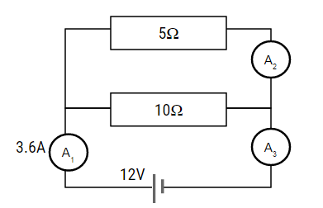

  - If 3.6 A of current is measured at the first ammeter A₁, determine the ammeter reading in A₂ and A₃.

(3 marks)

  - What is the voltage across the 5Ω resistor?

(2 marks)

  - What is the combined resistance of the circuit?

(2 marks)

- Two electrical devices are being used X and Y.
.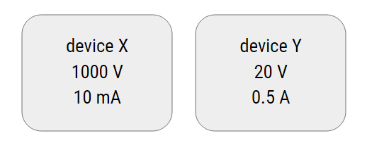

Explain which electrical device poses the greatest risk if an unintentional electric shock occurs.

(2 marks)

- The diagram below shows an ECG trace which gives an indication of heart function.

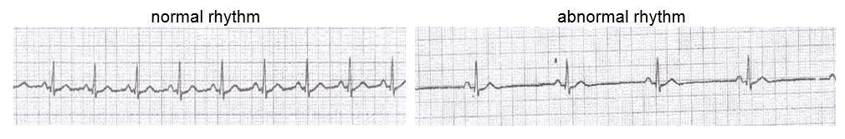
  - Describe how an ECG measures heart activity.

(4 marks)

- Below is a diagram showing the circuit diagram of a defibrillator.

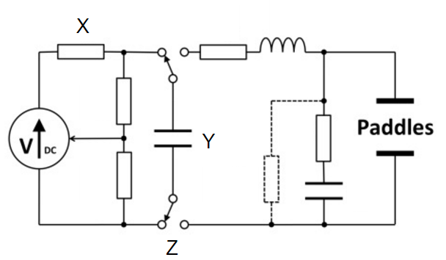

  - State the name of circuit elements Y and Z and describe the function of these in the circuit.
Y

Z

(4 marks)

  - Describe one safety measure that must be used when using a defibrillator.

(2 marks)

- A student performs and investigation the results are shown below.
Potential Difference (V) | Current (A)
0 | 0
2 | 0.12
4 | 0.15
6 | 0.25
8 | 0.30
10 | 0.42

0.50
0.40
0.30
0.20
0.10
 |  |  |  | 2 |  |  |  | 4 |  |  |  | 6 |  |  |  | 8 |  |  |  | 10

  - Complete the graph of the student’s data using the grid on the previous page. (4 marks)

  - State how the graph shows that random errors occurred.

(2 marks)

  - Use your graph and/or the relationship V = IR to calculate the resistance of the wire that was used.

(3 marks)

9. A recent news report indicated that an international study has found that prostate cancer treated with low-dose radioactive ‘seeds’ implanted directly into the prostate gland was more effective, had fewer side effects, and was less invasive than other treatments.

Refer to one or more of the key ideas (Communication and Collaboration, Development, Influence, or Application and Limitation) to explain how such a report can show evidence of science as a human endeavour.

(6 marks)
 | A | B | C | D | E
Investigation, Analysis and Evaluation | Critically deconstructs a problem and designs a logical, coherent, and detailed physics investigation. | Logically deconstructs a problem and designs a well-considered and clear physics investigation. | Deconstructs a problem and designs a considered and generally clear physics investigation. | Prepares a basic deconstruction of a problem and an outline of a physics investigation. | Attempts a simple deconstruction of a problem and a procedure for a physics investigation.
 | Obtains, records, and represents data, using appropriate conventions and formats accurately and highly effectively. | Obtains, records, and represents data, using appropriate conventions and formats mostly accurately and effectively. | Obtains, records, and represents data, using generally appropriate conventions and formats with some errors but generally accurately and effectively. | Obtains, records, and represents data, using conventions and formats inconsistently, with occasional accuracy and effectiveness. | Attempts to record and represent some descriptive data, with limited accuracy or effectiveness.
 | Systematically analyses and interprets data and evidence to formulate logical conclusions with detailed justification. | Logically analyses and interprets data and evidence to formulate suitable conclusions with reasonable justification. | Undertakes some analysis and interpretation of data and evidence to formulate generally appropriate conclusions with some justification. | Describes data and undertakes some basic interpretation to formulate a basic conclusion. | Attempts to describe results and/or interpret data to formulate a basic conclusion.
 | Critically and logically evaluates procedures and their effects on data. | Logically evaluates procedures and their effects on data. | Evaluates procedures and some of their effects on data. | Attempts to evaluate procedures or suggest an effect on data. | Acknowledges that procedures affect data.
Knowledge and Application | Demonstrates deep and broad knowledge and understanding of a range of physics concepts. | Demonstrates some depth and breadth of knowledge and understanding of a range of physics concepts. | Demonstrates knowledge and understanding of a general range of physics concepts. | Demonstrates some basic knowledge and partial understanding of physics concepts. | Demonstrates limited recognition and awareness of physics concepts.
 | Applies physics concepts highly effectively in new and familiar contexts. | Applies physics concepts mostly effectively in new and familiar contexts. | Applies physics concepts generally effectively in new or familiar contexts. | Applies some physics concepts in familiar contexts. | Attempts to apply physics concepts in familiar contexts.
 | Critically explores and understands in depth the interaction between science and society. | Logically explores and understands in some depth the interaction between science and society. | Explores and understands aspects of the interaction between science and society. | Partially explores and recognises aspects of the interaction between science and society. | Attempts to explore and identify an aspect of the interaction between science and society.
 | Communicates knowledge and understanding of physics coherently, with highly effective use of appropriate terms, conventions, and representations. | Communicates knowledge and understanding of physics mostly coherently, with effective use of appropriate terms, conventions, and representations. | Communicates knowledge and understanding of physics generally effectively, using some appropriate terms, conventions, and representations. | Communicates basic physics information, using some appropriate terms, conventions, and/or representations. | Attempts to communicate information about physics.

