2022 Music Performance — Solo Subject Assessment Advice
Overview
Subject assessment advice, based on the 2022 assessment cycle, gives an overview of how students performed in their school and external assessments in relation to the learning requirements, assessment design criteria, and performance standards set out in the relevant subject outline. They provide information and advice regarding the assessment types, the application of the performance standards in school and external assessments, and the quality of student performance.
Teachers should refer to the subject outline for specifications on content and learning requirements, and to the subject operational information for operational matters and key dates.
Across the Assessment Types for this subject, students can present their responses in oral or multimodal form, where 6 minutes is the equivalent of 1000 words. Students should not speed-up the recording of their videos excessively in an attempt to exceed this limit.
From 2023, if a video is flagged by markers/moderators as impacted by speed, a transcript will be produced and markers/moderators will be advised to mark/moderate based on the evidence in the transcript, and up to the maximum word limit (e.g., up to 2000 words for AT3).
If the speed of the recording makes the speech incomprehensible, it affects the accuracy of transcriptions and it also impacts the ability of markers/moderators to find evidence of student achievement against the performance standards.
School Assessment
Teachers can improve the moderation process and the online process by:
- thoroughly checking that all grades entered in schools online are correct
- checking that PSR grades are consistent with uploaded teacher mark/comment sheets
- ensuring that all files are accurately labelled and uploaded for each student
- including performance notes sheets in the moderation materials for each individual student.
Assessment Type 1: Performance
Students present a solo performance, or set of performances, of a single work or a set of works by one or more composers.
Teachers can elicit more successful responses by:
- selecting repertoire that enables the student to present works that appropriately align with their technical and musical capabilities
- selecting musical works that are soloistic in nature (i.e. students perform the predominant part in the music)

The more successful responses commonly:
- presented a thoroughly prepared performance which was fluent and cohesive
- showed great attention to all musical aspects during the performance
- demonstrated consistently high control of tone, dynamics, articulation and phrasing within the range of styles presented
- demonstrated a high level of musicianship in presenting a range of techniques
- demonstrated a confident level of engagement and appropriate stage etiquette.
The less successful responses commonly:
- included performances that were under-prepared
- performed repertoire that was outside the scope of the student’s technical level
- demonstrated inconsistent technique and fluency within the performance of the repertoire
- presented works that limited students’ ability to demonstrate a variety of techniques or styles
- showed a partial understanding of the stylistic aspects of the repertoire
- prepared repertoire that was simplistic in nature
- presented a part of an ensemble work as a solo performance
- used backing tracks that included the solo part as accompaniment.
Assessment Type 2: Performance and Discussion
For this assessment type students present a solo performance or set of performances to a maximum of 6–8 minutes, of a single work or a set of works by one or more composers. This assessment also includes a discussion of key musical elements of the chosen repertoire, with a critique of strategies to improve and refine the student’s performance to a maximum of 800 words if written, 4 minutes as an oral presentation, or the multimodal equivalent.
Teachers can elicit more successful responses by:
- selecting repertoire that allows for an in-depth level of analysis
- ensuring that the focus of the Discussion is on musical elements — particularly analysis of structure and style, and practice strategies developed by the student to improve and refine their performance(s)
- marking all the student’s evidence for the assessment type holistically, there is no weighting to the Discussion. Teachers can mark against the features of the criteria as indicated in the diagram below:
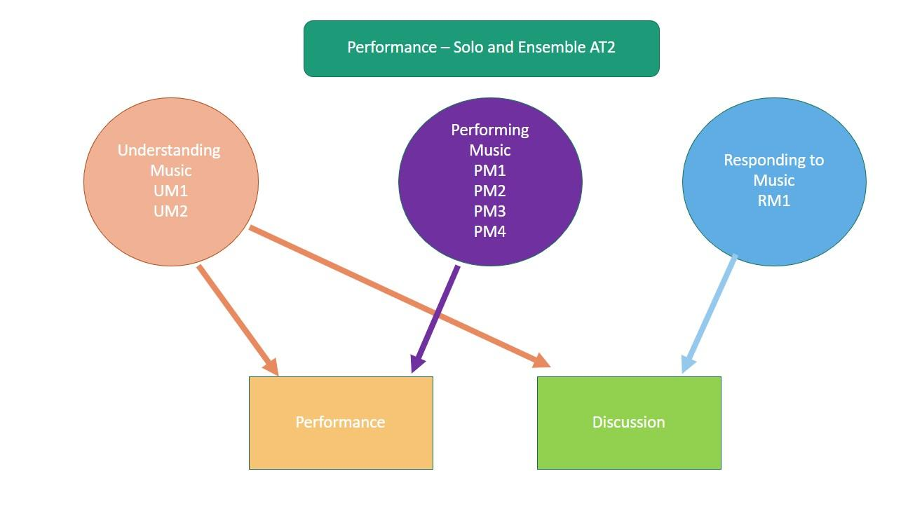

The more successful responses commonly:
- demonstrated a high level of technique and confidence within the Performance(s)
- performed with poise and fluency whilst engaging with their repertoire
- addressed structural and stylistic elements of the chosen repertoire within the Discussion
- included a discussion that focused on the analysis of a variety of musical elements in detail
- addressed practice strategies used to develop and prepare their performance within the Discussion
- included consistent, accurate, and highly effective use of musical terminology
- showed evidence of their understanding through relevant examples and annotations
The less successful responses commonly:
- focused purely on analysis within the Discussion, and didn’t include refinements and strategies developed to improve their skills, technique or accuracy within the Performance
- submitted Discussions that focused more on evaluative features rather than analytical information
- focused on a limited number of musical elements within the Discussion (e.g. dynamics, key signature, time signature)
- did not elaborate on practice strategies used by the student in the development and preparation of their performance
- lacked technical fluency and stylistic understanding within the performance of the work(s)
- included performances that did not allow the student to demonstrate a variety of techniques and skills
- did not submit the Discussion, which is a requirement of AT2: Performance and Discussion, or submitted Discussions that focused on irrelevant historical and/or biographical aspects.
External Assessment
Assessment Type 3: Performance Portfolio
Teachers can elicit more successful responses by:
- including musical scores relevant to the chosen repertoire
- submitting the Evaluation for each student. The focus of the evaluation should be on performance preparation, critique of their performance and aspects of stage presence (refer to the subject outline for further detail)
- mark all the student’s evidence for the external assessment AT3 holistically, there is no weighting to the Evaluation.
The more successful responses commonly:
- demonstrated a high level of technical facility and stylistic understanding within the performance
- reflected a high level of energy and focus throughout the performance
- demonstrated sophisticated control of tone and a wide variety of dynamics and articulations within the performance
- performed repertoire which enabled the student to display a range of techniques and musical interpretation
- demonstrated insight into key musical elements, critiquing skills, accuracy, and technique of the chosen repertoire within the Evaluation
- addressed how their preparation throughout their study influenced their final performance
- critically evaluated their stage presence and engagement as a performer
- completed the Evaluation soon after the Performance had occurred, providing the student opportunity to demonstrate RM2 consistently.
The less successful responses commonly:
- presented ensemble parts to a backing track that were outside the scope of the subject (i.e. presenting an ensemble performance as a solo performance)
- demonstrated limited use of dynamic contrast, a variety of articulations and a range of tone colours
- lacked technical fluency and accuracy within the performance
- submitted Evaluations that made statements without providing supporting evidence or examples
- lacked attention to detail of musical indications marked on the score (where provided)
- made limited use of musical terminology in relation to the elements of music
- did not address how their preparation influenced their final performance for the assessment
- only evaluated their stage presence, engagement and confidence as a performer
- lacked detail or omitted a critique of skills relating to accuracy and technique within the Evaluation
- included irrelevant, extensive biographical details about the composer/original recording artist
- did not submit the Evaluation.
General
- Teachers should ensure students understand the differences between the purpose of the Discussion in Assessment Type 2, and the Evaluation in Assessment Type 3. The Discussion focuses on analytical and stylistic features of the repertoire (RM1), and practice techniques used to develop and refine the performance given in Assessment Type 2. The Evaluation in Assessment Type 3 focuses on an evaluation and critique of the final performance and the learning undertaken throughout the year (RM2).
- Take note of the differences in the discussion points between the two performance subjects (Solo and Ensemble). Refer to the subject outline for further details.
- Provide students with several formative performance opportunities prior to assessment.
- Ensure balance in recordings is satisfactory, the student should be clearly heard over the accompanying instrument.
- Compress files where possible to mp4 for quicker upload and download.
- In 2022 COVID-19 adjustments in place were, ‘Where a ‘live audience’ is referred to in the assessment types, replace with ‘an audience such as a live or online audience’.

