Stage 2
Religion Studies
Assessment Type 2: Folio
Religion and Human Rights Policies
Student Response
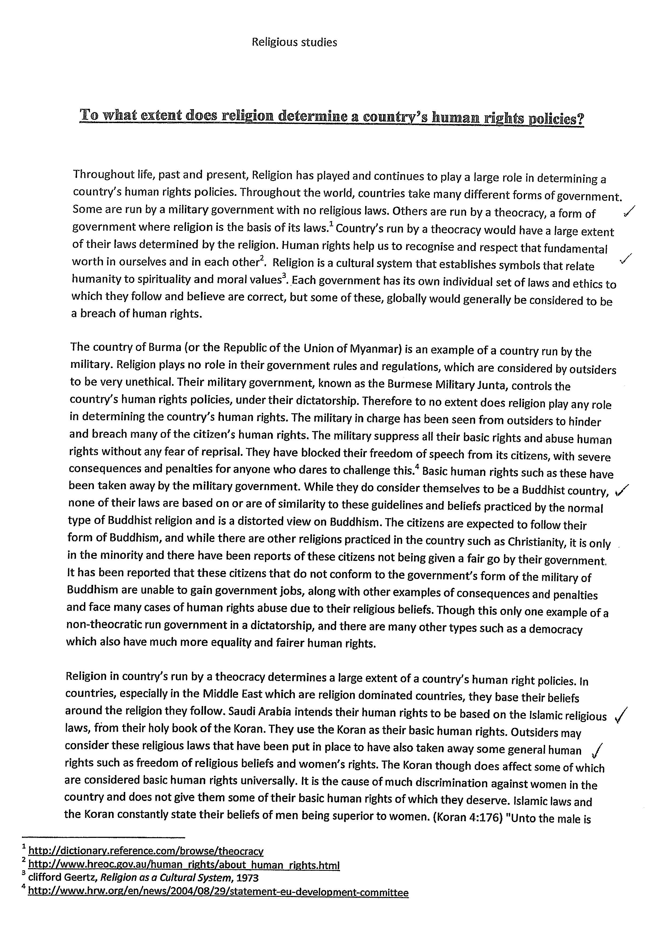
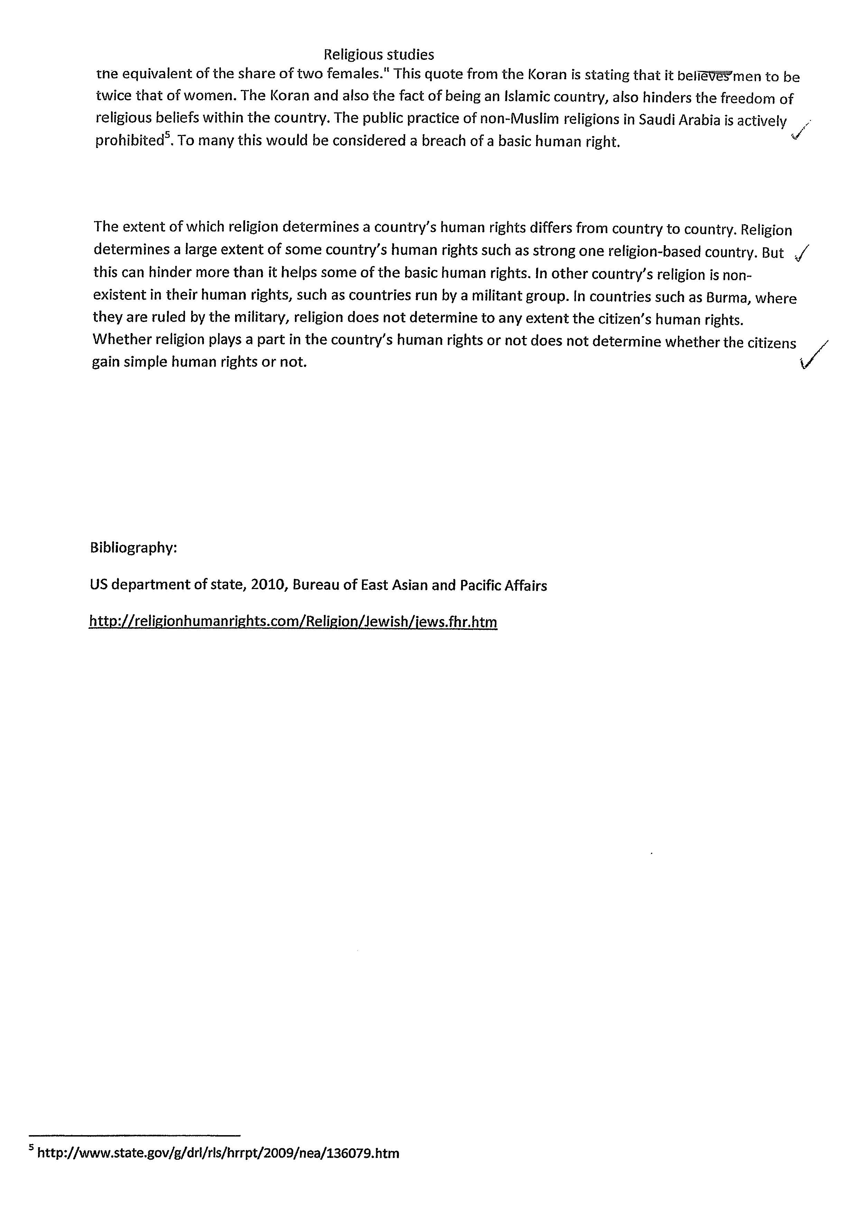

Stage 2 Religion Studies

Assessment Type 2: Written Assignments

Written Assignments – Grade: B

Knowledge and Understanding
KU1 Explanation of different religious beliefs, perspectives, and experiences within and across traditions.
KU2 Knowledge and understanding of religious and spiritual ideas, concepts, and issues in selected sources.
Shows evidence of ‘mostly clear and detailed knowledge of religious and spiritual ideas’ in paragraph 2. Shows knowledge that Burma is a Buddhist country; however, none of Burma’s laws are based on this religion. The evidence also covers the issue of human rights being taken away by the military; this reflects the capacity to provide a well-considered explanation.
There is effective use of a quote at the top of page 2 to back up the point being made gives a ‘well considered explanation of different religious beliefs’.

Investigation and Application
IA1 Development and application of appropriate methods of investigation, including use of inquiry skills.
IA2 Application of knowledge and understanding of religions and spiritualties in local and global contexts.
IA4 Clarity of communication, including presentation of conclusions.
‘A clear development and application of investigation methods’ is shown in the use of secondary sources that are referred to in the essay.
Also, an appropriate application of knowledge and understanding of religions in global contexts is shown in the discussion of Burma and the Middle East.
Overall the evidence is ‘mostly well-informed’ with ‘reasoned conclusions’ presented in the final paragraph.

Analysis and Application
AE1 Analysis of religious and spiritual ideas, concepts, and issues in selected sources.
‘Clear and critical analysis of religious issues in selected sources’ is shown in the main body of the essay. Some simplistic conclusions reached; for example, it could be argued that it is not the Qur’an that teaches inequality.

Performance Standards for Stage 2 Religion Studies – Written Task
 | Knowledge and Understanding | Investigation and Application | Analysis and Evaluation | Reflection
A | Insightful explanation of different religious beliefs, perspectives, and experiences, within and across traditions.  Clear and in-depth knowledge and perceptive understanding of religious and spiritual ideas, concepts, and issues in selected sources. | Sustained and logical development and application of appropriate investigation methods, including highly productive use of inquiry skills.  Insightful and appropriate application of knowledge and understanding of religions and spiritualties in local and global contexts.  In-depth investigation and detailed explanation of a range of religious and spiritual phenomena.  Well-informed, clear, and well-structured communication, and well-reasoned presentation of conclusions. | Perceptive and critical analysis of religious and spiritual ideas, concepts, and issues in selected sources.  In-depth and well-informed analysis of the various ways in which religion and spirituality in Australia have an impact on, and are influenced by, sociocultural, historical, and/or political events and attitudes.  Insightful and critical evaluation of definitions of religion and spirituality. | Insightful and critical reflection on the personal significance of religions and spiritualities in traditional and contemporary societies.  Well-informed and perceptive consideration and explanation of the social significance of religions and spiritualities in traditional and contemporary societies.  Well-informed and perceptive exploration of the relevance of religions and spiritualities in contemporary Australia.
B | Well-considered explanation of different religious beliefs, perspectives, and experiences, within and across traditions.  Mostly clear and detailed knowledge and well-informed understanding of religious and spiritual ideas, concepts, and issues in selected sources. | Clear development and application of appropriate investigation methods, including productive use of inquiry skills.  Well-considered and appropriate application of knowledge and understanding of religions and spiritualties in local and global contexts.  Some depth of investigation and accurate explanation of a range of religious and spiritual phenomena.  Mostly well-informed, clear and structured communication and reasoned presentation of conclusions. | Clear and critical analysis of religious and spiritual ideas, concepts, and issues in selected sources.  Detailed and well-informed analysis of the various ways in which religion and spirituality in Australia have an impact on, and are influenced by, sociocultural, historical, and/or political events and attitudes.  Considered and critical evaluation of definitions of religion and spirituality. | Thoughtful and critical reflection on the personal significance of religions and spiritualities in traditional and contemporary societies.  Well-informed consideration and explanation of the social significance of religions and spiritualities in traditional and contemporary societies.  Well-informed exploration of the relevance of religions and spiritualities in contemporary Australia.
C | Some considered explanation of different religious beliefs, perspectives, and experiences, within and across traditions.  Generally relevant knowledge and informed understanding of religious and spiritual ideas, concepts, and issues in selected sources. | Competent development and application of appropriate investigation methods, including generally productive use of inquiry skills.  Appropriate application of knowledge and understanding of religions and spiritualties in local and global contexts.  Competent investigation and explanation of a range of religious and spiritual phenomena. Explanation may include some inaccuracies.  Generally informed, clear, and structured communication, with some reasoned conclusions. | Generally clear analysis of religious and spiritual ideas, concepts, and issues in selected sources.  Informed analysis of some of the ways in which religion and spirituality in Australia have an impact on, and are influenced by, sociocultural, historical, and/or political events and attitudes.  Some critical evaluation of definitions of religion and spirituality, tending towards description. | Considered reflection on the personal significance of religions and spiritualities in traditional and contemporary societies.  Generally informed consideration and explanation of the social significance of religions and spiritualities in traditional and contemporary societies.  Informed exploration of the relevance of religions or spiritualities in contemporary Australia.
D | Description of aspects of more than one religious belief, perspective, or experience, within or across traditions.  Identification and some consideration of one or more religious and/or spiritual ideas, concepts, or issues in a selected source or sources. | Application of aspects of an investigation method, including inconsistent use of some inquiry skills.  Application of some basic knowledge of religions or spiritualties in local and global contexts.  Partial investigation and explanation of aspects of religious and spiritual phenomena, with limited detail and some inaccuracies.  Disjointed and partly informed communication, with inclusion of some summary comments. | Description and some attempted analysis or consideration of aspects of religious or spiritual ideas, concepts and issues, with partial reference to sources.  Description and some attempted analysis or consideration of one or more ways in which religion and spirituality in Australia have an impact on, and are influenced by, events or attitudes.  Some recognition and description of definitions of religion or spirituality. | Some reflection on the personal significance of religions or spiritualities in traditional and contemporary societies.  Some basic consideration and description of the social significance of a religion or spirituality in a traditional and contemporary society.  Partial exploration of the relevance of religions or spiritualities in contemporary Australia.
E | Identification of one or more beliefs, perspectives, or experiences, in a religious tradition.  Limited consideration of any religious or spiritual ideas, concepts, or issues in a selected source. | Attempted application of aspects of an investigation method, including identification of one or more sources of information.  Attempted application of some emerging awareness of religions or spiritualties.  Communication of some awareness of a religious phenomenon.  Attempted communication of limited information. | Attempted description of a religious or spiritual idea, concept, or issue, with limited reference to any sources of information.  Description of limited aspects of religion or spirituality in Australia.  Listing of some definitions of religion or spirituality. | Recognition of the personal significance of an aspect of religion or spirituality in traditional or contemporary societies.  Limited consideration of the social significance of religions or spiritualities in traditional or contemporary societies.  Attempted exploration of an aspect of the relevance of religion or spirituality in contemporary Australia.

