Australian Road Deaths Infographic

Name: ______________________

Purpose
Source data and analyse data sets to identify patterns, trends and make predictions to solve an issue of interest.

Assessment Description
More than 1,160 people died on Australian roads in 2022 compared to 1,132 in 2021 and 1,097 in 2020. Why is our death toll worsening? https://www.abc.net.au/news/2023-01-02/road-toll-2022-why-is-it-getting-worse-analysis/101821372

What factors do you believe influence Australian road deaths? Are the road safety initiatives working?

You will collect and analyse data, draw conclusions and identify patterns and trends. Using this data, you will need to identify key information, and summarise it in a format that will be useful in the development of a digital solution (infographic). When analysing this data, you will be required to consider ethical considerations regarding what data you would store and how this data would be expected to be used. You may choose to look at Australia as a whole or to focus on South Australia.

You will be working collaboratively in groups, therefore you will need to keep an electronic record of evidence (notes, reflections, draft design annotations etc) of your contributions, and others’, to the collaborative task.

Assessment Conditions
Create a 5-minute multimodal presentation. Your presentation should include:
- An explanation of your findings and predictions with evidence (ie what went into your infographic and why)
- Your analysis summary
- Evidence of your own role in and contribution to the task.

Learning Requirements  2. analyse data sets related to problems of interest to identify patterns and/or trends, draw conclusions, and make predictions  6. work individually and collaboratively to create and explain digital solutions. | Computational Thinking  CT3 Analysis of relationships in data sets to draw conclusions and make predictions.  Development and Evaluation  DE4 Explanation, with supporting evidence, of own role in and contribution to projects.
Comments:  Teacher: _________________________________ Date: ___________________ |  | Final Grade:

Performance Standards

 | Computational Thinking | Development and Evaluation | Research and Ethics
A | Astute and creative application of computational thinking concepts and techniques to clearly identify and deconstruct problems of interest.  Insightful use of abstraction to identify core concepts and ideas.  In-depth analysis of relationships in data sets to draw insightful conclusions and make well-justified predictions.  Highly purposeful application of skills and processes to develop highly efficient and logical solutions to complex problems of interest. | Clear and consistent use of initiative in the design and creation of digital solution or prototype that includes innovative features.  Highly purposeful and strategic application of iterative development, testing, modification, and documentation of an innovative digital solution or prototype.  Insightful evaluation of the effectiveness of a digital solution or prototype.  Insightful explanation, supported by clear and highly convincing evidence of own role in and contribution to projects. | In-depth research and discussion of the ethical considerations in digital technologies.
B | Well-considered application of computational thinking concepts and techniques to identify and deconstruct problems of interest.  Some insights in the use of abstraction to identify core concepts and ideas.  Some depth in analysis of relationships in data sets to draw informed conclusions and make justified predictions.  Purposeful application of skills and processes to develop efficient and mostly logical solutions to some complex problems of interest. | Mostly consistent use of initiative in the design and creation of digital solution or prototype that includes one or more innovative features.  Mostly purposeful application of iterative development, testing, modification, and documentation of a digital solution or prototype, with some innovation.  Well-considered evaluation of the effectiveness of a digital solution or prototype.  Some depth in explanation, supported by clear and mostly convincing evidence of own role in and contribution to projects. | Some depth in research and discussion of the ethical considerations in digital technologies.
C | Application of computational thinking concepts and techniques to identify and deconstruct problems of interest.  Some use of abstraction to identify core concepts and ideas.  Description, with some analysis, of relationships in data sets to draw generally informed conclusions and make predictions, with some justification.  Application of skills and processes to develop generally efficient and logical solutions to problems of interest. | Some use of initiative in the design and creation of digital solution or prototype, which may include one or more innovative features.  Competent application of iterative development, testing, modification, and documentation of a digital solution or prototype, with one or more innovative features.  Description of the effectiveness of a digital solution or prototype, with evaluation of some features.  Explanation, supported by generally clear evidence, of own role in and contribution to projects. | Considered research and discussion of the ethical considerations in digital technologies.
D | Partial application of basic computational thinking concepts and techniques to identify and describe problems of interest.  Identification and description of some basic core concepts and/or ideas.  Identification and use of one or more simple relationships in data sets to draw a partial conclusion and/or make a prediction based on limited evidence.  Partial application of skills and processes to develop solutions to simple problems of interest. | Partial design and creation of digital solution or prototype.  Basic application of some iterative development, testing, modification, and/or documentation of a digital solution or prototype.  Partial description of the effectiveness of a digital solution or prototype.  Basic explanation of own role in and/or contribution to projects, with limited supporting evidence. | Basic research and discussion of one or more ethical considerations in digital technologies.
E | Attempted application of a limited number of basic computational thinking concepts or techniques to describe a problem of interest.  Attempted identification and description of a core concept or idea.  Attempted use of limited, simple data sets to draw a conclusion or make a prediction.  Attempted application of skills and processes to develop partial solutions to some simple problems of interest. | Attempted design and creation of digital solution or prototype.  Attempted application of simple iterative development, testing, modification, or documentation of a digital solution or prototype.  Limited description of a digital solution or prototype.  Limited description of own participation in projects. | Attempted research and discussion of ethical considerations in digital technologies.

Infographics
Infographics are graphic visual representations of information, data or knowledge intended to present information quickly and clearly. They can improve cognition by utilizing graphics to enhance the human visual system's ability to see patterns and trends. Similar pursuits are information visualization, data visualization, statistical graphics, information design, or information architecture. Infographics have evolved in recent years to be for mass communication, and thus are designed with fewer assumptions about the readers' knowledge base than other types of visualizations.

Graphical displays should
- show the data
- induce the viewer to think about the substance rather than about methodology, graphic design, the technology of graphic production, or something else
- avoid distorting what the data has to say
- present many numbers in a small space
- make large data sets coherent
- encourage the eye to compare different pieces of data
- reveal the data at several levels of detail, from a broad overview to the fine structure
- serve a reasonably clear purpose: description, exploration, tabulation, or decoration
- be closely integrated with the statistical and verbal descriptions of a data set.
- Graphics reveal data. Indeed, graphics can be more precise and revealing than conventional statistical computations.[8]

Examples:
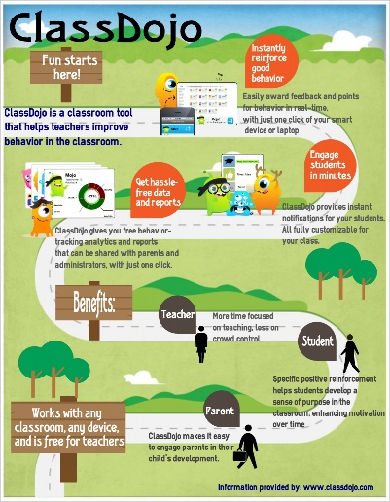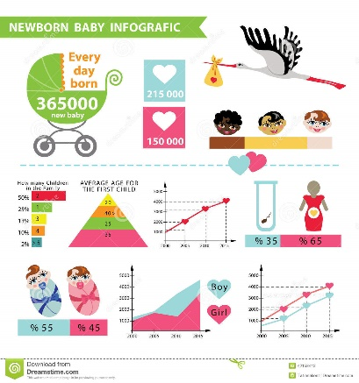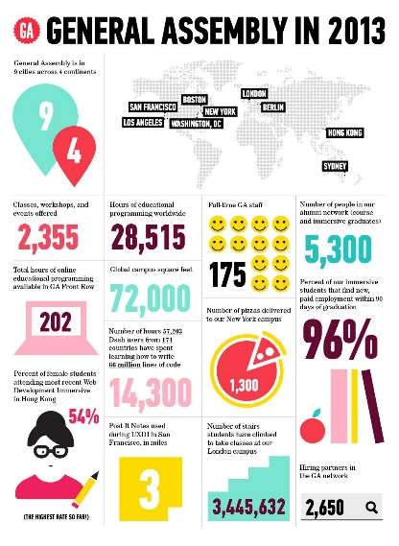

Road Deaths in Australia Data

Resources:
https://data.gov.au/dataset/ds-dga-5b530fb8-526e-4fbf-b0f6-aa24e84e4277/details?q=crash
https://www.bitre.gov.au/publications/ongoing/road_deaths_australia_monthly_bulletins.aspx
https://en.wikipedia.org/wiki/List_of_motor_vehicle_deaths_in_Australia_by_year
https://www.dpti.sa.gov.au/towardszerotogether/resources/archive
https://www.abc.net.au/news/2019-12-30/education-program-for-older-drivers-scrapped-despite-road-toll/11831400
https://www.bitre.gov.au/statistics/safety

