Stage 2 Specialist Mathematics
Assessment Type 2: Folio
Topic: Differential Equations
Purpose
To demonstrate your ability to:
- accurately apply mathematical concepts and relationships to explore a mathematical model
- communicate your results and solutions in report format.
A completed investigation should include:
- an introduction that outlines the problem to be explored, including its significance, its features, and the context
- the method required to find a solution, in terms of the mathematical model or strategy to be used
- the appropriate application of the mathematical model or strategy, including
- the generation or collection of relevant data and/or information, with details of the process of collection
- mathematical calculations and results, and appropriate representations
- the analysis and interpretation of results
- reference to the limitations of the original problem where appropriate
- a statement of the results and conclusions in the context of the original problem
- appendices and a bibliography as appropriate.
Performance Standards for Stage 2 Specialist Mathematics
 | Mathematical Knowledge and Skills and Their Application | Mathematical Modelling and Problem-solving | Communication of Mathematical Information
A | Comprehensive knowledge of content and understanding of concepts and relationships.  Appropriate selection and use of mathematical algorithms and techniques (implemented electronically where appropriate) to find efficient solutions to complex questions.  Highly effective and accurate application of knowledge and skills to answer questions set in applied and theoretical contexts, especially proof. | Development and effective application of mathematical models.  Complete, concise, and accurate solutions to mathematical problems set in applied and theoretical contexts.  Concise interpretation of the mathematical results in the context of the problem.  In-depth understanding of the reasonableness and possible limitations of the interpreted results and recognition of assumptions made.  Development and testing of valid conjectures, with proof. | Highly effective communication of mathematical ideas and reasoning to develop logical arguments, especially proof in applied and theoretical contexts.  Proficient and accurate use of appropriate notation, representations, and terminology.
B | Some depth of knowledge of content and understanding of concepts and relationships.  Use of mathematical algorithms and techniques (implemented electronically where appropriate) to find some correct solutions to complex questions.  Accurate application of knowledge and skills to answer questions set in applied and theoretical contexts, including proof. | Attempted development and appropriate application of mathematical models.  Mostly accurate and complete solutions to mathematical problems set in applied and theoretical contexts.  Complete interpretation of the mathematical results in the context of the problem.  Some depth of understanding of the reasonableness and possible limitations of the interpreted results, and recognition of assumptions made.  Development and testing of reasonable conjectures, with substantial attempt at proof. | Effective communication of mathematical ideas and reasoning to develop mostly logical arguments, including proof in applied and theoretical contexts.  Mostly accurate use of appropriate notation, representations, and terminology.
C | Generally competent knowledge of content and understanding of concepts and relationships.  Use of mathematical algorithms and techniques (implemented electronically where appropriate) to find mostly correct solutions to routine questions.  Generally accurate application of knowledge and skills to answer questions set in applied and theoretical contexts, including some attempts at proof. | Appropriate application of mathematical models.  Some accurate and generally complete solutions to mathematical problems set in applied and theoretical contexts.  Generally appropriate interpretation of the mathematical results in the context of the problem.  Some understanding of the reasonableness and possible limitations of the interpreted results and some recognition of assumptions made.  Development and testing of reasonable conjectures, with some attempt at proof. | Appropriate communication of mathematical ideas and reasoning to develop some logical arguments, including some attempt at proof in applied and/or theoretical contexts.  Use of generally appropriate notation, representations, and terminology, with some inaccuracies.
D | Basic knowledge of content and some understanding of concepts and relationships.  Some use of mathematical algorithms and techniques (implemented electronically where appropriate) to find some correct solutions to routine questions.  Sometimes accurate application of knowledge and skills to answer questions set in applied or theoretical contexts. | Application of a mathematical model, with partial effectiveness.  Partly accurate and generally incomplete solutions to mathematical problems set in applied or theoretical contexts.  Attempted interpretation of the mathematical results in the context of the problem.  Some awareness of the reasonableness and possible limitations of the interpreted results.  Attempted development or testing of a reasonable conjecture. | Some appropriate communication of mathematical ideas and reasoning.  Some attempt to use appropriate notation, representations, and terminology, with occasional accuracy.
E | Limited knowledge of content.  Attempted use of mathematical algorithms and techniques (implemented electronically where appropriate) to find limited correct solutions to routine questions.  Attempted application of knowledge and skills to answer questions set in applied or theoretical contexts, with limited effectiveness. | Attempted application of a basic mathematical model.  Limited accuracy in solutions to one or more mathematical problems set in applied or theoretical contexts.  Limited attempt at interpretation of the mathematical results in the context of the problem.  Limited awareness of the reasonableness and possible limitations of the results.  Limited attempt to develop or test a conjecture. | Attempted communication of emerging mathematical ideas and reasoning.  Limited attempt to use appropriate notation, representations, or terminology, and with limited accuracy.

Stage 2 Specialist Mathematics
Assessment Type 2: Folio
Topic: Differential Equations

Note: While this task is presented with numbered steps, students should present their investigation in report format as per the Subject Outline.
Problem 1: Newton’s Law of Cooling (or Warming)

If an object with the temperature T is placed in the medium with the temperature, the temperature of the object will change in time at the rate directly proportional to the difference between its temperature and the temperature of the surrounding medium .
- Explain when an object cools and when it warms.
- In all following questions, we assume that the temperature of the surrounding medium is constant: T_{m} = const. Explain under what condition(s) this assumption is reasonable.
- Using the proportionality symbol , express the Newton’s law of Cooling (Warming) in mathematical notation. Then write a differential equation (DE) that models the process of cooling (warming). Is the value of the coefficient proportionality k in the DE positive or negative (explain why)?
- Suppose that you just poured a cup of freshly brewed coffee with temperature 95ºC in a room where the temperature is 20ºC.
- When do you think the coffee cools most quickly? What happens with the rate of cooling as time goes by? Explain.
- What is the temperature of the coffee after a very long time?
- Write a DE that expresses Newton’s law of cooling for this specific situation. What is the initial condition?
- Make a rough sketch of the T(t) function, which is your predicted graph fora particular solution of the DE (i.e. your conjecture in a graphical format).
- Consider the differential equation in part 3, i.e. Newton’s Law of Cooling DE in general form:
- Using the method of separation of variables, find the general solution of the DE.
- If the initial condition is T(0) = T₀, find a particular solution (in terms of T_{m}, T₀ and the coefficient proportionality k)
- Suppose that when time is t₁, the temperature is T₁. Find the coefficient k (in term of T_{m}, T₀, T₁ and t₁).
- Consider a cup of coffee described in part 4.
- Using your result in part 5(c), find the value of the coefficient k if it is known that after 30 minutes the temperature of coffee is 25ºC (find both the exact value and approximate value with 3sf).
- Using your result in part 5(b) and the numerical values of T_{m}, T₀, and k, write down a particular solution for the temperature of the coffee.
- You wish to drink your coffee at 65ºC. How long after making coffee should it be served so that the temperature of the coffee is between 64ºC and 66ºC?

- Solve the coffee problem from part 4, using Euler’s method.
For this, design a spreadsheet (EXCEL) to estimate the temperature of coffee for the first 30 minutes at half-minute intervals, where the initial temperature and the medium temperature are as in part 4, and the coefficient of proportionality k is as calculated in part 6(a).
Hint: you may use the following approach to your design:
- Provide cells to enter the constants k and
- Provide cells to enter the time interval boundaries (initial and final ) and the step h
- Provide a cell for the number of steps n required for your interval
- Table of 3 columns and rows (number of steps) //1 row for
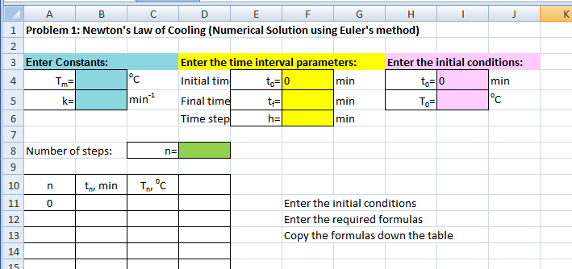
You will use the following formulae:
- Using the spreadsheet you designed, modify the table by adding one more column, in which you have to calculate the values of using the exact solution function found in 6(b).
- Use EXCEL to draw one chart showing both the graph for approximate values of calculated from the Euler’s method in part 7 and the values of calculated from the exact solution in part 8.
Comment on how well the temperatures from the two methods match.
Also comment on your conjecture from (4d).
Problem 2: The Lotka-Volterra Predator-Prey Population
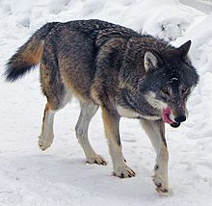  Eurasian wolf (Canis lupus lupus) atKolmarden, Sweden  http://en.wikipedia.org/wiki/Gray_wolf | Consider an ecosystem system consisting of two species, wolves (predators) and rabbits (prey), and the wolves prey on the rabbits.  Assume that the rabbits have unlimited food supply (grass, leaves, berries, etc), i.e. when there were no wolves the number of rabbits would grow exponentially.  Another assumption is that if there were no rabbits then the number of wolves would exponentially decrease to zero. | 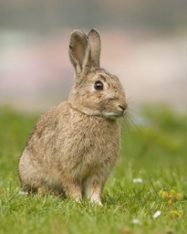  European Rabbit  http://en.wikipedia.org/wiki/European_Rabbit
Let is the number of predators (wolves) and is the number of prey (rabbits) at time t. The populations of the predators and prey are modelled by the Lotka-Voltera system of two differential equations (non-linear!):
The constants a, b, c and d depend on eco-parameters of the system, such as the availability of food for the prey, food requirements for the wolves and their hunting abilities, weather conditions, breeding factors, etc.
Suppose that the values of the constants are:
The task is to find the population functions and. The analytical solution of the above system of DE equations should be solved numerically by using Euler’s method and EXCEL programming as in Problem 1.
- Design an EXCEL spreadsheet to estimateanddaily for the first 1000 days.
Initially let there be 100 wolves and 1000 rabbits.
Hint: You will be asked to estimate the populations for different and. So, enter the numerical values of and 000
only in cells F5, G5. Then you have to use the fixed references to these cells (using the symbol $ in the formulae), when you enter the formulae to calculate and.
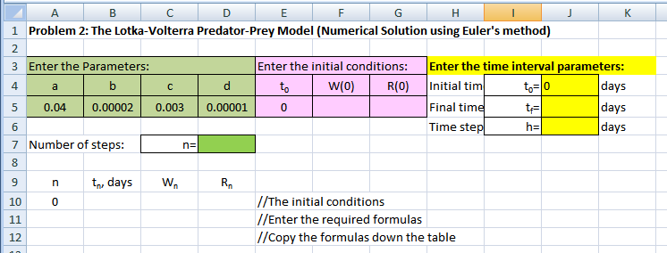

You will use the following formulae:
Use EXCEL to prepare one chart showing both populations and.
What is the maximum and minimum of the predator population? When do they occur?
- What is the maximum and minimum of the prey population? When do they occur?
- Comment on how the two populations interact.

- Use EXCEL to draw the graph of . Discuss the graph.

- Update the initial values for the populations (the table values and the both graphs should update automatically if you programmed the spreadsheet properly):

Discuss the graphs and comment on the behavior of the populations.
- Conjecture what happens with the both populations if initially there are 300 wolves and 2000 rabbits.
Use and to prove your conjecture. Interpret what happens in this case.
References:
- R.Haese and others, Mathematics for Year 12 (Specialist Mathematics), page 297, 283 – 285
- J.Stewart, Calculus, 4th Edition, Brooks/Cole Publishing Company, 1999 (p. 620, 662 - 666)

