Stage 2 Earth and Environmental Science

Program 1: Assessment Type 1: Investigations Folio

Groundwater Hydrology formative activity: Exploring a groundwater system through a sand-tank model

In this activity, you will use a groundwater model, like the one shown in figure 1 (p. 2), to study the movement of water through an aquifer. The model represents a cross-section of a groundwater system.

Features of the Model

1 Use the signs on the model to label the photograph of figure 1, indicating the groundwater system features.

2 Describe the difference between the situations of the shallow, unconfined, aquifer and the artesian aquifer.

___________________________________________________________________________

___________________________________________________________________________

3 Compare the grain sizes of the sediments that make up the shallow, unconfined, aquifer with those of the coarse wedge and the artesian aquifer.

___________________________________________________________________________

___________________________________________________________________________

4 In what way does the confining layer differ from the two aquifers?

___________________________________________________________________________

___________________________________________________________________

5 From where is water fed into the system? __________________________________

6 Describe the feature of the model that represents the intake area for the groundwater system.

___________________________________________________________________________

___________________________________________________________________
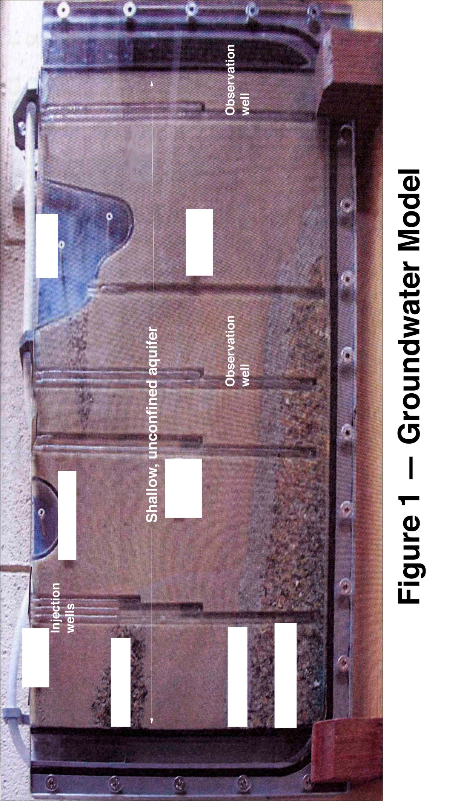

7. Describe the two locations from which water leaves the system.

___________________________________________________________________________

___________________________________________________________________

The Water Table
Turn on the tap so that water flows through the model. Make sure that the water level remains constant, so that the system does not overflow.

N.B. Take great care when handling the long needle. Do not force the tip through the fine mesh at the base of the wells.

1. To locate the water table of the groundwater model:

- Dip the tip of the long needle into food colouring and then carefully insert it down one of the shallow observation wells, just below the water level.
The level of the water surface in this well is the water table.

- Repeat step 1 a. using the other shallow observation well.

- Use a felt pen on the glass front of the model to join the water tables indicated by the two wells. Include the level of the water in the lake, if the lake contains water.

- Indicate on figure 2 the approximate position of the water table in the model.

2. Place the small grey nozzle of the pump firmly but gently into the top of one of the shallow observation wells. Squeeze the trigger a few times to begin pumping water from the well.

- Describe what happens to the water levels in the adjacent wells and in the lake if it contains water.

___________________________________________________________________________

___________________________________________________________________

- Indicate these changes on figure 2.

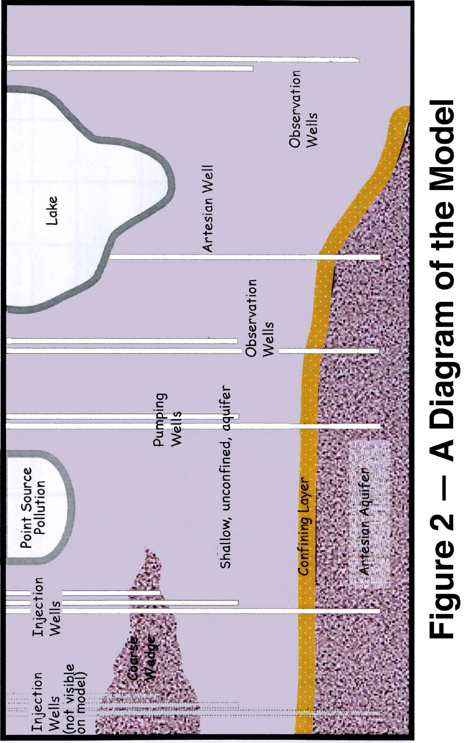

The Groundwater Flow Path

1. Attach the long needle to the large syringe and carefully inject a small amount of colouring into the injection wells. Observe the movement of coloured water as is travels through the shallow aquifer and the deep aquifer.

- Compare the water velocities and flow patterns in the shallow aquifer with those in the deep aquifer.

___________________________________________________________________________

___________________________________________________________________

b. On figure 2, draw and label the paths of the coloured water through the two aquifers.

2. Describe and explain any changes you can see in the lake.

___________________________________________________________________________

___________________________________________________________________________

___________________________________________________________________

3. a. Explain why the water spreads out to form a plume of colour as it moves across the shallow aquifer.

___________________________________________________________________________

___________________________________________________________________

b. Make sure you show this spreading effect on Figure 2.

Effects of Pumping Water from the Wells

Use the pump to extract more water from one of the shallow observation wells.

1. a. Describe what happens to the level of water around the well you are pumping from.

___________________________________________________________________________

___________________________________________________________________

b. Sketch this effect in figure 2.

2. Describe what happens to the plumes of colour you have been observing.

___________________________________________________________________________

3. Discuss the impact of pumping on the groundwater system as a whole, including the artesian aquifef.

___________________________________________________________________________

Contamination of a Groundwater System
Attach one of the small grey tips to the smaller syringe, extract some more colour and add a few drops to the point source to represent a contaminated site.

Now squirt some water from the wash bottle provided to represent rain falling on the area.

1.. Describe the effect of rain on the spread of contamination.

___________________________________________________________________________

___________________________________________________________________

2 Pump water from different observation wells and observe changes in the entire groundwater system. Describe these changes.

___________________________________________________________________________

___________________________________________________________________

