Stage 2 Physics
Program 2: Science as a Human Endeavour Investigation

You are to investigate an aspect of physics with an emphasis on science as a human endeavour (SHE).
Your topic must be related to at least one aspect of the Stage 2 Physics Curriculum.

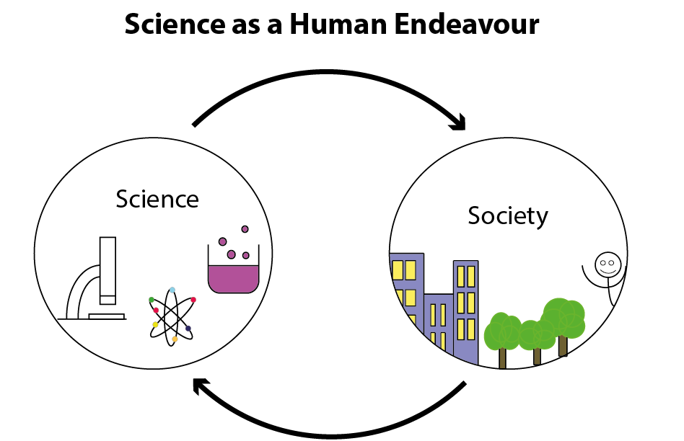

Some aspects of Science as a Human Endeavour from the curriculum statement given below, however, you are encouraged to formulate your own questions or areas of contemporary science exploration.
- Explore examples of the way that scientists have been able to develop solutions affecting aerodynamics (such as shape, texture, and spin).
- Explore perspectives in the public debate about the economics of space exploration
- Research spacecraft propulsion systems, considering technical challenges and speculative technology
- Explore how scientists use the gravitational force to indirectly detect the existence of stars, planets. Moons, black holes, and other celestial bodies, and to predict the existence of dark matter
- Explore how new evidence led scientists to modify models to account for high speed particles that exhibited properties that were inconsistent with Newtonian physics
- Assess the benefits and limitations of applications developed by scientists for electrostatic shielding
- Evaluate the economic, social, or environmental impacts of some contemporary applications developed by scientists based on charges moving within magnetic fields
- Explore the need for cyclotrons and nuclear reactors in the production of radioisotopes, including the role of public debate in influencing their use
- Explore the role of scientists in new technologies enabled by an understanding of electromagnetic waves
- Explore emerging technologies developed by scientists using optical data storage
- Explore innovations developed by scientists that make use of the photoelectric effect
- Explore how the wave nature of electrons has led to a diverse range of contemporary applications.
- Explore new ways that lasers have been utilised by scientists to measure quantities, solve problems and store and transmit data.
- Explore how scientists collect and analyse data from the Large Hadron Collider

You are to access information from different sources, select relevant information, analyse your findings, and develop and explain your own conclusions from the investigation.
Possible starting points for investigation could include:

- an article from a scientific journal (e.g. Cosmos)
- critiquing a blog or TED talk based on a physics concept
- an advertisement or a film clip in which a physics concept is misconstrued
- scientifically analysing a game
- an expert’s point of view
- a new development in the field of physics endeavour
- the impact of a technique and its historical development
- concern about issue which has environmental, social, economic, or political implications
- emerging physics-related careers
- changes in government funding for physics-related purposes, e.g. for scientific research into decommissioned satellites and spent rocket stages, various forms of medical imaging, quantum computers and extremely high data transfer, ring laser guidance systems and their application for accurate aircraft navigation, use of nuclear isotopes for industrial or medical applications, monitoring changes in global temperature.

The report on your science as a human endeavour investigation should be a maximum of 1500 words if written or a maximum of 10 minutes for an oral presentation, or the equivalent in multimodal form. You be assessed on according to the performance standards given below.
The scientific report must include the use of scientific terminology and:
- an introduction to identify the focus of the investigation and the key concept(s) of science as a human endeavour that it links to
- relevant physics concepts or background
- an explanation of how the focus of the investigation illustrates the interaction between science and society, including a discussion of the potential impact of the focus of the investigation, e.g. further development, effect on quality of life, environmental implications, economic impact, intrinsic interest
- a conclusion that summarises the connection between your topic and the selected key concept(s) of science as a human endeavour
- citations and referencing.

The key concepts of Science as a Human Endeavour are:
Communication and Collaboration
- Science is a global enterprise that relies on clear communication, international conventions, and review and verification of results.
- Collaboration between scientists, governments and other agencies is often required in scientific research and enterprise.
Development
- Development of complex scientific models and/or theories often requires a wide range of evidence from many sources and across disciplines.
- New technologies improve the efficiency of scientific procedures and data collection and analysis; this can reveal new evidence that may modify or replace models, theories, and processes.
Influence
- Advances in scientific understanding in one field can influence and be influenced by other areas of science, technology, engineering, and mathematics.
- The acceptance and use of scientific knowledge can be influenced by social, economic, cultural, and ethical considerations.
Application and Limitation
- Scientific knowledge, understanding, and inquiry can enable scientists to develop solutions, make discoveries, design action for sustainability, evaluate economic, social, and environmental impacts, offer valid explanations, and make reliable predictions.
- The use of scientific knowledge may have beneficial or unexpected consequences; this requires monitoring, assessment, and evaluation of risk, and provides opportunities for innovation.
- Science informs public debate and is in turn influenced by public debate; at times, there may be complex, unanticipated variables or insufficient data that may limit possible conclusions.

Performance Standards for Stage 2 Physics
- | Investigation, Analysis and Evaluation | Knowledge and Application
A | Critically deconstructs a problem and designs a logical, coherent, and detailed physics investigation.  Obtains, records, and represents data, using appropriate conventions and formats accurately and highly effectively.  Systematically analyses and interprets data and evidence to formulate logical conclusions with detailed justification.  Critically and logically evaluates procedures and their effect on data. | Demonstrates deep and broad knowledge and understanding of a range of physics concepts.  Applies physics concepts highly effectively in new and familiar contexts.  Critically explores and understands in depth the interaction between science and society.  Communicates knowledge and understanding of physics coherently, with highly effective use of appropriate terms, conventions, and representations.
B | Logically deconstructs a problem and designs a well-considered and clear physics investigation.  Obtains, records, and represents data, using appropriate conventions and formats mostly accurately and effectively.  Logically analyses and interprets data and evidence to formulate suitable conclusions with reasonable justification.  Logically evaluates procedures and their effect on data. | Demonstrates some depth and breadth of knowledge and understanding of a range of physics concepts.  Applies physics concepts mostly effectively in new and familiar contexts.  Logically explores and understands in some depth the interaction between science and society.  Communicates knowledge and understanding of physics mostly coherently, with effective use of appropriate terms, conventions, and representations.
C | Deconstructs a problem and designs a considered and generally clear physics investigation.  Obtains, records, and represents data, using generally appropriate conventions and formats with some errors but generally accurately and effectively.  Undertakes some analysis and interpretation of data and evidence to formulate generally appropriate conclusions with some justification.  Evaluates procedures and some of their effect on data. | Demonstrates knowledge and understanding of a general range of physics concepts.  Applies physics concepts generally effectively in new or familiar contexts.  Explores and understands aspects of the interaction between science and society.  Communicates knowledge and understanding of physics generally effectively, using some appropriate terms, conventions, and representations.
D | Prepares a basic deconstruction of a problem and an outline of a physics investigation.  Obtains, records, and represents data, using conventions and formats inconsistently, with occasional accuracy and effectiveness.  Describes data and undertakes some basic interpretation to formulate a basic conclusion.  Attempts to evaluate procedures or suggest an effect on data. | Demonstrates some basic knowledge and partial understanding of physics concepts.  Applies some physics concepts in familiar contexts.  Partially explores and recognises aspects of the interaction between science and society.  Communicates basic physics information, using some appropriate terms, conventions, and/or representations.
E | Attempts a simple deconstruction of a problem and a procedure for a physics investigation.  Attempts to record and represent some data, with limited accuracy or effectiveness.  Attempts to describe results and/or interpret data to formulate a basic conclusion.  Acknowledges that procedures affect data. | Demonstrates limited recognition and awareness of physics concepts.  Attempts to apply physics concepts in familiar contexts.  Attempts to explore and identify an aspect of the interaction between science and society.  Attempts to communicate information about physics.

