Merit Policy and Procedures

1. Introduction

This policy, and set of associated procedures, relate to the public acknowledgment, by the SACE Board of South Australia, of students' meritorious achievements in the South Australian Certificate of Education (SACE).

2. Principles

This policy is guided by the following principles:

* excellence in a field of study/outstanding overall achievements in the SACE should be publicly acknowledged (public acknowledgment of meritorious achievement);
* awards/commendations/merits/prizes reflect and support the Board’s values: SACE is for all; diversity of students; diversity of pathways in and through the SACE; success for all (diversity, inclusivity, excellence);
* awards/commendations/merits/prizes support students to complete their SACE in the time they need to do so (flexibility);
* awards/commendations/merits/prizes be granted consistently and fairly, and have continuity from the past, present, and into the future (consistency, fairness, continuity);
* awards/commendations/merits/prizes be meaningful and valued by the community (value);
* awards/commendations/merits/prizes celebrate the completion of the senior secondary certificate (celebrate completion of the qualification);
* awards/commendations/merits/prizes encourage and acknowledge students towards excellence/achievement (encouragement, acknowledgment).

3. Relevant legislation

The SACE Board of SA operates under the authority of the SACE Board of South Australia Act 1983, Section 15 (1) of the Act set out the functions of the Board. The functions that relate to this policy are:

(f) to assess, in such manner and to such extent as the Board thinks fit, achievements in or satisfactory completion of subjects, courses or other requirements determined by the Board for the purpose of the SACE;

(g) to recognise, in such manner and to such extent as the Board thinks fit–

1. assessments of students made by schools, institutions or other authorities or organisations;
2. the achievements of a student in or towards completion of any activities or requirements recognised by the Board for the purposes of the SACE;

(h) to assure the quality and suitability of processes and standards used to assess the achievement of students for the purposes of the SACE;

(i) to prepare and maintain records of assessments or achievements made or recognised by the Board and to provide, on request, a copy or extract of those records to a student or former student or to such other person as the student or former student may direct.

4. Policy statement

The SACE Board of SA will publicly acknowledge students' meritorious achievements in the SACE by awarding:

1. Governor of South Australia Commendations
2. Subject merits
3. Other awards and prizes

Governor of South Australia Commendations

There are three types of Governor of South Australia Commendations presented to students each year:

1. Governor of South Australia Commendation – Excellence Award

This commendation is presented to South Australian students who have demonstrated meritorious achievement in Board-accredited subjects, and who have demonstrated excellence in Board-accredited subjects and the development of one or more SACE capabilities.

1. Governor of South Australia Commendation – Aboriginal Student SACE Excellence Award

This commendation is awarded to an Aboriginal student with the best overall performance in the SACE (and who has undertaken the majority of their studies in a South Australian school).

1. Governor of South Australia Commendation – Excellence in Modified SACE Award

This commendation is awarded to a student with identified intellectual disabilities who has demonstrated outstanding achievement whilst undertaking SACE modified subjects.

Subject Merits

Subject merits are presented to students for meritorious achievement in a Board-accredited subject.

Other awards and prizes

Other awards and prizes are presented to South Australian students who meet the criteria for specific awards/prizes. (Refer to the Prizes and Awards Policy).

5. Policy monitoring

The operation and outcomes of the Merit Policy and Procedures will be monitored on an annual basis and a report provided to the Board.

6. Policy procedures

6.1 Governor of South Australia Commendation — Excellence Award

Students can gain a Governor of South Australia Commendation – Excellence Award in one of two ways:

* by demonstrating meritorious achievement in Board-accredited subjects
* by demonstrating excellence in Board-accredited subjects and the development of one or more SACE capabilities.

6.1.1 Meritorious achievement in Board-accredited subjects

To be eligible, students must achieve Subject Merits in Stage 2 Board-accredited subjects to the equivalent of 90 credits (which must include a Subject Merit in either Research Project A or Research Project B).

Students may gain Subject Merits over more than one year.

Selection process

Students will be identified by the SACE Board through the end-of-year results process.

6.1.2 Excellence in the development of one or more SACE capabilities

Students are nominated by their school. Each secondary school may nominate one student only.

To be eligible, students must meet two criteria:

* *Criterion 1*: demonstrate how he/she has developed one or more of the SACE Capabilities – learning, citizenship, communication, personal development, and work during their SACE studies. The Board will provide a concise explanation of the major features of each of the five capabilities against which schools, on behalf of the student, can provide information.
* *Criterion 2*: achieve the equivalent of an A (A+, A, A–) in Stage 2 Board-accredited subjects and/or Board-recognised courses for 70 credits. This must include an A (A+, A, A–) in either Research Project A or Research Project B.

In the 70 Stage 2 credits, students can include, to the maximum of 20 credits, an International Baccalaureate Diploma Subject (at Higher or Standard level with a completed score of 6 or 7); or a University Studies subject (at Credit or Distinction level), or a subject from another Australian accrediting agency (with a grade equivalent to an A as defined by the SACE Board).

Students are able to obtain up to 70 Stage 2 credits in Vocational Education and Training. The achievements of such students must be deemed excellent by the school, and supported with testimonials from the Registered Training Organisation. Students must undertake an AQF CII or above aligned to Stage 2 level in one of the national industry areas. Students must demonstrate a high level of commitment, skill and achievement whilst undertaking a VET program as part of the SACE.

Nomination process

* Schools provide details of the nominated student’s major achievements against one or more of the capabilities by completing the Governor of South Australia Commendations nomination form.
* Nominations must reach the SACE Board by the due date (determined by the SACE Board each year).
* A Board-appointed selection panel shortlists the nominations received, using the selection criteria.
* Students may meet the requirements of this award over the years that they undertake the SACE.
* The Governor of South Australia Commendations are open to students who complete the requirements for the award over more than one year, but are only awarded in the year in which the student first completes the SACE.
* The Governor of South Australia Commendations are open to all students who complete the SACE in South Australia only. Commendations are not available to students in the Northern Territory, Malaysia, or China (as the Research Project is not compulsory for these students).

Selection panel

* A Board member (chair)
* The Governor of South Australia or nominee
* Three nominees from the schooling sectors
* A nominee from the vocational education and training sector
* A member of the business community;
* A member of the SACE Board executive team.

Selection process

* From the nominations, a Board-appointed selection panel undertakes an initial shortlisting process, using the selection criteria.
* The shortlist of students is provided to the SACE Board’s Information Services Group.
* The selection panel is not required until final subject and merit achievements are known.
* At the time of results processing, when Subject Merits are known, the SACE Board’s Information Services Group informs the selection panel of those students still eligible for the award, i.e. those students who have received at least an A– for Research Project A or B, and other achievement data (including data from interstate, VET, and IB).
* The selection panel makes its final recommendation from the updated shortlist.
* The SACE Board informs schools and students of the outcome of the selection process.
* The award is presented to students at the annual SACE Merit Ceremony.
* The award consists of a parchment-style document, ‘Governor of South Australia Commendation’.

6.2 Governor of South Australia Commendation — Aboriginal Student SACE Excellence Award

The Governor of South Australia Commendation — Aboriginal Student SACE Excellence Award will be presented to the Aboriginal student who has achieved excellence in their SACE studies taking into account the level of achievement reached in (a) Stage 1 and Stage 2 SACE subjects, (b) other recognised courses; and who can demonstrate excellence against one or more of the capabilities.

*Selection process*

Students are nominated by their school. Each secondary school may nominate one student only for an Aboriginal Student SACE Excellence Award (this is in addition to one nomination for a Governor of SA Commendation).

\* An Aboriginal student who is nominated for a Governor of SA Commendation – Aboriginal Student SACE Excellence Award, and who becomes eligible for the ‘Governor of SA Commendation – Excellence Award (i.e. receives the equivalent of an A (A+, A, A–) in Stage 2 subjects or courses for 70 Stage 2 credits, including an A in the Research Project) will also be considered by the panel for a Governor of South Australia Commendation – Excellence Award, irrespective of whether or not the student was nominated by his or her school. (So, it is possible that a student who is awarded the Aboriginal Student SACE Excellence Award could also be awarded a Governor of SA Commendation — Excellence Award).

Selection criteria

To be eligible for this award the student must:

1. self-identify as an Aboriginal person in their SACE enrolment
2. have undertaken the majority of the certificate studies in a South Australian school
3. have completed the SACE
4. be judged by a selection panel, appointed by the Board, as having achieved overall excellence in the SACE taking into account the level of achievement reached in (a) Stage 1 and Stage 2 SACE subjects, (b) other recognised courses
5. demonstrate how he/she has developed one or more of the SACE capabilities – learning, citizenship, communication, personal development, and work during their SACE studies.

Nomination process

* Schools provide details of the nominated student’s major achievements against one or more of the capabilities by completing a Governor of South Australia Commendation – Aboriginal Student SACE Excellence Award nomination form.
* Nominations must reach the SACE Board by the due date (determined by the SACE Board each year).
* A Board-appointed selection panel shortlists the nominations received, using the selection criteria.
* Students may meet the requirements of this award over the years that they undertake the SACE.
* The Governor of South Australia Commendation – Aboriginal Student SACE Excellence Award is open to students who complete the requirements for the award over more than one year.
* The Governor of South Australia Commendation – Aboriginal Student SACE Excellence Award is open to all students who complete the SACE in South Australia only. Commendations are not available to students in the Northern Territory, Malaysia, or China (as the Research Project is not compulsory for these students).

Selection panel

The selection panel, to be appointed by the SACE Board after consultation with the SACE Aboriginal Education Strategy Steering Committee, will consist of:

* Chair of the SACE Aboriginal Education Steering Committee
* An eminent member of the Aboriginal community
* An Aboriginal member from a government agency that has a focus on developing pathways for Aboriginal students
* A member of the SACE Board
* An executive officer from the SACE Board.

Selection process

* the list of nominated students is provided to the Board’s Information Services Group
* the Information Services Group provides data for the nominated students that includes grades for Stage 1, grades for Stage 2, and any VET, or ‘other’ recognised learning
* the selection panel is not required to meet until final results are known
* the selection panel follows appropriate protocols for transparent and ethical decision making
* the selection panel considers the information provided on the school nomination forms for each nominated student, based on:
* overall subject achievement in the SACE, taking into account levels of achievement in Stage 1 and Stage 2 subjects, and other recognised courses (e.g. Vocational Education and Training Qualifications, or University Studies). Preference is given to Stage 2 results
* the demonstrated excellence against the capabilities,
* the selection panel recommends whether or not an award would be granted in any one year
* the selection panel makes its recommendation to the Chief Executive of the SACE Board based on overall achievement in the SACE, and the demonstrated excellence against the capabilities outlined on the nomination form submitted by the school

The SACE Board informs schools and students of the outcome of the selection process.

The award is presented to students at the annual SACE Merit Ceremony

The award consists of a parchment-style document with the wording, ‘Governor of South Australia Commendation – Aboriginal Student SACE Excellence Award’.

6.3 Governor of South Australia Commendation — Excellence in Modified SACE Award

The Governor of South Australia Commendation — Excellence in Modified SACE Award will be awarded to the student with identified intellectual disabilities who demonstrates outstanding achievement in SACE modified subjects.

Selection criteria

To be eligible for this award the student must:

1. have an identified intellectual disability
2. be enrolled in a South Australian school
3. complete the SACE using

either

* only modified subjects at Stage 1 and Stage 2

or

* modified subjects at Stage 1 and Stage 2, and a completed Board-recognised course (e.g. a student who has completed a Board-recognised course, such as VET, as part of their SACE may be considered for the award).

1. receive the award in the year that they first complete the SACE Board of South Australia
2. have been nominated by their school.

Selection panel

* Board member
* Member of the Ministerial Advisory Committee for Students with Disabilities
* Three representatives of the schooling sectors experienced in senior secondary special education
* Co-opted member (as required to provide specific advice)
* A member of the SACE Board executive team
* An executive officer from the SACE Board.

Nomination process

* Each school may nominate one student only.
* Nominations must reach the SACE Board by the due date (determined by the SACE Board each year).
* Nominations need to include:
  + a brief listing of the nominated student’s outstanding achievements, and the personal goals achieved described against one or more of the SACE Capabilities while undertaking the SACE; and
  + a brief testimonial from a person or organisation in the wider community who can support the nomination.

6.4 Subject Merits

Students can gain a Subject Merit in a Stage 2 Board-accredited subject, if they meet the following two criteria:

1. gain an overall subject grade of A+ for that subject, *and*
2. be selected by a panel, appointed by the SACE Board, as demonstrating exceptional achievement in the subject. Typically, fewer than 2% of the subject cohort would meet this criterion.

Subject Merits will be reported on the student's SACE Record of Achievement as 'A+ with Merit'. The student will receive a parchment-style document that will attest to being awarded a SACE Merit in a Board-accredited subject.

Students who have been approved as 'private candidates' in a subject are not eligible for a Subject Merit.

Subject merit determination process

The Subject Merit Determination Process consists of the following steps:

* Determining the Assessment Type Grades
* Deriving the Numeric Equivalents for Each Assessment Type
* Combining the assessment type and numeric equivalents to determine:
* a final subject grade
* a final subject numeric equivalents
* Selecting the Subject Merits, ensuring students:
* gain an overall A+ against the performance standards
* demonstrate exceptional achievement (typically fewer than 2% meet this criterion).
* Putting in place a shortlisting process if the Merit Selection Panel believes that this is necessary
* Awarding Meritorious Students.

Diagram – subject merit determination process

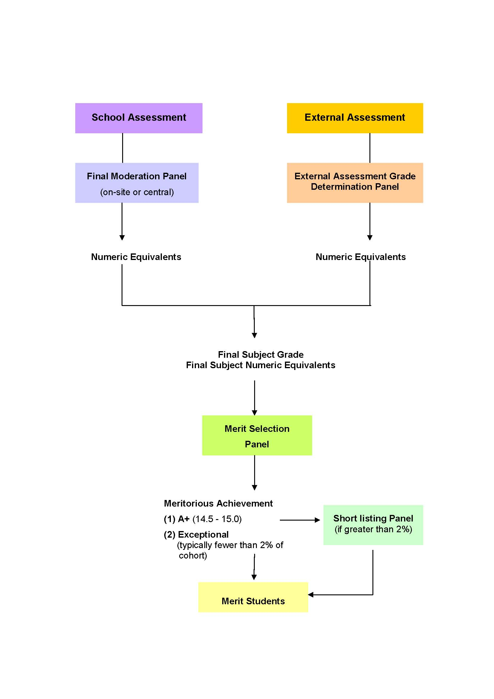

6.5 Other awards and prizes

The SACE Board of SA may acknowledge meritorious achievement by granting awards/prizes designed to recognise specific achievements (e.g. the Tennyson Medal; and awards/prizes provided by subject associations).

The form these awards/prizes will take will vary and may include, for example, parchment-style documents, prizes, and/or medals. For more information on other prizes and awards refer to the *Prizes and Awards Policy.*