Stage 2 Politics, Power and People
Summative Task 2: Production of news report/article
Theme: Mediatisation of politics
Weighting: 15%

Task
Students create a recorded news report or write a news article that responds to one of the following inquiry questions.

1. To what extent does the media protect the fundamental rights and responsibilities of western liberal democracies?
2. To what extent has global politics been revolutionized by new media?
4. Can Australian political journalism survive the twenty-first century?

Students are required to invoke case studies to demonstrate their knowledge and skills of their chosen inquiry questions. Case studies may include (but are not limited to) historical news reports, opinion pieces, factual reports, or social media posts and may be of an international or national political focus.

Conditions of assessment
Assessment Style: Recorded news report or written news article

Word Count: Maximum of 1000 words (news article), 6-minute presentation (recorded news report), or equivalent in multimodal form

Allocated class time: 8 hours (students required to work on task outside of class)
Draft due date (submitted via Moodle, in ‘Draft submissions’ tab): Friday May 28 by 1.30pm
Final due date (submitted via Moodle, in ‘Summative Task submission’ tab): Friday June 4 by 5pm
File name: yourSACEnumber-2PPP20-AT1-yourlastnameNewspiece

Marking Criteria
CCT1: Develops solutions, makes judgements, and composes arguments that relate to political issues
CC1: Communication of political ideas, opinions, and arguments
UER1: Understanding of political concepts and the interconnectedness of Australian politics and the world
UER2: Explanation of the political and ethical nature of the issues
RA1: Application of inquiry skills to research political issues and perspectives

Performance standards for Politics, Power, and People
(Stage 2)

- | Critical and Creative Thinking | Communication and Collaboration | Understanding and Ethical Reasoning | Research and Analysis
A | Proposes insightful solutions, makes reflective judgments, and composes arguments that relate to political issues.  Comprehensively and thoughtfully analyses and evaluates political concepts. | Highly organised and fluent communication of political ideas, opinions, and arguments.  Insightful and constructive collaboration in order to build on the ideas of others, solve political problems, or improve solutions. | Perceptive and well-informed understanding of political concepts and the interconnectedness of Australian politics and the world.  Insightful and coherent explanation of the political and ethical nature of the issues. | Uses comprehensive and discerning inquiry skills to research political issues and perspectives, using a variety of relevant and current literature.  Critical analysis and evaluation of political issues using primary and secondary sources.
B | Proposes balanced solutions, makes thoughtful judgments, and composes arguments that relate to political issues.  Competently analyses and evaluates political concepts. | Logical and clear communication of political ideas, opinions, and arguments.  Thoughtful collaboration in order to build on the ideas of others, solve political problems, or improve solutions. | Thoughtful understanding of political concepts and the interconnectedness of Australian politics and the world.  Clear explanation of the political and ethical nature of the issues. | Uses in-depth inquiry skills to research political issues and perspectives, using relevant and current literature.  Purposeful analysis and evaluation of political issues using primary and secondary sources.
C | Proposes solutions, makes judgments, and composes arguments that relate to political issues.  Analyses and evaluates political concepts. | Competent communication of political ideas, opinions, and arguments.  Collaboration in order to build on the ideas of others, attempt to solve problems, or improve political solutions. | Informed understanding of political concepts and the interconnectedness of Australian politics and the world.  Sound explanation of the political and ethical nature of the issues. | Uses sound inquiry skills to research political issues and perspectives, using relevant literature.  A sound analysis and evaluation of the political issues using primary and secondary sources.
D | Refers to solutions and recounts information related to political issues.  Explains a political concept. | Communication of ideas and opinions.  Some collaboration in order to attempt to solve problems. | Some understanding of political concepts.  Some recognition of the political nature of issues. | Limited inquiry using some relevant literature.  Limited analysis of the political issues using some sources.
E | Identification of a simplistic solution.  Identification of a political concept. | Basic communication of ideas.  Limited evidence of contributions. | Minimal understanding political concepts.  Limited recognition of the basic political ideas. | Minimal inquiry using a source.  Superficial recognition of political issues.

Scaffolding for each inquiry question (things to consider when choosing, and creating, your news piece.

1. To what extent does the media protect the fundamental rights and responsibilities of western liberal democracies?
In this question, you should consider some of the following:
Media: social media, TV, radio, print media (newspapers, magazines), online news websites (from all along the political spectrum)
Fundamental rights and responsibilities: freedom of opinion, freedom of expression, responsible use of expression, freedom of the media, the right for the public to access information, freedom of expression in a democratic society
Western liberal democracies: Australia, New Zealand, United States of America, United Kingdom, Canada etc.

2. To what extent has global politics been revolutionized by new media?
In this question, you may consider any of the following:
Global politics: Any decent political story from the past 25-30 years can be considered, and how new media impacted it. Examples may include USA Presidential elections, the Arab Spring, Brexit, political relations during the Covid-pandemic, Australian political story and so forth. The choices are endless really.
New media: emerging in the 1980s, new media includes the following: talk radio, television talk shows, tabloid newspapers, political party websites, election websites, viral videos, social media platforms, the 24/7 news cycle.

4. Can Australian political journalism survive the twenty-first century?
If considering this question, remember that the majority of Australians are not politically engaged the way they should be. Can political journalism survive if that is the case? If it is to survive, what does it need to do so? Consider how much journalism has changed even in your own life time, and if political journalism can survive the next 80 years…

Hints for your news piece

Structure Your Article
Once you have gathered the information and done with your research, it is the time to structure your article.

Create an Informative and Catchy Headline
The headline can make or break your reader’s interest. If it is not interesting, engaging and creative, it is less likely to draw the attention of the reader. Not only should it be creative enough to grab the reader’s attention but also precise and concise to reflect what your article is all about.
- A good headline informs the reader about “what, when and where” in a glance.
- Keep it clear and brief, not more than five words
- You can also make the headline in the end, after you have finished writing. It will give you a better idea of what to focus on that can appropriately sum-up your article.

Create a Lead or Opening Paragraph
Lead, undeniably, is an essential part of your newspaper article. Learning ‘ how to make a lead ‘ will not only make your article engaging but also help you inform your readers in the better way. You can take the assistance of an expert or pro journalist to not only learn’ what is lead’ but also specific techniques to use them in your news article.
Lead is an opening paragraph in the article. Newspaper articles often seem banal with a multitude of sources and details. Most readers like to just skim through the first paragraph or first few sentences unless they find it interesting enough to read further.
A good Lead example tells readers important information in a concise, clear and interesting manner. Not only this, it further establishes a direction, tone, and voice of an article.
The following tips may help you create an impactful lead.
- Answer Five W’s: Before you begin writing a lead, decide the important aspects associated with the story that answers who, when, what, why and where. Emphasize these aspects in the lead of your article. Do not go into the details to explain them.
- Talk about Conflict: Highlight the point of conflict to develop the reader’s interest
- Specificity: The briefer the better. Summarize the information in lead and keep it specific to make it informative
- Conciseness: Learning how to present information in a brief yet effective manner is very important to deliver what your reader is expecting to know. Be concise and relevant about the information you are giving in the lead.
- Pertinent Vocabulary: Try using specific jargon and active verbs in lead to make it interesting, impactful and lively. Avoid passive construction as it may leave readers bewildered with incomplete reporting.
- Update Your Readers: Readers already know the breaking news due to modern media culture and technology. So if you are working for print media, try to update the information instead just regurgitating an old news.
- Honesty: This tip refers to your promise that you deliver the correct information in the article.

Things to Avoid
- Flowery And Exaggerated Language: Remember that you are writing a news article and using flowery language never makes a good news lead example. Avoid overusing unnecessary adjectives and focus on using lively verbs.
- Avoid Redundancy: Smart journalists never waste lead space with random words and unintentional redundancy. Consider this news lead example, p.m, Tuesday afternoon. Try to avoid repeated information as much as you can, come right to the point.
- Formulaic Leads: Delivering information in mechanical tone brings monotonous effect. Your readers want to be entertained so create a lead that is genuine and engaging.
- Avoid Using ‘It’ In the Beginning: Clarity is an essential element of a press release or newspaper article. Never begin your article with pronouns like ‘it’. It can disorient your readers.

Follow a Chronological Order When Writing a Lead
Beginning with a well-crafted lead, always follow a chronological order. That means to place the most important and current details first and so on. This will not only make your news article comprehensive but also help your reader skim through the beginning section. Provide updated information in the first 1-3 lines following the inverted pyramid approach.

Expand Your Article with Supporting Details
Once you created a lead, and if it is interesting enough to capture the reader’s attention and make him/her curious, he/she might want to discover more. Expanding the key details is all about telling people how something happened. Provide in-depth coverage on all the important aspects of the news story.
Summarize and reflect on the first-hand information you explored from the sources. Add a background, contextual information or any other detail related to subject matter or incident. Do not extend each paragraph more than 3 – 4 sentences to make it easy to follow along.

Include Supporting Quotations
Referring to sources in the article increases the credibility of information and adds value to your organization’s reputation. By including supporting quotation/ statement from sources, you can validate the information you are providing.
Choose pertinent, short, and brief quotations that are informative. Plus, make sure you attribute the used quotes to its source in the article.
- For example, “The baby was unconscious and had his leg broken, stated Police Chief Peter Wilborn.”
- Avoid using too many quotes as the reader may get confused.

Finish Your Article with Informative Link or Quote
To wrap up the news article, you can use an impactful quote. Including a link to a company/ organization’s website is also a good option if your article focuses on any specific organization.
For example, you can write, “the family of victim expressed a concern about his health” as they say ‘We just hope he’ll be okay won’t suffer from these symptoms”.
Alternatively, “Local police has recommended parents to accompany their children everywhere they go, website. www.ty.org

Use Appropriate Tone

Easy and Clear Language
Making your news article linguistically complicated is not something your reader appreciates. Remember that your purpose is to inform the reader and if you use unintelligible language it will only distract them.
To put it simply, avoid using vague language, or the words which are not useful. Talk to your readers in lay man’s language to make it accessible to all kind of readers. Avoid constructing longer sentences or run-on sentences.

Use Active Voice
Being a journalist, your job is to inform ‘WHO’ did what. That means, including subject when writing a news article is a key to reduce obscurity. It is only possible when you use the active voice. The sentence structure becomes more vivid and informative in the active voice.

Maintain an Informative Tone
The newspaper article is for everyone and aims to inform the readers by giving them correct and updated information. That is why it is crucial to maintaining an informative tone that does not show your subjectivity. It must be based on a factual account, incident or event. Do not exaggerate the details by using hyperbolic language.

Polish Your Article
Last but not the least, once you are done with structuring your article, read it again to revise and refine it. The first draft has a lot of room to improvise. Read it from the perspective of your reader. See if it is informative, engaging and communicate what it intended to.
- Make sure leads, quotes and references are clear and intelligible
- Check it for any linguistic complexity or spelling, grammar errors
- You can show it to a peer for feedback, critique on voice and tone.
- Revise your articleand create a final draft

Bottom Line
In conclusion, writing a newspaper article requires you to collect factual details, and data from the verified sources. Plus, catchy lead, headline, and appropriate structure are some important features you need to consider. Thus, the above-mentioned tips are very helpful to make you write a well-structured news article.
https://www.aresearchguide.com/write-a-newspaper-article.html
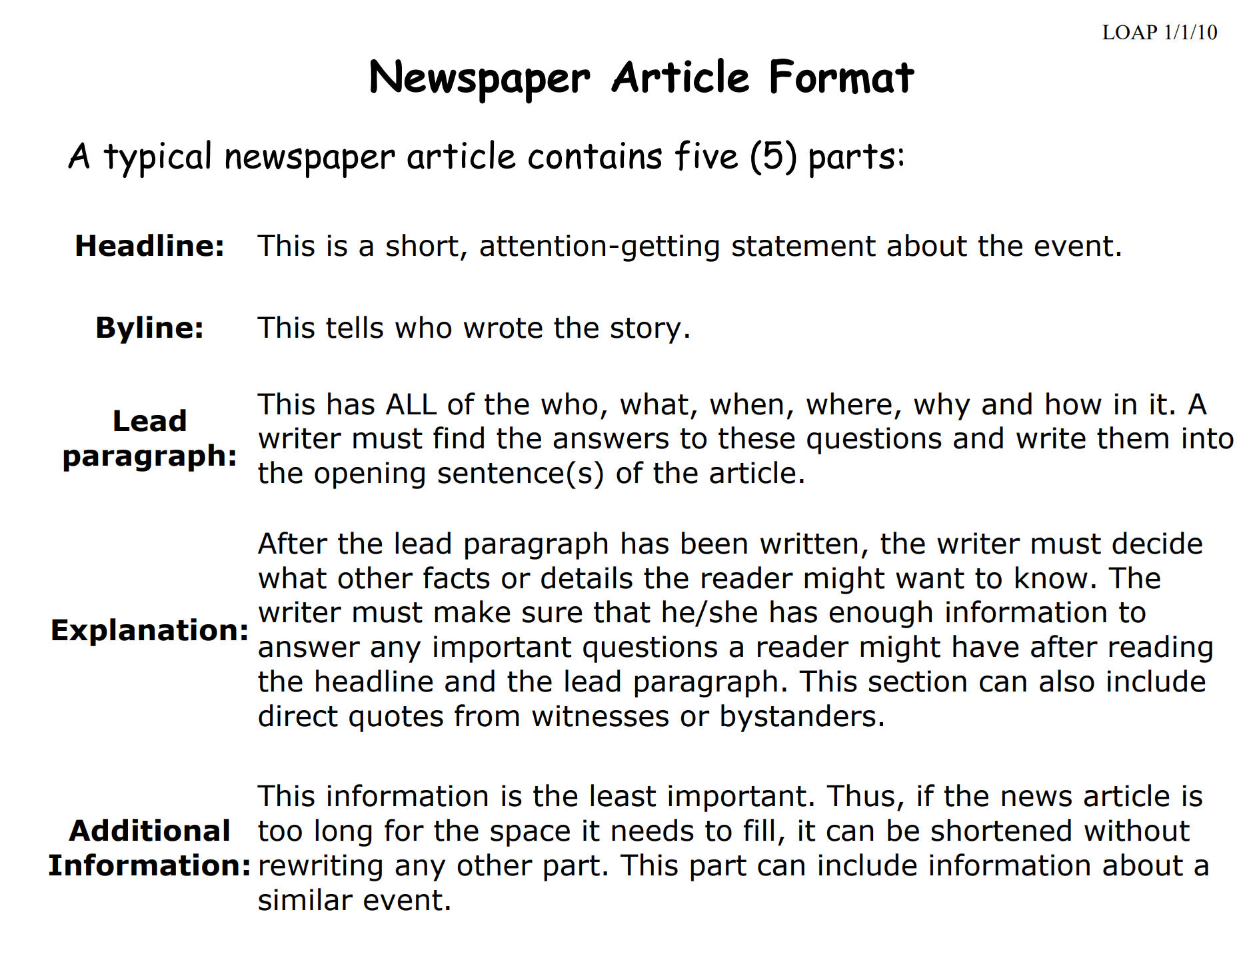

https://www.historyisfun.org/pdf/tea-overboard/newspaper_article_format.pdf
Published with kind permission Muirden Senior College

