Stage 1 Power, Politics and People
Summative Task 2: Source Analysis
Theme: Understanding How Politics Works
Task
Students will be provided sources to analyse. These sources will come in a multimodal format, requiring students to respond to Inquiry Question 4 ‘In what ways does your vote count?’ Students will consider how the different sources may have influenced voters during the election process. Students will be required to compare and contrast the provided sources by responding to questions set by the teacher.
Assessment Conditions
Assignment format: Comparative Source Analysis
A maximum of 1000 words if written or a maximum of 6 minutes if oral or the equivalent in multimodal form for the final product.
Final due date: Thursday 23 September, 5pm. Submitted via Moodle
File name: SACEnumber-1PPP-AT2-lastnameAnalysis
Marking criteria
CCT2 – analysis of political concepts
CC1 – communication of political ideas, opinions, and arguments
UER1 – understanding of political concepts and the interconnectedness of Australian politics and the world
UER2 – explanation of the political and ethical nature of the issues
RA2 – analysis and evaluation of political issues, using primary and secondary sources

Performance standards for Politics, Power, and People
Stage 1
Downloaded from the online subject outline
- | Critical and Creative Thinking | Communication and Collaboration | Understanding and Ethical Reasoning | Research and Analysis
A | Proposes creative and insightful solutions and makes reflective judgments that relate to political issues.  Comprehensively and thoughtfully analyses political concepts. | Highly organised and fluent communication of political ideas, opinions, and arguments.  Insightful and constructive collaboration in order to build on the ideas of others, solve political problems, or improve solutions. | Perceptive and well-informed understanding of political concepts and the interconnectedness of Australian politics and the world.  Insightful and coherent explanation of the political and ethical nature of the issues. | Employs comprehensive and discerning inquiry skills to research political issues and perspectives, using a variety of relevant and current literature.  Critical analysis and evaluation of political issues, using primary and secondary sources.
B | Proposes creative and balanced solutions and thoughtful judgments that relate to political issues.  Competently analyses political concepts. | Logical and clear communication of political ideas, opinions, and arguments.  Thoughtful collaboration in order to build on the ideas of others, solve political problems\or improve solutions. | Thoughtful understanding of political concepts and interconnectedness of Australian politics and the world.  Clear explanation of the political and ethical nature of the issues. | Employs in-depth inquiry skills to research political issues and perspectives, using relevant and current literature.  Purposeful analysis and evaluation of political issues, using primary and/or secondary sources.
C | Proposes solutions and makes judgments that relate to political issues.  Analyses political concepts. | Competent communication of political idea, opinions, and arguments.  Collaboration in order to build on the ideas of others, attempt to solve problems, or improve political solutions. | Informed understanding of political concepts and interconnectedness of Australian politics and the world.  Sound explanation of the political and ethical nature of the issues. | Employs sound inquiry skills to research political issues and perspectives, using relevant literature.  A sound analysis and evaluation of the political issues, using primary and/or secondary sources.
D | Refers to solutions and recounts information related to political issues.  Explains a political concept. | Communication of ideas and opinions.  Some collaboration in order to attempt to solve problems. | Some understanding of political concepts.  Some recognition of the political nature of issues. | Limited inquiry using some relevant literature.  Limited analysis of the political issues, using some sources.
E | Identification of a simplistic solution.  Identification of a political concept. | Basic communication of ideas.  Limited evidence of contributions. | Minimal understanding political concepts.  Limited recognition of the basic political ideas. | Minimal inquiry, using a source.  Superficial recognition of political issues.

Source One

1. Does this source present the continuing lockdown in Melbourne in a positive or negative manner? Using a minimum of 3 examples from the source, please explain your answer.
2. Considering the manner of the of source, how could this source influence undecided voters in Victoria’s next election?
Source 2

3. Compare this source to source 1. How is it different to source one in the way it is portraying its message? Use examples from each text to validate your answer.
4. Comparing source 1 and 2, which state (Victoria or New South Wales) is presented as doing better in its Covid response? Using evidence from the sources, please justify your answer.
Source 3
Health more likely to be key arena in election than a new stadium
Matthew Abraham
18 September 2021
Building stadiums has been a great path to retaining power for governments. But SA’s next election will be fought in a very different arena, says Matthew Abraham.
It took the Romans 600 years to become bored with building amphitheatres as venues to relax and enjoy watching gladiators maim and slaughter each other.
It looks like our love affair with ritzy, taxpayer-funded sporting arenas is fading much faster than that.
The Romans did love their stadiums, constructing more than 300 dotted across the empire, from small temporary 10,000-seat wooden affairs up to the sensational Colosseum that could put 50,000 toga-clad bums on seats.
Restoration work at Rome’s Colosseum has revealed remnants of an “ingenious system of platforms, winches and ramps, manned by hundreds of stage technicians and animal handlers”, reports the latest National Geographic, with trapdoors to release animals, elaborate painted sets lifting out of the stadium floors, and elevators taking gladiators up to their fights.
“Spectators didn’t know what would open when, or where,” German archaeologist Heinz Best told the magazine.
Sadly, our sporting stadiums aren’t anywhere near as much fun. They still serve the same purpose however – keeping the unwashed masses happy and distracted, and governments in power. Build a new stadium, or a new hospital, and the votes will follow.
The design for Adelaide’s proposed Riverbank Arena.
It’s why we ended up with the new Adelaide Oval and the new Royal Adelaide Hospital, both projects that helped Labor remain in power for 16 unbroken years.
And it’s why Premier Steven Marshall has promised a $667m stadium on the banks of the River Torrens as a major plank of his 2022 re-election campaign.
He calls it the “Riverside Arena”. Labor calls it “another basketball stadium” and has instead pledged to pump the earmarked arena cash into the health system.
Now a new opinion poll shows the gloss may have worn off the “stadiums for votes” strategy. The July poll, oddly commissioned by the Canberra-based Australia Institute think tank, asked voters how they’d prefer to see the $677m of public money spent – on the Riverside Arena or the health system.
A whopping 82 per cent of voters polled wanted the money spent on health, with even 81 per cent of Liberal voters backing health over their party’s arena.
A tight contest between Opposition Leader Peter Malinauskas, left, and Premier Stephen Marshall is looming, says Matthew Abraham.
To be fair, if a similar poll before the 2014 election had asked voters if they wanted former Labor premier Jay Weatherill to spend $160m on his weird O’Bahn tunnel promise or to instead invest the cash in health, the result would probably have been the same.
Labor won that election, but it had already delivered the brand new RAH.
The poll shows a tight contest heading toward the March ballot box, with the Liberals holding a slender 51 to 49 per cent two-party preferred lead over the ALP.
While the figures show a wildcard 17 per cent primary vote for anonymous independents and the zombie SA Best, these are still not good numbers for the Marshall Government.
It’s risky reading too much into one poll. But it shows voter intentions haven’t budged since the Sunday Mail’s authoritative statewide YouGov poll published in March this year. That also showed a 51-49 split.
They show that despite Premier Marshall’s management of the Covid-19 pandemic, his wheels appear to be spinning in the mud. Whether the hoopla over the new nuke subs deal gives him traction, or whether voters aren’t keen on becoming a missile target for China, remains to be seen.
The latest poll shows health is overwhelmingly the major issue in the minds of voters – unsurprising given the pandemic – and we’re evenly split on who we most trust to fix the health system. Both Liberal and Labor rank 36 per cent support on this key question.
That’s good news for Premier Marshall, but it’s good news for Labor leader Peter Malinauskas too.
It confirms the smarts of the Labor leader’s dogged refusal to be sidetracked into bagging the government’s pandemic response, instead hammering away at problems in the public health system, particularly ambulance ramping.
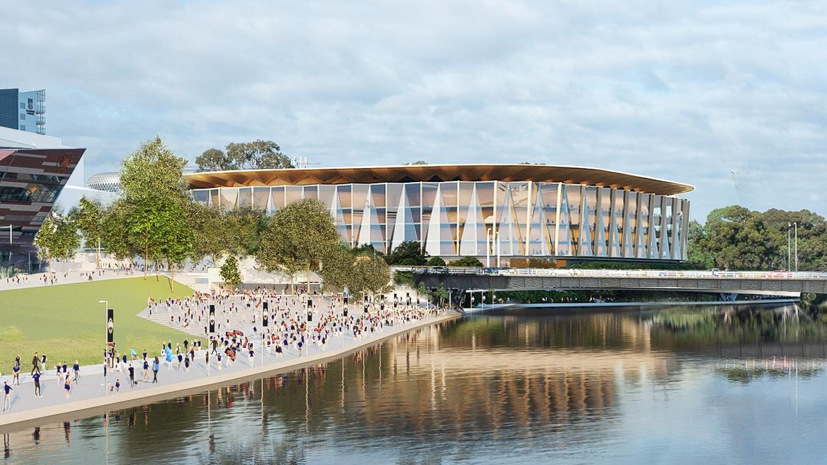
Ironically, the proposed Riverbank Arena would be only a short stroll from the Royal Adelaide Hospital.
The fact that Labor is so well positioned on health, despite its Transforming Health mess while in office, including the dumb closure of the Daw Park Repat Hospital, shows voters are either very forgiving, or we have the attention spans of goldfish.
Add to this mix the rogue element – Adelaide’s ambulance fleet, festooned with pithy slogans attacking the government’s funding of the health system.
The ambos have become the political equivalent of cranky Roman gladiators, riding around in their chalked-up chariots, belting big dents in the government’s health armour.
Spectators didn’t know what would open when, or where, in a Roman amphitheatre. And nobody knows when, or where, an ambulance will change a vote.

5. Is this source a news article or opinion piece? Using evidence from the text, please explain your answer.
6. Is this source impartial in its presentation of the Liberal and Labor parties of South Australia? Using evidence from the text, please validate your answer.
7. Using the information presented in this article, would you be more likely to vote for the Liberal or Labor party? Using textual evidence, justify your answer.

Reproduced with kind permission Muirden Senior College

