How effectively do yeast process sugar substitutes?

Have you ever wondered how bread gets its "spongy" structure? If you have ever baked homemade bread yourself, you know that you need yeast (single-celled fungi) to make the bread dough rise.

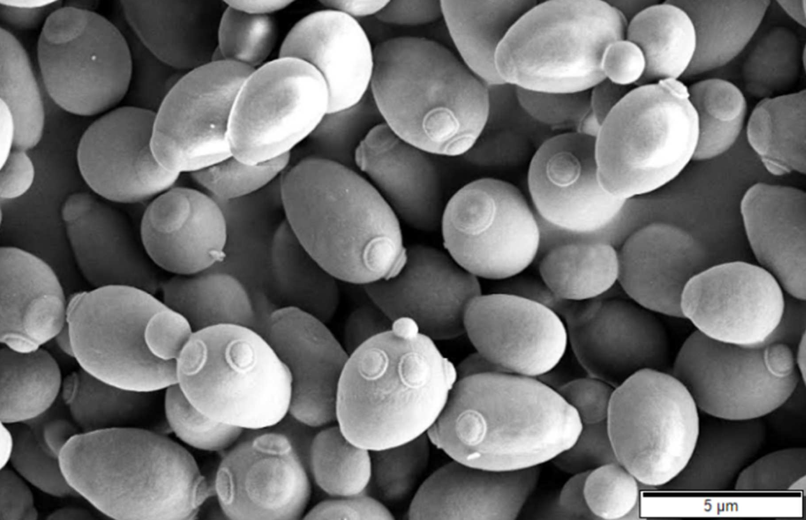
Figure 1. Baker's yeast (Saccharomyces cerevisiae) viewed with a scanning electron microscope.

Like the cells in your body, fungi can derive energy from sugar. They can also break down larger carbohydrates (like starches present in flour) into simple sugars. But what about sugar substitutes? Can the yeast use sugar substitutes to grow and reproduce? In this task you will investigate this question by providing yeast with different sources of energy, including sugar substitutes. To measure the reproduction of the yeast under the different conditions, you will collect the carbon dioxide gas and ethanol that the yeast produce.

MATERIALS required (per group):
Distilled Water | 1 x 50ml Measuring Cylinder
3 x Equal Tablets (Aspartame) | 1 x 10ml Measuring Cylinder
3 x Sugarine Tablets (Saccharin) | 1 x 200ml Beaker
Labels | 5 x 100ml Beaker
3 x Natvia Sachets (Erythritol) | Stop watch
3 x 10 ML Stock solution of 10% Glucose Solution | Stirring Rod
2 sachets of Dry Yeast | Vernier Carbon Dioxide Sensor + Nalgene Bottle
2 x Disposable Pipettes | Kettle

METHOD
To prepare the yeast solution:

- Collect a small amount (approx. 50mL) of boiling water from the kettle using the 200 mL beaker.

- Add room temperature water from the taps available to adjust the temperature to reach 37ºC. The total volume of water should reach approximately 140 mL.

- Add 2 sachets of dry yeast into the warm water and mix well. You should observe that it starts to foam slightly.

To prepare the 3 sugar substitute solutions:

- Collect 3 tablets each of Equal and Sugarine, and collect 3 sachets of Natvia.

- Place 3 Equal tablets into a 100mL beaker and add 50mL boiling water.

- Mix well to dissolve the tablets. Label the beaker as ‘Equal’.

- Reapt steps 2 and 3 for Sugarine and Natvia.

To prepare the glucose and water solutions:

- Collect 50mL of 10% glucose in a 100mL beaker. Label it as ‘glucose’.

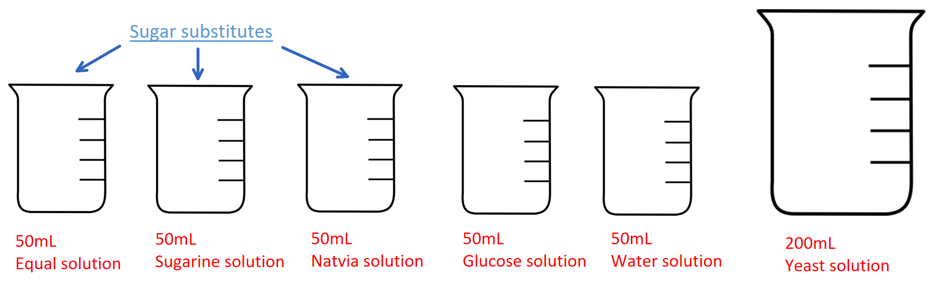
- Collect 50mL of distilled water in a 100mL beaker. Label it as ‘water’.

To collect results:

- Set up the Vernier ethanol sensor wirelessly to your laptop.

- Using a pipette, place 10mL of the yeast solution into the Nalgene bottle. Using a different pipette, place 10mL of the Equal solution into the Nalgene bottle.

- After 3 minutes, record the final amount of carbon dioxide produced in the table below. If you do not have a reading after 3 minutes, wait a further 2 minutes.

- Repeat step 2 and 3 for two more trials.

- Repeat steps 2 – 4 for Sugarine, Natvia, Glucose and Water.

After conducting the practical, the data collected will be used to write an individual report to determine how effectively yeast process sugar substitutes. The report is to be a maximum of 4 pages.

The report should include the sections, outlined below:
- Introduction (with relevant scientific concepts explained)
- Results (appropriate table/s and graph/s to display the data collected)
- Analysis (of results, identifying trends and linking results to concepts)
- Evaluation (of procedures and data, and identifying sources of uncertainty)
- Conclusion (with justification and awareness of limitations).

Pages should be single-sided A4 with minimum font size 10.

Stage 2 Scientific Studies Performance Standards
- | Investigation, Analysis, and Evaluation | Knowledge and Application
A | Critically deconstructs a problem and designs a logical, coherent, and detailed scientific investigation, using a scientific method and/or engineering design process.  Obtains, records, and represents data, using appropriate procedures, conventions, and formats accurately and highly effectively.  Systematically analyses and interprets data and evidence to formulate logical conclusions with detailed justification.  Critically and logically evaluates procedures and their effect on data.  Critically and perceptively evaluates the effectiveness of collaboration and its impact on results/outcomes. | Demonstrates deep and broad knowledge and understanding of a range of science inquiry skills and scientific concepts.  Applies science inquiry skills and scientific concepts highly effectively in new and familiar contexts.  Critically explores and understands in depth the interaction between science and society.  Communicates knowledge and understanding of scientific concepts coherently, with highly effective use of appropriate terms, conventions, and representations.
B | Logically deconstructs a problem and designs a well-considered and clear scientific investigation, using a scientific method and/or engineering design process.  Obtains, records, and represents data, using appropriate procedures, conventions, and formats mostly accurately and effectively.  Logically analyses and interprets data and evidence to formulate suitable conclusions with reasonable justification.  Logically evaluates procedures and their effect on data.  Critically evaluates the effectiveness of collaboration and its impact on results/outcomes. | Demonstrates some depth and breadth of knowledge and understanding of a range of science inquiry skills and scientific concepts.  Applies science inquiry skills and scientific concepts mostly effectively in new and familiar contexts.  Logically explores and understands in some depth the interaction between science and society.  Communicates knowledge and understanding of scientific concepts, with mostly coherent and effective use of appropriate terms, conventions, and representations.
C | Deconstructs a problem and designs a considered and generally clear scientific investigation, using a scientific method and/or engineering design process.  Obtains, records, and represents data, using generally appropriate procedures, conventions, and formats, with some errors but generally accurately and effectively.  Undertakes some analysis and interpretation of data and evidence to formulate generally appropriate conclusions with some justification.  Evaluates procedures and some of their effect on data.  Evaluates the effectiveness of collaboration and its impact on results/outcomes. | Demonstrates knowledge and understanding of a general range of science inquiry skills and scientific concepts.  Applies science inquiry skills and scientific concepts generally effectively in new or familiar contexts.  Explores and understands aspects of the interaction between science and society.  Communicates knowledge and understanding of scientific concepts, with generally effective use of appropriate terms, conventions, and representations.
D | Prepares a basic deconstruction of a problem and an outline of a scientific investigation using a scientific method and/or engineering design process.  Obtains some evidence using procedures and safe ethical working practices inconsistently, with occasional accuracy and effectiveness.  Describes procedures and results with some basic interpretation and formulates a basic conclusion.  Represents and describes evidence to formulate some results.  Attempts to evaluate the effectiveness of collaboration and its impact on results/outcomes. | Demonstrates some basic knowledge and partial understanding of science inquiry skills and scientific concepts.  Applies some science inquiry skills and understanding of scientific concepts in familiar contexts.  Partially explores and recognises aspects of the interaction between science and society.  Communicates basic scientific information, using some appropriate terms, conventions, and/or representations.
E | Attempts a simple deconstruction of a problem and a procedure for a scientific investigation, using a scientific method and/or engineering design process.  Attempts to obtain evidence using some procedures and safe ethical practices, with limited accuracy or effectiveness.  Attempts to describe results with limited interpretation of data and formulates a basic conclusion.  Limited description of some evidence to present some basic results.  Acknowledges the effectiveness of collaboration and its impact on results/outcomes. | Demonstrates limited recognition and awareness of science inquiry skills and/or scientific concepts.  Attempts to apply science inquiry skills and understanding of scientific concepts in familiar contexts.  Attempts to explore and identify an aspect of the interaction between science and society.  Attempts to communicate information about science.

