OWA - Adding Another Mailbox
- With OWA open click on the down arrow to the right of your name top right of the OWA screen as seen below
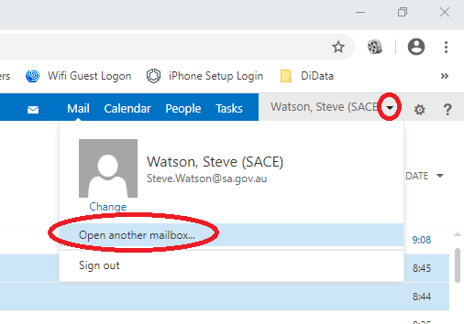
- Start typing in the name of the mailbox you need access to as seen below

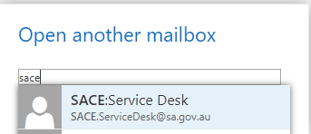
- Click on “Open” as seen below
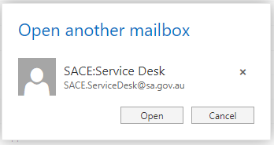

- The additional mailbox will open in a new browser tab

