How to change an existing meeting into a Teams Meeting from Outlook
Step by step procedure to change an existing meeting into a Teams meeting, which will allow team participants to dial into an online meeting.

Instructions:
- Open the meeting request in your calendar and click the Teams meeting button
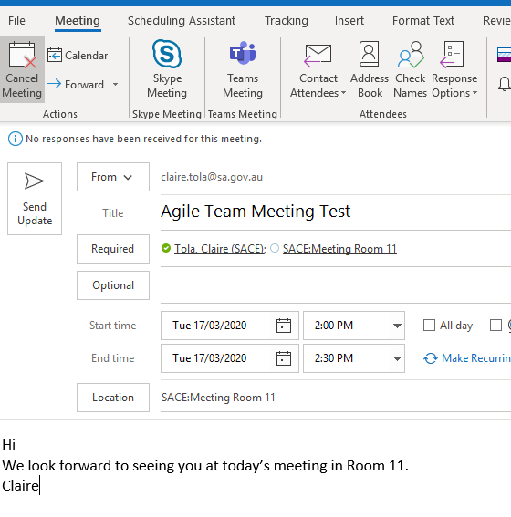
- The email invite will automatically populate making the meeting a Teams meeting by adding in a link.

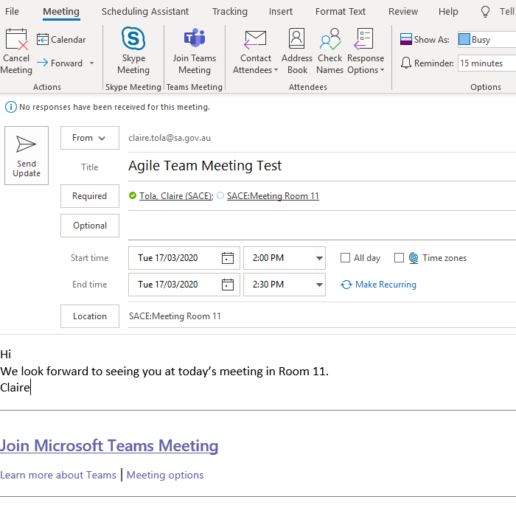
Any issues please call the Service Desk on 0881154777 or email at SACE.ServiceDesk@sa.gov.au

