STAGE 2 NUTRITION

Assessment Type 2: Skills and Application Task

Case Study

Description of Task

Purpose: To support students to research relevant Australian information about a selected diet related disorder/s and analyse the suitability of a diet plan using an endorsed Australian Food Guide in management and/or prevention of the disorder/s. Students are to demonstrate their knowledge, understanding and skills in a report or oral presentation. (Communication & Critical Thinking)

Description of Assessment

‘ Most Australians do not meet the minimum recommended serves for the five major food groups, according to new figures released by the Australian Bureau of Statistics (Australian Bureau of Statistics, 2016).’ The report shows that Australian diets are not in line with the 2013 Australian Dietary Guidelines, which recommend minimum serves for vegetables, fruit, dairy products, lean meats and alternatives, and grain-based foods. "Among the five food groups, fruits and grains had the best compliance, with nearly one in three people consuming the minimum recommended number of serves for each group. However, one-third of the fruit serves was from juice and dried fruit, and two-thirds of the grains and cereals were from refined grains rather than whole grain or high fibre sources," said Ms Gates (ABS, 2016).

Task: Students are to analyse the typical eating plan of the individual below and make comparisons between the Australian Dietary Guidelines food group recommendations and actual consumption of the individual. Students will look at the specific nutrients that each of the five food groups provides and identify undernutrition or overnutrition disorders that the individual may be at risk of based on their findings. Students will then modify the person's daily meal plan to include suitable servings from each of the food groups to meet their nutritional needs.

Access to Foodworks code:

Only one draft is permitted:
- Peer Review/feedback
- Feedback will be provided to your working Google Document on Google Classroom.

Due Dates –
Draft - START OF LESSON-

Final- Turnitin , AND shared file on drive

Word count: 1500 words maximum (excluding reference list and data tables) if written, or a maximum of 9 minutes for an oral presentation, or the equivalent in multimodal form.

Case Study:

Below is Janes typical eating pattern over one day:

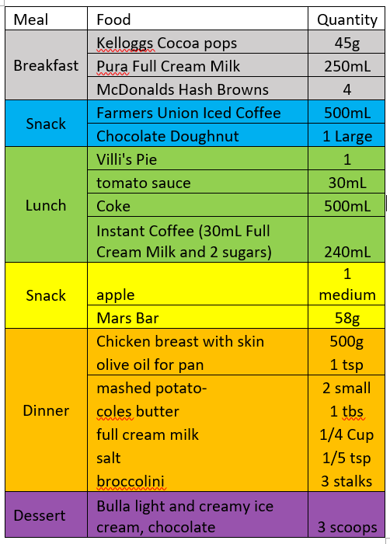

Personal Details:

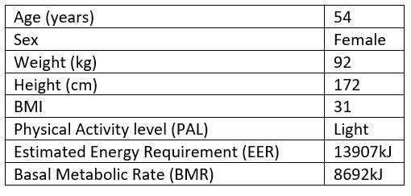

Raw Data :
1. Enter the diet plan for Jane into Foodworks 9 and extract nutritional information and place it into a suitable table.
- Energy (kJ)
- Protein (g)
- Total fat (g)
- - Saturated
- - Polyunsaturated
- - Monounsaturated
- Cholesterol (mg)
- Total Carbohydrate (g)
- - Sugars (g)
- Dietary fibre (g)
- Sodium (mg)
- Calcium (mg)
- Iron (mg)

2. Extract information on Janes servings from the 5 Food Groups (ADG’s) in Foodworks 9/10 or the eatforhealth website. Present in a suitable table.
3. Extract information in relation to servings from the 5 Food Groups recommended by the (ADG’s) in regards to Janes age and gender. Present in a suitable table.

Processed Data :
4. Place the nutritional information into suitable graphs for comparison (this can be based on findings from Foodworks 9)

- Percentage Energy Derived from Protein, Fat, Carbohydrate (compare to AMDR)
- Fibre (g)
- Fat Intake (% Polyunsaturated, Monounsaturated, Saturated). (PMS)
- Calcium, iron, sodium (NRV’s RDI’s/UL compare)
- Comparison of 5 food groups from ADG’s consumed vs recommended.

Data Analysis and interpretation :
4. Analyse each of the graphs above. Compare recommended ADG serves from each of the 5 food groups with Janes typical meal pattern and nutrients. The link here is between the ‘FOOD GROUP’ and the “NUTRIENTS’ they provide. IF Jane is under consuming calcium and the milk, yogurt and alternatives group,this would suggest that increasing the amount of serves in this group would increase the amount of calcium in the diet. Discuss the data in relation to possible risk factors under/over consumption of these particular nutrients and food groups could have on his health short term/long term.For example, if Jane is under consuming calcium, he could be at risk of osteoporosis later in life. Draw on the personal details of Jane's to make sound judgments as to what nutrition related disorders he could be at risk of and why. For example, if Jane has a larger energy intake than expenditure, a high BMI and low physical activity could he be at risk of obesity?

Make recommendations for promoting good health:

5. Modify Janes typical eating pattern over a day (24hrs) to suit an individual at risk of nutritional related disorders identified previously. Remember, Guideline 2 states ‘Enjoy a wide variety of nutritious foods from these five groups every day’.*This can be presented in a table as per above in the task sheet.

Using the Eat for Health Website, determine the number of serves of the modified eating plan from each of the 5 food groups in reference to diet related disorders at risk. *This can be presented in a table.

Discuss your modified meal plan servings from each of the 5 food groups with the previous diet and recommended serves as per the ADG for Janes age and gender. Ensure you justify your modifications with reference to particular dietary modifications required (if you change the amount of fibre, discuss how increasing fibre will impact an individual at risk of CVD).

References (I2):

Select and appropriately acknowledge information from a range of sources. Include an appropriate referencing format to source the information; appropriate sources include: Nutrition Australia, DAA, AIHW, ABS, AGHE, National Health and Medical Research Council, Groups such as Diabetes Australia, Heart Foundation.
Stage 2 Nutrition Performance Standards
- | Investigation, Analysis, and Evaluation | Knowledge and Application
A | Critically designs and conducts investigations using appropriate methodologies.  Obtain, record and display findings of investigations, using appropriate conventions and formats accurately and highly effectively.  Systematically analyse and interpret data and /or information to justify logical conclusions.  Critically and logically evaluates methodologies and/ or research processes and the effect on data or findings. | Deep and broad knowledge and understanding of a range of nutrition concepts.  Highly effective application of nutrition concepts in familiar and unfamiliar contexts  Critically explores and understands the relationship between nutrition science and society.  Coherent and clear communication of nutrition concepts and nutrition literacy and numeracy.
B | Logically designs and conducts investigations using well considered methodologies.  Obtain, record, and display findings of investigations, using appropriate conventions and formats mostly accurately and effectively.  Analyse and interpret of data and /or information to justify reasonable conclusions.  Logically evaluates methodologies and/ or research processes and the effect on data or findings. | Some depth and breadth of knowledge and understanding to a range of nutrition concepts.  Mostly effective application of nutrition concepts in familiar and unfamiliar contexts.  Logically explores and understands the relationship between nutrition science and society.  Mostly coherent and clear communication of nutrition concepts and nutrition literacy and numeracy.
C | Design and conducts investigations using appropriate clear methodologies.  Obtain, record, and display findings of investigations, using appropriate conventions and formats, with some errors but generally accurately and effectively.  Interpret data and /or information to justify generally appropriate conclusions.  Evaluates methodologies and/ or research processes and some of the effect on data or findings. | Knowledge and understanding of a general range of nutrition concepts.  Generally effective application of nutrition concepts in familiar and unfamiliar contexts.  Explores and understands aspects of the relationship between nutrition science and society.  Generally coherent and clear communication of nutrition concepts and nutrition literacy and numeracy.
D | Prepare and conducts investigations using some appropriate methodologies.  Obtain, record, and display findings of investigations, using appropriate conventions and formats inconsistently, with occasional accuracy and effectiveness.  Describe data and /or information to formulate basic conclusions.  Attempts to evaluate methodologies and/ or research processes and suggest an effect on data or findings. | Some basic knowledge and partial understanding of nutrition concepts.  Application of some nutrition concepts in familiar contexts.  Partially explores and recognises aspects of the relationship between nutrition science and society.  Some clear communication of nutrition concepts and nutrition literacy and numeracy.
E | Attempts to prepare and conducts investigations using simple methodologies.  Attempts to record and represent some data, with limited accuracy or effectiveness.  Attempts to describe data and /or information and formulates a simple conclusion.  Acknowledges that methodologies and/ or research processes effect data or findings. | Limited recognition and awareness of nutrition concepts.  Attempted application of nutrition concepts in contexts.  Attempts to explore and identify an aspect of the relationship between nutrition science and society.  Attempted communication of nutrition concepts and nutrition literacy and numeracy.

The 4 Cs Continuum
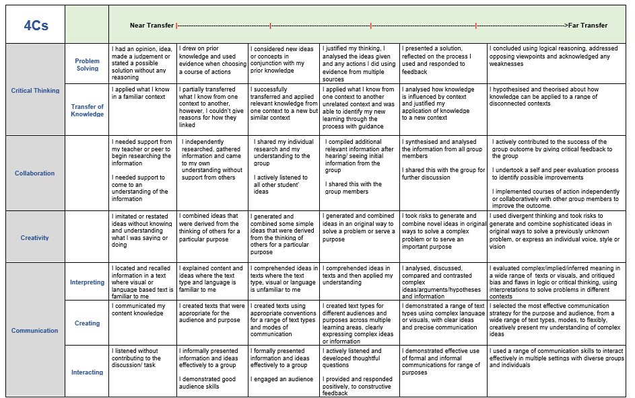

TASK LAYOUT

Raw Data:

Table 1: Janes Food Intake (from task sheet)

Table 2: Janes Personal Details (from task sheet)

Table 3: Janes Overall (& not per food) Nutrient Profile (taken from Foodworks)

Table 4: ADG 5 Food groups consumed vs recommendations and Discretionary (should you wish)

*** Remember any data or evidence you discuss needs to be included in your raw data. So if you don’t discuss discretionary choices, don’t include them. If you don’t discuss the personal details, don’t include them. Your data should drive your discussion….

Processed Data:

Graph 1: AMDR (%) Janes vs Recommended Range (indicate what point of the range was used in your graph)

Graph 2: PMS % Graph (fat comparison)

Graph 3: Fibre intake vs recommended (indicate what point of the range was used in your graph)

Graph 4: ADG 5 Food groups consumed vs recommendations and Discretionary (should you wish)

Graph 5: Calcium and Iron intake vs recommended (RDI)

Graph 6: Sodium intake vs (UL)

Analysis

Table 5: Modified meals plan presented as per the task sheet example.

Table 6: Comparison of modified meal plan food groups vs previous meal plan

Discussion of changes in comparison to recommendations with justification.

**EXAMPLE ONLY**

 | Grain/cereal foods, mostly wholegrain and high fibre | Vegetables and legumes/beans | Lean meats and poultry, fish, eggs, tofu, nuts and seeds and legumes/beans | Milk, yoghurt, cheese and/or alternatives, mostly reduced fat | Fruit | Discretionary choices
Number of recommended serves | 7 | 5.5 | 2.5 | 3.5 | 2 | 0-5
Number of serves in Janes Diet | 7.5 | 1.5 | 9.5 | 6 | 0 | 12

Food Group | Number of serves in Janes diet | Number of recommended serves by ADG
Grain/cereal foods, mostly wholegrain and high fibre | 7.5 | 7
Vegetables and legumes/beans | 1.5 | 5.5
Lean meats and poultry, fish, eggs, tofu, nuts and seeds and legumes/beans | 9.5 | 2.5
Milk, yoghurt, cheese and/or alternatives, mostly reduced fat | 6 | 3.5
Fruit | 0 | 2
Discretionary choices | 12 | 0-5

