Stage 2 Nutrition

Assessment Type 1: Investigation Folio Task- Science as a Human Endeavour

Introduction and purpose of task:

In this task you will investigate and demonstrate a comprehensive understanding of science as a human endeavour in Nutrition related to any of the topics in Stage 2 Nutrition. The focus of this task is to explore a contemporary aspect of
science related to nutrition with emphasis on the interaction between science and society. This might include, for example; the application and use of newly discovered nutritional knowledge, or the influence and development of new technologies on nutrition.

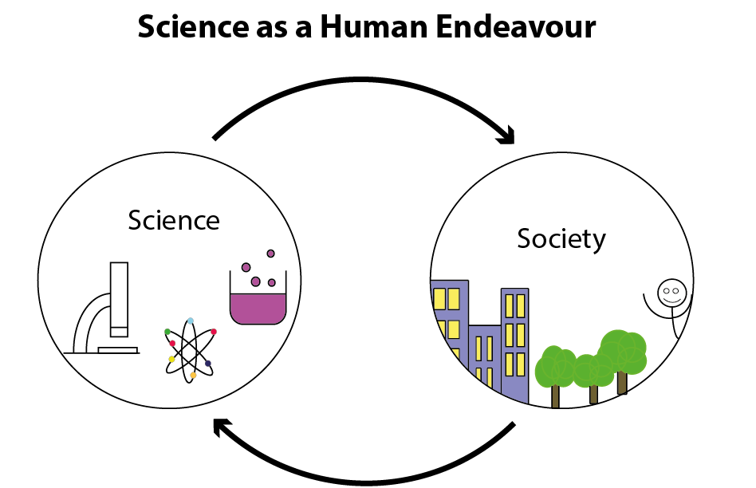
Source: Stage 2 Physics Task 3 - SHE

You will use and acknowledge a variety of relevant sources to find data and information to support your chosen topic.

You may choose to present your research findings as either an article in a scientific journal, as a written report providing an expert’s point of view, an analysis of a new development in a field or a concern about a development that has economic, social, environmental or political implications on any aspect related to any topic in the Stage 2 Nutrition science understandings.

Your research, findings and outcome should have a focus on at least one, maximum two aspects of the key concepts of Science as a Human Endeavour.

The key concepts of Science as a Human Endeavour are:

Communication and Collaboration
- Science is a global enterprise that relies on clear communication, international conventions, and review and verification of results.
- Collaboration between scientists, governments, and other agencies is often required in scientific research and enterprise.

Development
- Development of complex scientific models and/or theories often requires a wide range of evidence from many sources and across disciplines.
- New technologies improve the efficiency of scientific procedures and data collection and analysis. This can reveal new evidence that may modify or replace models, theories, and processes.

Influence
- Advances in scientific understanding in one field can influence and be influenced by other areas of science, technology, engineering, and mathematics.
- The acceptance and use of scientific knowledge can be influenced by social, economic, cultural, and ethical considerations.

Application and Limitation
- Scientific knowledge, understanding, and inquiry can enable scientists to develop solutions, make discoveries, design action for sustainability, evaluate economic, social, and environmental impacts, offer valid explanations, and make reliable predictions.
- The use of scientific knowledge may have beneficial or unexpected consequences; this requires monitoring, assessment, and evaluation of risk, and provides opportunities for innovation.
- Science informs public debate and is in turn influenced by public debate; at times, there may be complex, unanticipated variables or insufficient data that may limit possible conclusions.

Part A: Information Search and Planning

- Use the internet and other sources of information to do an initial search related to a topic of Nutrition that is of interest to you e.g. 3D food, new genetically modified foods, dietary guidelines, cures for dietary diseases…. Consider the advances in technology, cultural influences, sustainability, public debate, environmental concerns etc. of this topic of interest.

- In a table, make a list of possible topics and related questions or contexts for your scientific communication.

- Search for articles, data or other information that you could use to support your discussion.
Record the resources in a reference list using Harvard Referencing, for future reference. This will assist you in your selection of your final focus.

- Choose the focus of your work for the scientific communication.

e.g. The use of 3D printers to print food to reduce the amount of waste/disposable food that goes into landfill.

- Link your chosen focus to at least one, maximum two aspects of the key concepts of SHE.

e.g. The use of scientific knowledge may have beneficial or unexpected consequences; this requires monitoring, assessment, and evaluation of risk, and provides opportunities for innovation could be considered when investigating the use of using 3D printers to print food for consumption.

- Check the focus you have chosen with your teacher before you proceed.

Date Due:……………………………………….

- Choose the format of your work: an article in a scientific journal, as a written report providing an expert’s point of view, an analysis of a new development in a field or a concern about an issue.
You might like to formulate a question or statement that relates to your chosen focus and SHE key concept as the heading for your work.

- Plan your article or report - this will be submitted to your teacher for feedback.

Date Due: …………………………………………………….

Part B: Refinement of Information for your chosen focus

- Search for any further information that will enable you to provide a comprehensive and detailed report, with highly relevant nutrition as determined by your plan from Part A.

This will also assist you in being able to justify your conclusions.

Record the resources in a reference list use Harvard Referencing.

Part A and B are not included in the word count.

Part C: Scientific Communication

Use the information and data gathered to write an article in a scientific journal, a report providing an expert’s point of view, an analysis of a new development in a field or a concern about an issue you have chosen.

Your report must include:

- an introduction, to identify the focus of the investigation and the key concept(s) of science as a human endeavour that it links to
- an explanation of how the focus of the investigation illustrates the interaction between science and society
- relevant nutrition concepts or background (this should support your report but not be the focus)
- an explanation of how the focus of the investigation illustrates the interaction between science and society, including a discussion of the potential impact of the focus of the investigation e.g. further development, effect on quality of life, environmental implications, economic impact, intrinsic interest.
- a conclusion (summarise the main points and their link to the SHE topic)
- citations and referencing

Assessment Conditions:

4 weeks to complete. Class time provided for research and support.

Students may submit one draft of the final scientific communication for feedback. This does not include the checkpoints and plan.

Verification of student work will occur throughout the task.

Word Count: maximum of 1500 words for Part C or 10 minutes for an oral presentation.

Assessment Design Criteria

Knowledge and Understanding: KU1, 3, 4

Due Dates

Draft submission due date: …………………………………………………….

Final submission due date: …………………………………………………….

Stage 2 Nutrition Performance Standards
- | Investigation Analysis, and Evaluation | Knowledge and Understanding
A | Logical and detailed planning of investigations using appropriate methodologies  Obtains, records, and displays findings of investigations, using appropriate conventions and formats accurately and highly effectively  Systematically analyses and interprets data and /or information to justify logical conclusions  Critically and logically evaluates methodologies and/ or research processes and its effect on data. | Demonstrates deep and broad knowledge and understanding of a range of nutritional concepts  Highly effective application of nutritional concepts in familiar and unfamiliar contexts  Critically explores and understands the relationship between nutritional science and society  Coherent and clear communication of nutritional concepts and nutritional literacy
B | Well considered planning of investigations using appropriate methodologies  Obtains, records, and displays findings of investigations, using appropriate conventions and formats mostly accurately and effectively  Analysis and interpretation of data and /or information to justify reasonable conclusions  Logically evaluates methodologies and/ or research processes and its effect on data | Demonstrates some depth and breadth of knowledge and understanding to a range of nutritional concepts  Mostly effective application of nutritional concepts in familiar and unfamiliar contexts  Logically explores and understands the relationship between nutritional science and society  Mostly coherent and clear communication of nutritional concepts and nutritional literacy
C | Consider planning of investigation using appropriate methodologies  Obtains, records, and displays findings of investigations, using appropriate conventions and formats, with some errors but generally accurately and effectively  Interpretation of data and /or information to justify generally appropriate conclusions  Evaluates methodologies and/ or research processes and some of their effect on data | Demonstrates knowledge and understanding of a general range of nutritional concepts  Generally effective application of nutritional concepts in familiar and unfamiliar contexts  Explores and understands aspects of the relationship between nutritional science and society  Generally coherent and clear communication of nutritional concepts and nutritional literacy
D | Basic planning of investigations using some appropriate methodologies  Obtains, records, and displays findings of investigations, using appropriate conventions and formats inconsistently, with occasional accuracy and effectiveness  Describes data and /or information to formulate basic conclusions  Attempts to evaluate methodologies and/ or research processes and suggest an effect on data | Demonstrates some basic knowledge and partial understanding of nutritional concepts  Application of some nutritional concepts in familiar contexts  Partially explores and recognises aspects of the relationship between nutritional science and society  Some clear communication of nutritional concepts and nutritional literacy
E | Attempts an outline of a plan for an investigation  Attempts to record and represent some data, with limited accuracy or effectiveness  Attempts to describe data and /or information and formulates a simple conclusion  Acknowledges that methodologies and/ or research processes affect data | Demonstrates limited recognition and awareness of nutritional concepts  Attempted application of nutritional concepts in contexts  Attempts to explore and identify an aspect of the relationship between nutritional science  Attempted communication of nutritional concepts and nutritional literacy

A scaffolding document that could be used to support students.

Science as a Human Endeavour Task
Sections of the report | Description | Comments
Introduction (approx. 100 words)  - an introduction to identify the focus of the investigation and the key concept(s) of science as a human endeavour that it links to | - Identify the focus of the report  - Say what the main purpose of what will be covered by the report  - State which key concepts of Science As a Human Endeavour you will be talking about
Relevant Nutrition: Purpose, Use, Concepts or Background (approx. 300-500 words)  - relevant nutrition concepts or background  KU1/KU4 | - Write out and discuss your processed information about the nutritional concepts that link to this topic  - the source of this information is (name of person or organisation)  - Explain exactly how this information is linked to your topic.  - Give specific examples to support your links (this could be statistics, equations, diagrams, quotes, and professional opinions.)
Explanation of how this topic illustrates the interaction between science and society (approx. 500 -700 words)  - an explanation of how the focus of the investigation illustrates the interaction between science and society  KU3/KU4 | - Explain how the focus of the investigation illustrates the aspects of science that is interacting with society and vice versa.
Potential Impact of the Focus (approx. 100 words)  - a discussion of the purpose, potential impact, or application of the focus of the investigation, e.g. further development, effect on quality of life, environmental implications, economic impact, intrinsic interest  KU3/KU4 | Discuss the potential impact of the focus of the investigation e.g.  - Who will this benefit and why?  - What future directions or developments or applications are possible | These two sections are now considered to be one as they are about interaction of science and society but slight change of emphasis
Conclusion with justification (approx. 100 words)  - a conclusion | - Summarise your main points and their link to the SHE topic (justification)
Communication KU4 | - Use of clear communication, nutritional concepts and nutritional literacy
Record your sources  - Citations and referencing. | - List the sources of information which you used  - Make sure that someone else could access the same information just by using your list  - Suggest using APA or Harvard referencing

Developed from support materials in Biology and discussions with Lois Ey and Anna Palombaro

