Assessment Type 2: Skill and Application Folio Task

Formative task: Practical skills and terminology
Graphing

Table 1: The foods for their iron content and energy value
Food | Serving size | Iron content (mg) | Energy value (kcal)
Milk, fat-free | 1 cup | 0.10 | 85
Cheddar cheese | 1 oz | 0.19 | 114
Broccoli, cooked from fresh, chopped | 1 cup | 1.31 | 44
Sweet potato baked in skin | 1 each | 0.51 | 117
Rock melon | ½ a melon | 0.56 | 93
Carrots, from fresh | ½ cup | 0.48 | 35
Whole wheat bread | 1 slice | 0.87 | 64
Green peas cooked from frozen | ½ cup | 1.26 | 62
Apple, medium | Medium | 0.38 | 125
Sirloin steak, lean | 4 oz | 3.81 | 228
Pork chop, lean, broiled | 1 each | 0.66 | 166
Source: Understanding Nutrition 3rd Ed. Page 461

1. Above is a list of foods with the iron content and energy amount per serving.

a. How could the data be best represented in a graph to show the foods iron content and energy amount compared to each other?

-----------------------------------------------------------------------------------------------------------------------------------------------------------

-----------------------------------------------------------------------------------------------------------------------------------------------------------

B. Justify the choice of graph.

-----------------------------------------------------------------------------------------------------------------------------------------------------------

-----------------------------------------------------------------------------------------------------------------------------------------------------------

-----------------------------------------------------------------------------------------------------------------------------------------------------------

-----------------------------------------------------------------------------------------------------------------------------------------------------------

Note: The above question can be changed by reviewing other micronutrients value of foods.
It can also be used to compare existence of micronutrients content and its food preparation, cooking or processing methods.

Table 2: Recommended intake of bone-related nutrients (1998 data)
Age  (years) | Calcium  (mg/day) | Phosphorus  (mg/day) | Magnesium  (mg/day) |  | Vitamin D (µg/day) | Fluoride(mg/day)
 |  |  | Males | Females |  | Males | Females
1-3 | 500 | 460 | 80 | 80 | 5 | 0.7 | 0.7
4-8 | 800 | 500 | 130 | 130 | 5 | 1.1 | 1.1
9-13 | 1300 | 1250 | 240 | 240 | 5 | 2.0 | 2.0
14-18 | 1300 | 1250 | 410 | 360 | 5 | 3.2 | 3.9
19-30 | 1000 | 700 | 400 | 310 | 5 | 3.8 | 3.1
31-50 | 1000 | 700 | 420 | 320 | 5 | 3.8 | 3.1
51-70 | 1200 | 700 | 420 | 320 | 10 | 3.8 | 3.1
>70 | 1200 | 700 | 420 | 320 | 15 | 3.8 | 3.1
5 micrograms = 200 IU Source: Food, Nutrition, and Diet therapy 11th Ed. Page 650

Note: Figures are not up to date.
Relevant figures for Australia can be accessed from Australian Bureau of Statistics (ABS)

2. Above is information on the USA recommended intake of vitamin D and minerals per day.

a. Describe how the data may differ for the Australian recommended intake for vitamin D and minerals per day?

-----------------------------------------------------------------------------------------------------------------------------------------------------------

-----------------------------------------------------------------------------------------------------------------------------------------------------------

-----------------------------------------------------------------------------------------------------------------------------------------------------------

-----------------------------------------------------------------------------------------------------------------------------------------------------------

b. How could the data be best represented in a graph to show the comparison of the recommended intake of calcium and vitamin D for males and females through the years?

-----------------------------------------------------------------------------------------------------------------------------------------------------------

-----------------------------------------------------------------------------------------------------------------------------------------------------------

c. Justify the choice of graph.

-----------------------------------------------------------------------------------------------------------------------------------------------------------

-----------------------------------------------------------------------------------------------------------------------------------------------------------

-----------------------------------------------------------------------------------------------------------------------------------------------------------

-----------------------------------------------------------------------------------------------------------------------------------------------------------

Table 3: Nutritional analysis of possible non-dairy milk substitutes

The table below compares the energy, composition and cost of 100 mL of milk alternatives and compares these to 100 mL of dairy milk.

Nutritional analysis per 100mL | Coconut milk | Rice milk | Almond milk | Soy milk | Lactose-free milk | Dairy milk – organic, full cream
Energy | 103 kJ | 213 kJ | 86 kJ | 175 kJ | 271 kJ | 288 kJ
Protein | 0.2 g | 0.3 g | 0.7 g | 3 g | 3.3 g | 3.2 g
Fat, total  Saturated | 2.2 g  2.1 g | 1.2 g  0.1 g | 1.8 g  0.2 g | 1.8 g  0.3 g | 3.6 g  2.4 g | 4.1 g  2.7 g
Carbohydrates  Sugars | 0.8 g  0.2 g | 9.5 g  5.8 g | 0.3 g  0.1 g | 3.1 g  2.1 g | 4.7 g  4.7 g | 4.8 g  4.8 g
Calcium  Many plant-based milk alternatives are fortified with calcium | 120 mg | 120 mg | 120 mg | 120 mg | 123 mg | 12 3mg
Cost | $0.33 | $0.24 | $0.25 | $0.24 | $0.29 | $0.29
Source: Food & Nutrition 2019 v1.1 IA3 high-level annotated sample response QCAA Page 9 (PDF)
3.
a. How could the data be represented in a graph to show the comparison of the nutritional content of Lactose-free milk?

-----------------------------------------------------------------------------------------------------------------------------------------------------------

-----------------------------------------------------------------------------------------------------------------------------------------------------------

b. Justify the choice of graph.

-----------------------------------------------------------------------------------------------------------------------------------------------------------

-----------------------------------------------------------------------------------------------------------------------------------------------------------

-----------------------------------------------------------------------------------------------------------------------------------------------------------

c. How could the data be represented in a graph to show the comparison of the cost of the various milks?

-----------------------------------------------------------------------------------------------------------------------------------------------------------

-----------------------------------------------------------------------------------------------------------------------------------------------------------

d. Justify the choice of graph.

-----------------------------------------------------------------------------------------------------------------------------------------------------------

-----------------------------------------------------------------------------------------------------------------------------------------------------------

-----------------------------------------------------------------------------------------------------------------------------------------------------------

Graph 1:
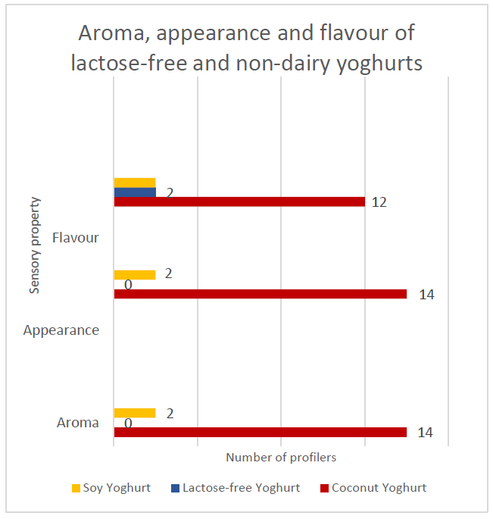
Source: Food & Nutrition 2019 v1.1 IA3 high-level annotated sample response QCAA Page 11 (PDF)

4.
a. Comment on the graphing choice for Aroma, appearance, and flavour of lactose free and non-dairy yogurts.

-----------------------------------------------------------------------------------------------------------------------------------------------------------

-----------------------------------------------------------------------------------------------------------------------------------------------------------

-----------------------------------------------------------------------------------------------------------------------------------------------------------

-----------------------------------------------------------------------------------------------------------------------------------------------------------

-----------------------------------------------------------------------------------------------------------------------------------------------------------

b. What other graph types could be used?

-----------------------------------------------------------------------------------------------------------------------------------------------------------

-----------------------------------------------------------------------------------------------------------------------------------------------------------

-----------------------------------------------------------------------------------------------------------------------------------------------------------

Graph 2:
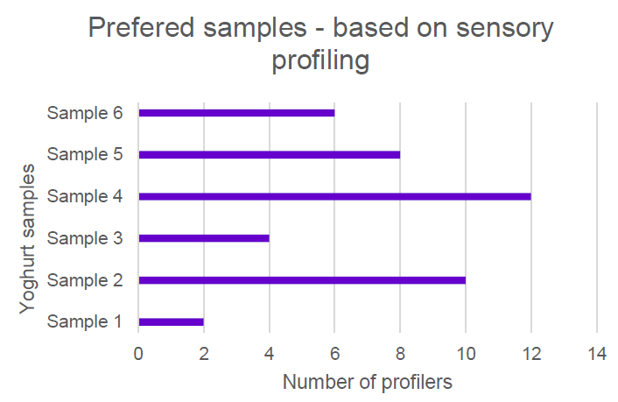
Source: Food & Nutrition 2019 v1.1 IA3 high-level annotated sample response QCAA Page 16 (PDF)
5.
a. How could this data be better presented as a graph?

-----------------------------------------------------------------------------------------------------------------------------------------------------------

-----------------------------------------------------------------------------------------------------------------------------------------------------------

-----------------------------------------------------------------------------------------------------------------------------------------------------------

Table 4: Prevalence of inadequate fruit and vegetable intake for persons aged 18 and over (per cent), 2014-15

Age group (years) | Inadequate fruit |  |  | Inadequate vegetables
 | Men | Women | Persons | Men | Women | Persons
18-24 | 60.3 | 53.1 | 56.6 | 98.0 | 93.1 | 95.9
25-34 | 61.3 | 48.3 | 54.6 | 97.2 | 89.4 | 93.1
35-44 | 57.3 | 50.6 | 53.7 | 97.7 | 90.7 | 94.0
45-54 | 59.3 | 44.4 | 51.5 | 98.0 | 89.2 | 93.3
55-64 | 53.3 | 40.2 | 46.5 | 96.1 | 89.1 | 92.5
65-74 | 47.9 | 31.4 | 39.6 | 93.5 | 85.7 | 89.0
75-84 | 42.5 | 38.6 | 41.2 | 86.2 | 91.1 | 89.1
85+ | *37.8 | 33.3 | 35.3 | 92.9 | 91.3 | 93.4
All persons | 56.0 | 44.6 | 50.2 | 96.2 | 89.8 | 92.9
Source: ABS 2015. National Health Survey: First Results, 2014–15. ABS cat. no. 4364.0.55.001. Canberra: Australian Bureau of Statistics.
6.
a. How could the data be represented in a graph to show the comparison of the inadequate fruit and vegetable intake for men for all age groups?

-----------------------------------------------------------------------------------------------------------------------------------------------------------

-----------------------------------------------------------------------------------------------------------------------------------------------------------

b. Justify the choice of graph.

-----------------------------------------------------------------------------------------------------------------------------------------------------------

-----------------------------------------------------------------------------------------------------------------------------------------------------------

-----------------------------------------------------------------------------------------------------------------------------------------------------------

c. How could the data be represented in a graph to show the inadequate fruit and vegetable intake for men compared to women for all age groups?

-----------------------------------------------------------------------------------------------------------------------------------------------------------

-----------------------------------------------------------------------------------------------------------------------------------------------------------

d. Justify the choice of graph.

-----------------------------------------------------------------------------------------------------------------------------------------------------------

-----------------------------------------------------------------------------------------------------------------------------------------------------------

-----------------------------------------------------------------------------------------------------------------------------------------------------------

e. How could the data be represented in a graph to show the inadequate fruit and vegetable intake for men, women and persons for the 18-24 age group?

-----------------------------------------------------------------------------------------------------------------------------------------------------------

-----------------------------------------------------------------------------------------------------------------------------------------------------------

f. Justify the choice of graph.

-----------------------------------------------------------------------------------------------------------------------------------------------------------

-----------------------------------------------------------------------------------------------------------------------------------------------------------

-----------------------------------------------------------------------------------------------------------------------------------------------------------

g. How could the data presented in this table be used to analyse and access general health of males, females and persons?

-----------------------------------------------------------------------------------------------------------------------------------------------------------

-----------------------------------------------------------------------------------------------------------------------------------------------------------

-----------------------------------------------------------------------------------------------------------------------------------------------------------

-----------------------------------------------------------------------------------------------------------------------------------------------------------

-----------------------------------------------------------------------------------------------------------------------------------------------------------

h. State a possible hypothesis for the data?

-----------------------------------------------------------------------------------------------------------------------------------------------------------

-----------------------------------------------------------------------------------------------------------------------------------------------------------

Table 5: The breakdown of advertising in the United Kingdom
Media | Percent
Cinema | 2%
Newspapers and magazines | 62%
Posters | 2%
Radio | 2%
Televisions | 32%
Source: Examining Food and Nutrition 1996 Page 174
7.
a. How could the data be represented in a graph to show the comparison of the methods used in the United Kingdom to advertise and market food?

-----------------------------------------------------------------------------------------------------------------------------------------------------------

-----------------------------------------------------------------------------------------------------------------------------------------------------------

b. Justify the choice of graph.

-----------------------------------------------------------------------------------------------------------------------------------------------------------

-----------------------------------------------------------------------------------------------------------------------------------------------------------

-----------------------------------------------------------------------------------------------------------------------------------------------------------

c. How could this data compare to present day methods used to advertise and promote food?

-----------------------------------------------------------------------------------------------------------------------------------------------------------

-----------------------------------------------------------------------------------------------------------------------------------------------------------

-----------------------------------------------------------------------------------------------------------------------------------------------------------

Table 6: Household spending of food and drink in the United Kingdom in 1993
Food or drink | Percent
Bread and cereal | 16%
Fruit | 7%
Vegetables | 12%
Milk and dairy | 13%
Meat, fish, and eggs | 30%
Sugar and preserves | 4%
Drinks and sweets | 11%
Beverages and miscellaneous | 7%
Source: Examining Food and Nutrition 1996 Page 170
8.
a. How could the data be represented in a graph to show the household spending on food and drink in the United Kingdom in 1993?

-----------------------------------------------------------------------------------------------------------------------------------------------------------

-----------------------------------------------------------------------------------------------------------------------------------------------------------

b. Justify the choice of graph.

-----------------------------------------------------------------------------------------------------------------------------------------------------------

-----------------------------------------------------------------------------------------------------------------------------------------------------------

-----------------------------------------------------------------------------------------------------------------------------------------------------------

c. How could this data compare to present day household shopping trends on food and drink?

-----------------------------------------------------------------------------------------------------------------------------------------------------------

-----------------------------------------------------------------------------------------------------------------------------------------------------------

-----------------------------------------------------------------------------------------------------------------------------------------------------------

Table 7: Comparison of Group and Class Results of Escherichia Coli Growth
 | Average Bacterial Growth Along 5cm Swabbing Line (5cm)
Treatment of Chopping Board | Group Results | Class Results
Uncleaned (Not Considered) | 78% | 91.6%
Cleaned with Water (pH 7) | 86% | 76%
Cleaned with Palmolive Detergent (pH 7.5) | 84% | 79.6%
Cleaned with Ajax Spray and Wipe (pH 3.5) | 84% | 73.6%
Cleaned with Domestos Bleach (pH 13.2) | 82% | 84.8%
Cleaned with White Vinegar (pH 2.2) | 100% | 66.8%

9.
a. Does the data need to be graphed?

-----------------------------------------------------------------------------------------------------------------------------------------------------------

-----------------------------------------------------------------------------------------------------------------------------------------------------------

-----------------------------------------------------------------------------------------------------------------------------------------------------------

b. How could it be graphed? Justify.

-----------------------------------------------------------------------------------------------------------------------------------------------------------

-----------------------------------------------------------------------------------------------------------------------------------------------------------

-----------------------------------------------------------------------------------------------------------------------------------------------------------

Table 8: Sensory Characteristic Score Means
 | Sensory Characteristics
Yoghurt | Sweetness | Creaminess | Flavour | Consistency
Nestle Ski D-Lite #1/☐ | 3.75 | 2.53 | 2.95 | 2.66
Nestle Ski Regular/O | 3.01 | 3.29 | 3 | 3.41
Nestle Ski D-Lite #2/Δ | 3.51 | 2.8 | 2.98 | 2.86

Table 9: Preference Score Means
Yoghurt | Preference
Nestle Ski D’Lite #1/☐ | 6.56
Nestle Ski Regular/O | 7.48
Nestle Ski D’Lite #2/Δ | 6.61

10. The data from tables 8 and 9 was collected from a food sensory survey of ‘regular’ and ‘lite’ Nestle yoghurt.

a. State a possible hypothesis for the investigation.

-----------------------------------------------------------------------------------------------------------------------------------------------------------

-----------------------------------------------------------------------------------------------------------------------------------------------------------

-----------------------------------------------------------------------------------------------------------------------------------------------------------

b. How would the data be graphed to show the comparison of sensory characteristic and preferences for the different types of yoghurt? Justify.

-----------------------------------------------------------------------------------------------------------------------------------------------------------

-----------------------------------------------------------------------------------------------------------------------------------------------------------

-----------------------------------------------------------------------------------------------------------------------------------------------------------

-----------------------------------------------------------------------------------------------------------------------------------------------------------

-----------------------------------------------------------------------------------------------------------------------------------------------------------

-----------------------------------------------------------------------------------------------------------------------------------------------------------

c. Below it the method used by the group to test their hypothesis. Use this information to answer the question which follow.

Method:
- Collect equipment.
- Prepare and thoroughly clean the ‘tasting station’.
- Tie long hair back, thoroughly wash hands and apply apron, gloves and hair net.
- Rinse cups and spoons under water and dry.
- Label the bottom of 60 cups with ‘☐’, 60 cups with ‘O’ and 60 cups with ‘Δ’ and align on separate trays.
- Accurately measure one tablespoon (15 mL) of ‘Nestle D’Lite’ and place into 60 cups labelled with ‘☐’, 60 cups with ‘Δ’.
- Place a plastic spoon into each cup and refrigerate.
- Repeat steps 6 – 7, measuring one tablespoon (15 mL) of ‘Nestle Regular’ into 60 cups labelled with ‘O’.
- Invite three participants over to the ‘tasting station’.
- Instruct participants to wash hands and read disclaimer (Appendix 4).
- Provide each participant with one sample of ‘Nestle Regular’ (O) between two samples of ‘Nestle D’Lite’ (☐, Δ).
- Request participants to rate samples one at a time, sipping water between each tasting.
- Collate data and statistically analyse results.

i. Identify and explain safety measures carried out by the group.

-----------------------------------------------------------------------------------------------------------------------------------------------------------

-----------------------------------------------------------------------------------------------------------------------------------------------------------

-----------------------------------------------------------------------------------------------------------------------------------------------------------

-----------------------------------------------------------------------------------------------------------------------------------------------------------

-----------------------------------------------------------------------------------------------------------------------------------------------------------

-----------------------------------------------------------------------------------------------------------------------------------------------------------

ii. What measures did the group make to prevent influencing the responses of the taste testers?

-----------------------------------------------------------------------------------------------------------------------------------------------------------

-----------------------------------------------------------------------------------------------------------------------------------------------------------

-----------------------------------------------------------------------------------------------------------------------------------------------------------

-----------------------------------------------------------------------------------------------------------------------------------------------------------

-----------------------------------------------------------------------------------------------------------------------------------------------------------

-----------------------------------------------------------------------------------------------------------------------------------------------------------

iii. How reliable is the data collected from this investigation. Explain.

-----------------------------------------------------------------------------------------------------------------------------------------------------------

-----------------------------------------------------------------------------------------------------------------------------------------------------------

-----------------------------------------------------------------------------------------------------------------------------------------------------------

-----------------------------------------------------------------------------------------------------------------------------------------------------------

-----------------------------------------------------------------------------------------------------------------------------------------------------------

Refer to the photograph to answer question 11.
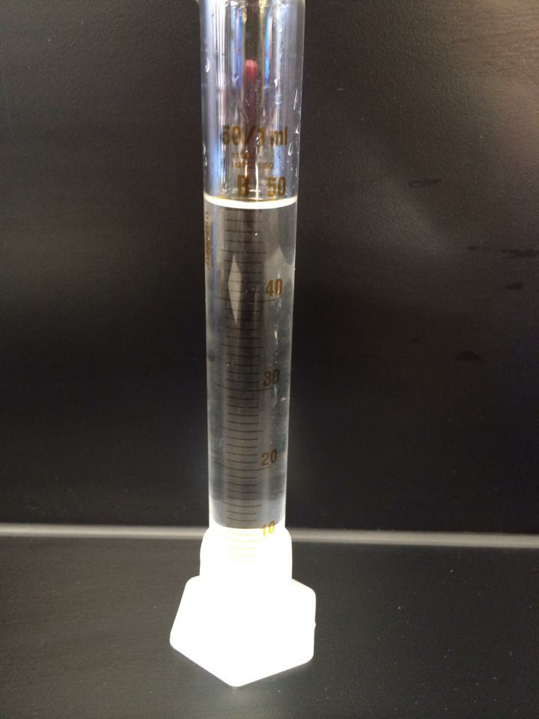
11.
a. What type of error can arise from the reading of volume using a measuring cylinder?

---------------------------------------------------------------------------------------------------

---------------------------------------------------------------------------------------------------

---------------------------------------------------------------------------------------------------
b. How can this error be minimised?

---------------------------------------------------------------------------------------------------

--------------------------------------------------------------------------------------------------

--------------------------------------------------------------------------------------------------

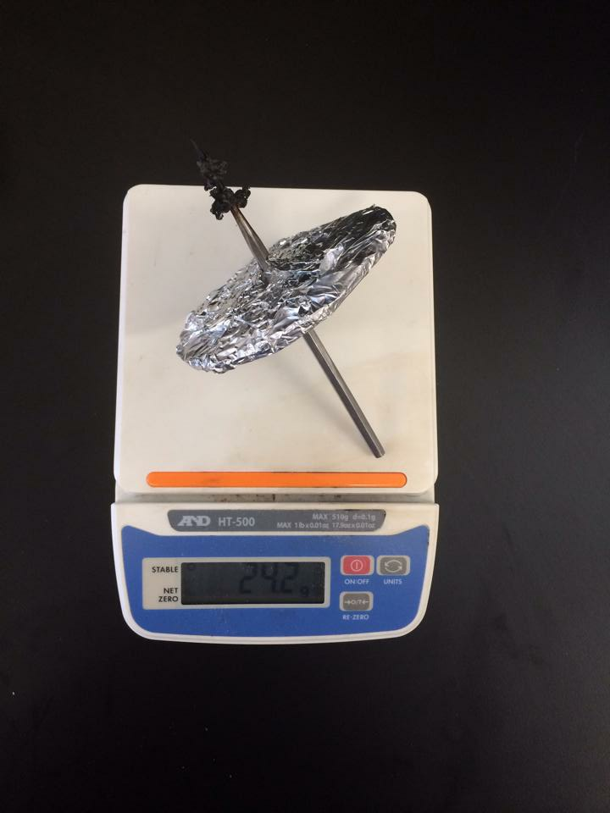

Refer to the photograph above to answer question 12.
12.
a. What type of errors could arise from using an electronic scale? Justify

-----------------------------------------------------------------------------------------------------------------------------------------------------------

-----------------------------------------------------------------------------------------------------------------------------------------------------------

-----------------------------------------------------------------------------------------------------------------------------------------------------------

-----------------------------------------------------------------------------------------------------------------------------------------------------------

-----------------------------------------------------------------------------------------------------------------------------------------------------------

b. How could it be determined if the errors in the data were the result of a random error or a systematic error?

-----------------------------------------------------------------------------------------------------------------------------------------------------------

-----------------------------------------------------------------------------------------------------------------------------------------------------------

-----------------------------------------------------------------------------------------------------------------------------------------------------------

-----------------------------------------------------------------------------------------------------------------------------------------------------------

-----------------------------------------------------------------------------------------------------------------------------------------------------------

c. What would be a way to improve the reliability of the data collected from the investigation?

-----------------------------------------------------------------------------------------------------------------------------------------------------------

-----------------------------------------------------------------------------------------------------------------------------------------------------------

-----------------------------------------------------------------------------------------------------------------------------------------------------------

-----------------------------------------------------------------------------------------------------------------------------------------------------------

