Stage 2 Dance
Assessment Type 3: Skills Development Portfolio 30%
(External assessment)

The portfolio should be approximately 2000 words or 12 minutes multimodal equivalent. The portfolio must include some recorded or photographic evidence of the student’s development as a dance artist collected throughout the year.
Student evidence may include analysis of recordings, photographs, reflective journal entries, and annotated research into the practice of professional performing artists.
For this assessment type, students provide evidence of their learning primarily in relation to the following assessment design criteria:
- understanding dance — UD1, UD2
- responding to dance — RD1.

Select an area for development specific to your needs this year.
Have your teacher validate your topic.
Research the complexities of this skill – e.g. the biomechanics of how the body performs.
Develop a personal program that will help you improve your skills.
Reflect on what you have learnt and how you have grown as a dancer and performer.

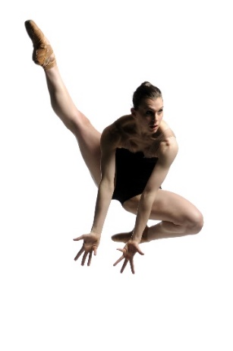
Suggestions:
Technique evaluation – select a technique exercise that you need to improve upon, devise a process and a program for development.
Strategies for refining performance skills – understanding characterization, awareness of working to an audience/camera, building stamina, improving dance skills, gathering feedback from a variety of sources. Inspirational dancers.
Complementary programs to develop strength/flexibility – pilates, yoga, swimming, running, weights. What areas of the body are targeted, how are the muscles used? How does this improve your strength/flexibility? How can you measure this?

