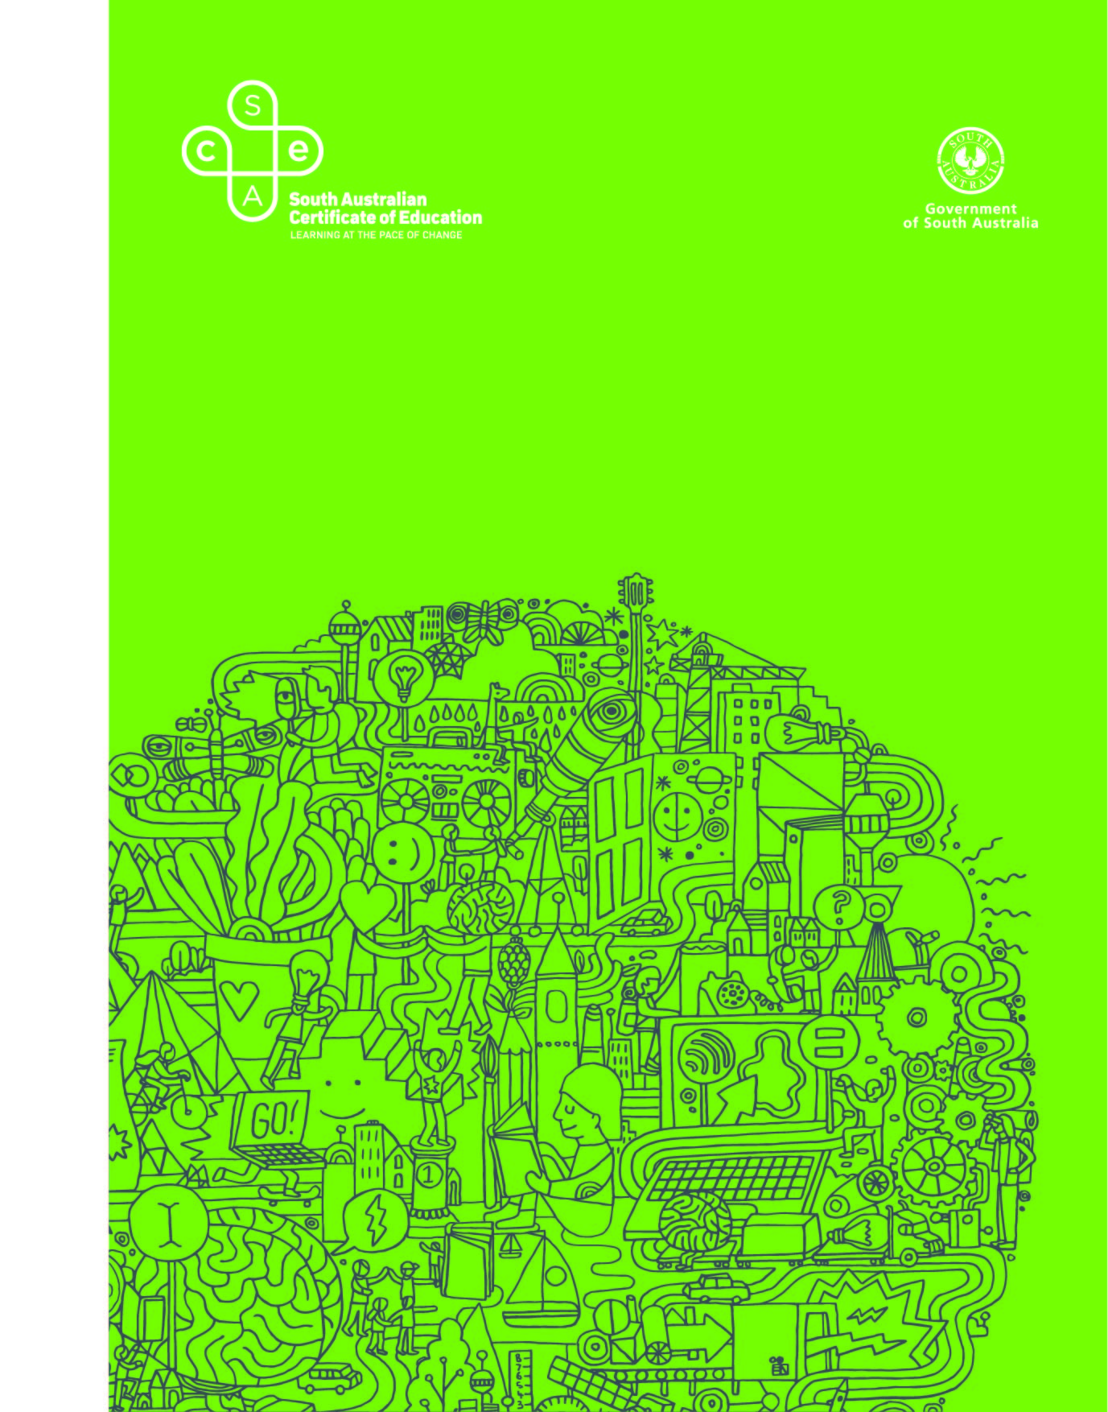
Nutrition
OFFICIAL
2022 Subject Outline | Stage 1

Published by the SACE Board of South Australia,
11 Waymouth Street, Adelaide, South Australia 5000
OFFICIAL
Copyright © SACE Board of South Australia 2020
First published 2020
Published online November 2020
Reissued for 2022
ISBN 978 1 74102 953 6 (online Microsoft Word version)
ref: A994392
This subject outline is accredited for teaching at Stage 1 from 2021

contents
Introduction 1
Subject description 1
Capabilities 2
Aboriginal and Torres Strait Islander knowledge, cultures, and perspectives 4
Learning scope and requirements 5
Learning requirements 5
Content 5
Assessment scope and requirements 13
Evidence of learning 13
Assessment design criteria 13
School assessment 14
Performance standards 18
Assessment integrity 20
Support materials 21
Subject-specific advice 21
Advice on ethical study and research 21

Introduction
Subject description
Nutrition can be studied as either a 10-credit subject or a 20-credit subject at Stage 1.
Nutrition is a science that immerses students in the fundamentals of human nutrition, physiology, and health, and promotes investigation of current and emerging trends. It is the study of dietary, lifestyle, and healthy eating patterns with specific focus on nutrients in food, how the body uses nutrients, and the relationship between diet, health, and disease. Students apply knowledge and understanding of nutrition to conduct investigations and examine scenarios. Students use technologies, scientific evidence, and research to critically analyse information and make informed decisions or recommendations.
Students consider how the food and nutrition needs of different population demographics are affected by food availability and product development. Students examine political, economic, cultural, and ethical influences and ecological sustainability in order to recommend actions or develop arguments about future food needs and food ethics. Critical literacy and numeracy skills and a deep understanding of nutrients enable students to analyse diets that improve health outcomes for individuals, community groups, and/or society.
Students develop an understanding of the need to evaluate food systems and food quality standards, marketing of food, food availability, and cultural influences on food selection. Through this understanding, students develop their personal and social capabilities, and ethical and intercultural understanding. Students explore the link between food systems, environmental impacts, climate change, and food sustainability. They suggest solutions to complex issues, informed by current research and Australian consumer-protection practices.
Students have opportunities to investigate contemporary issues of global and local food trends, advances in technology, and the development of new foods and food packaging. These issues will affect the future health and nutrition of populations.

Capabilities
The capabilities connect student learning within and across subjects in a range of contexts.
The SACE identifies seven capabilities. They are:
- literacy
- numeracy
- information and communication technology (ICT) capability
- critical and creative thinking
- personal and social capability
- ethical understanding
- intercultural understanding.
Literacy
In this subject students extend and apply their literacy capability by, for example:
- communicating appropriately using nutrition and food literacy for specific purposes and audiences
- using a range of communication formats to express ideas logically and fluently, incorporating the terminology and conventions of nutrition
- comprehending and interpreting the work of scientists across disciplines, using nutrition knowledge
- critically analysing and evaluating primary and secondary data
- identifying nutrition information presented in a variety of modes
- synthesising evidence to produce a logical argument
- formulating appropriate questions and hypotheses that guide nutrition investigations and their design.
Numeracy
In this subject students extend and apply their numeracy capability by, for example:
- solving problems using calculations and critical thinking skills
- measuring with appropriate instruments
- recording, collating, representing, and analysing primary data
- accessing and interpreting secondary data
- identifying and interpreting trends and relationships between data sets
- calculating and predicting values by manipulating data and using appropriate scientific conventions.
Information and communication technology (ICT) capability
In this subject students extend and apply their ICT capability by, for example:
- locating and accessing information
- collecting, analysing, and representing data electronically
- using technologies to create new ways of thinking about nutrition
- communicating ideas, processes, and information about nutrition
- understanding the impact of technological devices on the development of nutrition and its application in society
- evaluating the application of ICT to advance understanding and investigations in nutrition.
Critical and creative thinking
In this subject students extend and apply their critical and creative thinking by, for example:
- analysing and interpreting problems or issues from different perspectives
- constructing a hypothesis and designing an experiment, observational study, or investigation
- interpreting and evaluating data and procedures to develop logical conclusions
- analysing interpretations and claims, for validity and reliability
- devising innovative solutions to nutrition issues and making reasonable predictions
- recognising the value of creative thinking in the development of nutrition knowledge.
Personal and social capability
In this subject students extend and apply their personal and social capability by, for example:
- understanding the importance of nutrition knowledge on health and wellbeing, both personally and globally
- making decisions and taking initiative while working independently and collaboratively
- planning effectively, managing time, following procedures, and working safely
- sharing and discussing ideas about nutrition issues, developments, and innovations while respecting the perspectives of others
- analysing the role of their own beliefs and attitudes on personal nutrition status
- analysing cultural beliefs and attitudes and the impact of these on nutrition
- seeking, valuing, and acting on feedback.
Ethical understanding
In this subject students extend and apply their ethical understanding by, for example:
- considering the implications of their investigations on food production sustainability
- making ethical decisions based on an understanding of nutrition principles
- using data and reporting the outcomes of investigations accurately and fairly
- acknowledging the need to plan for the future and to protect and sustain the biosphere
- recognising the importance of their responsible participation in influencing policies and practices in society
- respecting individual values and preferences relating to nutrition choices
- understanding the influence of food production on environmental sustainability.

Intercultural understanding
In this subject students extend and apply their intercultural understanding by, for example:
- recognising that nutrition is a science with significant contributions from diverse cultures
- respecting and engaging with different cultural views and customs
- understanding that nutrition is influenced by cultural factors
- acknowledging traditional foods within Aboriginal and Torres Strait Islander communities
- negotiating diverse cultural perspectives
- incorporating a range of cultural knowledge about nutrition.
Aboriginal and Torres Strait Islander knowledge, cultures, and perspectives
In partnership with Aboriginal and Torres Strait Islander communities, and schools and school sectors, the SACE Board of South Australia supports the development of high-quality learning and assessment design that respects the diverse knowledge, cultures, and perspectives of Indigenous Australians.
The SACE Board encourages teachers to include Aboriginal and Torres Strait Islander knowledge and perspectives in the design, delivery, and assessment of teaching and learning programs by:
- providing opportunities in SACE subjects for students to learn about Aboriginal and Torres Strait Islander histories, cultures, and contemporary experiences
- recognising and respecting the significant contribution of Aboriginal and Torres Strait Islander peoples to Australian society
- drawing students’ attention to the value of Aboriginal and Torres Strait Islander knowledge and perspectives from the past and the present
- promoting the use of culturally appropriate protocols when engaging with and learning from Aboriginal and Torres Strait Islander peoples and communities.

Learning scope and requirements
Learning requirements
The learning requirements summarise the knowledge, skills, and understanding that students are expected to develop and demonstrate through their learning in Stage 1 Nutrition.
In this subject, students are expected to:
1. apply knowledge and understanding of nutrition concepts and food ethics
2. conduct nutrition investigations, using appropriate methodologies
3. evaluate data and/or information from nutrition investigations and form conclusions
4. apply critical and creative thinking skills in response to nutrition issues
5. explore and understand nutrition science as a human endeavour
6. communicate knowledge and understanding of nutrition concepts and nutrition literacy and numeracy.
Content
Stage 1 Nutrition is a 10-credit subject or a 20-credit subject that consists of the following three concepts and two underpinning skill sets:
Concepts
- Principles of nutrition, physiology, and health
- Health promotion and emerging trends
- Sustainable food systems
Underpinning skill sets
- Nutrition literacy and numeracy
- Nutrition and technology.
‘Nutrition literacy and numeracy’ and ‘Nutrition and technology’ underpin the content. They are not discrete concepts that can be taught in isolation but should be contextualised through case studies and real-life examples.
Nutrition literacy and numeracy involves students developing the skills to research and understand different sources of information. Students interpret and make decisions about nutrition information and advice. They consider how and where to seek contemporary, valid, and reliable information to promote and maintain good nutrition.

Nutrition and technology involves students developing skills to use computer applications to source and analyse nutrition information and in understanding how advances in technology are changing the way foods are produced, manufactured, distributed, and marketed. Improving people’s access to, and understanding of, nutrition information empowers them to make informed decisions.
The relationship of these is shown in the following diagram.
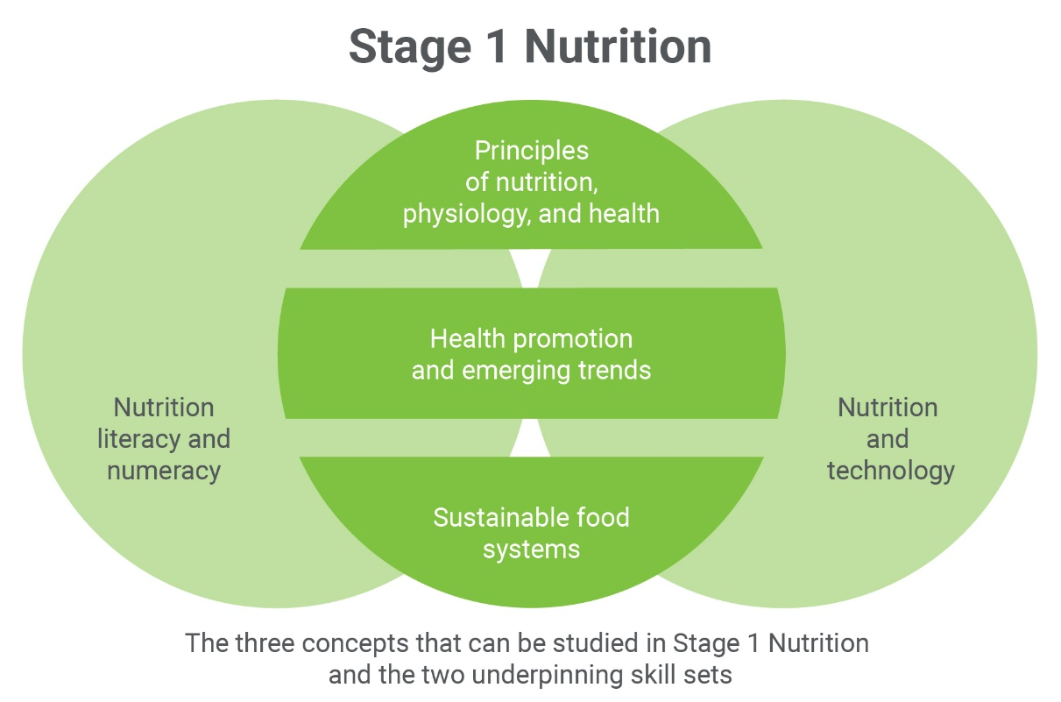
For a 10-credit subject, students study two or three nutrition understandings, preferably from different concepts. These understandings may be selected from the table on page 12 or developed by the teacher. A teacher-developed understanding must relate to one of the three concepts.
For a 20-credit subject, students study five nutrition understandings across the three concepts. These understandings may be selected from the table on page 12 or developed by the teacher. A teacher-developed understanding must relate to one of the three concepts.
Decisions about what is studied should reflect areas in nutrition that have personal relevance and significance for students within a learning group and should take into account local needs and interests.
The list of possible contexts in the table on page 12 is presented as a guide to the scope of the nutrition understandings considered appropriate at Stage 1. The list is neither prescriptive nor exhaustive.
The concepts in Stage 1 Nutrition provide the framework for developing integrated programs of learning through which students extend their skills, knowledge, and understanding of the three strands of science.
The three strands of science to be integrated throughout the student learning are:
- science inquiry skills
- science as a human endeavour
- nutrition science understanding.
Together with science as a human endeavour, the science inquiry skills and science understanding form the basis of teaching, learning, and assessment in this subject.
The following pages describe the three strands of science in more detail.
Science Inquiry Skills
In Nutrition, inquiry is an integral part of the learning and understanding of concepts.
Practical investigations involve a range of both individual and collaborative activities, during which students extend the science inquiry skills described in the table that follows.
Practical activities may take the form of experiments or observational studies. Students develop investigable questions and/or testable hypotheses. The data may be observations, measurements, or other information obtained during the investigation. Students represent and analyse the data they have collected; evaluate procedures, and describe the limitations of the data and procedures; consider explanations for their observations; and present and justify conclusions appropriate to the initial question or hypothesis.
It is recommended that class time involves some practical activities.
Science inquiry skills are fundamental to students investigating the social, ethical, and environmental impacts and influences of the development of scientific understanding and the applications, possibilities, and limitations of science. These skills enable students to critically consider the evidence they obtain so that they can present and justify conclusions.
Science Inquiry Skills | Possible contexts
Scientific methods enable systematic investigation to obtain measurable evidence.  - Design or conduct an investigation, including:  - a hypothesis or inquiry question  - types of variables  - dependent  - independent  - factors held constant  - (how and why they are controlled)  - factors that may not be able to be controlled (and why).  - materials required  - the method to be followed  - the type and amount of data to be collected  - identification of ethical and safety considerations. | Develop inquiry skills by, for example:  - designing investigations that require investigable questions and imaginative solutions (with or without implementation)  - critiquing proposed investigations  - using the conclusion of one investigation to propose subsequent experiments  - changing an independent variable in a given procedure and adapting the method  - researching, developing, and trialling a method  - improving an existing procedure  - identifying options for measuring the dependent variable  - identifying relevant ethical and/or legal considerations in different contexts  - comparing experimental and observational research methodologies.
Obtaining meaningful data depends on conducting investigations using appropriate procedures and safe, ethical working practices.  - Conduct investigations, including:  - collection of appropriate primary and/or secondary data (numerical, visual, descriptive)  - individual and collaborative work. | Develop inquiry skills by, for example:  - practising techniques and safe use of apparatus  - comparing resolution of different measuring tools  - distinguishing between, and using, primary and secondary data.
Results of investigations are represented in a well-organised way to allow them to be interpreted.  - Represent results of investigations in appropriate ways, including:  - use of appropriate SI units, symbols  - construction of appropriately labelled tables  - drawing of graphs. | Develop inquiry skills by, for example:  - practising constructing tables to tabulate data, including column and row labels with units  - identifying the appropriate representations to graph different data sets  - selecting appropriate axes and scales to graph data  - comparing data from different sources to describe as quantitative or qualitative.
Scientific information can be presented using different types of symbols and representations.  - Select, use, and interpret appropriate representations, to explain concepts, solve problems, and make predictions. | Develop inquiry skills by, for example:  - writing equations  - drawing and labelling diagrams  - recording images  - constructing flow diagrams.
Analysis of the results of investigations allows them to be interpreted in a meaningful way.  - Analyse data, including identification and discussion of trends, patterns, and relationships. | Develop inquiry skills by, for example:  - analysing data sets to identify trends and patterns  - determining relationships between independent and dependent variables  - using graphs from different sources (e.g. CSIRO, the Australian Bureau of Statistics (ABS), or Food Standards Australia New Zealand (FSANZ)) to predict values other than plotted points  - calculating mean values.
Critical evaluation of procedures and data can determine the meaningfulness of the results.  - Identify sources of uncertainty.  - Evaluate reliability, accuracy, and validity of results, by discussing factors including:  - sample size  - random error  - systematic error  - improvements. | Develop inquiry skills by, for example:  - discussing how the repeating of an investigation with different materials/equipment may detect a systematic error  - using an example of an investigation report to develop report-writing skills.
Conclusions can be formulated that relate to the hypothesis or inquiry question.  - Select and use evidence and scientific understanding to make and justify conclusions.  - Recognise the limitations of conclusions.  - Recognise that the results of some investigations may not lead to definitive conclusions. | Develop inquiry skills by, for example:  - evaluating procedures and data sets provided by the teacher to determine and hence comment on the limitations of possible conclusions  - using data sets to discuss the limitations of the data in relation to the range of possible conclusions that could be made.
Effective scientific communication is clear and concise.  - Communicate to specific audiences and for specific purposes using appropriate:  - language  - terminology  - conventions. | Develop inquiry skills by, for example:  - reviewing scientific articles or presentations to recognise conventions  - developing skills in referencing and/or footnoting  - distinguishing between reference lists and bibliographies  - practising scientific communication in written, oral, and multimodal formats (e.g. presenting a podcast or writing a blog).

Science as a Human Endeavour
The science as a human endeavour strand highlights the development of science as a way of knowing and doing, and explores the purpose, use, and influence of science in society.
By exploring science as a human endeavour, students develop and apply their understanding of the complex ways in which science interacts with society, and investigate the dynamic nature of nutrition science. They explore how scientists develop new understanding and insights, and produce innovative solutions to everyday and complex problems and challenges in local, national, and global contexts. In this way, students are encouraged to think scientifically and make connections between the work of others and their own learning. This enables them to explore their own solutions to current and future problems and challenges.
Students understand that the development of science concepts, models, and theories is a dynamic process that involves analysis of evidence and sometimes produces ambiguity and uncertainty. They consider how and why science concepts, models, and theories are continually reviewed and reassessed as new evidence is obtained and as emerging technologies enable new avenues of investigation. They understand that scientific advancement involves a diverse range of individual scientists and teams of scientists working within an increasingly global community of practice.
Students explore how scientific progress and discoveries are influenced and shaped by a wide range of social, economic, ethical, and cultural factors. They investigate ways in which the application of science may provide great benefits to individuals, the community, and the environment, but may also pose risks and have unexpected outcomes. They understand how decision-making about socio-scientific issues often involves consideration of multiple lines of evidence and a range of needs and values. As critical thinkers, they appreciate science as an ever-evolving body of knowledge that frequently informs public debate, but is not always able to provide definitive answers.
The key concepts of science as a human endeavour underpin the contexts, approaches, and activities in this subject, and must be integrated into all teaching and learning programs.
The key concepts of science as a human endeavour, with elaborations that are neither comprehensive nor exclusive, in the study of Nutrition are:
Communication and Collaboration
- Science is a global enterprise that relies on clear communication, international conventions, and review and verification of results.
- Collaboration between scientists, governments, and other agencies is often required in scientific research and enterprise.
Development
- Development of complex scientific models and/or theories often requires a wide range of evidence from many sources and across disciplines.
- New technologies improve the efficiency of scientific procedures and data collection and analysis. This can reveal new evidence that may modify or replace models, theories, and processes.
Influence
- Advances in scientific understanding in one field can influence and be influenced by other areas of science, technology, engineering, and mathematics.
- The acceptance and use of scientific knowledge can be influenced by social, economic, cultural, and ethical considerations.
Application and Limitation
- Scientific knowledge, understanding, and inquiry can enable scientists to develop solutions, make discoveries, design action for sustainability, evaluate economic, social, cultural, and environmental impacts, offer valid explanations, and make reliable predictions.
- The use of scientific knowledge may have beneficial or unexpected consequences; this requires monitoring, assessment, and evaluation of risk, and provides opportunities for innovation.
- Science informs public debate and is in turn influenced by public debate; at times, there may be complex, unanticipated variables or insufficient data that may limit possible conclusions.

Stage 1 Concepts and Nutrition Understandings

Concept | Nutrition Understanding | Possible contexts
Principles of nutrition, physiology, and health | Fundamentals of nutrition | - Macronutrients and overnutrition  - Micronutrients and undernutrition  - Dietary disorders
Health promotion and emerging trends | Food marketing and nutrition guidelines | - The psychology of food marketing  - Australian dietary guidelines  - Nutrition in the life cycle  - Indigenous Australians: food changes from the traditional to the contemporary  - Organic food versus genetically modified food  - Health promotion for specific community groups
 | Food trends | - Specific foods and nutrition value  - Future foods  - Harvest to plate
Sustainable food systems | Water and sustainable food supply | - Water quality and health  - Famine  - Sustainable food futures  - Waste management  - Food banks
 | Food processing | - Fresh versus processed foods  - Food packaging and labelling  - Contaminated food  - Safe food handling  - Preservation methods  - Chemical and functional changes in macronutrients

Assessment scope and requirements
Assessment at Stage 1 is school based.
Evidence of learning
The following assessment types enable students to demonstrate their learning in Stage 1 Nutrition:
- Assessment Type 1: Investigations Folio
- Assessment Type 2: Skills and Applications Tasks.
For a 10-credit subject, students provide evidence of their learning through three assessments. Each assessment type should have a weighting of at least 20%. Students undertake:
- one practical investigation
- one investigation with a focus on science as a human endeavour
- one skills and applications task that could be a case study.
For a 20-credit subject, students provide evidence of their learning through six assessments. Each assessment type should have a weighting of at least 20%. Students undertake:
- two practical investigations
- two investigations with a focus on science as a human endeavour
- two skills and applications tasks, one of which must be a case study.
Assessment design criteria
The assessment design criteria are based on the learning requirements and are used by teachers to:
- clarify for the student what they need to learn
- design opportunities for students to provide evidence of their learning at the highest possible level of achievement
The assessment design criteria consist of specific features that:
- students should demonstrate in their learning
- teachers look for as evidence that students have met the learning requirements
For this subject the assessment design criteria are:
- investigation, analysis, and evaluation
- knowledge and application.

The specific features of these criteria are described below.
The set of assessments, as a whole, must give students opportunities to demonstrate each of the specific features by the completion of study of the subject.
Investigation, Analysis, and Evaluation
The specific features are as follows:
IAE1 Design or conduct of investigations using appropriate methodologies.
IAE2 Obtaining, recording, and displaying findings of investigations, using appropriate conventions and formats.
IAE3 Analysis and interpretation of data and/or information to form conclusions.
IAE4 Evaluation of methodologies and/or research processes and their effect on data or findings.
Knowledge and Application
The specific features are as follows:
KA1 Demonstration of knowledge and understanding of nutrition concepts.
KA2 Application of nutrition concepts in familiar and unfamiliar contexts.
KA3 Exploration and understanding of the relationship between nutrition science and society.
KA4 Communication of nutrition concepts and nutrition literacy and numeracy.
School assessment
Assessment Type 1: Investigations Folio
For a 10-credit subject, students undertake one practical investigation and one investigation with a focus on science as a human endeavour.
For a 20-credit subject, students undertake two practical investigations and two investigations with a focus on science as a human endeavour.
Students inquire into aspects of nutrition through practical discovery and data analysis, and/or by selecting, analysing, and interpreting information.
Practical Investigation
As students design and safely carry out investigations, they demonstrate their science inquiry skills by:
- designing or conducting an appropriate method for experiments, observational studies, or investigations
- formulating a hypothesis
- using appropriate equipment, apparatus, and techniques
- identifying variables
- collecting, representing, analysing, and interpreting data
- evaluating procedures and considering their impact on results
- drawing conclusions
- communicating knowledge and understanding of concepts.
Practical investigations can be conducted individually or collaboratively. For each investigation, students present an individual report.
A practical report must include:
- introduction with relevant nutrition concepts
- hypothesis
- variables (independent, dependent, controlled) in an experiment
- materials/apparatus used in an experiment (e.g. as a table or image)
- the method that was implemented (e.g. as a flow chart, table, or image)
- identification and management of safety and/or ethical risks
- results, including table(s) and/or graph(s)
- analysis of results, including identifying trends and linking results to concepts
- evaluation of procedures and their effect on data
- conclusion, with justification.
Suggested formats for presentation of a practical investigation report include:
- a written report
- an oral presentation
- a multimodal product.
The report should be a maximum of 1000 words if written, or a maximum of 6 minutes for an oral presentation, or the equivalent in multimodal form.
Only the following sections of the report are included in the word count:
- introduction
- analysis of results
- evaluation of procedures
- conclusion and justification.
Science as a Human Endeavour Investigation
Students individually investigate a contemporary example of how nutrition science interacts with society. This may focus on one or more of the key concepts of science as a human endeavour described on pages 10 and 11, and may draw on a context suggested in the possible contexts on page 12 or relate to a new context.
Students could consider, for example, how:
- humans seek to improve their understanding and explanation of nutrition science in society
- working scientifically is a way of obtaining knowledge that allows for testing scientific claims
- scientific theory can change in the light of new evidence
- technological advances change ways of working scientifically
- links between advances in nutrition science impact and influence society
- society influences scientific research
- emerging nutrition-related careers and pathways involve science.
Students access information from different sources, select relevant information, analyse their findings, and explain the connection to science as a human endeavour.
Possible starting points for the investigation could include, for example:
- the announcement of a discovery in the field of nutrition science
- an expert’s point of view on a controversial innovation
- a TED talk based on a nutrition development
- an article from a scientific publication (e.g. Cosmos, Nutridate)
- public concern about an issue that has environmental, social, economic, or political implications.
Based on their investigation, students prepare a scientific text, which must include the use of scientific terminology. The scientific text could take the form of, for example:
- a report
- an article
- a blog
- a multimodal presentation.
The text should be a maximum of 1000 words if written, or a maximum of 6 minutes for an oral presentation, or the equivalent in multimodal form.
For this assessment type, students provide evidence of their learning in relation to the following assessment design criteria:
- investigation, analysis, and evaluation
- knowledge and application.
Assessment Type 2: Skills and Applications Tasks
For a 10-credit subject, students undertake one skills and applications task that could be a case study.
For a 20-credit subject, students undertake two skills and applications tasks, one of which must be a case study.
Skills and applications tasks allow students to provide evidence of their learning in tasks that may:
- be applied, analytical, and/or interpretative
- pose problems in new and familiar contexts
- be individual or collaborative, depending on task design.
The skills and applications tasks should be designed to enable students to apply their science inquiry skills, and demonstrate knowledge and understanding of key nutrition concepts and learning. Problems and scenarios should be set in a relevant context, which may be practical, social, or environmental. For collaborative tasks, students present an individual report.
Case Study
Students investigate a patient/client case study in which they analyse and/or evaluate nutrition data. This could be set by the teacher or individually planned.
Students may, for example, analyse and evaluate one or more of the following data sets:
- personal history
- general information about the subject, including age, gender, ethnicity, economic data, psychological factors, religion
- medical/health history
- patient and family medical/health history, allergies, or intolerances
- anthropometrics
- height, weight, body mass index (BMI), basal metabolic rate (BMR)
- food/nutrition intake
- for example, intake of food and beverages over 24 hours with specificity of size/quantity and brands
- knowledge, beliefs, and attitudes related to food and health
- physical activity history
- wellness case study
- for example, assessing the impacts of cooking, exercising, and eating together as teams or communities on wellness, or the impact of healthy eating interventions on wellness
- secondary diagnoses
- any other medical issues.
A case study may also include representation of data such as nutrients, and comparisons of findings to analyse and evaluate.
Students may demonstrate their critical thinking by:
- analysing specific nutrients, macronutrients, and/or micronutrients
- representing, analysing, and interpreting data
- evaluating procedures and considering their impact on results
- drawing conclusions
- communicating knowledge and understanding of concepts
- comparing nutrient intake to the five food groups
- identifying undernutrition or overnutrition disorders that the subject may be at risk of based on the findings
- suggesting modifications to the subject’s food and beverage intake to include suitable servings from each of the food groups to meet their nutrition needs
- referring to the Australian dietary guidelines and the Australian Guide to Healthy Eating
- making a recommendation with justification for future healthier options.
The case study could take the form of, for example:
- an article for a scientific publication
- a report
- a video
- an oral or multimodal scientific presentation.
The case study should be a maximum of 1000 words if written, or a maximum of 6 minutes for an oral presentation, or the equivalent in multimodal form.
Other Skills and Applications Task
Besides case studies, skills and applications tasks may include, for example:
- developing simulations
- practical and/or graphical skills
- a multimodal product
- an oral presentation
- participation in a debate
- an extended response
- responses to short-answer questions
- a response to science in the media.
A skills and applications task may involve, for example:
- solving problems
- designing an investigation to test a hypothesis or investigable question
- considering different scenarios in which to apply knowledge and understanding of graphing, tabulating, and/or analysing data
- evaluating procedures and identifying their limitations
- formulating conclusions
- representing information diagrammatically or graphically
- using nutrition terms, conventions, and notations.
A student’s evidence for a task should be a maximum of 1000 words if written, or a maximum of 6 minutes for an oral presentation, or the equivalent in multimodal form.
For this assessment type, students provide evidence of their learning in relation to the following assessment design criteria:
- investigation, analysis, and evaluation
- knowledge and application.
Performance standards
The performance standards describe five levels of achievement, A to E.
Each level of achievement describes the knowledge, skills, and understanding that teachers refer to in deciding how well students have demonstrated their learning on the basis of the evidence provided.
During the teaching and learning program the teacher gives students feedback on their learning, with reference to the performance standards.
At the student’s completion of study of a subject, the teacher makes a decision about the quality of the student’s learning by:
- referring to the performance standards
- taking into account the weighting of each assessment type
- assigning a subject grade between A and E.

Performance Standards for Stage 1 Nutrition
- | Investigation, Analysis, and Evaluation | Knowledge and Application
A | Critically designs or conducts investigations using appropriate methodologies.  Obtains, records, and displays findings of investigations, using appropriate conventions and formats accurately and highly effectively.  Systematically analyses and interprets data and/or information to formulate logical conclusions.  Critically and logically evaluates methodologies and/or research processes and their effect on data or findings. | Demonstrates deep and broad knowledge and understanding of a range of nutrition concepts.  Applies nutrition concepts highly effectively in familiar and unfamiliar contexts.  Critically explores and understands the relationship between nutrition science and society.  Coherently and clearly communicates nutrition concepts and nutrition literacy and numeracy.
B | Logically designs or conducts investigations using appropriate methodologies.  Obtains, records, and displays findings of investigations, using appropriate conventions and formats mostly accurately and effectively.  Analyses and interprets data and/or information to formulate reasonable conclusions.  Logically evaluates methodologies and/or research processes and their effect on data or findings. | Demonstrates some depth and breadth of knowledge and understanding of a range of nutrition concepts.  Applies nutrition concepts mostly effectively in familiar and unfamiliar contexts.  Logically explores and understands the relationship between nutrition science and society.  Mostly coherently and clearly communicates nutrition concepts and nutrition literacy and numeracy.
C | Designs or conducts investigations using appropriate clear methodologies.  Obtains, records, and displays findings of investigations, using appropriate conventions and formats, with some errors but generally accurately and effectively.  Interprets data and/or information to formulate generally appropriate conclusions.  Evaluates methodologies and/or research processes and some of their effect on data or findings. | Demonstrates knowledge and understanding of a general range of nutrition concepts.  Applies nutrition concepts generally effectively in familiar and unfamiliar contexts.  Explores and understands aspects of the relationship between nutrition science and society.  Generally coherently and clearly communicates nutrition concepts and nutrition literacy and numeracy.
D | Prepares or conducts investigations using some appropriate methodologies.  Obtains, records, and displays findings of investigations, using appropriate conventions and formats inconsistently, with occasional accuracy and effectiveness.  Describes data and/or information to formulate basic conclusions.  Attempts to evaluate methodologies and/or research processes and suggest an effect on data or findings. | Demonstrates some basic knowledge and partial understanding of nutrition concepts.  Applies some nutrition concepts in familiar contexts.  Partially explores and recognises aspects of the relationship between nutrition science and society.  Clearly communicates some nutrition concepts and nutrition literacy and numeracy.
E | Attempts to prepare or conduct investigations using simple methodologies.  Attempts to record and represent some data, with limited accuracy or effectiveness.  Attempts to describe data and/or information and formulates a simple conclusion.  Acknowledges that methodologies and/or research processes affect data or findings. | Demonstrates limited recognition and awareness of nutrition concepts.  Attempts to apply nutrition concepts in familiar contexts.  Attempts to explore and identify an aspect of the relationship between nutrition science and society.  Attempts to communicate nutrition concepts and nutrition literacy and numeracy.

Assessment integrity
OFFICIAL
The SACE Assuring Assessment Integrity Policy outlines the principles and processes that teachers follow to assure the integrity of student assessments. This policy is available on the SACE website (www.sace.sa.edu.au) as part of the SACE Policy Framework.
The SACE Board uses a range of quality assurance processes so that the grades awarded for student achievement in the school assessment are applied consistently and fairly against the performance standards for a subject, and are comparable across all schools.
Information and guidelines on quality assurance in assessment at Stage 1 are available on the SACE website (www.sace.sa.edu.au).

Support materials
Subject-specific advice
Online support materials are provided for each subject and updated regularly on the SACE website (www.sace.sa.edu.au). Examples of support materials are sample learning and assessment plans, annotated assessment tasks, annotated student responses, and recommended resource materials.
Advice on ethical study and research
Advice for students and teachers on ethical study and research practices is available in the guidelines on the ethical conduct of research in the SACE, which are on the SACE website (www.sace.sa.edu.au).

