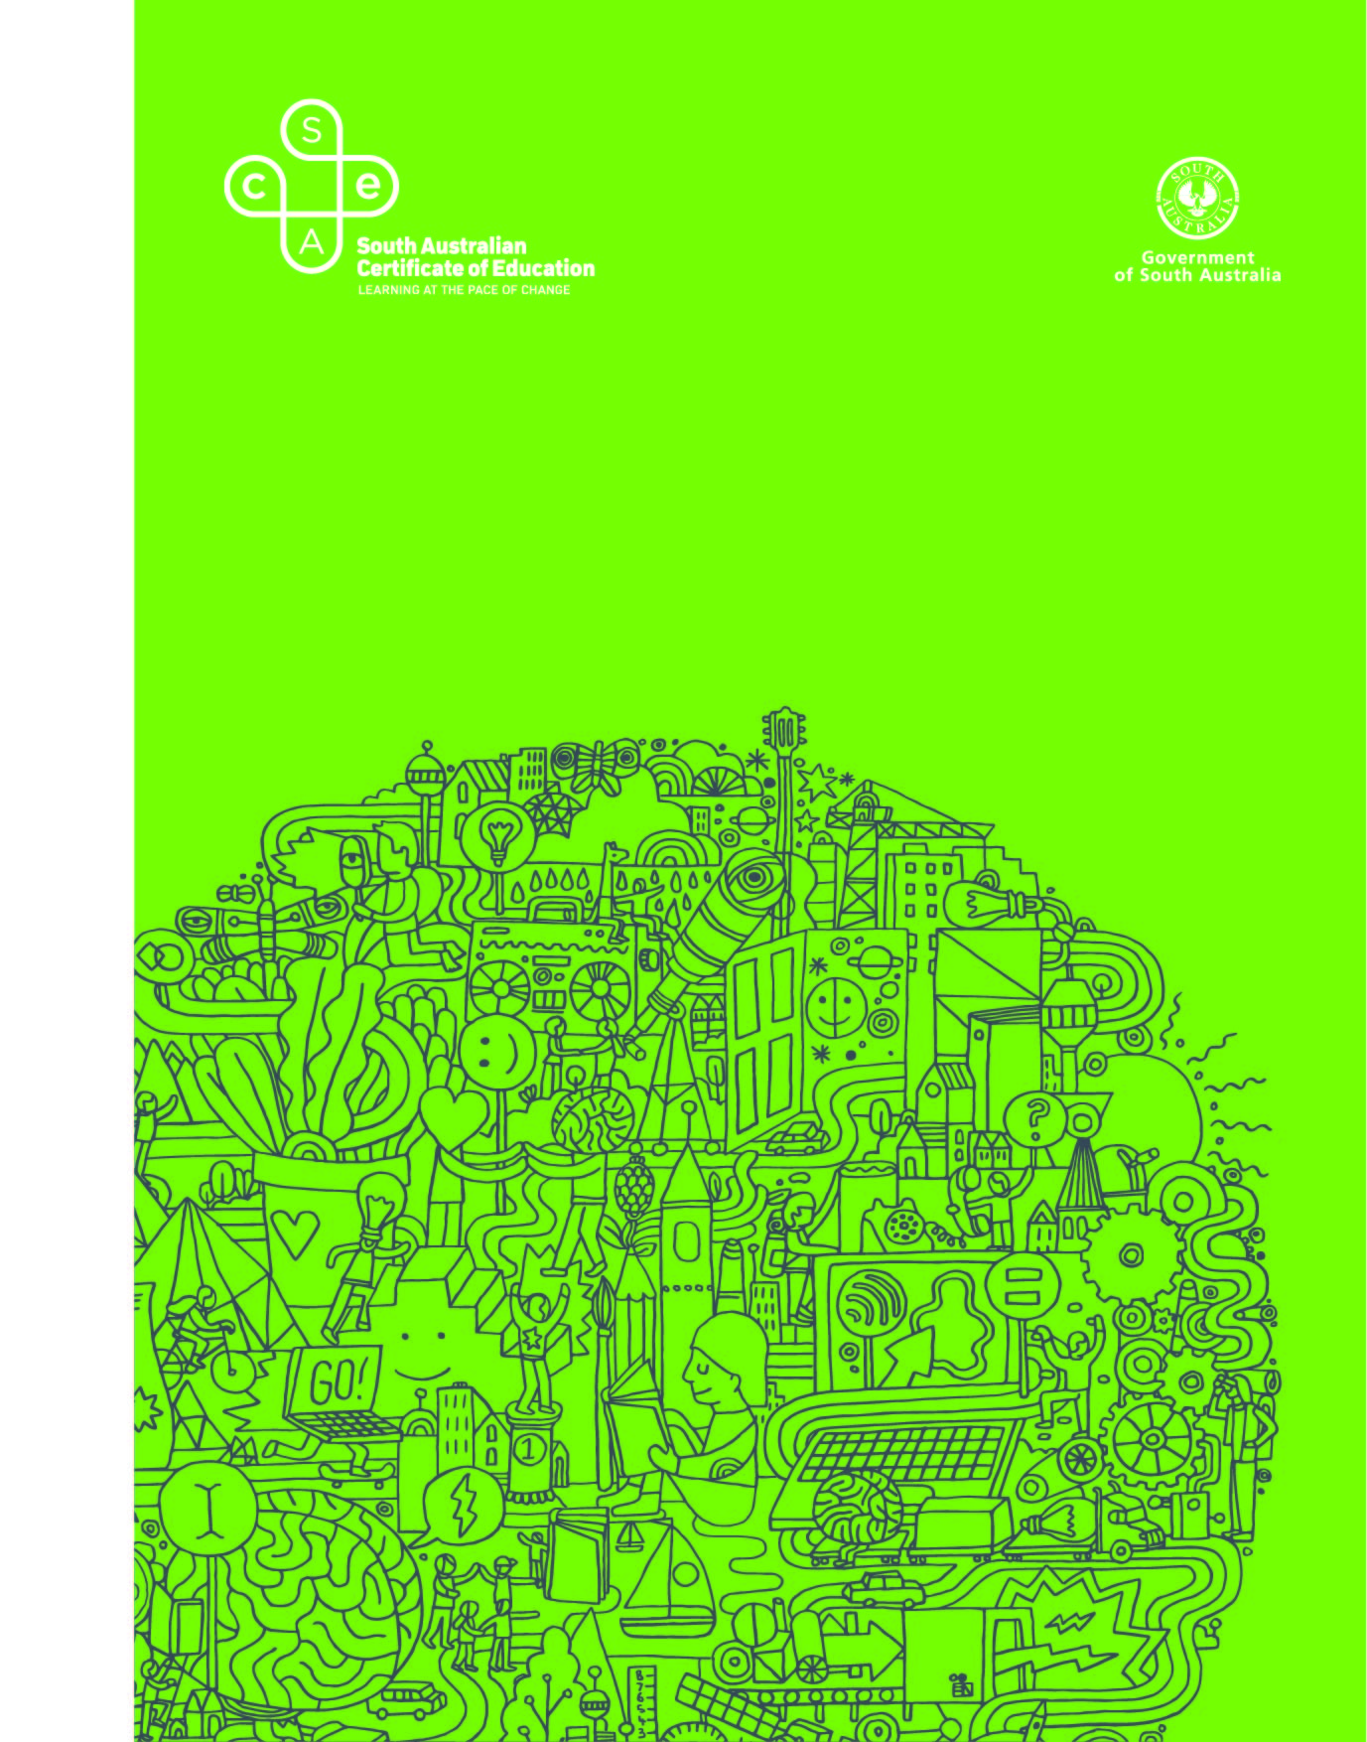
Research Practices
OFFICIAL
2022 Subject Outline | Stage 1

Published by the SACE Board of South Australia,
11 Waymouth Street, Adelaide, South Australia 5000
OFFICIAL
Copyright © SACE Board of South Australia 2013
First published 2013 for 2014 (published online October 2013)
Reissued for 2015, 2016, 2017, 2018, 2019, 2020, 2021, 2022
ISBN 978 1 74102 785 3 (online Microsoft Word version)
ref: A994362
This subject outline has been reaccredited for teaching at Stage 1 from 2017

contents
Introduction 1
Subject Description 1
Capabilities 1
Aboriginal and Torres Strait Islander Knowledge, Cultures, and Perspectives 4
Learning Scope and Requirements 5
Learning Requirements 5
Content 5
Assessment Scope and Requirements 10
Evidence of Learning 10
Assessment Design Criteria 10
School Assessment 11
Performance Standards 12
Assessment Integrity 14
Support Materials 15
Subject-specific Advice 15
Advice on Ethical Study and Research 15

OFFICIAL
Introduction
Subject Description
Stage 1 Research Practices is a 10-credit subject.
This subject provides students with opportunities to:
- examine the purpose of research
- explore a range of research approaches
- develop their investigative and inquiry skills.
Students explore research practices to develop skills in undertaking research, such as planning their research, developing and analysing their data, and presenting their research findings.
Capabilities
The capabilities connect student learning within and across subjects in a range of contexts. They include essential knowledge and skills that enable people to act in effective and successful ways.
The capabilities that have been identified are:
- literacy
- numeracy
- information and communication technology capability
- critical and creative thinking
- personal and social capability
- ethical understanding
- intercultural understanding.
Literacy
In Research Practices, students develop their capability for literacy by, for example:
- communicating with a range of people in a variety of contexts
- asking questions, expressing opinions, and taking different perspectives into account
- using language with increasing awareness, clarity, accuracy, and suitability for a range of audiences, contexts, and purposes
- accessing, analysing, and selecting appropriate primary and secondary sources
- engaging with, and reflecting on, the ways in which texts are created for specific purposes and audiences
- composing a range of texts — written, oral, visual, and multimodal
- reading, viewing, writing, listening, and speaking, using a range of technologies
- developing an understanding that different text types (e.g. website, speech, newspaper article, film, painting, data set, report, set of instructions, interview) have their own distinctive stylistic features
- acquiring an understanding of the relationships between literacy, language, and culture.
Numeracy
In Research Practices, students develop their capability for numeracy by, for example:
- using appropriate language and representations (e.g. symbols, tables, and graphs) to communicate ideas to a range of audiences
- analysing information displayed in a variety of representations and translating information from one representation to another
- justifying the validity of the findings, using everyday language, when appropriate
- applying skills in estimating and calculating, to solve and model everyday problems, using thinking, written, and digital strategies
- interpreting information given in numerical form in diagrams, maps, graphs, and tables
- visualising, identifying, and sorting shapes and objects in the environment
- interpreting patterns and relationships when solving problems
- recognising spatial and geographical features and relationships
- interpreting and incorporating statistical information that requires an understanding of the diverse ways in which data are gathered, recorded, and presented.
Information and Communication Technology Capability
In Research Practices, students develop their capability for information and communication technology by, for example:
- understanding how contemporary information and communication technologies affect communication
- critically analysing the limitations and impacts of current technologies
- considering the implications of potential technologies
- communicating and sharing ideas and information, to collaboratively construct knowledge and digital solutions
- defining and planning information searches of a range of primary and secondary sources when investigating research questions
- developing an understanding of hardware and software components, and operations of appropriate systems, including their functions, processes, and devices
- applying information and communication technology knowledge and skills to a range of methods, to collect and process data, and transmit and produce information
- learning to manage and manipulate electronic sources of data, databases, and software applications
- applying technologies to design and manage projects.

Critical and Creative Thinking
In Research Practices, students develop their capability for critical and creative thinking by, for example:
- thinking critically, logically, ethically, and reflectively
- learning and applying new knowledge and skills
- accessing, organising, using, and evaluating information
- posing questions and identifying and clarifying information and ideas
- developing knowledge and understanding of a range of research processes
- understanding the nature of innovation
- recognising how knowledge changes over time and is influenced by people
- exploring and experiencing creative processes and practices
- designing features that are fit for function (e.g. physical, virtual, or textual)
- investigating the place of creativity in learning, the workplace, and community life
- examining the nature of entrepreneurial enterprise
- reflecting on, adjusting, and explaining their thinking, and identifying the reasons for choices, strategies, and actions taken.
Personal and Social Capability
In Research Practices, students develop their personal and social capability by, for example:
- developing a sense of personal identity
- reviewing and planning personal goals
- developing an understanding of, and exercising, individual and shared obligations and rights
- participating actively and responsibly in learning, work, and community life
- establishing and managing relationships in personal and community life, work, and learning
- developing empathy for and understanding of others
- making responsible decisions based on evidence
- working effectively in teams and handling challenging situations constructively
- building links with others, locally, nationally, and/or globally.
Ethical Understanding
In Research Practices, students develop their capability for ethical understanding by, for example:
- identifying and discussing ethical concepts and issues
- considering ethical and safe research processes, including respecting the rights and work of others, acknowledging sources, and observing protocols when approaching people and organisations
- appreciating the ethical and legal dimensions of research and information
- reflecting on personal ethics and honesty in experience and decision-making
- exploring ideas, rights, obligations, and ethical principles
- considering workplace safety principles, practices, and procedures
- developing ethical sustainable practices in the workplace and the community
- inquiring into ethical issues, selecting and justifying an ethical position, and understanding the experiences, motivations, and viewpoints of others
- debating ethical dilemmas and applying ethics in a range of situations.
Intercultural Understanding
In Research Practices, students develop their capability for intercultural understanding by, for example:
- identifying, observing, analysing, and describing characteristics of their own cultural identities and those of others (e.g. group memberships, traditions, values, religious beliefs, and ways of thinking)
- recognising that culture is dynamic and complex and that there is variability within all cultural, linguistic, and religious groups
- learning about and engaging with diverse cultures in ways that recognise commonalities and differences, create connections with others, and cultivate mutual respect
- developing skills to relate to and move between cultures
- acknowledging the social, cultural, linguistic, and religious diversity of a nation, including those of Aboriginal and Torres Strait Islander societies in Australia
- recognising the challenges of living in a culturally diverse society and of negotiating, interpreting, and mediating difference.
Aboriginal and Torres Strait Islander Knowledge, Cultures, and Perspectives
In partnership with Aboriginal and Torres Strait Islander communities, and schools and school sectors, the SACE Board of South Australia supports the development of high-quality learning and assessment design that respects the diverse knowledge, cultures, and perspectives of Indigenous Australians.
The SACE Board encourages teachers to include Aboriginal and Torres Strait Islander knowledge and perspectives in the design, delivery, and assessment of teaching and learning programs by:
- providing opportunities in SACE subjects for students to learn about Aboriginal and Torres Strait Islander histories, cultures, and contemporary experiences
- recognising and respecting the significant contribution of Aboriginal and Torres Strait Islander peoples to Australian society
- drawing students’ attention to the value of Aboriginal and Torres Strait Islander knowledge and perspectives from the past and the present
- promoting the use of culturally appropriate protocols when engaging with and learning from Aboriginal and Torres Strait Islander peoples and communities.

Learning Scope and Requirements
Learning Requirements
The learning requirements summarise the knowledge, skills, and understanding that students are expected to develop and demonstrate through their learning in Stage 1 Research Practices.
In this subject, students are expected to:
1. demonstrate knowledge and understanding of the purpose of research
2. demonstrate knowledge and understanding of research approaches
3. develop specific research skills
4. consider the appropriateness, uses, and limitations of specific sources
5. interpret and analyse information and data.
Content
Stage 1 Research Practices is a 10-credit subject.
In this subject, students explore a range of research approaches and skills. They learn that different approaches to research are appropriate to different contexts and purposes.
Teachers and students select, for focused study, at least one topic from each of the following areas of study:
- Exploring Research Approaches
- Exploring Research Skills.
The topics may be integrated, undertaken in parallel, or undertaken consecutively.
They can be taught through the development of, for example:
- an investigation
- a performance
- a product
- an inquiry
- a research project.
The study of a topic may be linked to a theme, context, or area of interest.
The examples in each topic are suggestions and are not intended to be prescriptive or exhaustive.
Areas of Study
Exploring Research Approaches
Topic 1: The Purpose of Research
In this topic students explore the purpose of research in various contexts, and develop an understanding of the role of research in our lives.
Students have opportunities to explore how small-scale and large-scale research is conducted for specific purposes:
- how, for example
- societies use research to chart their futures
- large-scale research in society is conducted (e.g. the census)
- market research is conducted
- research is conducted for political purposes
- social media can be used to gather research data for specific purposes
- research is undertaken across cultures and nations
- practice-based research is undertaken
- why, for example
- research is undertaken by international organisations (e.g. the United Nations) and the scope of this research
- observational research is undertaken
- large-scale research is often conducted by cross-disciplinary teams
- and, for example
- the nature of research that looks into improving people’s health and well-being
- the different approaches to research into climate change
- the use of global positioning systems to collect data for a variety of purposes
- the nature of research that is conducted by individuals in relation to aspects of their own lives (e.g. buying a car, documenting their family history, researching what is needed to make something, or achieving a goal).
Topic 2: Research Methods
In this topic students develop conceptual understandings of some common approaches to research. The emphasis is on the use of appropriate methods to answer students’ research questions, in the two fundamental approaches to research:
- qualitative research
- quantitative research.
Students consider other research methods that complement these approaches (e.g. ethnographic research, case study research, practice-based research). Students consider the value of adopting a mixed-method approach in certain circumstances.
Topic 3: Research and Twenty-first Century Skills
In this topic students understand and develop twenty-first century skills (e.g. employability skills, capabilities).
Students deepen their understanding by, for example:
- discussing the nature and scope of particular skills, such as ‘collaboration’ and ‘problem-solving’
- undertaking independent research with a focus on one or more of these skills
- participating in cross-disciplinary research teams to develop their appreciation of a capability (e.g. personal and social capability, information and communication technology capability, intercultural understanding, and critical and creative thinking)
- participating in a discussion of ethical dilemmas raised by research or researchers
- taking part in a global project (and thereby developing their intercultural understanding capability and information and communication technology capability)
- testing their ideas and information through different perspectives.
Topic 4: Researchers in Society
In this topic students explore the work of different researchers in society, for example:
- discipline-based researchers, such as
- historians
- scientists
- anthropologists
- archaeologists
- social scientists
- mathematicians
- linguists
- government researchers
- individual researchers
- market researchers
- medical researchers
- multinational researchers
- researchers in business
- social media researchers
- thinkers in residence
- university researchers.

Exploring Research Skills
Students learn about and develop specific research skills in one or more of the following phases of research: planning, development, synthesis, and review and evaluation.
Topic 1: Planning
In this topic students learn about and develop one or more of the following skills:
- refine a specific research question from a broad research topic
- develop guiding questions
- select appropriate research method(s) for a research question
- create a project management plan
- conduct honest, safe, and ethical research.
Topic 2: Development
In this topic students learn about and develop one or more of the following skills:
- systematically collect data
- gather data through interviewing
- construct surveys and questionnaires
- choose a research method that ensures the integrity of the findings
- choose a research method appropriate to the discipline (e.g. history or chemistry)
- conduct an experiment with appropriate controls
- differentiate between primary and secondary sources
- determine what information from a source is appropriate and relevant for a specific purpose
- critically approach sources on the Internet
- acknowledge, cite, and reference data
- recognise and avoid plagiarism
- interpret qualitative data that has been gathered
- use statistical methods to analyse and interpret data
- keep records of the data
- explain how the research was undertaken
- prepare findings, using appropriate grammar and punctuation
- choose a presentation format that best suits the research data.
Topic 3: Synthesis
In this topic students learn about and develop one or more of the following skills:
- interpret and interrogate data
- synthesise information and data
- cross-reference information, data, and ideas
- make meaning of various sets of analyses
- select information that is relevant to the research question
- decipher key findings
- make conclusions and recommendations
- present a balanced interpretation of findings
- present findings to appropriate audiences.
Topic 4: Review and Evaluation
In this topic students learn about and develop one or more of the following skills:
- recognise the limitations of research
- reflect on their own progress and achievements
- respond to and make the most of unexpected challenges and/or opportunities
- seek and consider feedback from others
- evaluate the relevance of a research methodology
- evaluate research for quality, rigour, reliability, and validity

Assessment Scope and Requirements
Assessment at Stage 1 is school based.
Evidence of Learning
The following assessment types enable students to demonstrate their learning in Stage 1 Research Practices:
- Assessment Type 1: Folio
- Assessment Type 2: Sources Analysis.
For this 10-credit subject, students should provide evidence of their learning through four or five assessments. Each assessment type should have a weighting of at least 20%. Students undertake:
- one folio consisting of at least two assessment tasks
- at least two sources analysis assessments.
Assessment Design Criteria
The assessment design criteria are based on the learning requirements and are used by teachers to:
- clarify for the student what he or she needs to learn
- design opportunities for the student to provide evidence of his or her learning at the highest possible level of achievement.
The assessment design criteria consist of specific features that:
- students should demonstrate in their learning
- teachers look for as evidence that students have met the learning requirements.
For this subject the assessment design criteria are:
- knowledge and understanding
- development
- analysis.
The specific features of these criteria are described below.
The set of assessments, as a whole, must give students opportunities to demonstrate each of the specific features by the completion of study of the subject.

Knowledge and Understanding
The specific features are as follows:
KU1 Knowledge and understanding of the purpose of research.
KU2 Knowledge and understanding of research approaches.
Development
The specific feature is as follows:
D1 Development of specific research skills.
Analysis
The specific features are as follows:
A1 Consideration of the appropriateness, uses, and limitations of specific sources.
A2 Interpretation and analysis of information and data.
School Assessment
Assessment Type 1: Folio
Students undertake at least two tasks for the folio. At least one task should focus on ‘Exploring Research Approaches’, and at least one task should focus on ‘Exploring Research Skills’.
For the folio, students demonstrate knowledge and understanding of the purpose of research and of research approaches. They develop, experiment with, and apply specific research skills and techniques for specific purposes.
A folio task could take the form of, for example:
- an annotated survey, explaining the purpose of each question
- a mock interview, demonstrating a variety of techniques (e.g. what works, what does not work)
- a report on the key findings on a research question, from the perspectives of two different research approaches
- a fieldwork report, using tables and graphs to display findings
- a report on cases of unethical practices that have occurred in some research
- a report on the limitations of a chosen research method to answer a specific research question.
For this assessment type, students provide evidence of their learning in relation to the following assessment design criteria:
- knowledge and understanding
- development.
Assessment Type 2: Sources Analysis
Students undertake at least two sources analysis assessments. They consider the appropriateness, uses, and limitations of sources.
Sources may be selected by the teacher or student, and may be primary or secondary sources. Students may select for analysis a source that they have researched or have developed themselves.
A sources analysis assessment could take the form of, for example:
- a multimodal presentation, analysing the reliability of one or more sources
- a review of different sources from different perspectives
- a critical analysis and interpretation of data
- an oral presentation, justifying the selection of particular sources and evaluating their relevance to the research.
For this assessment type, students provide evidence of their learning in relation to the following assessment design criterion:
- analysis.
Performance Standards
The performance standards describe five levels of achievement, A to E.
Each level of achievement describes the knowledge, skills, and understanding that teachers refer to in deciding how well a student has demonstrated his or her learning on the basis of the evidence provided.
During the teaching and learning program the teacher gives students feedback on their learning, with reference to the performance standards.
At the student’s completion of study of a subject, the teacher makes a decision about the quality of the student’s learning by:
- referring to the performance standards
- taking into account the weighting of each assessment type
- assigning a subject grade between A and E.
Teachers can use a SACE Board school assessment grade calculator to help them to assign the subject grade. The calculator is available on the SACE website (www.sace.sa.edu.au).

Performance Standards for Stage 1 Research Practices
 | Knowledge and Understanding | Development | Analysis
A | KU1 Comprehensive knowledge and understanding of the purpose of research.  KU2 Thorough knowledge and understanding of relevant research approaches for a variety of purposes. | D1 Thorough development of specific research skills. | A1 Critical consideration of the appropriateness, uses, and limitations of specific sources.  A2 Insightful interpretation and analysis of information and data.
B | KU1 Detailed knowledge and understanding of the purpose of research.  KU2 Detailed knowledge and understanding of relevant research approaches for a purpose. | D1 Effective development of specific research skills. | A1 Some critical consideration of the appropriateness, uses, and limitations of specific sources  A2 Effective interpretation and analysis of information and data.
C | KU1 Knowledge and understanding of the purpose of research.  KU2 Knowledge and understanding of different research approaches. | D1 Satisfactory development of specific research skills. | A1 Satisfactory consideration of the appropriateness, uses, and limitations of specific sources.  A2 Satisfactory interpretation and analysis of information and data.
D | KU1 Superficial awareness of the purpose of research.  KU2 Some recognition and awareness of research approaches. | D1 Partial development of specific research skills. | A1 Superficial consideration of the appropriateness, uses, and limitations of one or more specific sources.  A2 Some interpretation and attempted analysis of information and data.
E | KU1 Basic identification of the purpose of research.  KU2 Identification of a research approach. | D1 Attempted development of some research skills. | A1 Basic attempt at consideration of the appropriateness, uses, and limitations of a specific source.  A2 Basic attempt at interpretation of information and data.

Assessment Integrity
OFFICIAL
The SACE Assuring Assessment Integrity Policy outlines the principles and processes that teachers and assessors follow to assure the integrity of student assessments. This policy is available on the SACE website (www.sace.sa.edu.au) as part of the SACE Policy Framework.
The SACE Board uses a range of quality assurance processes so that the grades awarded for student achievement in the school assessment are applied consistently and fairly against the performance standards for a subject, and are comparable across all schools.
Information and guidelines on quality assurance in assessment at Stage 1 are available on the SACE website (www.sace.sa.edu.au).

Support Materials
Subject-specific Advice
Online support materials are provided for each subject and updated regularly on the SACE website (www.sace.sa.edu.au). Examples of support materials are sample learning and assessment plans, annotated assessment tasks, annotated student responses, and recommended resource materials.
Advice on Ethical Study and Research
Advice for students and teachers on ethical study and research practices is available in the guidelines on the ethical conduct of research in the SACE on the SACE website (www.sace.sa.edu.au).

