SACE Management Conference
Term 3, 2019

Agenda
1. Welcome
2. Moving forward
a) subject renewal / subject accreditation
b) implementation
c) e-exams
d) moderation
e) online submissions
f) special provisions
g) Stage 1 moderation
h) Governor of South Australia Commendation Excellence Award
i) schools online
3. What’s new
a) PLATO SACE coordinators semester 2
b) IEA
c) C21 development
d) What’s new in SACE Communications
4. News flash
a) recognition reminders
b) badges in PLATO
c) reading time
d) exam information

Booklet Contents
Moving forward
2019 dispersed online moderation subjects 3
Moderation checklist – online submission 4
Students identification sheet – group evidence – online submission 5
Moderation checklist – hand copy submission 6
News flash
Credit for learning - recognition 7
Exam time reduction for Stage 2 Mathematical Methods and Specialist Mathematics
from 2020 9
What’s new in SACE Communications 9

Moving forward
2019 dispersed online moderation subjects
In 2019, the following 13 subjects will be moderated using an online dispersed format. Moderators for these subjects will not attend Mawson Lakes, and will work remotely by logging in to Schools Online to complete moderation over a specified period of days.
Moderators involved will be paid directly by the SACE Board, similar to the existing marker payment process, and so are expected to complete moderation tasks out of their normal school commitments. Please note that this means there will be no TRT’s provided for dispersed online moderation.
Moderators who were involved in dispersed moderation of three subjects in 2018 identified the following benefits:
- More autonomy and flexibility
- Travel not required
- More opportunity for remote teachers
- Minimal impact on teaching responsibility or school responsibilities
Semester 2, 2019 Dispersed Online Moderation Subjects
Ancient Studies
Business and Enterprise
Cross-disciplinary Studies
English
English Literary Studies
Essential English
Health
Indonesian (continuers)
Media Studies
Philosophy
Religion Studies
Research Project A and B
Workplace Practices A, B and C
- Remuneration

Moderation checklist – online submission

Moderation checklist — online submission

Please upload and complete the following materials:
Student samples
All assessment tasks for each assessment type for each student selected for moderation.
All A+ student samples for each assessment type
Variations – Moderation Materials (VMM) form to alert the moderation panel to variations, such as missing student materials , a breach of rules, or special provisions (if applicable)
Individual student identification form, if submitting group electronic evidence
(such as video or audio)
Teacher materials
Learning and assessment plan
Assessment tasks
Student group electronic evidence (such as video or audio), which is identified by assessment task and assessment type (if applicable)

Moderation feedback for online subjects can be found in the Moderation Summary, which is available in Schools Online after results release.

Student identification sheet – group evidence – online submission
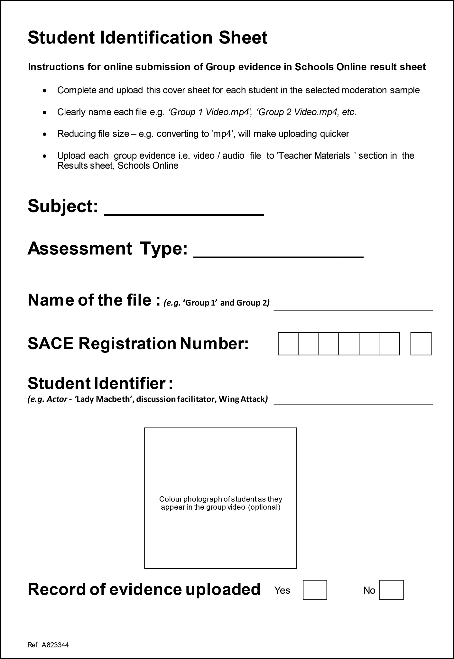

Moderation checklist – hard copy submission

Please package the following materials:
Student samples
All assessment tasks for each assessment type for each student selected for moderation
All A+ student samples for each assessment type
Individual or group evidence, electronic (such as video or audio) clearly labelled and student identified
Form 27: Variations – Moderation Materials (VMM) completed, to alert the moderation panel to variations, such as missing student materials, a breach of rules, or special provisions (if applicable)
Teacher materials
Learning and assessment plan
Assessment tasks

Moderation feedback for hard copy subjects can be found in Moderation Feedback, which is available in Schools Online after results release.

News flash
Credit for learning - recognition
It is important that students receive credit for the learning they undertake in SACE subjects.
For a range of reasons, teachers may believe that if a student is achieving poor results for their assessment, it is in the student’s best interest to be withdrawn from the subject. However, individual teachers may not always be aware that a D or E achievement may support a student’s SACE completion.
It is important schools understand that no credit can be provided when students are withdrawn from a subject. Supporting a student who is not engaging to demonstrate some evidence of the performance standards in a subject may mean the difference between completing and not completing the SACE for that student.
The table below compares late withdrawal of a student’s subject enrolment with three alternative options that may provide some credit.
Late withdrawal  Stage 1 or Stage 2  No credits  Any learning that has occurred is not recognised or credited | Exit assessment  (Form 13)  Stage 2  10 credits  (contributes to the 60 credits at Stage 2 requirement)  Credits for learning GRANTED if:  - student completes more than half the subject at C- or better  - Documentation provided  - Teacher authorises  - Principal endorses  NOT able to contribute to an ATAR | Community Studies B  Stage 2  10 or 20 credits  (contributes to the 60 credits at Stage 2 requirement)  Offers students who have enrolled in a Board accredited subject but are finding the subject challenging, the opportunity to remain in the original subject class, while approaching their learning in that subject in a different way.  NOT able to contribute to an ATAR | D or E grade result  Stage 1 or Stage 2  10 or 20 credits (contributes to the SACE 200 credit requirement)  Credits for learning and RESULTS:  - Confirmed by quality assurance processes  - May contribute to an ATAR calculation if SACE completion requirements have been met

Exit Assessment
An exit assessment can be granted for a student withdrawing from 20-credit Stage 2 subjects in the second half of the year or who have made a subject adjustment as a result of counselling after enrolments have closed and when:
- the student has completed at least half of the learning program and associated assessments on the LAP
- the student has achieved at least a C-result for the assessments that have been completed
- the school applies for an exit assessment (Form 13) and provides the approved LAP, indicating the tasks that have been completed at a C-level or better on the Assessment Overview
- the teacher authorizes the exit and the principal endorses it.
Evidence of student learning that validates the exit assessment must be retained in the school for 12 months for SACE Board auditing purposes.
A Stage 2 exit assessment can contribute to the 60 credits of Stage 2 subjects that students require for SACE completion.

Community Studies B
Students will be able to enrol in a 10-credit or a 20-credit subject, in up to three fields of study:
- Humanities and the Community
- STEM and the Community
- Interdisciplinary Learning and the Community
Community Studies B can contribute to the 60 credits of Stage 2 subjects that students require for SACE completion.

Submission of D and E grades
Another option for ensuring a student receives credit for learning in SACE subjects is submitting results in the D and E grades. The performance standards in each subject describe the qualities of learning in the D and E grades.
While this learning is not high, it is a level of achievement none-the-less. A student with results in the D and E grade bands has at least demonstrated attempted or limited learning at Stage 1 or 2 and should receive credit where they have demonstrated learning at this level.
D and E grade results can contribute to the 200 credits required for SACE completion but cannot be used to meet any of the compulsory requirements, including the 60 credits required at Stage 2.

Exam time reduction for Stage 2 Mathematical Methods and Specialist Mathematics from 2020
The length of time of Stage 2 examinations for Mathematical Methods and Specialist Mathematics are each being reduced to 130 minutes from the beginning of November 2020.
These changes will not impact on Stage 2 students from the 2019 cohort who will still undertake a three hour examination for both subjects.
To help teachers prepare for the change in 2020, sample examination papers for these subjects will be uploaded to the SACE website in December 2019. The style of questions will be similar to the current formats.
For both Mathematical Methods and Specialist Mathematics, there will be two booklets and the total mark will be approximately 100 marks. The balance of routine and complex questions will be similar to the current format. The questions will assess a selection of the key questions and key concepts from across the six topics.

Notes
Subject renewal / subject accreditation

Implementation

E-exams

Moderation

Online submissions

Special provisions

Stage 1 moderation

Governor of South Australia Commendation Excellence Award

Schools online

PLATO SACE Coordinators Semester 2

IEA

C21 development

Recognition reminders

Badges in PLATO

Reading time

Exam information

