Stage 2 Drama

Assessment Type 1: Group Production - Summative Task

Context
Welcome to our Group Production!

Today we begin our 12-week journey as a theatre company to develop, rehearse and perform a polished and artistically valuable piece of theatre. Each of us will have unique roles in creating our production, and we will work together to become a close, supportive and collaborative ensemble of artists - with one shared goal: to have maximum impact on our audiences in getting the message of this play across at the final performances.

Process
We will be following the dramatic process throughout the development of our production. We may modify this process a little as the need arises, but until then you can use this as a road-map for progressing through the process.
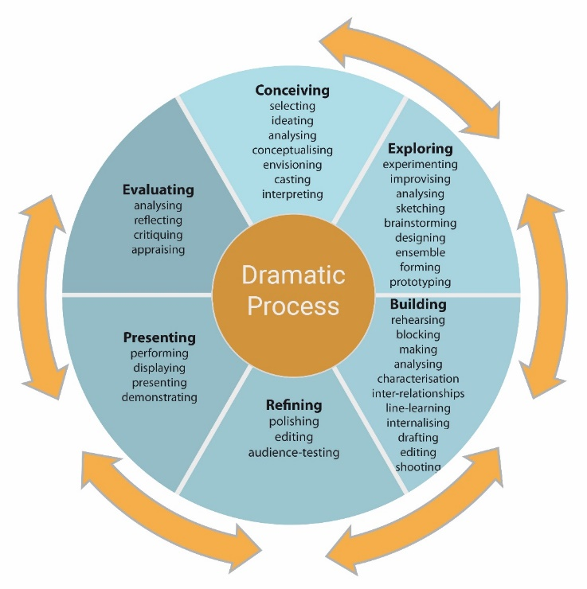

Description of Task:

Part 1 – gathering the evidence
As we collaborate to develop our production, you will need to keep a record through video (use your iPad), photos, and reflective notes about breakthroughs, times when you (and the people you’re collaborating with) really ‘cracked it’ in rehearsal, and/or learnt something dramatically important. You can keep these reflections in a ‘diary form’ which could be written or you can use the voice recorder on your iPad to keep them as audio files. MAKE SURE YOU BACK-UP AFTER EVERY REHEARSAL!!!

Here are some suggestions for things to think about for your diary (actors):

- rehearsals where you really ‘cracked’ a scene
- rehearsals where you really had difficulty getting something right, or working on stage
- discovering depth/layers in your character that you hadn’t seen before
- a breakthrough in a character relationship with someone else
- a scene that was exciting/emotionally rewarding to play …and why?
- a breakthrough moment about the play’s meaning/ideas
- a moment when you felt you’d been creative with someone else
- a point when you felt your character was finally in you
- feedback you received from the director or someone else in the cast/crew

Part 2 – presenting the evidence
Your final presentation of evidence is a video in mp4 format of up to a maximum of 15 minutes. After the closing night of our production, you will need to look through, select and assemble the video/photo/audio/written material, you want to use, analyse and evaluate.

Next, you’ll need to choose from one of these options to present your evidence of learning:

- a short video documentary in the style of ‘The Making of Our Group Production’ narrated by the student and including rehearsal video footage, interviews and excerpts.
OR
- an oral presentation – a video of you speaking to camera. You can use cutaways to video of scenes, script passages, photos, etc. as well.
OR
- a video essay – see the resources about this type of presentation that I’ve provided you.

Some things to consider including in your presentation:

The general stuff:
a) What were the main ideas in the play? (Name the play and playwright.)
b) What was the main concept that we used to put these ideas on the stage?
c) What was your role in the production, and how did it contribute to communicating the themes and ideas to the audience?
d) What were the main performance styles we used to present the play?
e) What sort of effect did we have upon the audience – and were we successful In conveying the playwright’s intentions?

The specific examples stuff:
Try to focus on how you and we solved theatrical problems. Examples of features, key moments and aspects may be: design, your acting in a scene, your acting of a small section of lines, solving technical problems, solving organizational problems, etc.

a) What was the scene or aspect?
b) In specific terms, what were the intentions of the playwright/director for this aspect?
c) What problem or difficulty needed to be solved?
d) What strategy, technique or solution did you/we find?
e) What impact did the final result have upon the audience (if necessary include the director’s feedback.)

Also consider:
a) What was the overall effect we were intending to have upon the audience?
b) How well did we have this effect AND express the playwright’s intentions?
c) What was the most successful attribute of our production?
d) What was one are we could improve upon?
e) Therefore, was the production (and all its elements) a success?
You will be marked on your presentation using this sheet:

Stage 2 Drama – Assessment Type 1 – Group Production

Process and Performance Assessment Record
Name (optional)
SACE registration number
School No._________________________________ Production Title_________________________________________________________________________________________
Insert a colour ‘head and shoulders’ photograph of the acting student as they appear in the video - including hairstyle, make-up and costume
Role(s) | Time first appear on video

Specific Features | Comments
KU1 Exploration and understanding of dramatic theory, style(s), conventions, roles and processes
[Sources: Presentation of Evidence, final performance or presentation]
CCT3 Evaluation of their own dramatic processes and outcomes, individually and in collaboration.
[Source: Presentation of Evidence]
CA1 Application of dramatic skills to develop and produce outcomes.
[Sources: Presentation of Evidence, final performance or presentation]
CA2 Collaborative application of dramatic elements and processes to realise outcomes.
[Sources: Presentation of Evidence, final performance or presentation]
CA3 Integration of dramatic ideas, theory and practice to make meaningful outcomes.
[Sources: Presentation of Evidence, final performance or presentation]
Grade Level:

Stage
- | Knowledge and Understanding | Critical and Creative Thinking | Creative Application
A | KU1 Sophisticated and highly detailed exploration and understanding of dramatic theory, style(s), conventions, roles and/or processes  KU2 Perceptive and insightful understanding and evaluation of the artistic and cultural value of local, global, contemporary and/or historical drama | CCT1 Highly creative thinking and experimentation in the development of dramatic ideas  CCT2 Sophisticated and creative analysis and evaluation of dramatic works, style(s), experiences, and/or practitioners  CCT3 Highly perceptive and insightful evaluation of dramatic processes and outcomes | CA1 Highly creative, and proficient application of dramatic skills to develop and/or produce outcomes  CA2 Highly focused, and sustained application of dramatic processes in collaboration with others  CA3 Highly original and coherent integration of theory and practice to make meaningful dramatic outcomes  Draft for consultation
B | KU1 Mostly detailed and some in-depth exploration and understanding of dramatic theory, style(s), conventions, roles and/or processes  KU2 Detailed and thorough understanding and evaluation of the artistic and cultural value of local, global, contemporary and/or historical drama | CCT1 Mostly creative thinking and experimentation in the development of dramatic ideas  CCT2 Astute analysis and evaluation of dramatic works, styles, experiences, and/or practitioners  CCT3 Thorough and detailed evaluation of dramatic processes and outcomes | CA1 Creative and mostly proficient application of dramatic skills to develop and/or produce outcomes  CA2 Mostly focused and productive application of dramatic processes in collaboration with others  CA3 Mostly original, valuable and coherent integration of ideas, theory and practice to make meaningful dramatic outcomes
C | KU1 Considered exploration and general understanding of dramatic theory, style(s), conventions, roles and/or processes  KU2 Understanding and evaluation of the artistic and cultural value of local, global, contemporary and/or historical drama | CCT1 Generally creative thinking and experimentation in the development of dramatic ideas  CCT2 Generally competent analysis and evaluation of dramatic works, styles, experiences, and/or practitioners  CCT3 Considered evaluation of dramatic processes and outcomes | CA1 Competent application of dramatic skills to develop and/or produce outcomes  CA2 Generally productive application of dramatic processes in collaboration with others  CA3 Some originality and coherence in the integration of ideas, theory and practice to make meaningful dramatic outcomes

- | Knowledge and Understanding | Critical and Creative Thinking | Creative Application
D | KU1 Some exploration and basic understanding of dramatic theory, style(s), conventions, roles and/or processes  KU2 Attempted understanding of the artistic and cultural value of local, global, contemporary and/or historical drama | CCT1 Attempted thinking and experimentation in the development of dramatic ideas  CCT2 Some general evaluation of dramatic works, styles, experiences, and/or practitioners  CCT3 Some broad recount of dramatic processes and outcomes | CA1 Partial application of a limited range of dramatic skills to develop and/or produce outcomes  CA2 Partial application of dramatic processes in collaboration with others  CA3 Basic expression and attempted integration of ideas, theory and practice to make meaningful dramatic outcomes
E | KU1 Limited exploration and understanding of dramatic theory, style(s), conventions, roles and/or processes  KU2 Limited understanding of the artistic and cultural value of local, global, contemporary and/or historical drama | CCT1 Limited thinking and experimentation in the development of dramatic ideas  CCT2 Limited recount of dramatic works, styles, experiences, and/or practitioners  CCT3 Limited reflection on dramatic processes and outcomes | CA1 Limited application of dramatic skills to develop and/or produce outcomes  CA2 Limited application of dramatic processes  CA3 Limited expression of ideas, theory and practice to make meaningful dramatic outcomes

