Stage 1 Drama

Assessment Type 3: Creative Synthesis – Summative Task

Description of Task

Following our study as a class of Scattered Lives by Sally McKenzie, devise a hypothetical production which uses new technology in an original way to express McKenzie’s ideas.

You can approach the creation of your hypothetical production as either a director or a designer.

Your hypothetical production and the technology you use needs to apply what you have learnt about the two styles we have studied: Verbatim Theatre and Brechtian Theatre. You may include one or both of these styles in your concept (or vision).

In creating your hypothetical production, you will need to develop a ‘concept’ or ‘vision’ for the play - as discussed in our work on ‘Conceptualising for the Theatre’ earlier in the semester. Once you have created your concept or vision, select 5 key moments or sections of script to illustrate your creative ideas, including your innovative use of technology.

Suggested ways you can explore the use of technology are:

- innovative interaction between live performers and video projections, including use of live on-stage camera and projection
- use of headphones and smart phones to individualise the audio experience for viewers of the production
- performing the play in real-time over the internet with a sister school in Canada using filmmaking techniques and live streaming
- applying an intelligent lighting design to the production

Oral Presentation

You will present your concept (or vision), ideas for staging, including innovative use of technology to the class in an oral presentation of up to 6 minutes.

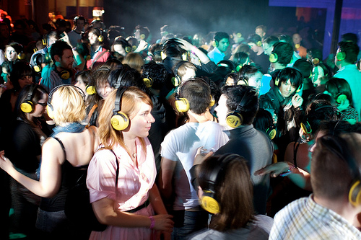

Performance Standards for Stage 1 Drama
 | Understanding and Exploration | Critical and Creative Thinking | Creative Application
A | UE1 Focused and astute understanding and exploration of dramatic roles, conventions and processes  UE2 Highly detailed and in-depth understanding and exploration of dramatic ideas, texts, styles and innovations | CCT1 Highly creative thinking and experimentation in the development of dramatic ideas  CCT2 Perceptive analysis and evaluation of dramatic ideas, products and technologies | CA1 Highly creative and proficient application of dramatic skills to produce outcomes  CA2 Focused and sustained collaborative application of ideas and processes
B | UE1 Mostly thorough understanding and exploration of dramatic roles, conventions and processes  UE2 Mostly detailed and in-depth understanding and exploration of dramatic ideas, texts, styles and innovations | CCT1 Creative thinking and experimentation in the development of dramatic ideas  CCT2 Comprehensive analysis and evaluation of dramatic ideas, products and technologies | CA1 Creative and capable application of dramatic skills to produce outcomes  Draft for consultation  CA2 Mostly focused collaborative application of ideas and processes
C | UE1 Competent understanding and exploration of dramatic roles, conventions and processes  UE2 Considered understanding and exploration of dramatic ideas, texts, styles and innovations | CCT1 Generally creative thinking and experimentation in the development of dramatic ideas  CCT2 Analysis and evaluation of dramatic ideas, products and technologies | CA1 Generally competent application of dramatic skills to produce outcomes  CA2 Generally focused collaborative application of ideas and processes
D | UE1 Some understanding and exploration of dramatic roles, conventions and processes  UE2 Attempted understanding and exploration of dramatic ideas, texts, styles and innovations | CCT1 Attempted creative thinking and experimentation in the development of dramatic ideas  CCT2 Some general reflection on dramatic ideas, products and technologies | CA1 Partial application of dramatic skills to produce outcomes  CA2 Some focused collaborative application of ideas and processes
E | UE1 Limited understanding and exploration of dramatic roles, conventions and processes  UE2 Limited understanding and exploration of dramatic ideas, texts, styles and innovations | CCT1 Limited thinking and experimentation in the development of dramatic ideas  CCT2 Limited reflection on dramatic ideas, products and technologies | CA1Limited application of dramatic skills to produce outcomes  CA2 Limited collaborative application of ideas and processes

