Stage 1 General Mathematics
Topic: Measurement SACE Test

You will be assessed on subtopics:
2.1 – Measurement devices and units of measure
2.2 – Perimeter and Area of plane shapes
2.3 – Surface Area of solids
2.4 Scales and Rates

INSTRUCTIONS TO STUDENTS:
- You will have 60 minutes to complete this paper.
- The total number of marks for the paper is 34 marks.
- Appropriate steps of working should be shown.
- Appropriate use electronic technology is allowed where appropriate
- Use black or blue pens for all work, other than graphs and diagrams, for which a pencil should be used.

STUDENT NAME: _______________________________________

Performance Standards for Stage 1 General Mathematics - Measurement
- | Concepts and Techniques | Reasoning and Communication
A | Comprehensive knowledge and understanding of concepts and relationships.  Highly effective selection and application of mathematical techniques and algorithms to find efficient and accurate solutions to routine and complex problems in a variety of contexts.  Successful development and application of mathematical models to find concise and accurate solutions.  Appropriate and effective use of electronic technology to find accurate solutions to routine and complex problems. | Comprehensive interpretation of mathematical results in the context of the problem.  Drawing logical conclusions from mathematical results, with a comprehensive understanding of their reasonableness and limitations.  Proficient and accurate use of appropriate mathematical notation, representations, and terminology.  Highly effective communication of mathematical ideas and reasoning to develop logical and concise arguments.  Formation and testing of appropriate predictions, using sound mathematical evidence.
B | Some depth of knowledge and understanding of concepts and relationships.  Mostly effective selection and application of mathematical techniques and algorithms to find mostly accurate solutions to routine and some complex problems in a variety of contexts.  Attempted development and successful application of mathematical models to find mostly accurate solutions.  Mostly appropriate and effective use of electronic technology to find mostly accurate solutions to routine and some complex problems. | Mostly appropriate interpretation of mathematical results in the context of the problem.  Drawing mostly logical conclusions from mathematical results, with some depth of understanding of their reasonableness and limitations.  Mostly accurate use of appropriate mathematical notation, representations, and terminology.  Mostly effective communication of mathematical ideas and reasoning to develop mostly logical arguments.  Formation and testing of mostly appropriate predictions, using some mathematical evidence.
C | Generally competent knowledge and understanding of concepts and relationships.  Generally effective selection and application of mathematical techniques and algorithms to find mostly accurate solutions to routine problems in different contexts.  Application of mathematical models to find generally accurate solutions.  Generally appropriate and effective use of electronic technology to find mostly accurate solutions to routine problems. | Generally appropriate interpretation of mathematical results in the context of the problem.  Drawing some logical conclusions from mathematical results, with some understanding of their reasonableness and limitations.  Generally appropriate use of mathematical notation, representations, and terminology, with reasonable accuracy.  Generally effective communication of mathematical ideas and reasoning to develop some logical arguments.  Formation of an appropriate prediction and some attempt to test it using mathematical evidence.
D | Basic knowledge and some understanding of concepts and relationships.  Some selection and application of mathematical techniques and algorithms to find some accurate solutions to routine problems in context.  Some application of mathematical models to find some accurate or partially accurate solutions.  Some appropriate use of electronic technology to find some accurate solutions to routine problems. | Some interpretation of mathematical results.  Drawing some conclusions from mathematical results, with some awareness of their reasonableness.  Some appropriate use of mathematical notation, representations, and terminology, with some accuracy.  Some communication of mathematical ideas, with attempted reasoning and/or arguments.  Attempted formation of a prediction with limited attempt to test it using mathematical evidence.
E | Limited knowledge or understanding of concepts and relationships.  Attempted selection and limited application of mathematical techniques or algorithms, with limited accuracy in solving routine problems.  Attempted application of mathematical models, with limited accuracy.  Attempted use of electronic technology, with limited accuracy in solving routine problems. | Limited interpretation of mathematical results.  Limited understanding of the meaning of mathematical results, their reasonableness or limitations.  Limited use of appropriate mathematical notation, representations, or terminology, with limited accuracy.  Attempted communication of mathematical ideas, with limited reasoning.  Limited attempt to form or test a prediction.

- Write 0.005234 in Scientific notation rounding to 3 significant figures
(2 mark)

- Find, giving your answer to 2 decimal places:
a) the perimeter b) the area
(4 marks)

100m

17m

- Convert the following:
a) 421 ha to m² b) 10.342 cm³ to mm³
(2 marks)

- The area of a room to be painted is estimated to be approximately 23m².The exact area is 24.28m²
- Calculate the absolute error b) Calculate the percentage error
(3 marks)

- The room needs to be painted with two coats of paint. Paint is sold in 1L tins. Each litre of paint covers approximately 12 m². How much paint would you recommend be purchased by the painter? Give your reason. (3 marks)

- What is the main limitation of estimating the area of a room to be painted?
(1 mark)
- A swimming pool at a resort is designed with the following measurements.
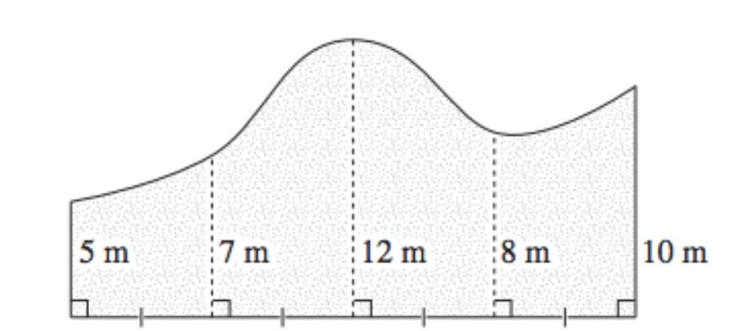
Width 24m

- Use Simpson’s rule to estimate the surface area of the pool. (3 marks)

- Descibe one way that the estimation of the suface area could be made more accurate. (1 mark)

- The diagram has not been drawn using a consistent scale.
- Use the marked width of 24 m to calculate what scale factor has been used for the width of the pool. (1marks)

- How long should the 8m length be drawn if the same scale you found in (i) was used for the width and height? (Give your answer to the nearest mm) (1 mark)
- Another option for the design of a pool is an ellipse. If the longest measurement across the ellipse is 22m, What is the width measurement of the ellipse that would have the same exact suface area 206.35 m²? Give your answer to 3 significant figures.

(3 marks)

22m

- What is the surface area of this shape, including the base.
(4 marks)
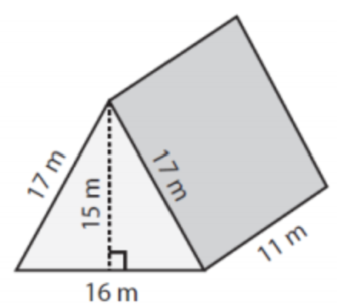

- The pyramid opposite has a rectangular base.

Find the length of PR and then calculate the vertical height of the pyramid.
P
Q
R
S
T
16cm
12cm
18cm

(2 marks)

8. A cone is filled with icecream with a hemi-spherical scoop on top.
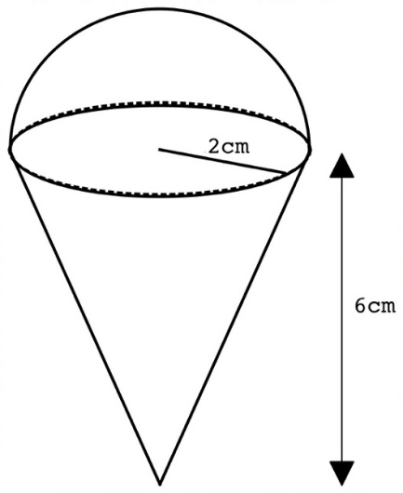

- The volume of this ice cream is 58.7 cm³
How many mL of icecream will be needed for one ice cream?
[1 mark]

- How many whole icecreams can be served from a 2L container of icecream?
[1 mark]

- What assumptions have been made in your calculations in a) and b), and how could these assumptions limit the accuracy of your answers.
[2 marks]

END OF QUESTION PAPER

