2019 Music Performance — Solo Subject Assessment Advice
Overview
Subject assessment advice, based on the previous year’s assessment cycle, gives an overview of how students performed in their school and external assessments in relation to the learning requirements, assessment design criteria, and performance standards set out in the relevant subject outline. They provide information and advice regarding the assessment types, the application of the performance standards in school and external assessments, and the quality of student performance.
Teachers should refer to the subject outline for specifications on content and learning requirements, and to the subject operational information for operational matters and key dates.
School Assessment
Assessment Type 1: Performance
Students present a solo performance, or set of performances, of a single work or a set of works by one or more composers.
The more successful responses commonly:
- fulfilled the time requirement as specified in the Learning and Assessment Plan
- presented musical works that were soloistic in nature
- presented works that were appropriately aligned with the technical and musical capabilities of the student
- showed great attention to detail of all musical aspects during the performance
- demonstrated consistently high control of tone and dynamics and fluent technique within the style and genre of the work(s) presented.
The less successful responses commonly:
- presented a part of an ensemble work as a solo performance
- presented works that did not allow the students to demonstrated a variety of techniques or styles on their instrument
- required improved technical fluency within the performance of the repertoire
- required an improved understanding of the stylistic aspects of the repertoire
- included performances that were under-rehearsed or too technically demanding for the student
- were well outside the 6–8 minute time requirement
- used backing tracks as accompaniment that included the solo part.
Additional advice for teachers
- Compress video files to mp4 for quicker upload and download.

Assessment Type 2: Performance and Discussion
For this assessment type students present a solo performance, or set of performances to a maximum of
6–8 minutes, of a single work or a set of works by one or more composers. This assessment also includes a discussion of key musical elements of the chosen repertoire, with a critique of strategies to improve and refine the student’s performance to a maximum or 800 words if written, 4 minutes as an oral presentation, or the multimodal equivalent.
The more successful responses commonly:
- demonstrated a high level of technique and confidence within the Performance(s)
- showed great attention to all musical aspects during both Performance(s)
- addressed the structural and stylistic elements of the chosen repertoire within the Discussion
- included a discussion that focused on the analysis of a range of musical elements
- addressed practice strategies used to develop and prepare their performance within the Discussion
- included consistent, accurate, and highly effective use of musical terminology
- gave a clear account of their repertoire discussing musical elements in detail, and explained how this informed their performance.
- included references (and a word count in the case of written Discussions)
- featured students clearly in videoed performance.
The less successful responses commonly:
- did not submit the Discussion
- lacked technical fluency and stylistic understanding within the performance of the work(s)
- included performances that did not allow the student to demonstrate a variety of techniques and skills
- focused too much on historical and/or biographical aspects within the Discussion
- did not use appropriate musical terminology within the Discussion
- focused on a limited number of musical elements within the Discussion
- focused purely on analysis within the Discussion, and didn’t include refinements and strategies developed to improve their skills, technique or accuracy within the Performance.
Additional advice for teachers
- Ensure that the Discussion is submitted in a separate file with the performance. The focus of the Discussion should be on the musical elements — particularly analysis of structure and style, and practice strategies developed by the student to improve and refine their performance(s).
- Ensure students understand the differences between the purpose of the Discussion in Assessment Type 2, and the Evaluation in Assessment Type 3. The Discussion focuses on analytical and stylistic features of the repertoire, and practice techniques used to develop and refine the performance given in Assessment Type 2, the Evaluation in Assessment Type 3 focuses on an evaluation and critique of the final performance and the learning undertaken throughout the year.
- Mark all of the student’s evidence for the assessment type holistically. Teachers are reminded that there is no weighting to the Discussion. Teachers can mark against the features of the criteria as indicated in the diagram below:
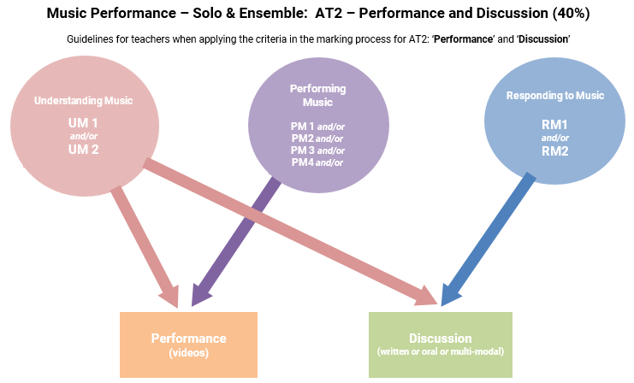
External Assessment
Assessment Type 3: Performance Portfolio
For this assessment type students present a solo performance, or set of performances to a maximum of
6–8 minutes, of a single work or a set of works by one or more composers. This assessment also includes an evaluation of their learning journey to a maximum or 500 words if written, 3 minutes as an oral presentation, or the multimodal equivalent.
The more successful responses commonly:
- demonstrated a high level of technical facility and stylistic understanding within the performance
- demonstrated sophisticated control of tone and a wide variety of dynamics and articulation within the performance
- successfully critiqued skills accuracy and technique of the chosen repertoire within the Evaluation
- addressed how their preparation throughout their study in this subject influenced their final performance for the assessment
- evaluated their stage presence, engagement and confidence as a performer
- completed the Evaluation shortly after the Performance
- avoided irrelevant, extensive biographical details about the composer/original recording artist
The less successful responses commonly:
- did not submit the Evaluation
- lacked technical fluency and accuracy within the performance
- lacked attention to detail of musical indications marked on the score (where provided)
- lacked detail or omitted a critique of skills relating to accuracy and technique within the Evaluation
- did not address how their preparation influenced their final performance for the assessment
- only evaluated their stage presence, engagement and confidence as a performer
- analysed the structure and style of the chosen repertoire (this is assessed in the Discussion in Assessment Type 2).

Additional advice for teachers
- Ensure the Evaluation is submitted for each and every student. The focus of the evaluation should be on performance preparation, critique of their performance and aspects of stage presence. Refer to the end of page 12 and beginning of page13 of the subject outline for further detail.
- Ensure students understand the differences between the purpose of the Evaluation in Assessment Type 3 and the Discussion in Assessment Type 2. While the Discussion focuses on analytical and stylistic features of the repertoire, and practice techniques used to develop and refine the performance given in Assessment Type 2, the Evaluation in Assessment Type 3 focuses on an evaluation and critique of the final performance and learning throughout the year.
- Take note of the differences in the discussion points between the two performance subjects (Solo and Ensemble). See the top of pages 12 and 13 of the Music Performance: Solo subject outline and page13 of the Music Performance: Ensemble subject outline, and for more details about the criteria students need to focus on in the Evaluation.
- Mark all of the student’s evidence for the external assessment AT3 holistically. Teachers are reminded that there is no weighting to the Evaluation. Teachers should mark against the features of the criteria as indicated in the diagram below:
