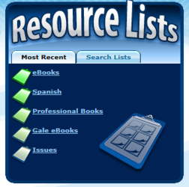
List of software / resources in my school:

- Computer lab ✓
- Headphones ✓
- ACID ✓
- Garage band ✓
- Ipads ✓
- Microphones (USB connect) ✓
- Zoom camera ✓
- E-lr.com subscription ✓
- Midnight Music subscription (Katie Wardrobe) ✓
- Loop files ✓
- Musical instruments ✓
- …
- …
- …
- …

