Instrument | Description of what extended technique  can be applied | Definition of the extended technique | What does instrument sound like with extended technique?
Any aerophone instrument (flute, trumpet) | Flutter Tongue | Rolling your R’s while playing | Watch first minute of clip  https://www.youtube.com/watch?v=VKeNFMF-vrw
Violin, Viola, Cello, Double Bass | Col Legno | Using the wood of the bow to hit the strings | Gustav Holst, “Mars”  https://www.youtube.com/watch?v=be7uEyyNIT4
Any aerophone instrument | Multi-phonics | The addition of the voice while the instrument is played | James Morrison https://www.youtube.com/watch?v=C1H3AvcFiZU
Saxophone | Slap Tongue | Producing a popping sound along with the note | https://www.youtube.com/watch?v=azOHrYXR318
Saxophone | Key noise | The audible and intentional noise created by the keys of a wind instrument | Barry Cockcroft, “Black and Blue”  Approx 1:40 mark is key noise  Flutter tonging is also featured https://www.youtube.com/watch?v=akjsNWOeOhQ
Flute | Beatboxing | Using vocal words, sounds to add a percussive effect to the instruments sound | Super Mario with beat boxing on flute  https://www.youtube.com/watch?v=crfrKqFp0Zg
Piano | Plucking / hitting strings | Intentionally opening up a piano and plucking or hitting the strings | https://www.youtube.com/watch?v=OaFpvT1i_jc
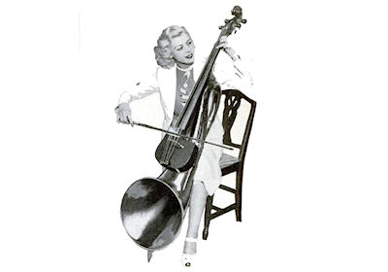Extended instrument techniques

