Stage 1 Music
Assessment Type 2: Musical Literacy Task 2

Purpose: To demonstrate musical literacy through identifying and understanding musical elements.

Assessment Description: Complete the following theory activities to demonstrate your understanding of musical elements.

1. Add accidentals to create the following scales. [10]

melodic minor
major
natural minor
harmonic minor
major

2. Identify the key of the melody below then transpose this excerpt down a major third on the staff. Add the time signature. [10]

Key: ________________________ [2]

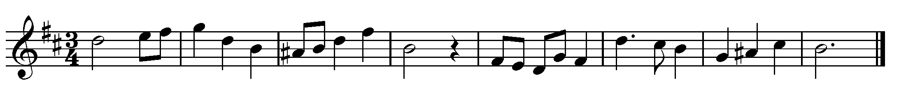

3. Add alto, tenor and bass parts to this soprano melody. Write two different cadences in bars 2 and 4. [16]

4. Identify the following intervals and write and label their inversions below [8]

5. Rhythmic Dictation: Write down the rhythm that will be played to you five times. [16]

6. Give definitions for the following Italian terms: [8]

Crescendo -

Maestoso –

Legato –

Accelerando –

Adagio –

Ritenuto –

Vivace –

Piano –

The specific features being assessed are:
Understanding Music
- UM1 Understanding of structural and stylistic features of music
- UM2 Development of musical literacy skills and communication of musical ideas.

