Stage 2 Specialist Mathematics Registration Number ……………………………..
Topic 3: Functions and Sketching Graphs
AT 1: Skills and Applications Tasks
PART 1: No Calculator 30 minutes Total: 22 marks
QUESTION 1 (5 marks)
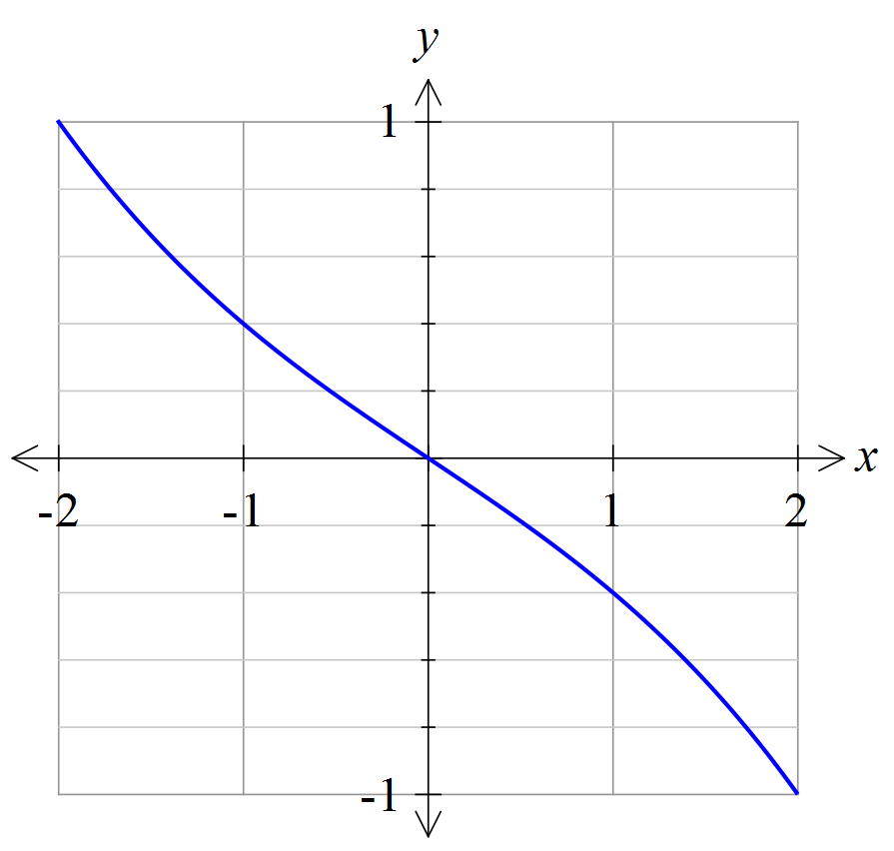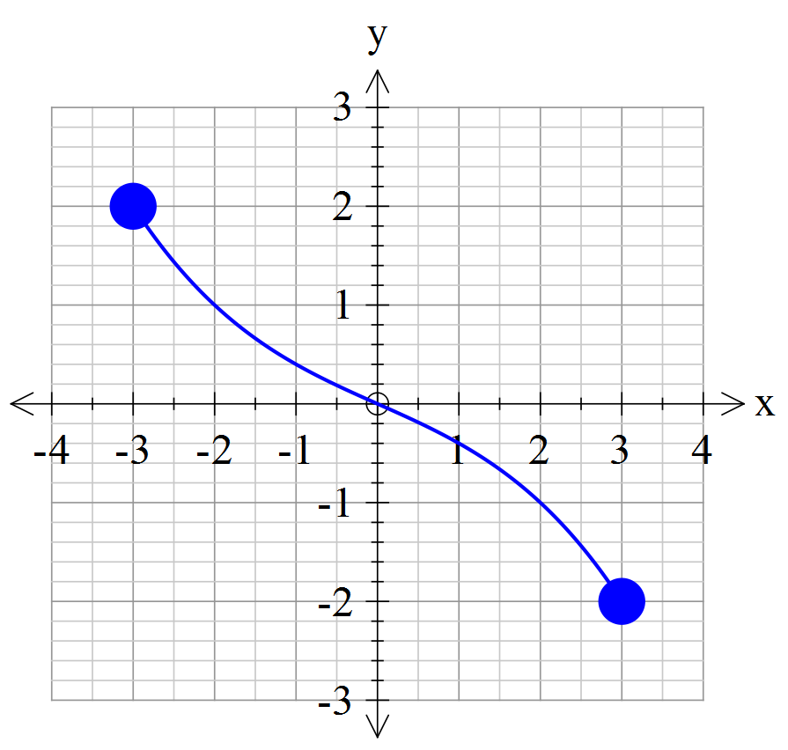The graph of 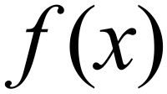 is given below.

- Why is the function one-to-one?
(2 marks)
- State the domain and range of 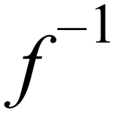.
(2 marks)
- Estimate the value of 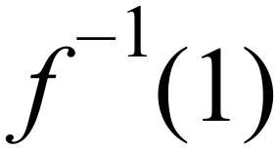.
(1 mark)

QUESTION 2 (5 marks)
Consider .
- Find 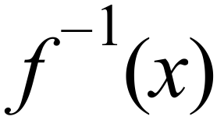.
(2 marks)
- Hence show that 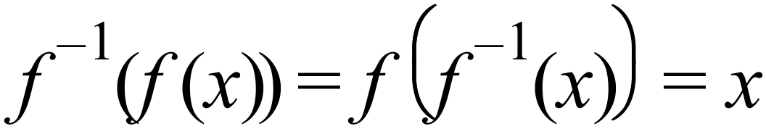.
(3 marks)
QUESTION 3 (3 marks)
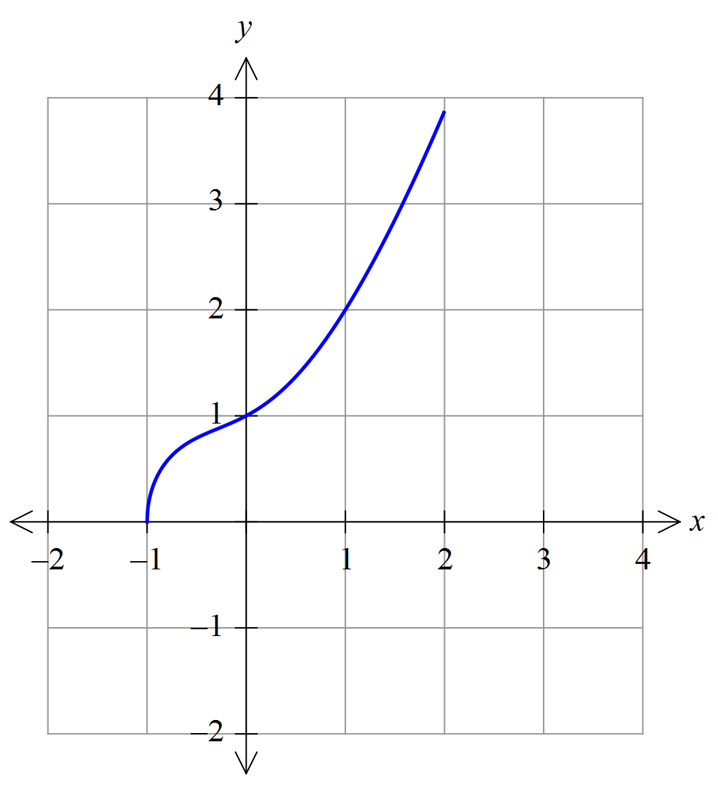The graph below is the function .

Draw the graph of on the set of axes above. (3 marks)

QUESTION 4 (9 marks)
Consider the functions defined by .
That is, and so on.
- Find 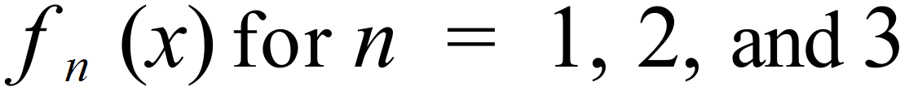.
(2 marks)
- Hence, propose a formula for 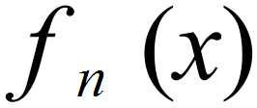
(1 mark)

- Use the Principle of Mathematical Induction to prove that 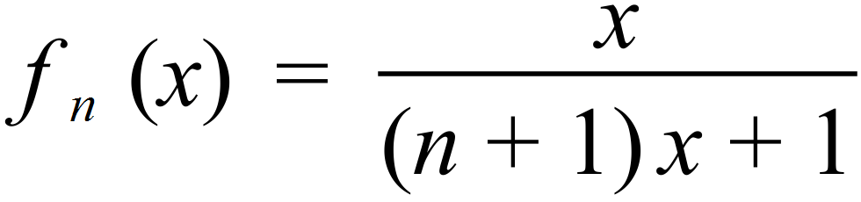 .
(5 marks)

END OF PART 1
Be sure to check your work thoroughly before handing it up at the end of the allocated time.
Stage 2 Specialist Mathematics Registration Number ……………………………..
Topic 3: Functions and Sketching Graphs
PART 2: Calculator 25 minutes Total: 22 marks
QUESTION 5 (8 marks)
Consider the functions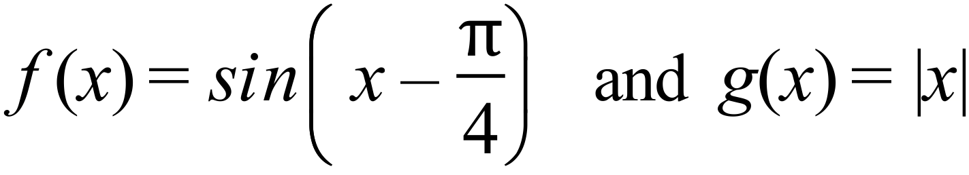.
- Find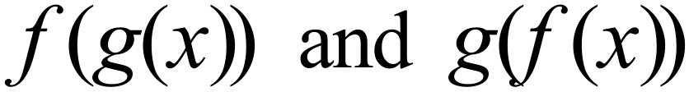.
(2 marks)
- On the set of axes below, draw the graphs of the functions in (a) for 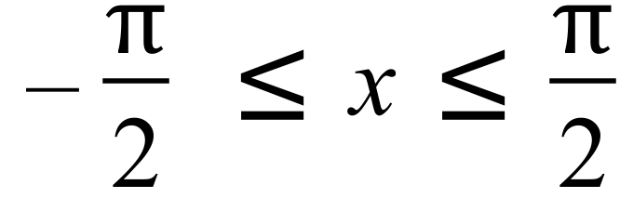 .
Clearly label the curves.
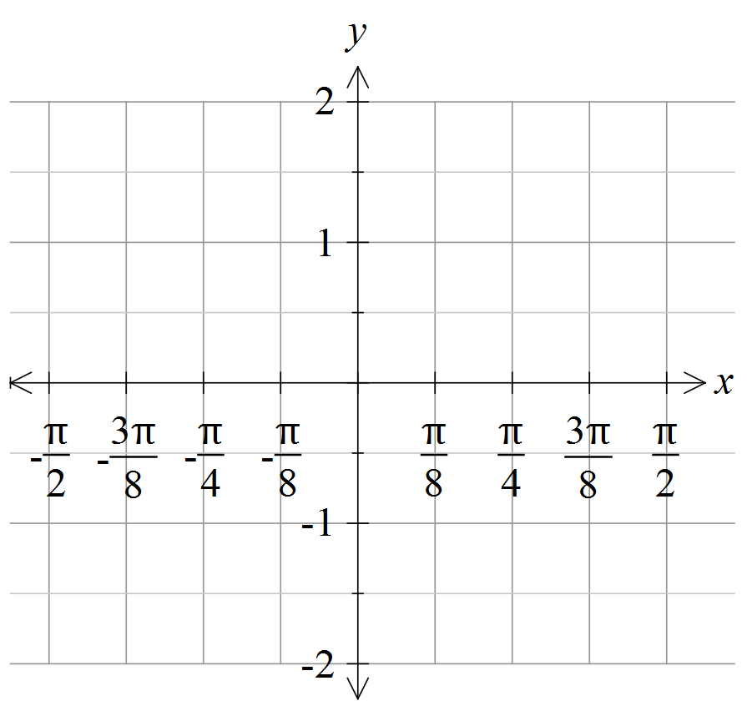

(3 marks)
- Use an accurate technique to find the maximum distance between the two functions on the domain given. Explain your reasoning clearly.
(3 marks)

QUESTION 6 (7 marks)
Graph the following rational functions on the given sets of axes. Label any asymptotes and clearly show the behaviour near the asymptotes.
- 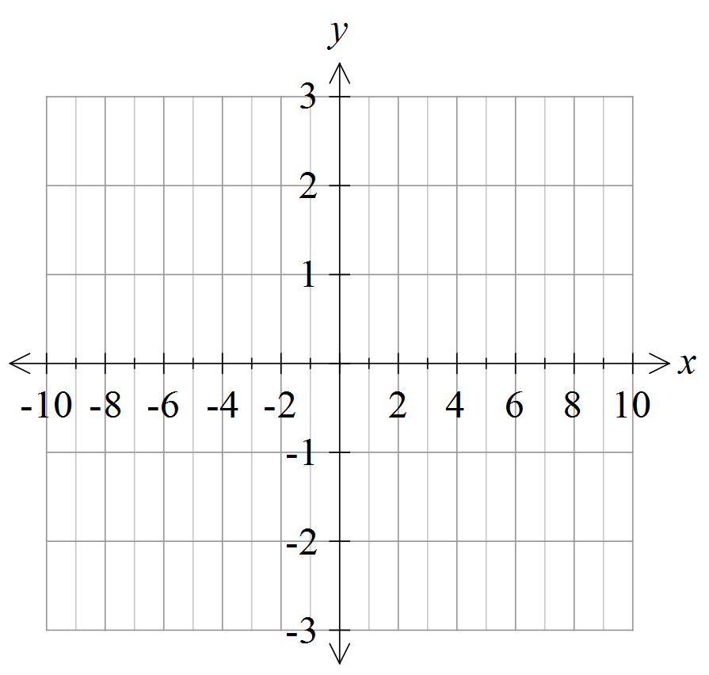 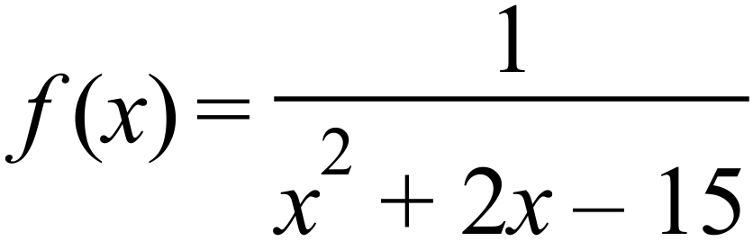.

(4 marks)
- 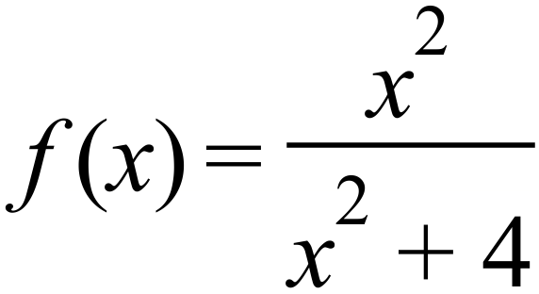 .
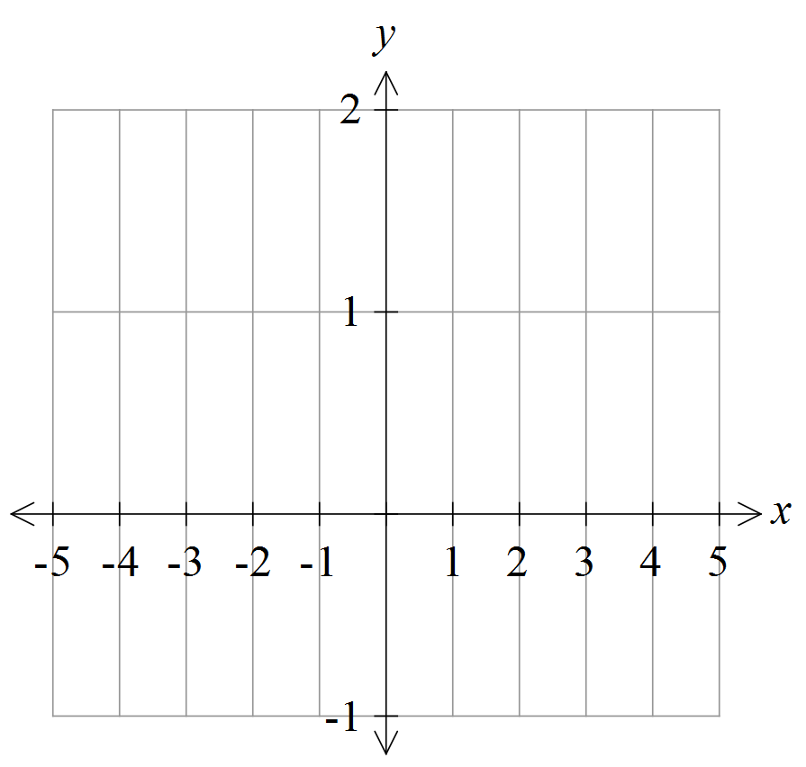

(3 marks)

QUESTION 7 (7 marks)
Consider 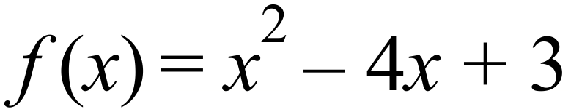
- Find  .
(2 marks)
- Graph and clearly label both functions on the set of axes below.
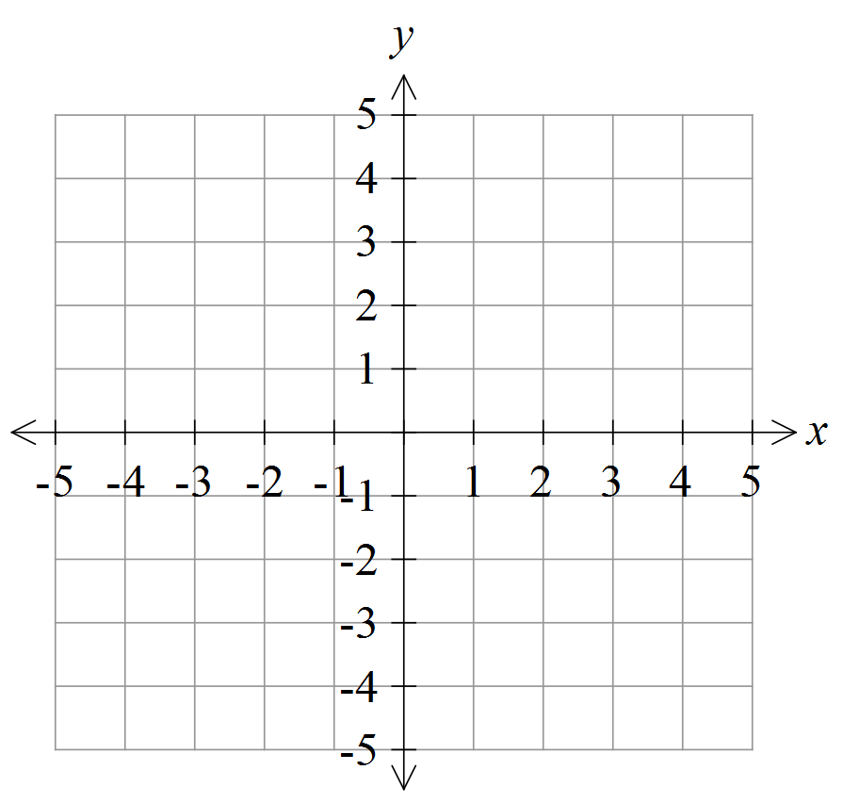

(3 marks)
- Explain clearly the graphical effects of both sets of moduli on the function to produce the graph of .

(2 marks)
END OF PART 2
Performance Standards for Stage 2 Specialist Mathematics
- | Concepts and Techniques | Reasoning and Communication
A | Comprehensive knowledge and understanding of concepts and relationships.  Highly effective selection and application of mathematical techniques and algorithms to find efficient and accurate solutions to routine and complex problems in a variety of contexts.  Successful development and application of mathematical models to find concise and accurate solutions.  Appropriate and effective use of electronic technology to find accurate solutions to routine and complex problems. | Comprehensive interpretation of mathematical results in the context of the problem.  Drawing logical conclusions from mathematical results, with a comprehensive understanding of their reasonableness and limitations.  Proficient and accurate use of appropriate mathematical notation, representations, and terminology.  Highly effective communication of mathematical ideas and reasoning to develop logical and concise arguments.  Effective development and testing of valid conjectures, with proof.
B | Some depth of knowledge and understanding of concepts and relationships.  Mostly effective selection and application of mathematical techniques and algorithms to find mostly accurate solutions to routine and some complex problems in a variety of contexts.  Some development and successful application of mathematical models to find mostly accurate solutions.  Mostly appropriate and effective use of electronic technology to find mostly accurate solutions to routine and some complex problems. | Mostly appropriate interpretation of mathematical results in the context of the problem.  Drawing mostly logical conclusions from mathematical results, with some depth of understanding of their reasonableness and limitations.  Mostly accurate use of appropriate mathematical notation, representations, and terminology.  Mostly effective communication of mathematical ideas and reasoning to develop mostly logical arguments.  Mostly effective development and testing of valid conjectures, with substantial attempt at proof.
C | Generally competent knowledge and understanding of concepts and relationships.  Generally effective selection and application of mathematical techniques and algorithms to find mostly accurate solutions to routine problems in a variety of contexts.  Successful application of mathematical models to find generally accurate solutions.  Generally appropriate and effective use of electronic technology to find mostly accurate solutions to routine problems. | Generally appropriate interpretation of mathematical results in the context of the problem.  Drawing some logical conclusions from mathematical results, with some understanding of their reasonableness and limitations.  Generally appropriate use of mathematical notation, representations, and terminology, with reasonable accuracy.  Generally effective communication of mathematical ideas and reasoning to develop some logical arguments.  Development and testing of generally valid conjectures, with some attempt at proof.
D | Basic knowledge and some understanding of concepts and relationships.  Some selection and application of mathematical techniques and algorithms to find some accurate solutions to routine problems in some contexts.  Some application of mathematical models to find some accurate or partially accurate solutions.  Some appropriate use of electronic technology to find some accurate solutions to routine problems. | Some interpretation of mathematical results.  Drawing some conclusions from mathematical results, with some awareness of their reasonableness or limitations.  Some appropriate use of mathematical notation, representations, and terminology, with some accuracy.  Some communication of mathematical ideas, with attempted reasoning and/or arguments.  Attempted development or testing of a reasonable conjecture.
E | Limited knowledge or understanding of concepts and relationships.  Attempted selection and limited application of mathematical techniques or algorithms, with limited accuracy in solving routine problems.  Attempted application of mathematical models, with limited accuracy.  Attempted use of electronic technology, with limited accuracy in solving routine problems. | Limited interpretation of mathematical results.  Limited understanding of the meaning of mathematical results, their reasonableness, or limitations.  Limited use of appropriate mathematical notation, representations, or terminology, with limited accuracy.  Attempted communication of mathematical ideas, with limited reasoning.  Limited attempt to develop or test a conjecture.

