View the performance standards, assessment overview,
assessment task and student work on the
following pages.

Performance Standards for Stage 1 English as an Additional Language
Consider using the MS Word highlight tool to highlight the performance standards as you make your assessment decision.
- | Communication | Comprehension | Analysis | Application
A | Consistently clear and coherent writing and speaking, using a diverse and sophisticated vocabulary.  Thorough and consistent demonstration of grammatical control and complexity. | Insightful comprehension and interpretation of complex information, ideas, and opinions in texts.  Thorough and effective understanding of the purpose, structure, and language features of texts. | Thorough analysis of personal, social, and cultural perspectives in texts.  Consistently clear analysis of ways in which texts are created for specific purposes and audiences. | Consistent use of complex language features and conventions for different purposes and audiences.  Discerning selection and use of relevant evidence and examples from a range of sources to support a point of view.
B | Mostly clear and coherent writing and speaking, using a varied vocabulary.  Effective and usually accurate grammatical control and complexity. | Detailed comprehension and interpretation of some complex information, ideas, and opinions in texts.  Well-considered understanding of the purpose, structure, and language features of texts. | Effective analysis of personal, social, and cultural perspectives in texts.  Well-considered analysis of ways in which texts are created for specific purposes and audiences. | Effective use of language features and conventions for different audiences and purposes.  Considered selection and use of evidence and examples from a range of sources to support a point of view.
C | Generally clear and coherent writing and speaking, with an appropriate vocabulary.  Appropriate grammatical control; some errors, but these do not impede meaning. | Appropriate comprehension and interpretation of information, ideas, and opinions in texts.  Appropriate understanding of the purpose, structure, and language features of some texts. | Some analysis of personal, social, and cultural perspectives in texts.  Analysis with some description of ways in which texts are created for purposes and audiences. | Appropriate use of language features and conventions for different audiences and purposes.  Selection of evidence and examples from a range of sources to support a point of view.
D | Occasionally clear and coherent writing and speaking, with a restricted vocabulary.  Partial grammatical control; some errors impede meaning. | Comprehension of aspects of information, ideas, and/or opinions in texts.  Some recognition and awareness of the purpose, structure, and/or language features of texts. | Recognition of personal, social, and/or cultural perspectives in texts.  Identification of ways in which texts are created for specific purposes and/or audiences. | Some use of language features and conventions.  Selection of some evidence and examples from a narrow range of sources.
E | Limited clarity and coherence in writing and speaking, with a limited vocabulary.  Limited grammatical control; errors impede meaning. | Limited comprehension of information or ideas in a text.  Limited recognition and awareness of the purpose, structure, and language features of a text. | Limited recognition of personal, social, and/or cultural perspectives in texts.  Identification of a purpose or audience for a text. | Attempted use of language features and conventions.  Selection of some evidence from a source.

Assessment Overview
The table below provides details of the planned tasks and shows where students have the opportunity to provide evidence for each of the specific features of all of the assessment design criteria.

Assessment Type and Weighting | Details of assessment | Assessment Design Criteria |  |  |  | Assessment conditions  (e.g. task type, word length, time allocated, supervision)
 |  | C | Cp | An | Ap
Responding to texts  Weighting 50% | Students explore the theme of how people who are different are treated in society. They view the film What’s Eating Gilbert Grape, read an extract from The Curious Incident of the Dog in the Night, or The Rosie Project or read or view another text with a similar theme. After viewing or reading the text, students adopt the persona of a minor character from the text and express their views about how the character is treated differently in society. For example they express their ideas about the decision to arrest Arnie Grape in What’s Eating Gilbert Grape. Students contribute two or more postings to the class blog. | 1 | 1,2 |  | 1,2 | Two or more blog entries to be a maximum of 600 words.
 | As a class students listen to two or more songs on a similar theme (e.g. John Lennon’s Imagine and Joan Armatrading’s More Than One Kind of Love) and prepare an oral presentation in which they reflect on the meaning of the lyrics and the relevance of the messages. They consider social perspectives in the songs and present their personal perspectives on the messages in the songs. Students use evidence from the texts to support their point of view. | 1 | 1,2 | 1 | 1,2 | An oral presentation to the class, to a maximum of 5 minutes.
Interactive Study Discussion  Weighting 25% | As a class students view the film Gattaca, and then consider another one or two texts on a similar theme such as The Island and Insight (9 October 2012) to gain an understanding of some of the ways that the use of genetic modification to design babies could impact on society. Students contribute to a discussion with their teacher where they present, explain and discuss the ideas, opinions, or perspectives in the texts. | 1,2 | 1 | 1 | 2 | An oral of a maximum of 5 minutes which includes your presentation, explanation and discussion.
Language Study  Weighting 25% | Students choose one or more text types and analyse the aspects of language used.  Possible text types may include, but are not limited to:  - Advertisements  - Music video clips  - Magazine articles  Students choose a method of presentation. | 2 | 1,2 | 1,2 | 2 | An oral presentation to a maximum of 5 minutes or a written response to a maximum of 800 words; or equivalent multi-modal.

Assessment task 1

ASSESSMENT TYPE 1: RESPONDING TO TEXTS
Purpose
The purpose of this task is to provide an opportunity for you to:
- comprehend and understand opinions in the film text What’s eating Gilbert Grape?
- write using appropriate vocabulary
- use language conventions relevant to a blog
- select evidence to support a point of view.

Task Description
- Imagine you are a character from the film What’s eating Gilbert Grape? As this character, write two or more posts on the class blog. (Cp2)
- Give your opinion about the decision to arrest Arnie Grape after he climbed into the water tower. (Ap2)
  - Support your views with evidence and examples from the film. You may also wish to use images. (Ap2)
  - Use language features (eg complete sentences, appropriate punctuation) and conventions of a blog (eg informal language, short sentences) to appeal to your audience in order to persuade the audience about the position you have taken. (C1, Ap1)

- Ensure that you understand the details of the arrest of Arnie – who arrested him, how the arrest was made, where members of Arnie’s family were at the time, how many times he had climbed the tower, background information about Arnie and his family members. (Cp1)
Assessment conditions
A maximum of 600 words

Assessment design criteria

Communication
C1 Clarity and coherence of written and spoken expression, using appropriate vocabulary

Comprehension
Cp1 Comprehension and interpretation of information, ideas, and opinions in texts.
Cp2 Understanding of the purpose, structure, and language features of texts.

Application
Ap1 Use of language features and conventions for different purposes and audiences.
Ap2 Selection of evidence and examples to support a point of view.

Assessment task 1 – Responding to Texts

 | Communication | Comprehension | Analysis | Application
A | Consistently clear and coherent writing and speaking, using a diverse and sophisticated vocabulary.  Thorough and consistent demonstration of grammatical control and complexity. | Insightful comprehension and interpretation of complex information, ideas, and opinions in texts.  Thorough and effective understanding of the purpose, structure, and language features of texts. | Thorough analysis of personal, social, and cultural perspectives in texts.  Consistently clear analysis of ways in which texts are created for specific purposes and audiences. | Consistent use of complex language features and conventions for different audiences and purposes.  Discerning selection and use of relevant evidence and examples from a range of sources to support a point of view.
B | Mostly clear and coherent writing and speaking, using a varied vocabulary.  Effective and usually accurate grammatical control and complexity. | Detailed comprehension and interpretation of some complex information, ideas, and opinions in texts.  Well-considered understanding of the purpose, structure, and language features of texts. | Effective analysis of personal, social, and cultural perspectives in texts.  Well-considered analysis of ways in which texts are created for specific purposes and audiences. | Effective use of language features and conventions for different audiences and purposes.  Considered selection and use of evidence and examples from a range of sources to support a point of view.
C | Generally clear and coherent writing and speaking, with an appropriate vocabulary.  Appropriate grammatical control; some errors, but these do not impede meaning. | Appropriate comprehension and interpretation of information, ideas, and opinions in texts.  Appropriate understanding of the purpose, structure, and language features of some texts. | Some analysis of personal, social, and cultural perspectives in texts.  Analysis with some description of ways in which texts are created for purposes and audiences. | Appropriate use of language features and conventions for different audiences and purposes.  Selection of evidence and examples from a range of sources to support a point of view.
D | Occasionally clear and coherent writing and speaking, with a restricted vocabulary.  Partial grammatical control; some errors impede meaning. | Comprehension of aspects of information, ideas, and/or opinions in texts.  Some recognition and awareness of the purpose, structure, and/or language features of texts. | Recognition of personal, social, and/or cultural perspectives in texts.  Identification of ways in which texts are created for specific purposes and audiences. | Some use of language features and conventions.  Selection of some evidence and examples from a narrow range of sources.
E | Limited clarity and coherence in writing and speaking with a limited vocabulary.  Limited grammatical control; errors impede meaning. | Limited comprehension of information or ideas in a text.  Limited recognition and awareness of the purpose, structure, and language features of a text. | Limited recognition of personal, social, and/or cultural perspectives in texts.  Identification a purpose or audience for a text. | Attempted use of language features and conventions.  Selection of some evidence from a source.

Assessment task 1 – Responding to Texts – student work
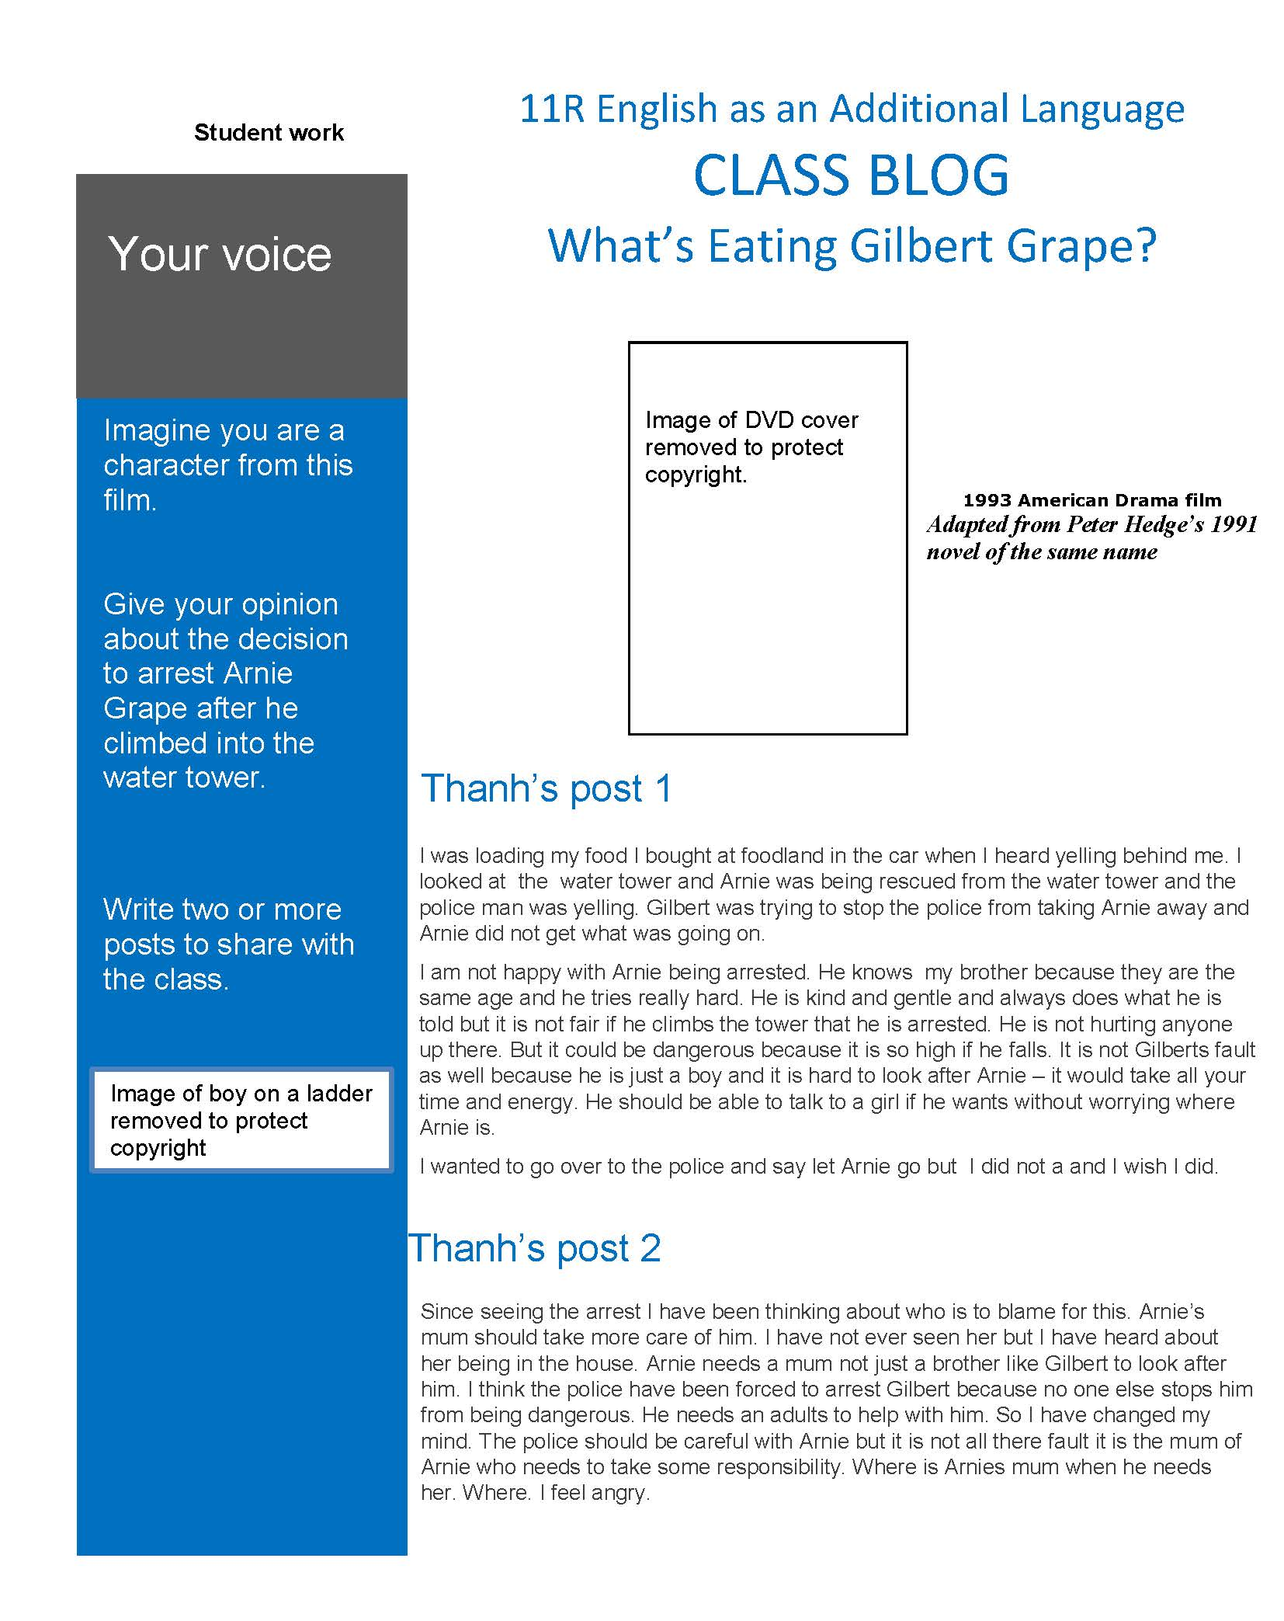
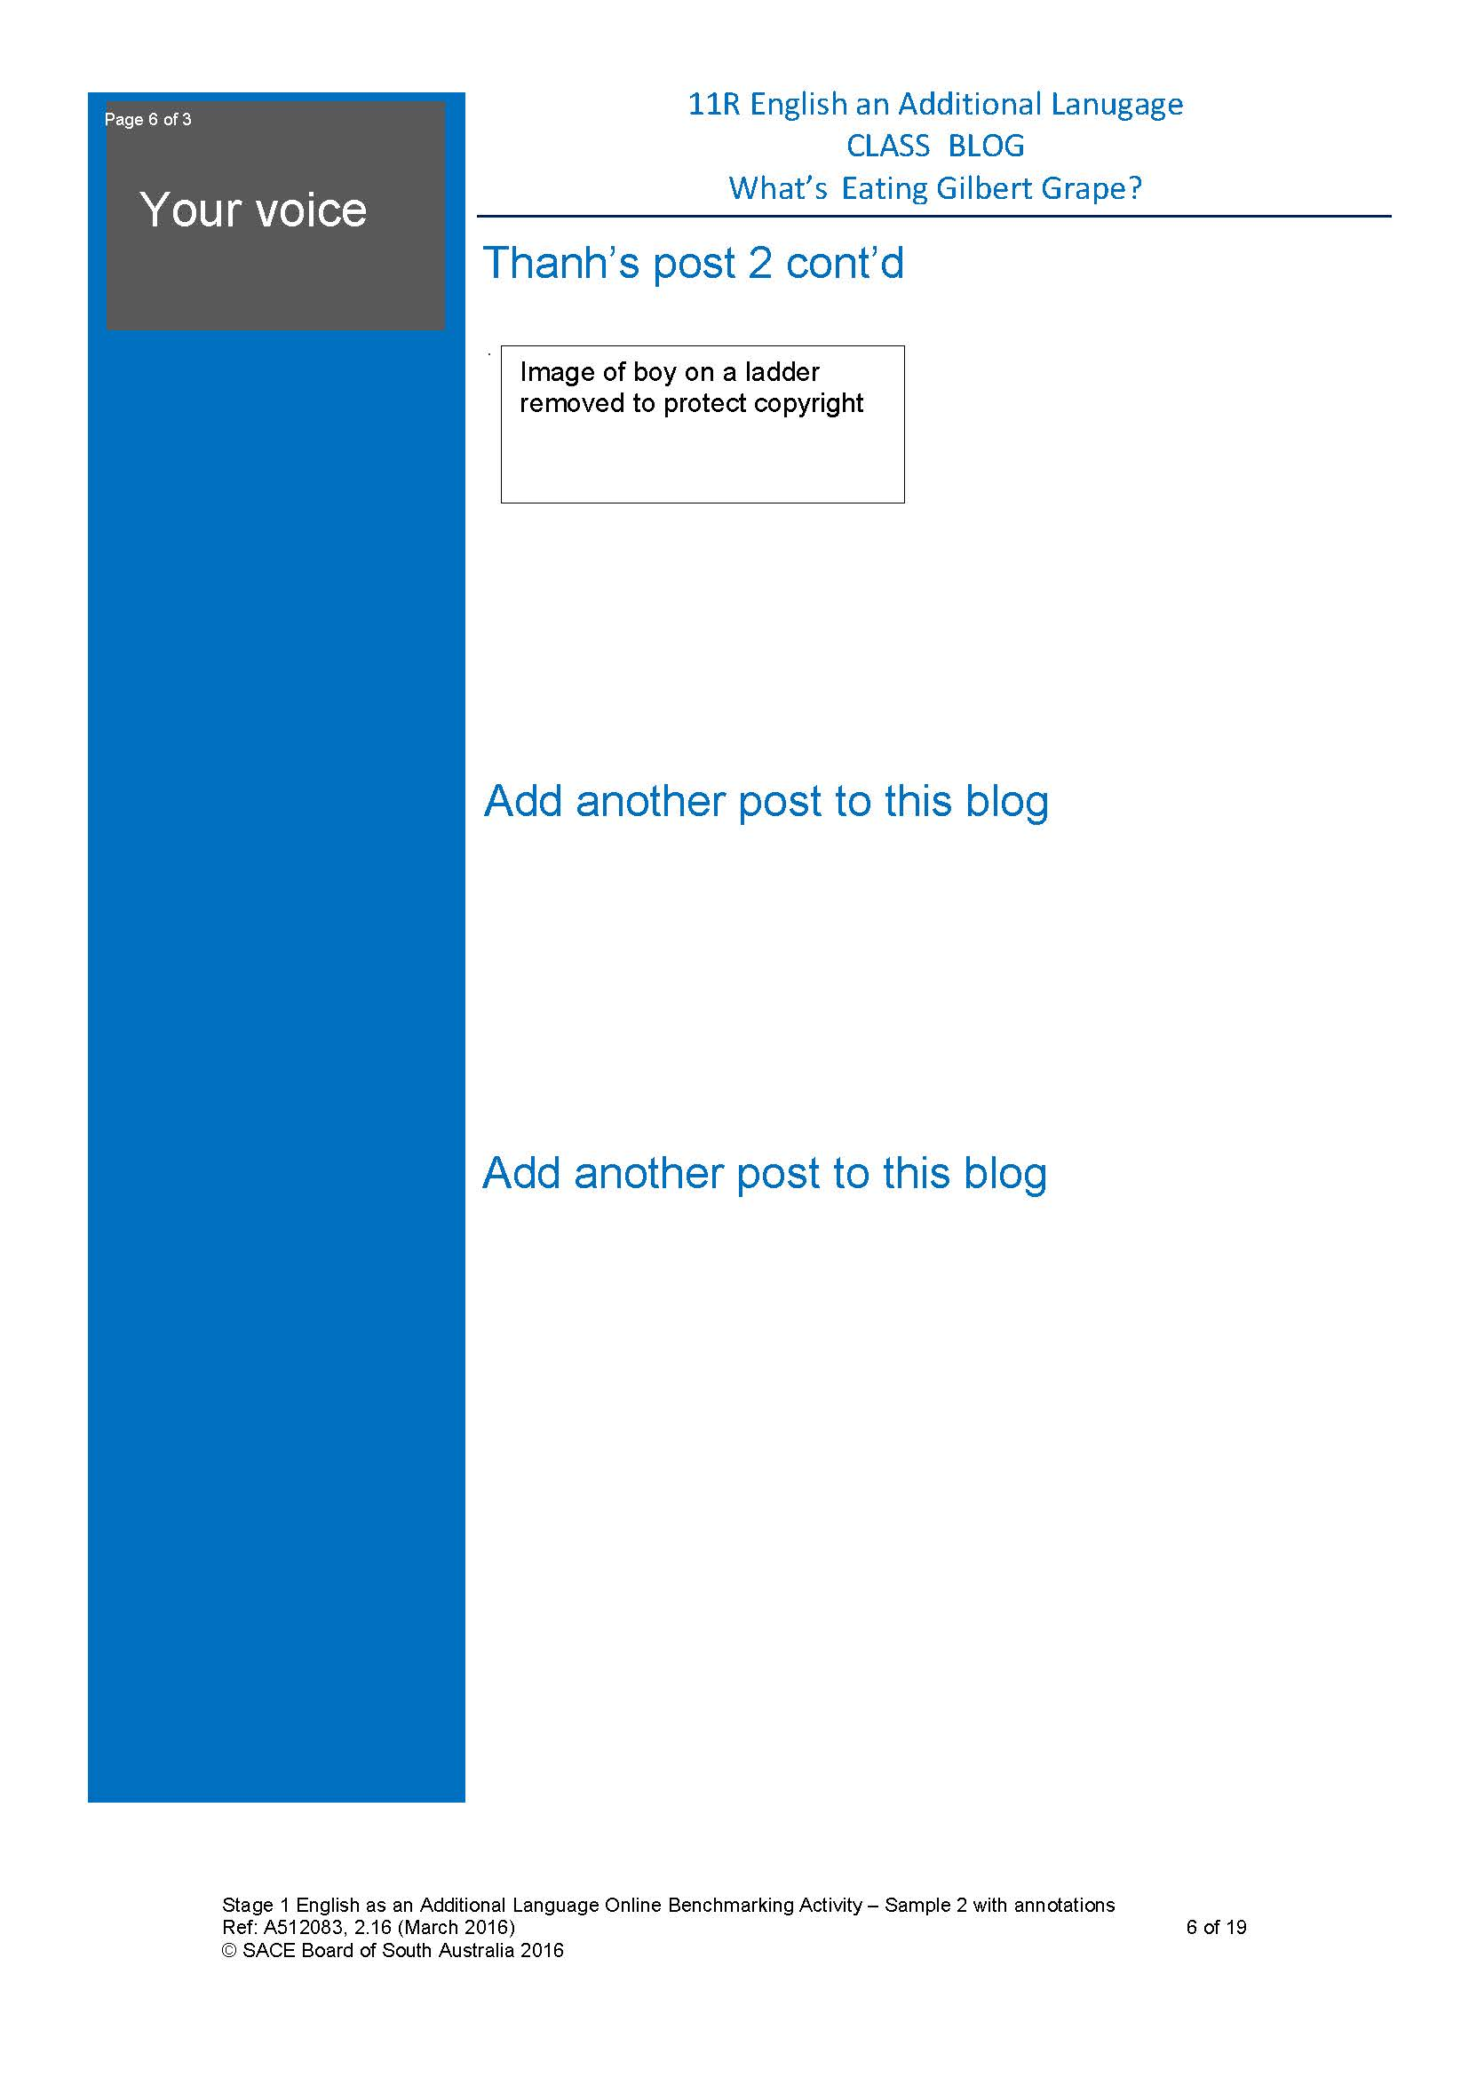

Assessment task 2

Assessment Type 1: Responding to Texts

Oral Response

As a class we have read and listened to the lyrics of John Lennon’s Imagine and Joan Armatrading’s More than One Kind of Love.

Reflect on the message in the lyrics and how relevant the message is today. Prepare an oral response using the guide below. (C1 and Ap1)

Task Description: Oral response

Compare the similarities in the songs Imagine and More than One Kind of Love.
(Cp1 and Cp2)
As a guide:
- consider the social perspectives evident in both songs (An1)
- give your personal perspective on the messages in the songs (An1)
- use evidence from the text to support your point of view. (Ap2)

Your response should be a maximum of 5 minutes.

Assessment Design Criteria

Communication
C1 Clarity and coherence of written and spoken expression, using appropriate
vocabulary

Comprehension
Cp1 Comprehension and interpretation of information, ideas and opinions in texts
Cp2 Understanding of the purpose, structure, and language features of texts

Analysis
An1 Analysis of personal, social, and cultural perspectives in texts

Application
Ap1 Use of language features and conventions for different purposes and
audiences
Ap2 Selection of evidence and examples to support a point of view

Getting started

Before you are able to present your work orally you will need to consider your thoughts and put this down in writing. Jot down notes in relation to the task requirements. You may like to prepare this into a piece of writing to make your ideas flow and ensure they are logical and well organised.

From this you should develop cue cards as your oral will flow better from looking at your dot points rather than reading a script from your longer draft of writing.

What is reflective writing/speaking?

Reflective writing and speaking is evidence of reflective thinking. In an academic context, reflective thinking usually involves:
  - Looking back at something (often an event, i.e. something that happened, but it could also be an idea or object. In this case it is song lyrics).
  - Analysing the event or idea (thinking in depth and from different perspectives).
  - Thinking carefully about what the event or idea means for you and your ongoing progress as a learner and/or practising professional.

Reflective writing/speaking is thus more personal than other kinds of academic writing. We all think reflectively in everyday life.

A possible structure for reflective writing/speaking

Description (keep this bit short!)
- What happened?
- What is being examined?

Interpretation
- What is most important / interesting / useful / relevant about songs/ideas?
- How can it be explained?
- How is it similar to and different from others?

Outcome
- What have I learned from this?
- What does this mean for my future?

Language Features of reflective writing / speaking

- You can write/speak in the first person when you are reflecting. That is, you can include yourself (I, me, we) in your writing/speaking when you are expressing personal experiences, observations or opinions.
- When you are referring to theory or other writers you should write in the third person. That is, refer to other writers by name and try not to use I, or me.
- The actions (verbs) when you reflect are usually those of feeling and thinking e.g. feeling, felt, considered, experienced, wondered, remembered, discovered, learned.
- When you are reflecting, if your opinion is not all that strong, you can modify or soften it by using words like may, perhaps or might.

Assessment task 2 – Responding to Texts

 | Communication | Comprehension | Analysis | Application
A | Consistently clear and coherent writing and speaking, using a diverse and sophisticated vocabulary.  Thorough and consistent demonstration of grammatical control and complexity. | Insightful comprehension and interpretation of complex information, ideas, and opinions in texts.  Thorough and effective understanding of the purpose, structure, and language features of texts. | Thorough analysis of personal, social, and cultural perspectives in texts.  Consistently clear analysis of ways in which texts are created for specific purposes and audiences. | Consistent use of complex language features and conventions for different audiences and purposes.  Discerning selection and use of relevant evidence and examples from a range of sources to support a point of view.
B | Mostly clear and coherent writing and speaking, using a varied vocabulary.  Effective and usually accurate grammatical control and complexity. | Detailed comprehension and interpretation of some complex information, ideas, and opinions in texts.  Well-considered understanding of the purpose, structure, and language features of texts. | Effective analysis of personal, social, and cultural perspectives in texts.  Well-considered analysis of ways in which texts are created for specific purposes and audiences. | Effective use of language features and conventions for different audiences and purposes.  Considered selection and use of evidence and examples from a range of sources to support a point of view.
C | Generally clear and coherent writing and speaking, with an appropriate vocabulary.  Appropriate grammatical control; some errors, but these do not impede meaning. | Appropriate comprehension and interpretation of information, ideas, and opinions in texts.  Appropriate understanding of the purpose, structure, and language features of some texts. | Some analysis of personal, social, and cultural perspectives in texts.  Analysis with some description of ways in which texts are created for purposes and audiences. | Appropriate use of language features and conventions for different audiences and purposes.  Selection of evidence and examples from a range of sources to support a point of view.
D | Occasionally clear and coherent writing and speaking, with a restricted vocabulary.  Partial grammatical control; some errors impede meaning. | Comprehension of aspects of information, ideas, and/or opinions in texts.  Some recognition and awareness of the purpose, structure, and/or language features of texts. | Recognition of personal, social, and/or cultural perspectives in texts.  Identification of ways in which texts are created for specific purposes and audiences. | Some use of language features and conventions.  Selection of some evidence and examples from a narrow range of sources.
E | Limited clarity and coherence in writing and speaking with a limited vocabulary.  Limited grammatical control; errors impede meaning. | Limited comprehension of information or ideas in a text.  Limited recognition and awareness of the purpose, structure, and language features of a text. | Limited recognition of personal, social, and/or cultural perspectives in texts.  Identification a purpose or audience for a text. | Attempted use of language features and conventions.  Selection of some evidence from a source.

Assessment task 2 – Responding to Texts – student work
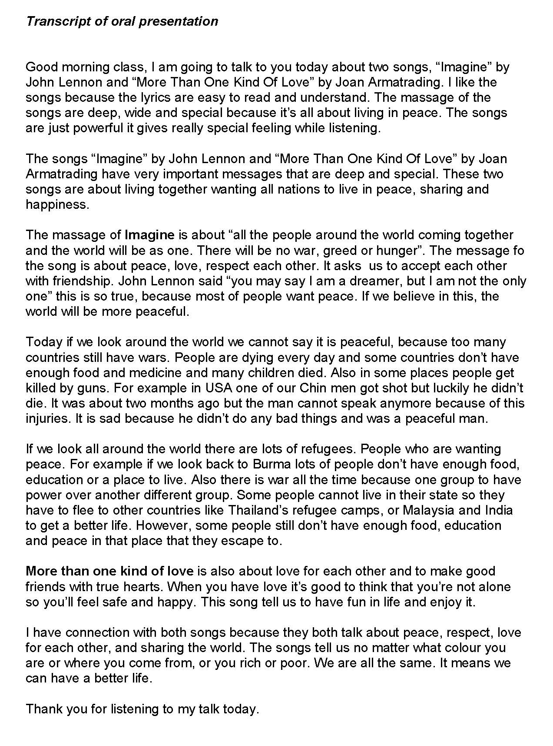

Assessment task 3

ASSESSMENT TYPE 2: INTERACTIVE STUDY (DISCUSSION)
Purpose
The purpose of this task is to provide an opportunity for you to:
- comprehend and understand the ideas, opinions or perspectives evident in at least two texts
- discuss with clarity and coherence using the spoken word with appropriate vocabulary
- select evidence to support your point of view.
Task Description
- View the films “Gattaca”, “The Island” and the “Insight Program” (9 October 2012) to gain an understanding of some of the ways that the use of genetic modification to design babies could impact on society.
  - Present, explain and discuss with your teacher the ideas, opinions, or perspectives you have studied with reference to the texts. (Cp1, An1)
  - Be prepared to lead the discussion and demonstrate grammatical control and complexity. (C1, C2)
    - Prepare cue cards or similar for the discussion
    - Make notes and draft your response
  - Be prepared to answer open-ended questions by the teacher such as:
    - Explain the similarities and/or differences between the texts.
    - What evidence did you find to support ….?
    - Could you elaborate on that point?
    - How do you think this issue is viewed by those with whom you disagree? (Cp1)
  - Support your views with evidence and examples from the films and documentary. (Ap2)
Assessment conditions
An oral of a maximum of 5 minutes which includes your presentation, explanation and discussion

Assessment design criteria

Communication
C1 Clarity and coherence of written and spoken expression, using appropriate vocabulary
C2 Demonstration of grammatical control and complexity.

Comprehension
Cp1 Comprehension and interpretation of information, ideas, and opinions in texts.

Analysis
An1 Analysis of personal, social, and cultural perspectives in texts.

Application
Ap2 Selection of evidence and examples to support a point of view.

Assessment task 3 – Interactive Study (Discussion)

 | Communication | Comprehension | Analysis | Application
A | Consistently clear and coherent writing and speaking, using a diverse and sophisticated vocabulary.  Thorough and consistent demonstration of grammatical control and complexity. | Insightful comprehension and interpretation of complex information, ideas, and opinions in texts.  Thorough and effective understanding of the purpose, structure, and language features of texts. | Thorough analysis of personal, social, and cultural perspectives in texts.  Consistently clear analysis of ways in which texts are created for specific purposes and audiences. | Consistent use of complex language features and conventions for different audiences and purposes.  Discerning selection and use of relevant evidence and examples from a range of sources to support a point of view.
B | Mostly clear and coherent writing and speaking, using a varied vocabulary.  Effective and usually accurate grammatical control and complexity. | Detailed comprehension and interpretation of some complex information, ideas, and opinions in texts.  Well-considered understanding of the purpose, structure, and language features of texts. | Effective analysis of personal, social, and cultural perspectives in texts.  Well-considered analysis of ways in which texts are created for specific purposes and audiences. | Effective use of language features and conventions for different audiences and purposes.  Considered selection and use of evidence and examples from a range of sources to support a point of view.
C | Generally clear and coherent writing and speaking, with an appropriate vocabulary.  Appropriate grammatical control; some errors, but these do not impede meaning. | Appropriate comprehension and interpretation of information, ideas, and opinions in texts.  Appropriate understanding of the purpose, structure, and language features of some texts. | Some analysis of personal, social, and cultural perspectives in texts.  Analysis with some description of ways in which texts are created for purposes and audiences. | Appropriate use of language features and conventions for different audiences and purposes.  Selection of evidence and examples from a range of sources to support a point of view.
D | Occasionally clear and coherent writing and speaking, with a restricted vocabulary.  Partial grammatical control; some errors impede meaning. | Comprehension of aspects of information, ideas, and/or opinions in texts.  Some recognition and awareness of the purpose, structure, and/or language features of texts. | Recognition of personal, social, and/or cultural perspectives in texts.  Identification of ways in which texts are created for specific purposes and audiences. | Some use of language features and conventions.  Selection of some evidence and examples from a narrow range of sources.
E | Limited clarity and coherence in writing and speaking with a limited vocabulary.  Limited grammatical control; errors impede meaning. | Limited comprehension of information or ideas in a text.  Limited recognition and awareness of the purpose, structure, and language features of a text. | Limited recognition of personal, social, and/or cultural perspectives in texts.  Identification a purpose or audience for a text. | Attempted use of language features and conventions.  Selection of some evidence from a source.

Assessment task 3 – Interactive Study (Discussion)

Discussion between teacher and student using the following questions:

Explain what you believe to be the key messages about genetic modification to design babies from the movies and documentary?

Explain the similarities between the texts?

Explain the differences between the texts?

Based on the texts, explain your personal opinion on the concept of genetic modification.

How does genetic modification to design babies affect society as shown in the texts?

Assessment task 3 – Interactive Study (Discussion) – student work

Click here to access audio file

(5 minutes)

Assessment task 4
ASSESSMENT TYPE 3: LANGUAGE STUDY
Purpose
The purpose of this task is to provide an opportunity for you to:
- identify and analyse aspects of language used in one or more texts
Task Description
As a class, we have reviewed music video clips.

- Choose a music video clip and identify and analyse the language used to reflect sociocultural aspects such as age, gender, race, identity (An1)
  - When analysing aspects of language contained in the music video clip ensure you discuss the:
    - specific purpose and audience eg Whom is the video aimed at? (An2)
    - structure and language features eg Explore the visual images, song lyrics, camera shots (Cp2)
    - ideas, opinions or perspectives expressed eg Explain the meaning of the song lyrics, explore stereotyping if applicable (Cp1)
- Use examples from the music videos to support your analysis of the language used in the music video clip. (Ap2)
Assessment conditions
An oral presentation to a maximum of 5 minutes or a written response to a maximum of 800 words; or the equivalent in multi-modal form.

Assessment design criteria

Communication
C2 Demonstration of grammatical control and complexity

Comprehension
Cp1 Comprehension and interpretation of information, ideas, and opinions in texts.
Cp2 Understanding of the purpose, structure, and language features of texts.

Analysis
An1 Analysis of personal, social, and cultural perspectives in text
An2 Analysis of the ways in which texts are created for specific purposes and audiences.

Application
Ap2 Selection of evidence and examples to support a point of view.

Assessment task 4 – Language Study

 | Communication | Comprehension | Analysis | Application
A | Consistently clear and coherent writing and speaking, using a diverse and sophisticated vocabulary.  Thorough and consistent demonstration of grammatical control and complexity. | Insightful comprehension and interpretation of complex information, ideas, and opinions in texts.  Thorough and effective understanding of the purpose, structure, and language features of texts. | Thorough analysis of personal, social, and cultural perspectives in texts.  Consistently clear analysis of ways in which texts are created for specific purposes and audiences. | Consistent use of complex language features and conventions for different audiences and purposes.  Discerning selection and use of relevant evidence and examples from a range of sources to support a point of view.
B | Mostly clear and coherent writing and speaking, using a varied vocabulary.  Effective and usually accurate grammatical control and complexity. | Detailed comprehension and interpretation of some complex information, ideas, and opinions in texts.  Well-considered understanding of the purpose, structure, and language features of texts. | Effective analysis of personal, social, and cultural perspectives in texts.  Well-considered analysis of ways in which texts are created for specific purposes and audiences. | Effective use of language features and conventions for different audiences and purposes.  Considered selection and use of evidence and examples from a range of sources to support a point of view.
C | Generally clear and coherent writing and speaking, with an appropriate vocabulary.  Appropriate grammatical control; some errors, but these do not impede meaning. | Appropriate comprehension and interpretation of information, ideas, and opinions in texts.  Appropriate understanding of the purpose, structure, and language features of some texts. | Some analysis of personal, social, and cultural perspectives in texts.  Analysis with some description of ways in which texts are created for purposes and audiences. | Appropriate use of language features and conventions for different audiences and purposes.  Selection of evidence and examples from a range of sources to support a point of view.
D | Occasionally clear and coherent writing and speaking, with a restricted vocabulary.  Partial grammatical control; some errors impede meaning. | Comprehension of aspects of information, ideas, and/or opinions in texts.  Some recognition and awareness of the purpose, structure, and/or language features of texts. | Recognition of personal, social, and/or cultural perspectives in texts.  Identification of ways in which texts are created for specific purposes and audiences. | Some use of language features and conventions.  Selection of some evidence and examples from a narrow range of sources.
E | Limited clarity and coherence in writing and speaking with a limited vocabulary.  Limited grammatical control; errors impede meaning. | Limited comprehension of information or ideas in a text.  Limited recognition and awareness of the purpose, structure, and language features of a text. | Limited recognition of personal, social, and/or cultural perspectives in texts.  Identification a purpose or audience for a text. | Attempted use of language features and conventions.  Selection of some evidence from a source.

Assessment task 4 – Language Study – student work

