Stage 1 Biology

Skills and Applications Task 1

Cells, Human Physiology and Immunology

Section A: Multiple Choice Questions
Select the alternative that you consider best answers the question by circling the appropriate letter beside that alternative.

- Which one of the following components is found in eukaryotic cells but not in prokaryotic cells?
  - Chloroplasts
Knowledge and Understanding
Answers questions 1 and 2 correctly, and 3 incorrectly, to demonstrate some knowledge and understanding of concepts related to the topics – cells and human physiology.
  - DNA
  - Cell membrane
  - Protein

- Plant cells can usually be distinguished from animal cells because only plant cells possess:
  - cell walls and mitochondria
  - Golgi bodies and central vacuoles
  - Cell walls and central vacuoles
  - Chromosomes and mitochondria

- Which choice below correctly identifies a component of the blood and a substance transported by that component?

 | Blood Component | Substance Transported
J. | platelets | haemoglobin
K. | white blood cells | carbon dioxide
L. | red blood cells | oxygen
M. | plasma | urine

The next 4 questions refer to the diagram of a human heart below.

- Structure 8 is called the
  - Left atrium
  - Right atrium
  - left ventricle
Knowledge and Understanding
Answers questions 4, and 5 correctly demonstrating knowledge and understanding of concepts related to the topics – cells and human physiology.
Answers question 6 and 7 incorrectly.
  - right ventricle

- Structure 2 is called the
  - Pulmonary vein
  - Pulmonary artery
  - Vena cava
  - Aorta

- Which of the following groups all transport oxygenated blood?
  - 1,2,8 and 10
  - 1,3,4 and 6
  - 2,3,8 and 10
  - 2,8,10 and 11

- Which of the following is a correct sequence of blood flow?
  - 8, 2, body, 3, 4
  - 6 ,1 ,body, 11, 10
  - 4, 3, lungs, 2, 8
  - 10, 11, lungs, 2, 8

Task annotation
Identification of ‘false’ can be more difficult for students because there are three correct answers.
- Antigens are found on the surface of all living cells. An individual’s immune system recognizes the antigens on the surface of their cells as ‘self’. In the event of an organ donation the antigens on the surface of the organs are different to that of the recipient and are therefore considered to be ‘foreign’ or ‘non-self’. Which of the following statements is false?
  - Cyclosporin specifically targets the white blood cells responsible for organ rejection.
  - The self antigens on the surface of an individual’s cells are known as HLA proteins
Application
Correctly applies knowledge to identify false application of biological concept in two situations.
  - White blood cells and antibodies are both responsible for the recognition of foreign or non-self antigens
  - Eventually, after numerous years a transplanted organ will no longer be considered ‘foreign’ by a recipient’s immune system.

- Blood typing is necessary before blood transfusions. People with blood belonging to the ‘A’ blood group can only give blood to:

Recipient
 | A | B | AB | O
J. | ✓ | ✓ | ✓ | ✓
K. | ✓ | X | ✓ | X
L. | ✓ | ✓ | ✓ | X
M. | X | X | X | ✓
Application
Incorrectly applies knowledge when identifying correct blood type.

- The function of the mitochondria can be best described as follows:
  - It controls all the activities of the cells
  - It is the power-house of the cell
  - It is responsible for protein synthesis
  - Is a semi-permeable structure that controls the entry and exit of small molecules

- Refer to the following graph, which shows the level of a specific antibody in the blood after one injection of a vaccine and after two injections of a vaccine
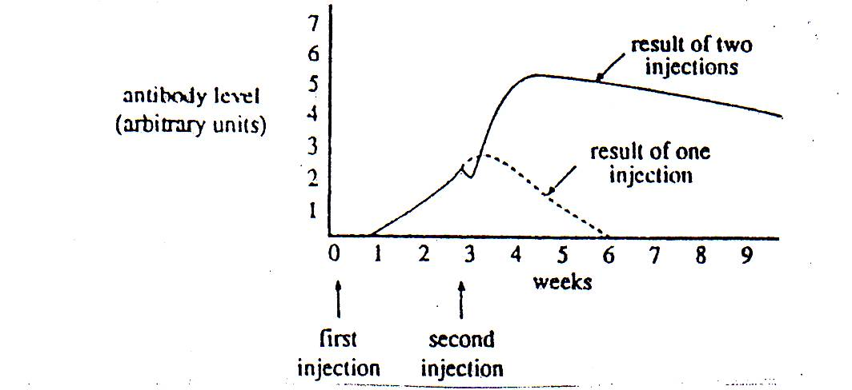
Application
Incorrectly applies knowledge and evidence when identifying an application of a biological concept about antibodies and vaccines.
The small decrease in the antibody level immediately after the second injection of vaccine is the result of the:
  - antigens in the vaccine being neutralized by antibodies in the blood.
  - antibodies in the vaccine being neutralized by antibodies in the blood.
  - antibodies in the vaccine being neutralized by antigens in the blood.
  - antigens in the vaccine being neutralized by antigens in the blood.

- Compared to a light microscope, an electron microscope would give
  - a greater resolution but a smaller magnification.
  - a greater resolution and a larger magnification.
  - a smaller resolution and a smaller magnification.
  - a smaller resolution and a larger magnification.
Task annotation
Questions 13 (b) and (c) allow for demonstration of ability to apply knowledge and understanding at a higher level.
Section B: Short Answer Questions:
- (a) Identify 3 structural features of the lungs.
(1) Lungs have a big surface.
(2) They have lots of blood vessels.
(3) They are moist.

(b) Select 2 of the above and explain how they improve the efficiency of gas exchange in the lungs.
Knowledge and Understanding
Demonstrates knowledge of gas exchange without explaining efficiency.
(1) moist – This helps diffusion because it works best on a moist surface.

(2) big surface – If there’s a big surface then there’s lots of room for exchange.

(c) Describe the physical factors that would limit the complete exchange of oxygen from the air into the alveoli.
Knowledge and Understanding
Demonstrates knowledge and understanding to identify a physical factor that limits oxygen exchange.
Have damaged their lungs, surface area smaller.

(d) A cellular process needs oxygen to release energy. Write a word equation that describes this process.
Application
Correctly uses biological terms and equations, for a purpose but has misread the question and not answered the question correctly.
C₆H₁₂O₆ + 6O₂ → 6CO₂ + 6H₂O

- The graph below shows the result of an experiment in which some plant tissue was placed in a range of different solutions of sucrose. After 60 minutes the percentage change in weight was measured and the results are represented in the graph below.

(a) At what percentage concentration of sucrose is there no change in the weight of the tissue?
3%
Knowledge and Understanding and Application
Explanation needs more detail e.g. ‘… the same concentration … and appropriate biological terms.

(b) Explain one reason why there would be no change in the weight at this point.
Because it’s the same on the inside as the outside

(c) Describe the process occurring in the plant tissue to cause a percentage increase in weight in the tissue when it is placed in a solution that has a low concentration of sucrose.
Application
Has given a minimal explanation of the process but has not described the process as stated in the question.
Because in a low concentration solution the tissues contain a higher percentage of sucrose so the solution is absorbed into the tissue to dilute the sucrose.

- A person is brought into hospital during an emergency, but is declared brain dead shortly after being admitted. Her driver’s licence indicates that she has agreed to donate her organs. After a number of medical tests the doctors say that she is a suitable organ donor for a number of patients on the waiting list.
Application
Correctly applies biological concepts related to the suitability of organs for donation.
(a) State two factors that contribute to her suitability as an organ donor.
(1) the organs are healthy.

(2) the organs are of an appropriate size.

Knowledge and Understanding
Identifies and explains some biological information that is relevant to a social issues - needs more than one sentence in response to a discuss type question.
(b) Explain the difference between cardiac death and brain death.
Cardiac death means the heart has stopped beating, brain death means the brain has died permanently.

(c) Discuss two different ethical perspectives that could arise if her family does not agree with her decision to donate.
The family do not agree because of their religion.

- A student examined stained onion root tip cells undergoing cell division using a light microscope.
(a) State the purpose of staining the onion root tip cells.
To be able to see individual cells, and parts of the cells.

(b) Under 100x magnification the student observed 8 cells across the diameter of the field of view. How many cells would the student observe under 400x magnification. Show your working.

2 cells

(c) If the diameter of the low power field of view is 1600 µm calculate the average length of each onion root tip cell. Show your working.

200 µm

(d) State two reasons why cells undergo cell division.
(1) Replace worn out cells
(2) To increase in number

The four photographs below show cells undergoing cell division.
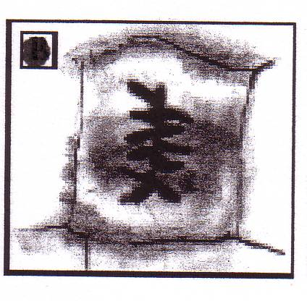 | 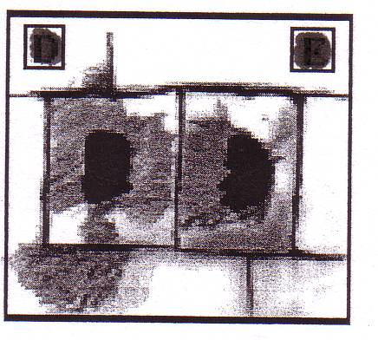 | 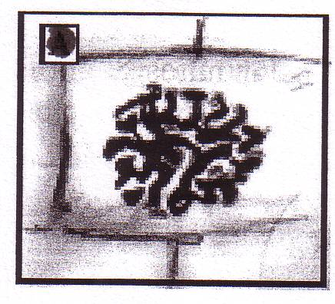 | 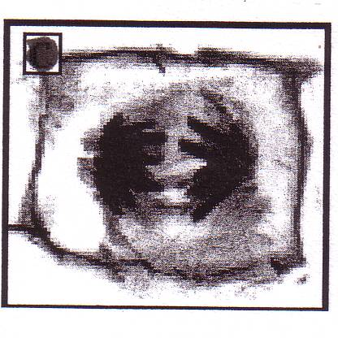
A | B | C | D
(e) Using the letters in the photos of cells undergoing cell division, place the letters in the correct mitotic sequence
C, A, D, B

- The dimensions of two different cells are shown below as well as details of their surface area and the formula for calculating volume.

2 cm
2 cm
1 cm
1cm
3 cm
2 cm
A
B
Formula: Volume = length x width x height
Cell A has a surface area of 14 cm²
Cell B has a surface area of 24 cm²
(i) Calculate the Surface Area to Volume Ratio for each of the cells.
Show your working out:
Volume A: 3 x 1 x 1 = 3 cm³
Volume B: 2 x 2 x 2 = 8 cm³
SA ; Vol Cell A = 14 : 3 = 5 : 1 SA ; Vol Cell B = 24 : 8 = 3 : 1

(ii) Considering the Surface area to Volume ratio only, state which cell is more likely to divide, explain your answer.
A cannot evenly distribute nutrients to survive must halve, decrease SA : Vol ratio so the nutrients dispersed more evenly.

Task annotation
- The test has12 multiple choice questions and 4 short answer questions. Both categories start with simpler tasks such as recall of knowledge and understanding but later in the test, questions allow for higher order responses.
- There is a range of question types requiring interpretation and/or analysis of text, diagrams, tables and graphs, experimental evidence, calculations and social/ethical issues.
- More than one assessment task would need to be considered to assess a student’s ability to Demonstrate knowledge and understanding of a general range of biology concepts. (Knowledge and Understanding).

Performance Standards for Stage 1 Biology
 | Investigation | Analysis and Evaluation | Application | Knowledge and Understanding
A | Designs a logical, coherent, and detailed biological investigation.  Critically and logically selects and consistently and appropriately acknowledges information about biology and issues in biology from a range of sources.  Manipulates apparatus and technological tools carefully and highly effectively to implement well-organised safe and ethical investigation procedures.  Obtains, records, and displays findings of investigations using appropriate conventions and formats accurately and highly effectively. | Systematically analyses data and their connections with concepts to formulate logical and perceptive conclusions and make relevant predictions.  Logically evaluates procedures and suggests a range of appropriate improvements. | Applies biological concepts and evidence from investigations to suggest solutions to complex problems in new and familiar contexts.  Uses appropriate biological terms, conventions, formulae, and equations highly effectively.  Demonstrates initiative in applying constructive and focused individual and collaborative work skills. | Consistently demonstrates a deep and broad knowledge and understanding of a range of biological concepts.  Uses knowledge of biology perceptively and logically to understand and explain social or environmental issues.  Uses a variety of formats to communicate knowledge and understanding of biology coherently and highly effectively.
B | Designs a well-considered and clear biological investigation.  Logically selects and appropriately acknowledges information about biology and issues in biology from different sources.  Manipulates apparatus and technological tools carefully and mostly effectively to implement organised safe and ethical investigation procedures.  Obtains, records, and displays findings of investigations using appropriate conventions and formats mostly accurately and effectively. | Logically analyses data and their connections with concepts to formulate consistent conclusions and mostly relevant predictions.  Evaluates procedures and suggests some appropriate improvements. | Applies biological concepts and evidence from investigations to suggest solutions to problems in new and familiar contexts.  Uses appropriate biological terms, conventions, formulae, and equations effectively.  Applies mostly constructive and focused individual and collaborative work skills. | Demonstrates some depth and breadth of knowledge and understanding of a range of biological concepts.  Uses knowledge of biology logically to understand and explain social or environmental issues.  Uses a variety of formats to communicate knowledge and understanding of biology coherently and effectively.
C | Designs a considered and generally clear biological investigation.  Selects with some focus, and mostly appropriately acknowledges, information about biology and issues in biology from different sources.  Manipulates apparatus and technological tools generally carefully and effectively to implement safe and ethical investigation procedures.  Obtains, records, and displays findings of investigations using generally appropriate conventions and formats with some errors but generally accurately and effectively. | Analyses data and their connections with concepts to formulate generally appropriate conclusions and make simple predictions with some relevance  Evaluates some procedures in biology and suggests some improvements that are generally appropriate. | Applies biological concepts and evidence from investigations to suggest some solutions to basic problems in new or familiar contexts.  Uses generally appropriate biological terms, conventions, formulae, and equations with some general effectiveness.  Applies generally constructive individual and collaborative work skills. | Demonstrates knowledge and understanding of a general range of biological concepts.  Uses knowledge of biology with some logic to understand and explain one or more social or environmental issues.  Uses different formats to communicate knowledge and understanding of biology with some general effectiveness.
D | Prepares the outline of a biological investigation.  Selects and may partly acknowledge one or more sources of information about biology or an issue in biology.  Uses apparatus and technological tools with inconsistent care and effectiveness and attempts to implement safe and ethical investigation procedures.  Obtains, records, and displays findings of investigations using conventions and formats inconsistently, with occasional accuracy and effectiveness. | Describes basic connections between some data and concepts and attempts to formulate a conclusion and make a simple prediction that may be relevant.  For some procedures, identifies improvements that may be made. | Applies some evidence to describe some basic problems and identify one or more simple solutions, in familiar contexts.  Attempts to use some biological terms, conventions, formulae, and equations that may be appropriate.  Attempts individual work inconsistently, and contributes superficially to aspects of collaborative work. | Demonstrates some basic knowledge and partial understanding of biological concepts.  Identifies and explains some biological information that is relevant to one or more social or environmental issues.  Communicates basic information to others using one or more formats.
E | Identifies a simple procedure for a biological investigation.  Identifies a source of information about biology or an issue in biology.  Attempts to use apparatus and technological tools with limited effectiveness or attention to safe or ethical investigation procedures.  Attempts to record and display some descriptive information about an investigation, with limited accuracy or effectiveness. | Attempts to connect data with concepts, formulate a conclusion and make a prediction.  Acknowledges the need for improvements in one or more procedures. | Identifies a basic problem and attempts to identify a solution in a familiar context.  Uses some biological terms or formulae.  Shows emerging skills in individual and collaborative work. | Demonstrates some limited recognition and awareness of biological concepts.  Shows an emerging understanding that some biological information is relevant to social or environmental issues.  Attempts to communicate information about biology.

