STAGE 2 MUSICAL STYLES
ASSESSMENT TYPE 2: INVESTIGATION

MAZURKA
Mazurka-Choro by Heitor Villa-Lobos
Marietta by Francisco Tarrega

Mazurka
The Mazurka is a Polish dance from the 16th century played in triple time with the second and occasionally third beat accented. The word Mazurka comes from the word mazur, which was the name given to the inhabitants of the Mazovia district df Poland.' The origins of the Mazurka came from the folk dances of this region including the slower Kujawiak which is one of five national dances in Poland, the mazur or mazurek and the faster, lively Oberek.² Although each have distinguishing features, they share certain characteristics common to all including triple time.
Analysis
Well-considered analysis and understanding of music in its historical and cultural context.
Mazurka rhythms are mainly in 3/4 or 3/8 time. The first beat is frequently a dotted quaver semi-quaver, the use of a triplet or occasionally two quavers. The second or third beat is syncopated by an accent. The main differences between the dances that will be analyzed here are the tempo's not so much the rhythm. The rhythms below are commonly used in Mazurkas.
Analysis
Well-considered analysis of stylistic features.
Notice that bar 1 of rhythm B and E are identical, though written differently
A
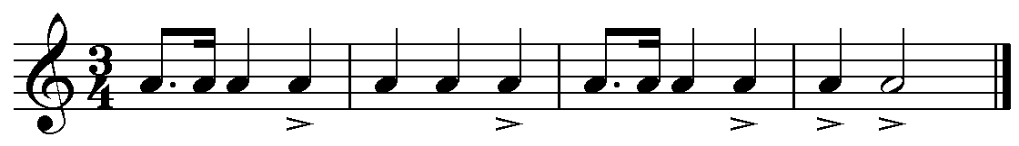
B
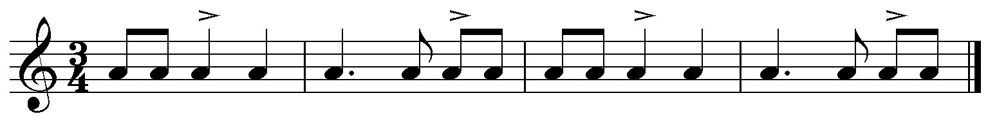
E
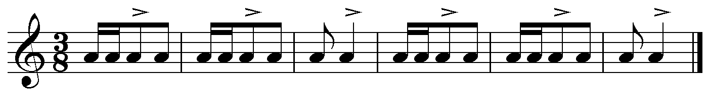

¹ Grove dictionary of Music, Mazurka,
² Ibid
History:
The Mazurka gradually spread to neighboring countries inspiring composers to write Mazurkas including Russian composers Tchaikovsky and Glinka and French composers Ravel and Debussy. The Mazurka rhythm can also be found in Cajun Music and noticeably in the guitar based music of Cape Verde Islands. Cajun people mainly reside in Louisiana, of America. They are French speaking settlers of an ethnic group, which in today's society make up a considerable amount of South Louisiana's population. 6
Frederic Chopin (1810-1849) was a Polish composer and a highly skilled pianist in the 19th century. Chopin developed the mazurka into a European art music form, composing 58 Mazurkas for the piano.' Chopin wrote his first Mazurka in 1810 and continued writing Mazurka's until the time of his death in 1849.⁸ Chopin arrived in Paris in 1831 where he published Mazurka op. 6 and 7. It was in 1847, two years before his death that Chopin completed the Mazurkas, op. 63. During the year of his death he became more ill, but never the less he continued writing. Chopin began planning his last composition, which was the Mazurka in F minor. Unfortunately Chopin was unable to finish his last composition. Frederic Chopin passed away on the 17th of October 1849.⁹ Some of the Mazurka's were then transcribed by composers such as Francisco Tarrega and Heitor Villa-Lobos for the guitar.
Analysis
Well-considered analysis and understanding of music in its historical and cultural context.
The Spanish had a rich tradition of works in 3/4 and 6/8 time and 12 beat cycle's for example folk music and flamenco which shares similarities to Mazurka accents, such as fandangos, malaguena, or sevillanas.
Analysis
Considered analysis of stylistic features.
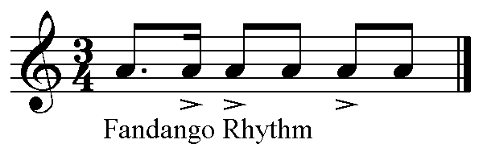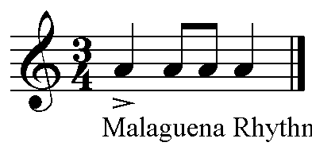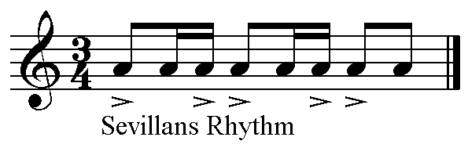

Discussion of Works - (see appendix for the notated scores.)
The "Mazurka - Choro" by Heitor Villa-Lobos and the "Marieta" by Francisco Tarrega are two Mazurkas of the standard classical guitar repertoire. The Mazurka form is widely used in concerts and new works are still being composed to this day, such as those by Australian Julian Cochran."0
Analysis
Well-considered analysis and understanding of music in its historical and cultural context.
Heitor Villa-Lobos (1887-1959) was a well-known 20th Century Brazilian guitarist and composer. He was a street performer in his youth. In addition Villa-Lobos played the cello and composed many orchestral, chamber, and instrumental works. He stayed in Paris in 1923 to 1924 and from 1927 to
fitttP.^{j}.1.14/21.15(-614,^{g}dldf,..kil^{g}Aidiall ... .....
7 http://www,pianosociety.comicms/index.php?section=127
8 httpj/www.culture,sdenjcultureiartykulyidz chopin mazurki httpj/www.dartmouth.edui—music33/Mus33projectsjnodes/Chopin/paris.html
10 http://www.absoluteastronomy,com/topics/Mazurka
1930 to further his study of music composition and to organize concerts.'1 Here he gained influence and exposure to the style of the Mazurka. Villa-Lobos also discovered a connection with the Choro/Valse which is a Brazilian folk/cultural rhythm and the Mazurka.12
Mazurka-Choro.by: Heitor Villa-Lobos
Mazurka-Choro by Heitor Villa-Lobos is one of 5 pieces that comes from the book The Suite Populaire Bresilienne which was composed during 1908 to 1912
Analysis
Considered analysis and understanding of music in its historical and cultural context.
Choro comes from the Portuguese Chorar which means to "weep", "lament" or "cry"). The Choro is compatible with the Mazurka because it's as if the beat is the same, but the time signature is different. For example Choro's are usually in duple meter, while Mazurka's are in triple metre. The common rhythmic unit is a dotted quaver followed by a semi quaver on the first beat of the bar."
Mazurka (Chorar) Choro
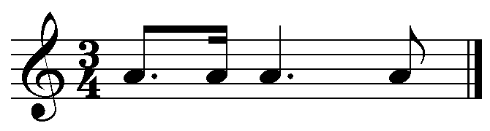
Knowledge and Communication
Knowledge and informed understanding of the topic, with mostly accurate use of musical terminology.
Mazurka-Choro follows the Mazurka tradition, having 3 beats to a bar, although there is no emphasis on the 2nd beat.
Mazurka's are generally in Ternary or Rondo form, which means that there are several sections. A variation of Rondo form that is played when hearing a Mazurka can be heard in "Mazurka-Choro" by Heitor Villa-Lobos. (AA, BB, AA, CC, AA & D). Though the variations may vary, each section is 16 bars in length, except the D (Final) section which is 12 bars in length. This section also deviates from the Mazurka rhythm by its use of continual triplets, use of arpeggios and flowing effect. The D section is more like a coda section. In this piece section C is major. Mazurka-Choro is quite rhythmic & dance like piece.
Analysis
Well-considered analysis of stylistic features.
Analysis:
Knowledge and Communication
Detailed knowledge and informed understanding of the topic, with clear and consistent use of musical terminology.
Rhythmic & Melodic ideas:-Section A
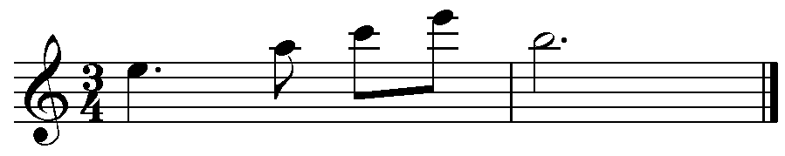
Ex.1
- Here is an example of the Mazurka-Choro rhythm, which is the general shape throughout the piece.
- Time signature is in triple metre (3/4 metre), with no emphasis on the 2nd beat.
Practical Application
Very capable management of the investigation, with well-considered use of resources and relevant documentation.
- Moving by leaps. A minor triad
"Grove dictionary of Music, Heitor Villa-Lobos
¹² Pixinguiha, Maria Jose Carrasquiera, 1998, 2" edition, irmaos Vitale Brazil
13 httpj/www.quitarramagazine.comiyillaloboschoro
Ex.2
- A stepwise melodic line

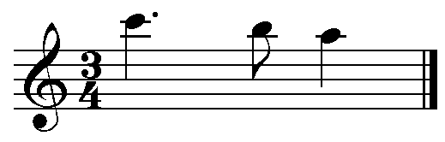

Ex. 3
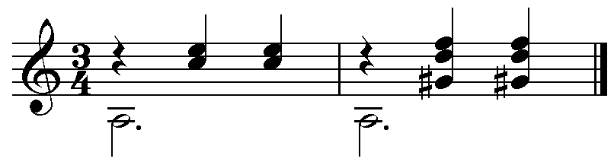

- The use of two voices, stems up line being the harmony (Bar 1 notated Ex.1) while the stems down is the bass together they make the accompaniment, which is common in Mazurkas.
Accompaniment notes are mainly dotted minims for the bass with crochet chords on beats 2 & 3 as shown in example 3.
Analysis
Well considered analysis of stylistic features.
Ex.1 is played over Ex.3
Section B
Ex.4
Knowledge and Communication
Detailed knowledge and informed understanding of the topic, with clear and consistent use of musical technology.
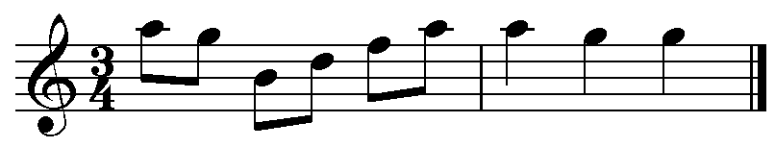

- Small range
- This has a balanced melodic phrase with 4 bars question by another 4 bars being the answer. - Question and answer technique.
- Contrasts with section A. Both in rhythm - no dotted rhythms and melody
Ex.5
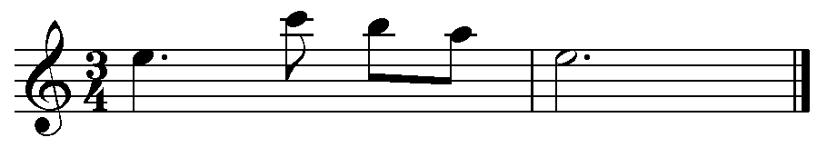
- Similar rhythm to section A
- A roughly inverted form of example 1.
Section D
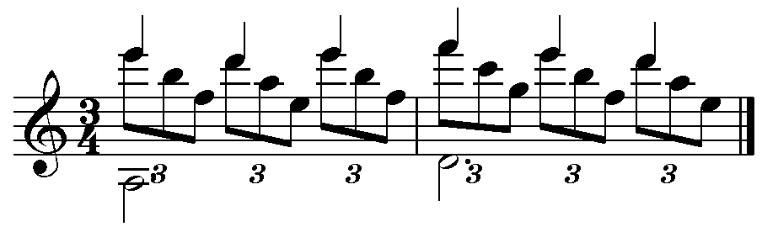
Ex.6

- D section is the last part of the piece which is telling the performer that the piece is going to end. But before finishing the D section is like a "show off" section.
Analysis
Well considered analysis of stylistic features.
- The melody, stems up, is moving in steps, played with quavers in the form of triplets.
Knowledge and Communication
Detailed knowledge and informed understanding of the topic, with clear and consistent use of musical technology.
- Bass - dotted minims
Form:
- The phrasing of each section being 2 & 4 bar phrasing
- AA, BB, AA, CC, AA & D.
Instrumentation:
- Guitar
- Use of harmonics - Finger gently touching the string covering the fret line.
- Glissandos - The drawing of a finger down or up a series of notes.14
- Grace notes - Ornaments in vocal and instrumental music, indicated in very small notation.15
Marieta by: Francisco Tarrega
Francisco Tarrega (1852-1909) was a well-known 19th century Spanish guitar composer. Tarrega went to Paris in 1881 and stayed there for a short period of time as he was only present to give concerts, rather than study there like Villa-Lobos did.¹⁶ Tarrega was a very shy person and prefered performing to small group of people. Tarrega's performances and commissions were generally for the aristocracy, wealthy, bureaucrats, royalty etc. They loved to dance such dances as the Mazurka.
Analysis
Considered analysis and understanding of music in the historical and cultural contexts.
Knowledge and Communication
Knowledge and informed understanding of the topic, with mostly accurate use of musical technology.
Marietta by Tarrega is played in a Romantic style by using the high and low register of the guitar, a range of dynamics which can also be expressed by the performer and the tempo marking of Lento, (meaning very slow) and uses a lot of ornamentation, embellishments, glissando and portamento. The form is Ternary (AA, BB & A) and is played at a slow tempo, which allows the position changes from one area to another on the guitar.

The speed of Marieta is quite different to the Mazurka-Choro as it is very slow (Lento), which makes Marieta more Romantic in style.
Marieta is also in ternary form, but the repetition is not the same. The first section is played twice, then the second section is played once and it then goes back to the beginning till the end of the first section. (A, A', B, 13', A, A'
Knowledge and Communication
Knowledge and informed understanding of the topic, with mostly accurate use of musical technology.
D.S Al Fine)
- Marieta has a different rhythm to Mazurka-Choro
- Notice the tie
- The accent on count 1
- Use of the dotted rhythm on beats 2 and 3
- Accompaniment uses the same approach to the rhythm
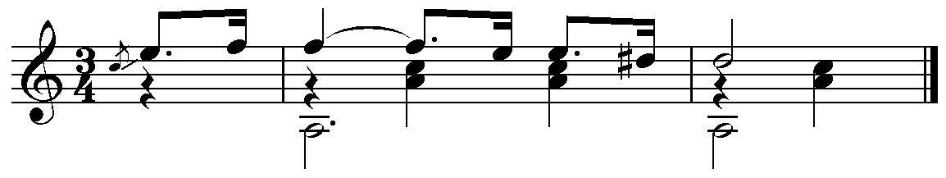
Analysis
Well-considered analysis of stylistic features.
- Marieta uses more grace notes compared to Mazurka-Choro and there
are some dynamics ranging from 'p' to 'f' (`p' at bar 23 and 'f' at bar
17)'' although the performer would put their own expression into the
piece.
- B section contrasting with triplet rhythm
- Balanced phrases - first 8 bars is played twice and the second 8 bars are varied with melodic decorations.
Practical Application
Very capable management of the investigation, with well-considered use of resources and relevant documentation.
¹⁴ The Concise Oxford Dictionary of Music
¹⁵ Ibid
¹⁶ http://www,g_eocities.cornithetropics/shores/8063/tarrega3.htm
¹⁷ Marieta - see score attached
Comparative analysis
Knowledge and Communication
Some creativity in exploration and considered discussion, of aspects of music.

Considered and generally clear communication of investigation findings.
In Marieta by Tarrega, the way that the piece is Romantic is by the different registers that are used to change the tone colour. For example in the first section of Marieta, the melody line is in the high register and then repeats the same melody in the lower register. Where as Villa-Lobos did not do this, he was more of an innovator where he kept on bringing in new ideas and not repeating the same ideas, such as Mazurka — Choro.
In both Mazurka's by Tarrega and Villa-Lobos a waltz accompaniment can be heard. Three even crotchets can be heard throughout the pieces. Both start and end in the same key. For example from 'A' minor 'A' major
In both of the Mazurka's there are few dynamics written in, as the performer would interpret their own dynamic feel into the piece. Both are coming from two different places, but with a shared heritage i.e. courts of Spain and courts Portugal. From a Polish dance that went through the courts of Europe until it became a European music
Conclusion
A mazurka is not a 'fixed' form but has survived for centuries due to innovations and differences as appearing in the works studied. The mazurkas have both maintained the dance feel even though they have gone through transformation.
Additional comments

On balance, a review of the response provides evidence of:
- knowledge and informed understanding of the topic, with mostly accurate use of musical terminology, and some creativity in exploration, and considered discussion, of aspects of music. (Knowledge and Communication)
- well-considered analysis and understanding of music in its historical and cultural context. (Analysis)
This well-considered investigation and listed bibliography demonstrates:
- effective independent work, and planning and investigation processes. (Practical Application)
- very capable presentation displaying effective use of musical examples, technologies and processes. (Practical Application)

Bibliography
Answer.com 2009, Mazurka, viewed 24 May 2009, <http://www.answers.com/topic/mazurka>.
Practical Application
Very capable management of the investigation, with well-considered use of resources and relevant documentation.
Culture.pl 2004, Music - FRYDERYK CHOPIN, MAZURKAS, viewed 18 May 2009,
<http://www.culture.pl/en/culture/artykuly/dz_chopin_mazurki>.
Dubai, D 2009, The Vancouver Chopin Society - The Mazurka, viewed 19 May 2209, <http://www.chopinsociety.org/chopin/mazurkas>.
Francisco Tarrega Biography, viewed 18 May 2009, <http://www.geocities.com/thetropics/shores/8063/tarrega3.htm>.
"Francisco Tarrega", 1980, The new grove dictionary of music and musicians, vol.11. Macmillan publishers limited. London.
"Fredrik Chopin", 1980, The new grove dictionary of music and musicians, vol.11. Macmillan publishers limited. London.
Gorbaty, 3 (n.d.), Polish folk music and Chopin's Mazurka's, viewed 19 May 2009,
<http://chopinfound.brinkster.net/Atimo_s/news/PolishFolkMusic.pdf>.
"Heitor Villa-Lobos", 1980, The new grove dictionary of music and musicians, vol.11. Macmillan publishers limited. London.
"Mazurka", 1980, The new grove dictionary of music and musicians, vol.11. Macmillan publishers limited. London.
Muller, R 1995, Chopin work list, viewed 6 June 2009, <http://www.geocities.com/Vienna/2217/list.htm>.
Patykula, J 2009, Villa-Lobo's and the Choro, viewed 2 June 2009, <http://www.guitarramagazine.com/villaloboschoro>.
Piano society 2009, Mazurka, viewed 21 May 2009, <http://www.pianosociety.com/cms/index.php?section=127>.
Pianostreet.com 2009, Chopin - Mazurka, viewed 29 May 2009,
<http ://www.pianostreet.com/search/searchcollection .php?id=100&ad = co100a&gclid=CLD4IdfPgZsCFUOwpAod3yQIdg>.
Powers, R 2007, The Russian Mazourka quadrilles, viewed 20 May 2009, <http://socialdance.stanford.edu/syllabi/russian_mazurka.htrn>.
Sweetswing.com Dance History Archives 2004, Mazurka, viewed 23 May 2009, <http:ThAiww.streetswing.com/histmain/z3mazrka.htm>.
TheFreeDictionary 2009, Mazurka, viewed 24 May 2009, <http://encyclopedia.farlex.com/mazurka>.
Tomaszewski, M 2009, Chopin - Chronicle of Life and Works, viewed 19 May 2009, <http://chopin.pl/kronika/kronika2_en.html>.
Trochimczyk, M 2009, Mazur (Mazurka), viewed 2 June 2009, <http://www.fiu.edu/—kneskij/mazurka/>.
18th and 19th Centaury Western Art Music 2009, Frederick Chopin in Paris (1831-1849), viewed 8
June 2009, <http://www.dartmouth.edu/—music33/Mus33projects/nodes/Chopin/p aris.html>.

Performance Standards Stage 2 Musical Styles

 | Practical Application | Knowledge and Communication | Analysis
A | Highly effective demonstration of independent work, and planning and investigation processes.  Extensive and highly effective management of the investigation, with insightful use of a range of resources and relevant documentation.  Confident and comprehensive presentation, displaying highly effective use of musical examples, technologies, and processes. | Comprehensive knowledge and understanding of the topic, with excellent use of musical terminology, and highly creative exploration and insightful discussion of aspects of music.  Incisive and clear communication of investigation findings.  Highly developed aural recognition skills. | Perceptive analysis and understanding of music in its historical and cultural context.  Perceptive analysis of stylistic features.  Discerning skills in aural analysis of music.
B | Effective demonstration of independent work, and planning and investigation processes.  Very capable management of the investigation, with well-considered use of resources and relevant documentation.  Very capable presentation displaying effective use of musical examples, technologies, and processes. | Detailed knowledge and informed understanding of the topic, with clear and consistent use of musical terminology, and creative exploration and well-considered discussion of aspects of music.  Well-considered and mostly clear communication of investigation findings.  Very good aural recognition skills. | Well-considered analysis and understanding of music in its historical and cultural context.  Well-considered analysis of stylistic features.  Very capable skills in aural analysis of music.
C | Appropriate demonstration of independent work, planning, and investigation processes.  Organised management of the investigation, with considered use of resources, and mostly relevant documentation.  Considered presentation displaying appropriate use of musical examples, technologies, and processes. | Knowledge and informed understanding of the topic, with mostly accurate use of musical terminology, and some creativity in exploration, and considered discussion, of aspects of music.  Considered and generally clear communication of investigation findings.  Generally competent aural recognition skills. | Considered analysis and understanding of music in its historical and cultural context.  Considered analysis of stylistic features.  Generally competent skills in aural analysis of music.
D | Demonstration of some independent work, planning, and basic investigation processes.  Attempted investigation, with inconsistent use of resources and documentation.  Presentation that displays inconsistent use of musical examples, technologies, or processes. | Some knowledge and understanding of aspects of the topic, with attempted use of appropriate musical terminology, and some basic exploration and description of aspects of music.  Communication of elements of an investigation.  Emerging aural recognition skills. | Description of some aspects of music in its historical and cultural context.  Description of some stylistic features.  Some skill in aural analysis of music.
E | Limited demonstration of independent work, effective planning, or investigation processes.  Limited investigation attempted with use of one or more resources, which may have limited relevance, and very little documentation.  Limited presentation with some identification of a musical example, technology, or process. | Some awareness of the topic, with limited use of musical terminology, and attempted exploration and description of aspects of music.  Attempted communication of limited elements of an investigation.  Limited aural recognition skills. | Identification of one or more aspects of music in its historical or cultural context.  Identification of one or more stylistic features.  Limited skill in aural analysis of music.

