2019 Music Performance — Ensemble Subject Assessment Advice
Overview
Subject assessment advice, based on the previous year’s assessment cycle, gives an overview of how students performed in their school and external assessments in relation to the learning requirements, assessment design criteria, and performance standards set out in the relevant subject outline. They provide information and advice regarding the assessment types, the application of the performance standards in school and external assessments, and the quality of student performance.
Teachers should refer to the subject outline for specifications on content and learning requirements, and to the subject operational information for operational matters and key dates.
School Assessment
Assessment Type 1: Performance
Students present an ensemble performance, or set of performances to a maximum of 6–8 minutes, of a single work or a set of works by one or more composers, and individual evidence of each student’s contribution to the chosen ensemble through individual part-testing.
The more successful responses commonly:
- completed performances within the specified time range of 6–8 minutes as stipulated in the subject outline
- included part-test videos for each individual student of approximately 2 minutes
- presented a range of works that demonstrated the breadth and depth of the student’s musical and stylistic understanding and skills, and provided contrast in the repertoire
- presented works that were appropriately aligned with the technical abilities and musical strengths of the student
- showed great attention to all musical aspects during both the performance and part-test
- demonstrated consistent control of tone and dynamics, and fluent technique in the performance.
The less successful responses commonly:
- presented works that did not allow students to demonstrate a wide variety of techniques or skills on their instrument
- lacked technical fluency within the performance of the repertoire
- lacked an understanding of the stylistic aspects of the repertoire
- included performances that were under-rehearsed or too technically demanding for the student
- did not identify individual students clearly within the performance video
- were well outside the 6 - 8 minute time requirement
- did not include a separate part-test video (approximately 2 minutes) for each individual student.

Additional advice for teachers
- Remember that moderators are the audience who will view the videos of students’ performances. Teachers should ensure that all students in the moderation sample can be clearly identified in all videos by moderators who are unfamiliar with the class of students.
- Ensure that all students are clearly labelled in videos so moderators can identify each student in each video, (using arrows or similar – see PLATO Clarifying examples - and/or headshots or position descriptions).
- Submit each student’s individual part-test video on a separate file.
- Ensure students are clearly visible and not obscured within performance and part test videos. Multiple angles may be required for large ensembles. Smartphone/tablet video recording quality is sufficient for extra angles.
- Compress files to mp4 for quicker upload and download.
Assessment Type 2: Performance and Discussion
For this assessment type students present an ensemble performance, or set of performances to a maximum of 6–8 minutes, of a single work or a set of works by one or more composers, and individual evidence of each student’s contribution to the chosen ensemble through individual part-testing. This is accompanied by an individual discussion of key musical elements of the repertoire, with a critique of strategies to improve and refine each student’s performance to a maximum or 800 words if written, 4 minutes as an oral presentation, or the multimodal equivalent.
The more successful responses commonly:
- demonstrated a high level of technique and confidence within the performance
- showed great attention to all musical aspects during both the performance and part-test
- addressed the structural and stylistic elements of the chosen repertoire within the Discussion
- included a Discussion that focused on the analysis of a range of musical elements
- addressed within the Discussion practice strategies applied to develop and prepare their performance
- included consistent, appropriate, and highly effective use of musical terminology
- included appropriate referencing (and a word count in the case of written Discussions).
The less successful responses commonly:
- did not submit the Discussion
- lacked technical fluency and stylistic aspects within the performance of the work(s)
- included performances that did not allow the student to demonstrate a variety of techniques and skills
- did not identify students clearly within the performance
- did not include a separate part-test video (approximately 2 minutes) for each individual student
- lacked depth and detail in relation to the elements of music in the Discussion
- lacked critique of strategies used to improve their skills, technique and accuracy of their performance in the Discussion
- in the Discussion, had not been drafted and edited to include a concise but wide range of analysis, avoiding repetition

Additional advice for teachers
- Ensure that the Discussion is submitted in a separate file with the performance. The focus of the Discussion should be on the musical elements – particularly analysis of structure and style, and practice strategies developed by the student to improve and refine their performance(s).
- Ensure that all students are clearly labelled in videos using arrows or similar and/or identified using headshots or position descriptions. Teachers are reminded that moderators are the audience who will view the videos of students’ performances. Teachers should ensure that all students in the moderation sample can be clearly identified in all videos by moderators who are unfamiliar with the class of students.
- Submit each individual student’s part-test video on a separate file.
- Ensure that moderators can clearly see, hear and identify each student being assessed in videos. Students should be clearly visible and not obscured within performances and part tests. Multiple angles may be required for large ensembles. Smartphone/tablet video recordings are sufficient for extra angles, if required.
- Compress files to mp4 for quicker upload and download.
- Keep in mind that moderators and markers are the audience who will watch the videos of your students. Teachers should ensure that every student being assessed can be clearly identified in all videos.
- Ensure students understand the differences between the purpose of the Discussion in Assessment Type 2, and the Evaluation in Assessment Type 3. The Discussion focuses on analytical and stylistic features of the repertoire, and practice techniques used to develop and refine the performance given in Assessment Type 2, the Evaluation in Assessment Type 3 focuses on an evaluation and critique of the final performance and the learning undertaken throughout the year.
- Mark all of the student’s evidence for the assessment type holistically. Teachers are reminded that there is no weighting to the Discussion. Teachers can mark against the features of the criteria as indicated in the diagram below:
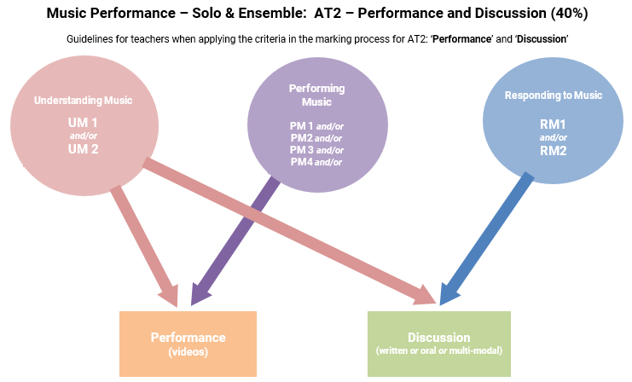

External Assessment
Assessment Type 3: Performance Portfolio
For this assessment type students present an ensemble performance, or set of performances to a maximum of 6–8 minutes, of a musical work or works, and individual evidence of each student’s contribution to the ensemble through individual part-testing. They also provide an individual evaluation of their learning journey to a maximum or 500 words if written, 3 minutes as an oral presentation, or the multimodal equivalent.
The more successful responses commonly:
- demonstrated a high level of technique and confidence within the performance and part-test
- showed close attention to all aspects of the repertoire during the performance and part-test
- demonstrated astute understanding of their role within the ensemble in the Evaluation
- addressed aspects of responsiveness and collaboration within the ensemble for the performance and rehearsals, as well as how they had learnt from practice and preparation strategies prior to the performance
- included consistent, accurate and highly effective use of musical terminology in the Evaluation.
The less successful responses commonly:
- did not submit the Evaluation
- did not include a separate part-test video (approximately 2 minutes) for each individual student
- lacked technical fluency and stylistic understanding within the performance of the work
- included performances that did not allow the student to demonstrate a range of techniques and skills
- did not identify students clearly within the videos. Teachers are reminded that SACE markers are the audience who will view the videos of students’ performances. Teachers should ensure that all students can be clearly identified in all videos and remember that SACE markers are unfamiliar with students
- lacked attention to the detail of musical indications marked on the score (where scores were provided)
- in the Evaluation, lacked depth and concise detail in relation to responsiveness and collaboration within the ensemble
- lacked detail in relation to the learning that had occurred throughout the preparation for the performance, in the Evaluation.
Additional advice for teachers
- Ensure that all students are clearly labelled and identified in both the performance and part test videos by SACE registration number. The performance and part test videos should be submitted as separate files. Compress files to mp4 for quicker upload and download.
- Ensure students are clearly visible and not obscured by line of sight within the performance and part test videos. Multiple angles may be required for large ensembles. Smartphone/tablet video recording quality is sufficient for extra angles.
- Submit every student’s individual part-test video as a separate file.
- Ensure that the Evaluation is submitted. The focus within the Evaluation should be on the student’s development in performing the music within the ensemble. Refer to page13, paragraph 1 and dot points of the subject outline for further information.
- Ensure students understand the differences between the purpose of the Evaluation in Assessment Type 3 and the Discussion in Assessment Type 2. While the Discussion focuses on analytical and stylistic features of the repertoire, and practice techniques used to develop and refine the performance given in Assessment Type 2, the Evaluation in Assessment Type 3 focuses on an evaluation and critique of the final performance and the learning throughout the year.

- Take note of the differences in the discussion points between the two performance subjects (Ensemble and Solo). See the top of page13 of the Music Performance: Ensemble subject outline, and pages 12 and 13 of the Music Performance: Solo subject outline for more details about the criteria students need to focus on in the Evaluation.
- Mark all of the student’s evidence for the external assessment AT3 holistically. Teachers are reminded that there is no weighting to the Evaluation. Teachers should mark against the features of the criteria as indicated in the diagram below:
