STAGE 2 NUTRITION
ASSESSMENT TYPE 1: Investigations Folio
Sensory Evaluation (Design)
Core Topic 3: Diet Evaluation and Food Selection

Aim:
To conduct a sensory evaluation test between organic and non-organic yogurt and from this conclude which yogurt type is preferred.

Hypothesis:
The organic yogurt will taste better than the regular yogurt and will be more nutritious.

Introduction:
Application:
Uses appropriate nutrition terms and conventions highly effectively.
Sensory analysis test are used to measure and interpret reactions people have to certain characteristics of food and how are senses of sight, smell, taste, sound and touch influence our food choices. Foods are evaluated on their appearance, flavor, aroma, texture, temperature and sound. These factors influence individuals in determining which foods they like and dislike. Producers use sensory analysis tests to gain an insight on what characteristics of their food product are appealing to consumers.
In this practical a sensory analysis will be conducted for two different types of yogurt, organic and non-organic to determine which product has a high sensory superiority over the other.

Materials:
See Appendix I

Method:
See Appendix II

Safety:
See Appendix III

Results:
Mean data results and optimum results of both yogurt types from sensory analysis scorecards can be seen in table 1.1. A graph of the mean can be seen in figure 1.1.

 | Appearance | Texture | Taste | Flavour | Aroma
Optimum | 3 | 3 | 3 | 3 | 3
YXX - Organic | 3 | 2 | 3 | 3 | 3
XXY – Non-organic | 2 | 3 | 4 | 4 | 3
Table 1.1: Mean data results of yogurt types

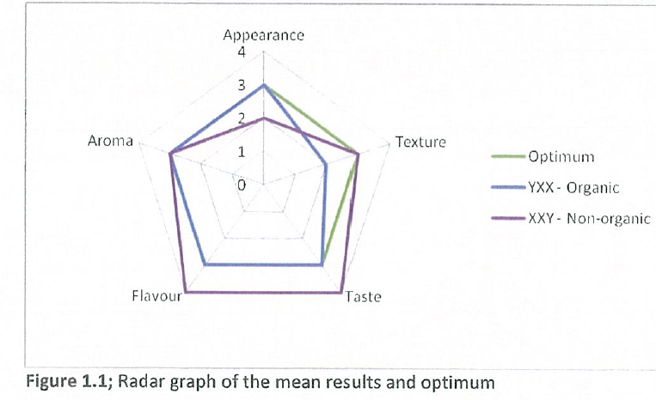
Investigating:
Obtains, records, and displays findings of investigations using appropriate conventions and formats accurately and highly effectively.
Investigation
Teacher verification of raw data enables confirmation of accurate recording of data.

The median of the results canbe summarised in table 1.2 and shown in figure 1.2.

 | Appearance | Texture | Taste | Flavour | Aroma
YXX - Organic | 2 | 2 | 2.5 | 3 | 3
XXY – Non-organic | 2 | 3 | 3 | 3 | 3
Table 1.2: Mode data results of yogurt types

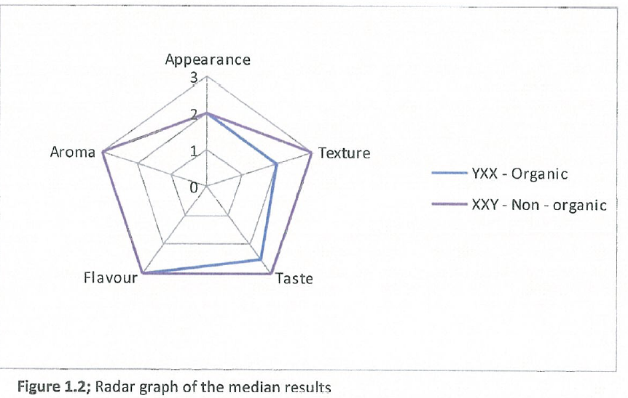

The mode of the sensory analysis results can be summarised in table 1.3 and shown in figure 1.3.

 | Appearance | Texture | Taste | Flavour | Aroma
YXX - Organic | 3 | 2 | 2 | 3 | 3
XXY – Non-organic | 2 | 3 | 3 | 3 | 2
Table 1.3: Mode data results of yogurt types

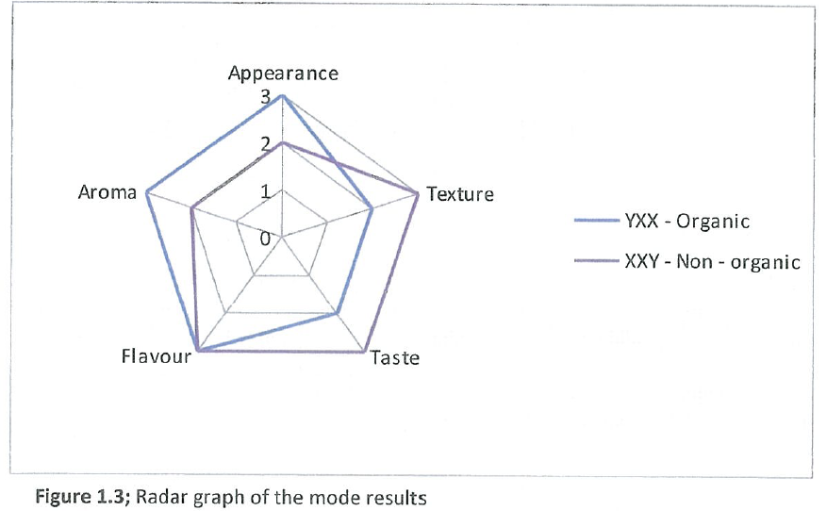

After all taste testers had completed their sensory analysis scorecards they were asked two questions. Question one was:
1. Which of the yogurts did you prefer most?

After all participants had answered this, it was then revealed to them which yogurt was organic and which was non-organic. They were then asked the following question.
2. After hearing this information, does this influence your decision on which product you would be most likely to choose?

The results of these questions are as follows:
1. 100% of taste testers preferred product XXY, the non-organic yogurt.
2. 75% of taster changed their opinion on which yogurt they would purchase after being told that YXX was organic.

Discussion:
From the results it was found that the product XXY, the non-organic yogurt was preferred over the organic variety by 100% of taste testers. From the mean data it can be seen in figure 1.1 that the non-organic yogurt has a smoother texture, was sweeter and had a fuller blueberry flavor than the organic and the optimum. This data shows that the consumers prefer creamy, sweet and flavoursome yoghurt. The organic variety had an appearance matching the optimum result with more visible fruity chunks than the non-organic. As this was the least preferred this suggests that visible fruit in yoghurt is not desirable to consumers.

The median of results (see figure 1.2) shows that the appearance, aroma and flavour were the same for both yoghurt varieties indicating that the yoghurts shared these characteristics. As the non-organic variety was more desirable, this suggests that in these characteristic areas, the organic yoghurt was also desirable. As the organic yoghurt had a relatively thin consistency and a slightly sour taste, this suggests that there characteristics are undesirable to consumers and what influences the choice of the nonorganic over the organic variety.

From the mode of results (see figure 1.3) this showed that the organic variety had more visible fruit chunks and a stronger aroma from the non-organic variety. The mode results also showed that the non-organic variety had a creamier texture and a sweeter taste. This was similar to the mean results which showed the same characteristics.

The results showed that 75% of taste testers claimed they would change their opinion on which product they would purchase after being informed that one of the products was organic. This shows that consumers are being more educated and aware of how products are manufactured. Organic products promote the humane treatment of animals and prevent the use of any artificial growth hormones and antibiotics that can increase production. The organic yogurt is also all made with natural ingredients, no preservatives and contains a higher content of naturally occurring nutrients. These elements are important to consumers and may influence them to purchase the organic over the non-organic variety even if it comes at a higher price.
Application:
Uses appropriate nutrition terms and conventions highly effectively.

Weakness of sensory analysis tests are that they are based on the taste tester’s opinion and their own individual likes and dislikes. When one taste tester considers a food sample to be too sweet, another taste tester may find it desirable. In this practical there were only 16 individuals who participated in the sensory analysis test. As there were not many taste testers and the majority was from the same age group, the results were not as reliable as if the test was carried out on a larger scale. The taste testers in this practical were also nutritionists which may have resulted in possible bias.
Analysis and Evaluation:
Logically evaluates procedures and suggests a range of appropriate improvements.

Random errors in this practical include that the sample size may not have been measured correctly resulting in different size servings of the yoghurt. Some of the samples may have been incorrectly labelled resulting in some taste testers scoring the wrong sample, giving inaccurate results.

Some systematic errors include that some of the taste testers may have been sick affecting one or more of their senses. Taste testers may have been talking to one another or looking at other’s scorecards which may have influenced their choice when scoring the yoghurts. Other systematic errors include one or both of the yoghurts may have been contaminated altering one or more of its sensory characteristics.

Improvements for this practical include conducting the sensory test with taste testers in individual booths or cubicles so that here is no influence from others around them. There could also be stricter rules on not speaking which conducting the test. As in this test the organic yoghurt was full cream and the non-organic was low fat, the test could be conducted with the samples being either both full cream or both low fat. Another improvement could be to also explain the nutritional value of both yoghurts to the tasters and from there ask them how this would influence their decision. The sensory test could also be done with a larger number of taste testers from a variety of age groups providing more reliable results.
Application:
Uses appropriate nutrition terms and conventions highly effectively.
Conclusion:
From the results of the sensory analysis test it is clear that the hypothesis was not supported as the organic yoghurt was the least desirable. The organic yoghurt also contained quite a high fat, sugar and sodium content in comparison to the non-organic variety. These particular nutrients should be limited or eaten in moderation in the diet to reduce the chance of developing over nutrition diet related disorders. Although the non-organic yoghurt seemed to be the tastier and more nutritious yoghurt, it may contain preservatives that give it such a sweet, creamy and flavoursome taste. It was evident from responses to questions two that the taste testers have some understanding of this and may be why 75% stated they would opt for the organic over the non-organic variety.

Peer Review:
In this practical I worked with two of my classmates. We all worked collaboratively together and followed all safety measure and method correctly. We divided the tasks up evenly with one person responsible for making and organizing the scorecard, measuring and preparing the non-organic samples. Another student labelled and distributed the sample cups to the taste testers and was responsible for collaborating and collecting the data from the sensory analysis scorecards. I was responsible for typing up part A of the practical and measuring and preparing the organic yoghurt samples. We worked together to answer all questions for part A in the cleanup process after the sensory test had been conducted.
Application:
Demonstrates initiative in applying constructive and focused individual and collaborative work skills.

Appendices:

Appendix I: Materials
Investigation:
Designs well-considered and clear nutrition investigations.
- 1X low fat blueberry yoghurt, 1kg tub
- 2X organic blueberry yoghurt, 500g tub
- 32X sample cups
- 32X spoons
- 1X measuring spoon
- 16X scorecards
- Sticky notes

Appendix II: Method
1. Yoghurt types were mixed to ensure blueberry flavor was evenly distributed throughout the yoghurt tubs.
2. Using the tablespoon measurer, 2 tablespoons of each yoghurt type were placed in separate sample cups. (See figure 1.4)
3. Sticky notes were used to label sample cups and a spoon was placed in each cup. (See figure 1.5)
4. 1 sample of each yoghurt type was handed out to each taste tester along with a score card.
5. After taste testers had finished, the scorecards were collected. Sample cups and spoons were collected and disposed of.

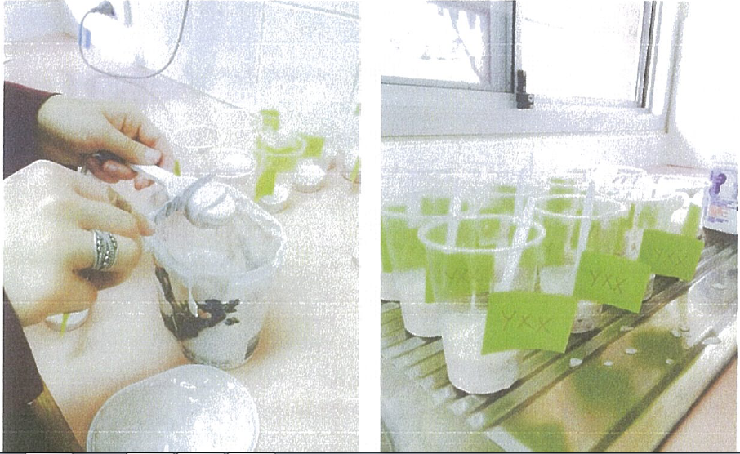
Figure 1.4; Yoghurt being measured Figure 1.5; Samples labelled

Appendix III: Safety Aspects
Safety aspects in this practical include that the yoghurts were kept refrigerated prior to serving to reduce the chance of contamination occurring. Each taste tester received their own cup and spoon for each sample so that there was no sharing of germs or cross contaminating samples. The samples were prepared in a sanitary environment including hands being washed before preparing samples and using a knife to level off measurements and scrape yoghurt into sample cups, not fingers.

Additional comments
- Teacher observation during the implementation of the investigation, together with the student’s own review, enables assessment of safe food handling and ethical implementation of the investigation (Investigation) and collaboration (Application)
- Evidence from this investigation contributes to an overall assessment for the Investigations Folio of a student’s use of appropriate nutrition terms and conventions (Application)

Performance Standards for Stage 2 Nutrition
 | Investigation | Analysis and Evaluation | Application | Knowledge and Understanding
A | Designs logical, coherent, and detailed nutrition investigations.  Critically and logically selects and consistently and appropriately acknowledges information about nutrition and issues in nutrition from a range of sources.  Manipulates apparatus, equipment, and technological tools carefully and highly effectively to implement well-organised safe and ethical investigation procedures.  Obtains, records, and displays findings of investigations using appropriate conventions and formats accurately and highly effectively. | Critically and systematically analyses data and their connections with concepts, to formulate logical and perceptive conclusions and make relevant predictions.  Logically evaluates procedures and suggests a range of appropriate improvements. | Applies nutrition concepts and evidence from investigations to suggest solutions to complex problems and to promote good health in new and familiar contexts.  Uses appropriate nutrition terms and conventions highly effectively.  Demonstrates initiative in applying constructive and focused individual and collaborative work skills. | Consistently demonstrates a deep and broad knowledge and understanding of a range of nutrition concepts.  Uses knowledge of nutrition perceptively and logically to understand and explain issues related to diet, lifestyle, culture, and health.  Uses a variety of formats to communicate knowledge and understanding of nutrition in different contexts coherently and highly effectively.
B | Designs well-considered and clear nutrition investigations.  Logically selects and appropriately acknowledges information about nutrition and issues in nutrition from different sources.  Manipulates apparatus, equipment, and technological tools carefully and mostly effectively to implement organised safe and ethical investigation procedures.  Obtains, records, and displays findings of investigations using appropriate conventions and formats mostly accurately and effectively. | Clearly and logically analyses data and their connections with concepts, to formulate consistent conclusions and make mostly relevant predictions.  Evaluates procedures and suggests some appropriate improvements. | Applies nutrition concepts and evidence from investigations to suggest solutions to problems and to promote good health in new and familiar contexts.  Uses appropriate nutrition terms and conventions effectively.  Applies mostly constructive and focused individual and collaborative work skills. | Demonstrates some depth and breadth of knowledge and understanding of a range of nutrition concepts.  Uses knowledge of nutrition logically to understand and explain issues related to diet, lifestyle, culture, and health.  Uses a variety of formats to communicate knowledge and understanding of nutrition in different contexts coherently and effectively.
C | Designs considered and generally clear nutrition investigations.  Selects with some focus, and mostly appropriately acknowledges, information about nutrition and issues in nutrition.  Manipulates apparatus, equipment, and technological tools generally carefully and effectively to implement safe and ethical investigation procedures.  Obtains, records, and displays findings of investigations using generally appropriate conventions and formats with some errors but generally accurately and effectively. | Analyses data and their connections with concepts, to formulate generally appropriate conclusions and make simple predictions, with some relevance.  Evaluates some procedures in nutrition and suggests some improvements that are generally appropriate. | Applies nutrition concepts and evidence from investigations to suggest some solutions to basic problems and to promote good health in new or familiar contexts.  Uses generally appropriate nutrition terms and conventions with some general effectiveness.  Applies generally constructive individual and collaborative work skills. | Demonstrates knowledge and understanding of a general range of nutrition concepts.  Uses knowledge of nutrition with some logic to understand and explain one or more issues related to diet, lifestyle, culture, and health.  Uses different formats to communicate knowledge and understanding of nutrition in different contexts with some general effectiveness.
D | Prepares the outline of a nutrition investigation.  Selects and may partly acknowledge one or more sources of information about nutrition or an issue in nutrition.  Uses apparatus, equipment, and technological tools with inconsistent care and effectiveness and attempts to implement safe and ethical investigation procedures.  Obtains, records, and displays findings of investigations using conventions and formats inconsistently, with occasional accuracy and effectiveness. | Describes basic connections between some data and concepts, and attempts to formulate a conclusion and make a simple prediction that may be relevant  For some procedures, identifies improvements that may be made. | Applies some evidence to describe some basic problems and identify one or more simple solutions, or to promote good health, in familiar contexts.  Attempts to use some nutrition terms and conventions that may be appropriate.  Attempts individual work inconsistently, and contributes superficially to aspects of collaborative work. | Demonstrates some basic knowledge and partial understanding of nutrition concepts.  Identifies and explains some nutrition information that is relevant to one or more issues related to diet, lifestyle, culture, and health.  Communicates basic information about nutrition to others, using one or more formats.
E | Identifies a simple procedure for a nutrition investigation.  Identifies a source of information about nutrition or an issue in nutrition.  Attempts to use apparatus, equipment, and technological tools with limited effectiveness or attention to safe or ethical investigation procedures.  Attempts to record and display some descriptive information about an investigation, with limited accuracy or effectiveness. | Attempts to connect data with concepts, formulate a conclusion, and make a prediction.  Acknowledges the need for improvements in one or more procedures. | Identifies a basic problem and attempts to identify a solution or promote good health in a familiar context.  Uses some nutrition terms or conventions.  Shows emerging skills in individual and collaborative work. | Demonstrates some limited recognition and awareness of nutrition concepts.  Shows an emerging understanding of an issue related to diet, lifestyle, culture, and health.  Attempts to communicate information about nutrition.

