Part 1
Problem
I have grown out of my old bed, so Mum and Dad will buy me a new mattress if I make a good bed. This will be my project this semester in Tech
Investigation
Demonstrates clear and considered identification of a need i.e. parents will buy mattress if student makes a good bed.

I plan to construct a bed frame made out of wood stained pine. This project must be able to be separated into three easy units that allow it to be transported and then put back together. Its design must be able to support a queen size mattress 153cm x 203cm (5’0” x 6’8”).
Investigation
Demonstrates ability to create an insightful validation of a clear and well-considered initial design brief e.g. by providing reason for number of units.

Part 2
Investigation
Bed Designs
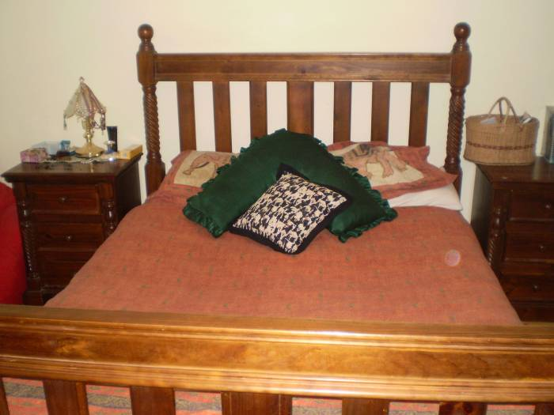
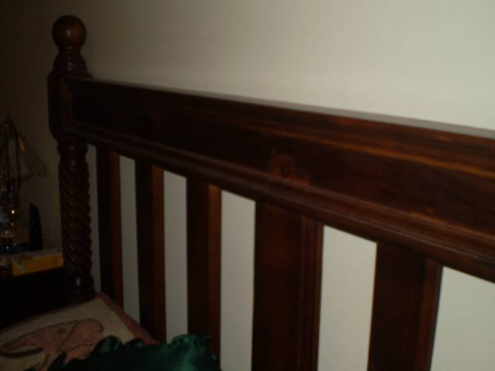

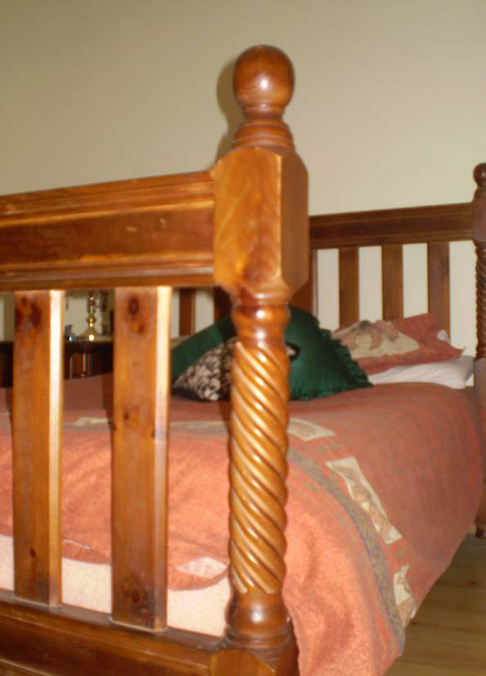
These pictures are taken from home. The slats vary in size, as the middle one is bigger. This is one idea I plan to include in my design.

The flash turned posts and the knobs on top are not what I like. Something plain and simple with straight edges is what I want.

The routed flashings that run along each the top and bottom beams of the frame look good. They give the bed a more chunkier appearance and a bit of character.
Planning
Shows insightful use of relevant investigated information to create individual product design ideas on pages 2 – 4. Refer to highlighted text for some examples.

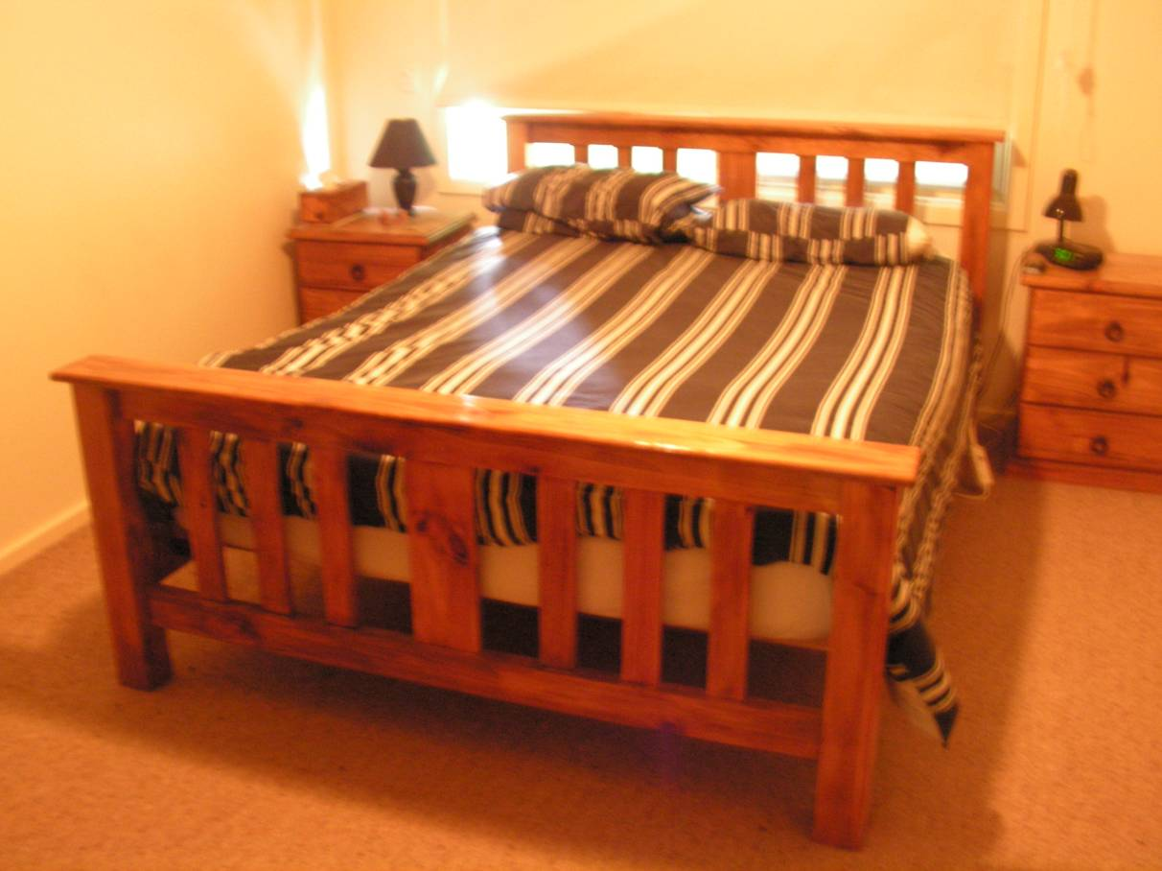

This bed is very close. It has a solid old school look. The slats at both ends are all the same sizes, and are spread evenly across. I like the way that the slats are close together as it makes the bed look stronger and more defined.

I will include the solid flat tops in my bed design. It gives the bed a smooth finish and hides all joints. The dark stain also gives the bed an older feeling. It matches in with my room.

This design contains the same elements I want.

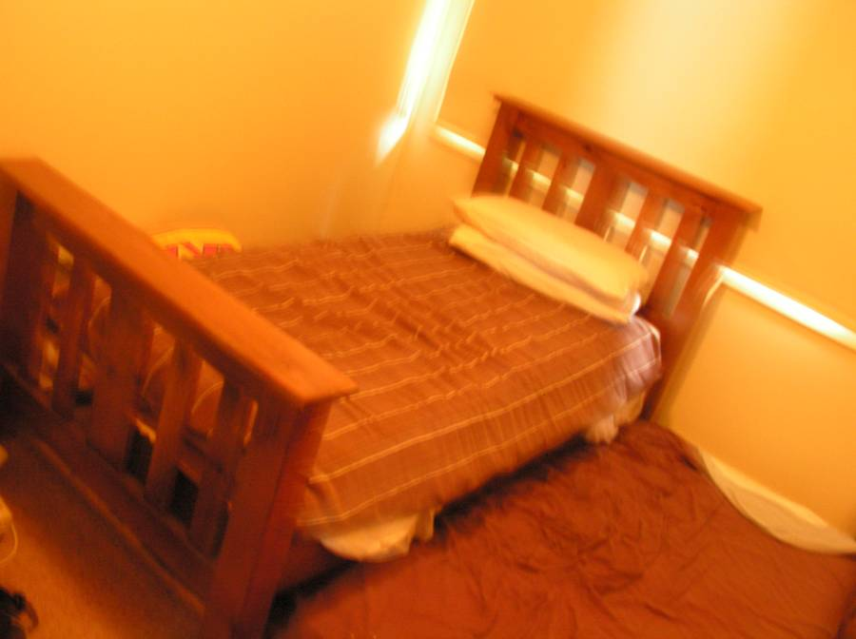
Although it is a single bed I like the proportions. The sharp corners need rounding for safety reasons
The bed is constructed using 90x90 for the posts which is a “chunky” appearance I like.

I don’t want a single bed, so I will think about the number of vertical slats I use ends.

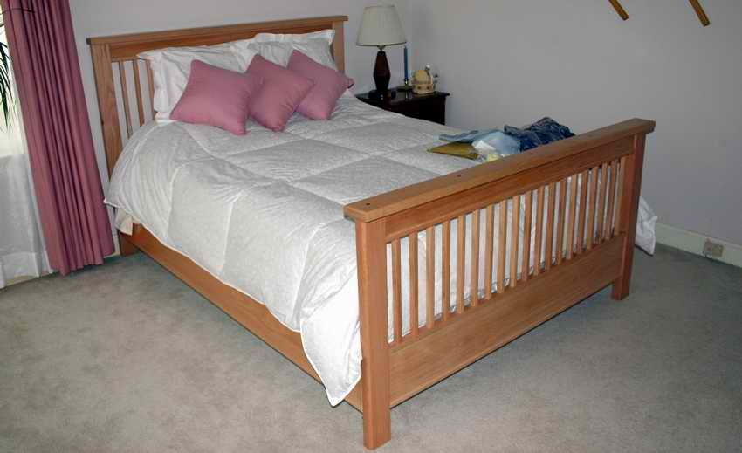
This bed I photographed uses the straight edges and basic techniques that I want to use.

It contains a chunky base beam that gives it a strong and reliable appearance, and has a separate top to hide all other joints. I will include these in my design.

I do not like the skinny slats as they are hard to look at. I also dislike using skinnier rectangular posts.

Investigating
Provides an in-depth investigation and analysis of the characteristics of existing products and materials in pages 2 - 4.

Own Ideas

Horizontal beams to have dowel joints into uprights.
Vertical slats to have biscuit joints into horizontal beams.
Flat bar to provide a top, biscuit jointed.
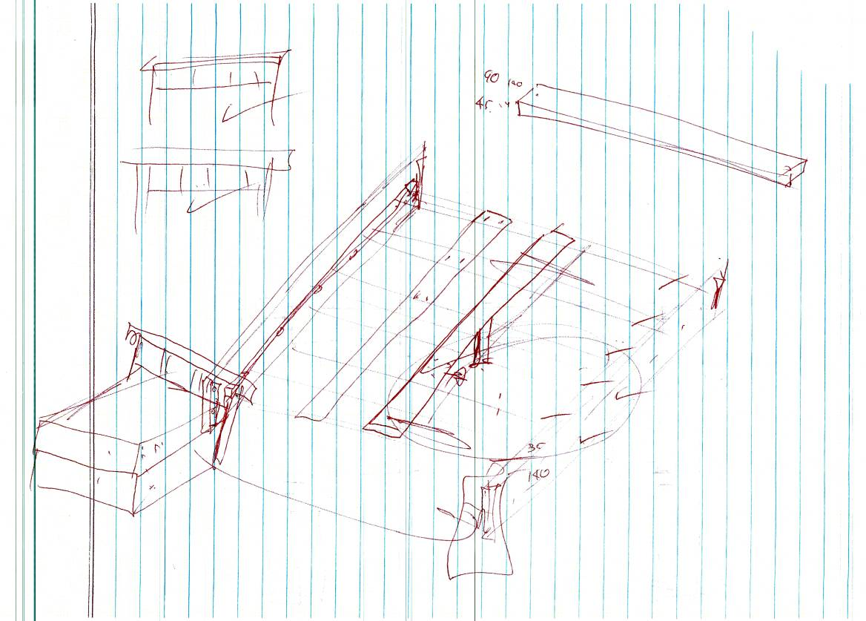
Planning
Demonstrates thoughtful compilation of broad, varied, and refined sketches, concept drawings, plans, and sequences for the planned outcome i.e. making the bed, on pages 6 – 7, and 11-12.
Ideas on how the slats that support the mattress will be fastened to long beams.

Bed to have a head and foot to contain mattress.
I decided on a queen size bed.

Mattress Sizes
Single | 3' x 6' 2" | 92cm x 188cm
Long Single | 3' x 6' 8" | 92cm x 203cm
Three Quarter | 3' 6" x 6' 2" | 107cm x 188cm
King Single | 3' 6" x 6' 8" | 107cm x 203cm
Double | 4' 6" x 6' 2" | 138cm x 188cm
Queen | 5' x 6' 8" | 153cm x 203cm
King | 6' x 6' 8" | 183cm x 203cm

Beams

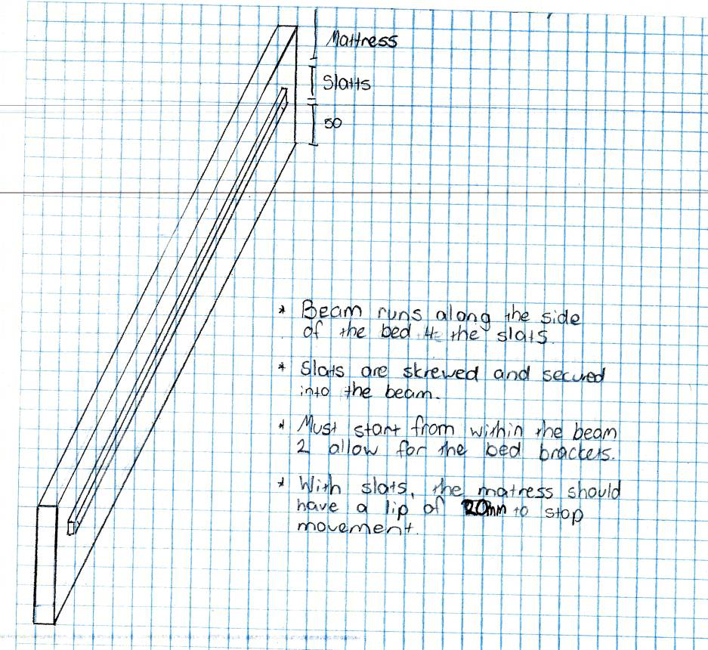
Part 3
Impact Investigation
I chose to use stained pine because with a stain you can fit any decor.
It is important to look at what effects wood stain chemicals might have on me as I apply it, or on individuals afterward- for example will it cause a rash?
I am using a transparent wood stain to keep the grained effect. The chemical I am using claims to be organic. That does not mean it is safe. Not all ingredients are natural - to get some colours.
Investigating
Provides evidence of a detailed investigation into the impact of the product i.e. the stain, on the individual in the prose, and by including the table.
The technical data sheet (1) claims there is danger of combustion because of linseed oil. It also says if it is swallowed do not induce vomiting. This normally happens if a product is corrosive but it might be because linseed oil reacts with acid (2) and would react with stomach acid.
The constituents of the can are listed as:
Linseed oil | not very harmful, according to the Material safety data sheet (2)
Stand oil | a particular type of linseed oil (3)
Natural resin ester | also part of the linseed oil product (3)
Iron oxide and mineral pigments | some mineral pigments are poisonous, but they are not identified. It depends on the colour. Iron oxide can be irritating or dangerous to the eye or skin for some people. (6)
Wood oil | Also part of the linseed oil family.
Micronized wax | Wax which has been reduced to very small particles so it can be part of the stain.
Orange oil | A solvent. There is a slight risk because it contains terpenes to which some people are allergic. (4) Terpenes are "A very large class of naturally occurring and synthetic organic compounds formally derived from the hydrocarbon isoprene" (5)
Isaliphates | A solvent. It contains terpenes
Alumina | This can be dangerous for some. (7)
Drying agents free of lead | Lead base agents are much more dangerous.

From looking at the data I have reported in the table, the product is fairly safe to use, and not likely to cause problems to most people. Once it dries, the wax will coat the other ingredients and make them less likely to harm anyone. When I apply it, I will wear a mask and use the spray booth.
(I) http://www.enviroqld.com.au/livos/pdfs/kaldet270.pdf (2)http://www.creativityunlimited.com.au/verve/_resources/Cold_Pressed_Linseed_Oil.pdf
(3) http://wwwJangridgecolours.com/pdf/Stand%20oil%20MSDS.pdf
(4) http://www.greendemon.com.au/factsheets/livos/aboutvoc.html
(5) http://en.wiktionary.org/wiki/terpene
(6) http://fscimage.fishersci.com/msds/09765.htiTi
(7) http://www.sciencelab.com/xMSDS-Alumina-9925577

Evaluating
Demonstrates perceptive reflection on the impact of the product i.e. the stain, on the individual.
Investigating
Provides an in-depth investigation and analysis of the characteristics of existing products and materials in pages 7 - 8.

Part 4
First Design
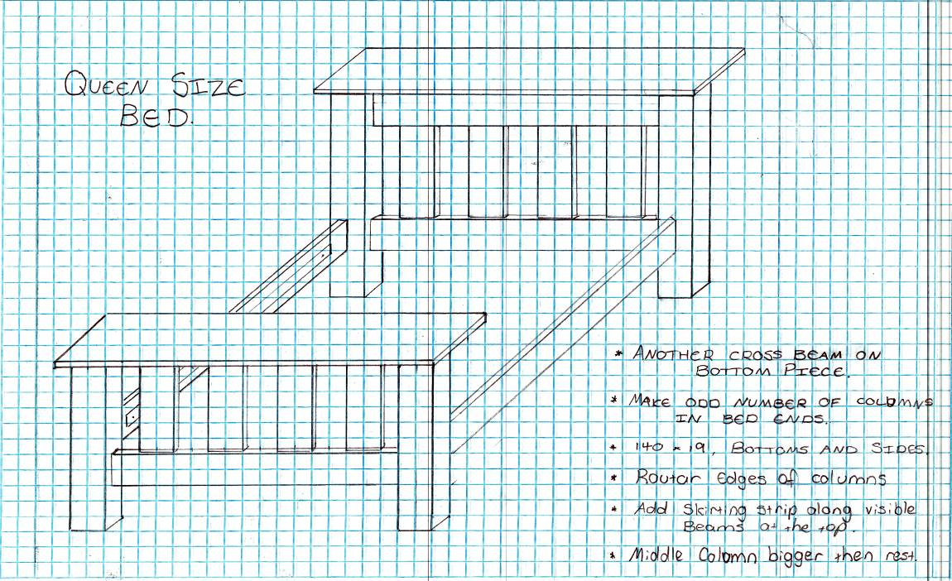
I made modifications so it was more like the bed on page 3.
Evaluating
Diagrams show thorough and focused consideration of possible modification of ideas or procedures.

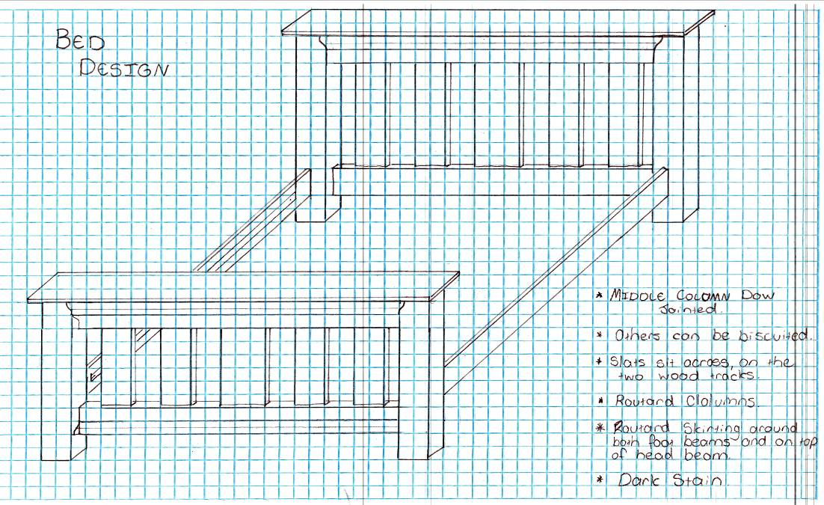
Planning
Diagrams above show considered testing, modification, and validation of ideas.
Planning
Demonstrates capable use of technical language relevant to context and purpose i.e. correctly used but misspelled.
Still not quite right.

Final Design
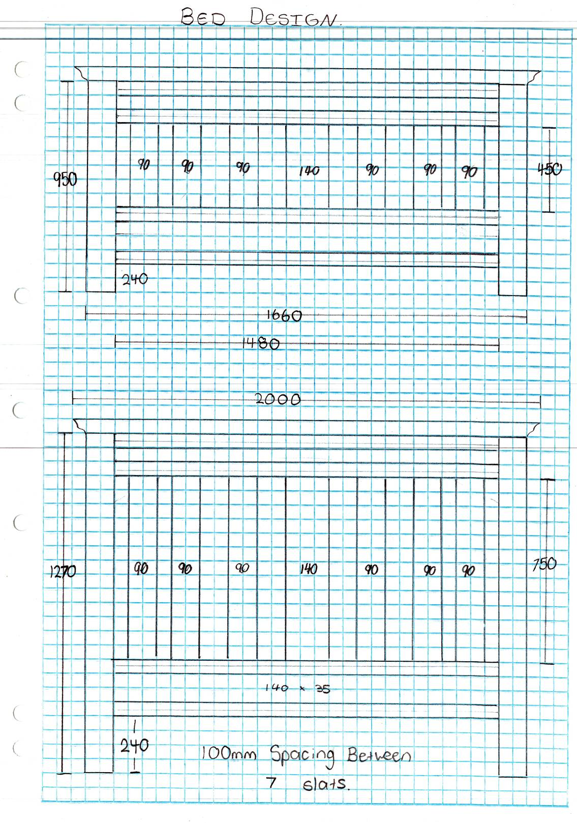

Costing Sheet
Part name | No | Material  Used | Cost of  material | (Length x Cost x Number of) or (length x width x Cost x Number of)
Bed Head
Posts | 2 | 90 x 90mm | $16 | 1.27 x 16 x 2 | $40.64
Cross beams | 2 | 140 x 35mm | $9.77 | 1.48 x 9.77 x 2 | $28.91
Skirting | 2 | 42 x 19mm | $1.08 | 1.48 x 1.08 x 2 | $ 3.20
Slats | 6 | 90 x 19 | $1.82 | .45 x 1.82 x 6 | $ 4.91
Middle slat | 1 | 140 x 19 | $3.10 | .45 x 3.10 x 1 | $ 1.40
Top | 1 | 140 x 35 | $9.77 | 2 x 9 77 x 1 | $19.54
Bed Foot
Posts | 2 | 90 x 90mm | $16 | .95 x 16 x 2 | $30.40
Cross beams | 2 | 140 x 35mm | $9.77 | 1.48 x 9.77 x 2 | $28.91
Skirting | 4 | 42 x 19mm | $1.08 | 1.48 x 1.08 x 2 | $ 6.40
Slats | 6 | 90 x 19 | $1.82 | .75 x 1.82 x 6 | $ 8.20
Middle slat | 1 | 140 x 19 | $3.10 | .75 x 3.10 x 1 | $ 2.33
Top | 1 | 140 x 35 | $9.77 | 2 x 9 77 x 1 | $19.54
TOTAL $ |  |  |  |  | 194.38
This does not include sides and slats.
Additional comments
- The student demonstrates thoughtful compilation of varied and refined sketches, concept drawings and plans throughout their folio. There is evidence of planning for production e.g. the number of parts required in the above table, but minimal information about the production techniques to be used (Planning).
- The student hasn’t provided an evaluation of the effectiveness of the product realisation process.
- The table of contents of the can of stain and associated bibliography, and the table of mattress measurements contains information used to finalise the design brief. They are not included in the word count.

Word Count - 789

 | Investigating | Planning | Producing | Evaluating
A | Comprehensive and well-considered identification of a need, problem, or challenge.  Creation and insightful validation of a clear and well-considered initial design brief.  In-depth investigation and analysis of the characteristics of existing products, materials, processes, systems and/or production techniques  Planned and thorough investigation into the impact of technological practices, products or systems on individuals, society, and/or the environment. | Insightful use of relevant investigated information to create individual product design ideas for a product or system.  Thoughtful compilation of broad, varied, and refined sketches, concept drawings, plans, and sequences for planned outcomes.  Polished use of technical language most relevant to context and purpose.  Broad and varied testing, modification, and validation of ideas or procedures. | Highly proficient application of skills, processes, procedures, and techniques to create a product or system to a chosen standard and specification.  Sophisticated use of a variety of materials, components, techniques, and equipment to create a product or system safely and accurately.  Development of sophisticated solutions to problems that arise during product or system realisation. | Comprehensive evaluation of how well the design brief requirements have been met.  Insightful and detailed evaluation of the effectiveness of the product or system realisation process.  Sophisticated and focused consideration of possible modifications to improve ideas or procedures.  Perceptive analysis of the impact of technological practices, products, or systems on individuals, society, and/or the environment.
B | Clear and considered identification of a need, problem, or challenge.  Well-considered creation and validation of an initial design brief.  Some depth of investigation into the characteristics of existing products, materials, processes, systems, and/or production techniques.  Detailed investigation into the impact of technological practices, products, or systems on individuals, society, and/or the environment. | Thoughtful use of relevant investigated information to create individual design ideas for a product or system.  Well-considered compilation of quality sketches, concept drawings, plans, and sequences for planned outcomes.  Capable use of technical language relevant to context and purpose.  Considered testing, modification, and validation of ideas or procedures. | Proficient application of skills, processes, procedures, and techniques to create a product or system to a chosen standard and specification.  Thorough use of different materials, components, techniques, and equipment to create a product or system safely and mostly accurately.  Development of thoughtful solutions to problems that arise during product or system realisation. | Well-informed evaluation of how well the design brief requirements have been met.  Well-considered and detailed evaluation of the effectiveness of the product or system realisation process.  Thorough and focused consideration of possible modifications to improve ideas or procedures.  Well-considered analysis of the impact of technological practices, products, or systems on individuals, society, and/or the environment.

 | Investigating | Planning | Producing | Evaluating
C | Considered identification of a need, problem, or challenge.  Considered creation and validation of an initial design brief.  Informed investigation into the characteristics of existing products, materials, processes, systems, and/or production techniques.  Generally competent investigation into the impact of technological practices, products, or systems on individuals, society, and/or the environment. | Use of relevant investigated information to create individual design ideas for a product or a system.  Considered compilation of sketches, concept drawings, plans, and sequences for planned outcomes.  Competent use of technical language relevant to the context and purpose.  Competent testing, modification, and validation of ideas or procedures. | Competent application of skills, processes, procedures, and techniques to create a product or system to a chosen standard and specification.  Appropriate use of materials, components, techniques, and equipment create a product or system safely and sometimes accurately.  Development of appropriate solutions to problems that arise during product or system realisation. | Informed evaluation of how well the design brief requirements have been met.  Considered evaluation of the effectiveness of the product or system realisation process.  Some focus in consideration of possible modification to improve ideas or procedures.  Considered analysis of some of the impacts of technological practices, products, or systems on individuals, society, and/or the environment, with mostly relevant detail.
D | Partial identification of a need, problem, or challenge.  Development and some testing of a basic, or perhaps incomplete, initial design brief.  Identification of a few of the characteristics of existing products, materials, processes, systems, or production techniques.  Some accessing of information on the impact of aspects of technological practices, products, or systems on individuals, society, and/or the environment. | Some use of identified information to create one or more individual design ideas for a product or system that may be only partially completed.  Some sketches, concept drawings, plans, and/or sequences for planned outcomes are completed.  Use of basic technical language with some relevance to the context and purpose.  Some basic testing, modification, and validation of aspects of one or more ideas or procedures. | Basic application of some skills in some processes, procedures, and techniques to create part of a product or system to a basic standard and specification.  Some use of materials, components, techniques, or equipment to create part of a product or system with some elements of safety and accuracy considered.  Some endeavour to solve problems that arise during product or system realisation. | Some description of how well the design brief requirements have been met.  Some description of the effectiveness of the product or system realisation process.  Some consideration of a possible modification to improve ideas or procedures.  Identification and description of one or more impacts of technological practices, products, or systems on individuals, society, and/or the environment.
E | Limited identification of a need, problem, or challenge.  Attempted development and testing of a design brief.  Attempted identification of one or more characteristics of existing products, materials, processes, systems, or production techniques.  Isolated and disjointed evidence of accessing information on the impact of an aspect of the technological practice, product, or system on individuals, society, or the environment. | Limited use of information to create an individual design idea for a product or system that may not be completed.  Compilation of few sketches, concept drawings, plans, or sequences for planned outcomes.  Limited use of technical language.  Recognition of the need for testing, modification, and validation of ideas or procedures, with some limited attempts. | Limited application of emerging skills and/or techniques to attempt to create part of a product or system to a limited standard or specification.  Attempted use of one or more basic materials, components, techniques, or equipment with limited consideration of safety procedures.  Some attempted description of problems that arise during product or system realisation. | Identification of some aspects of the design brief requirements that were attempted.  Identification of some aspects of the effectiveness of the product or system realisation process.  Emerging recognition of the need for modification to improve ideas or procedures.  Emerging recognition of one or more impacts of technological practices, products, or systems on individuals, society, or the environment.

