Student Work
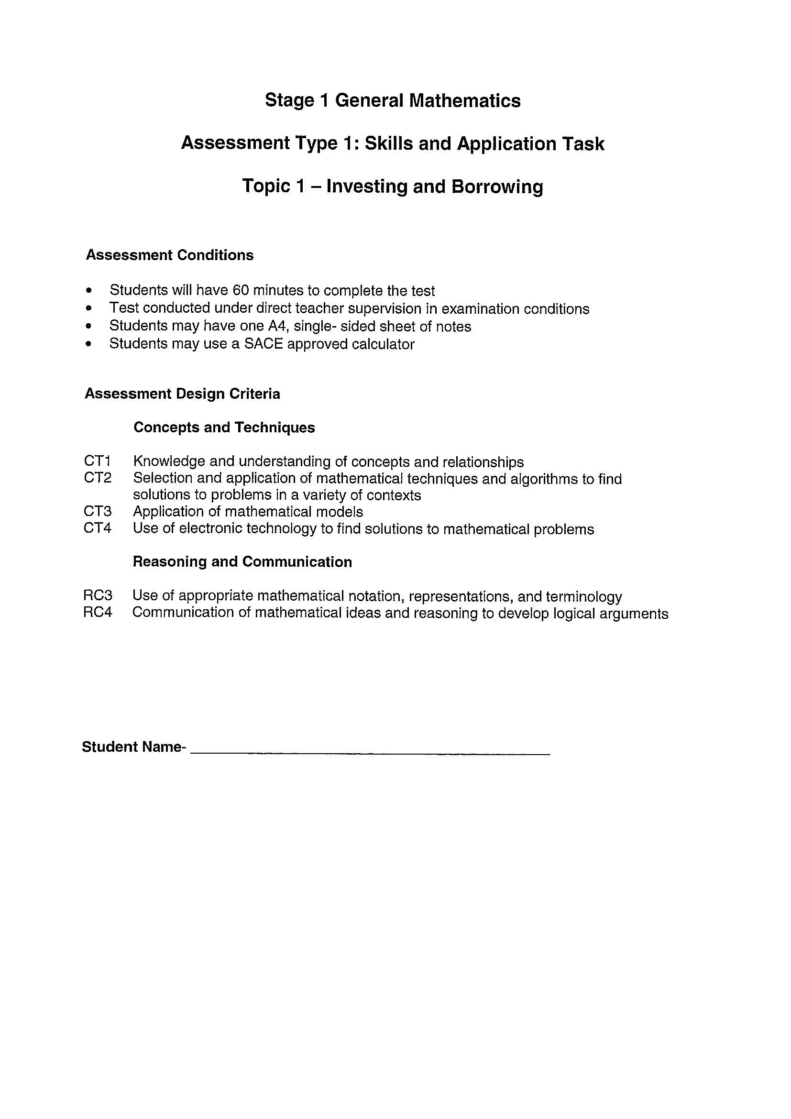
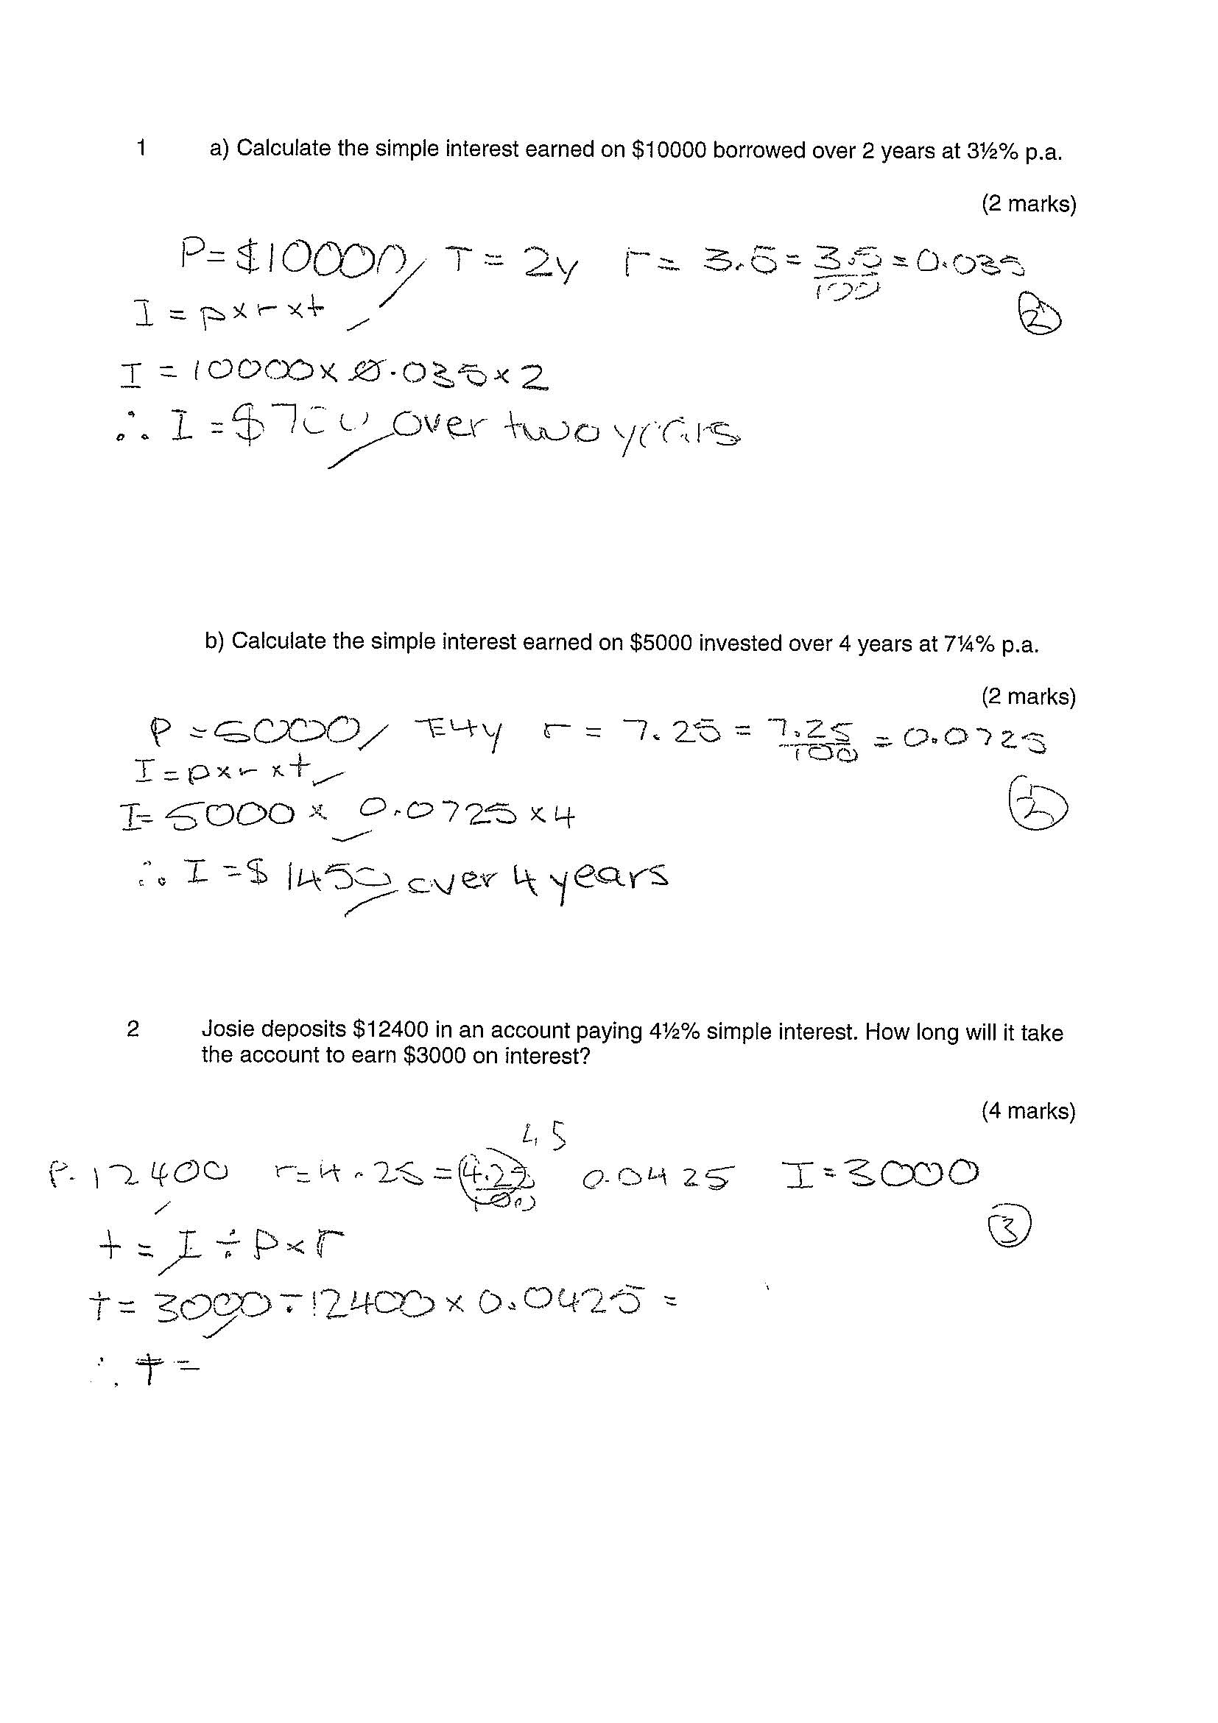
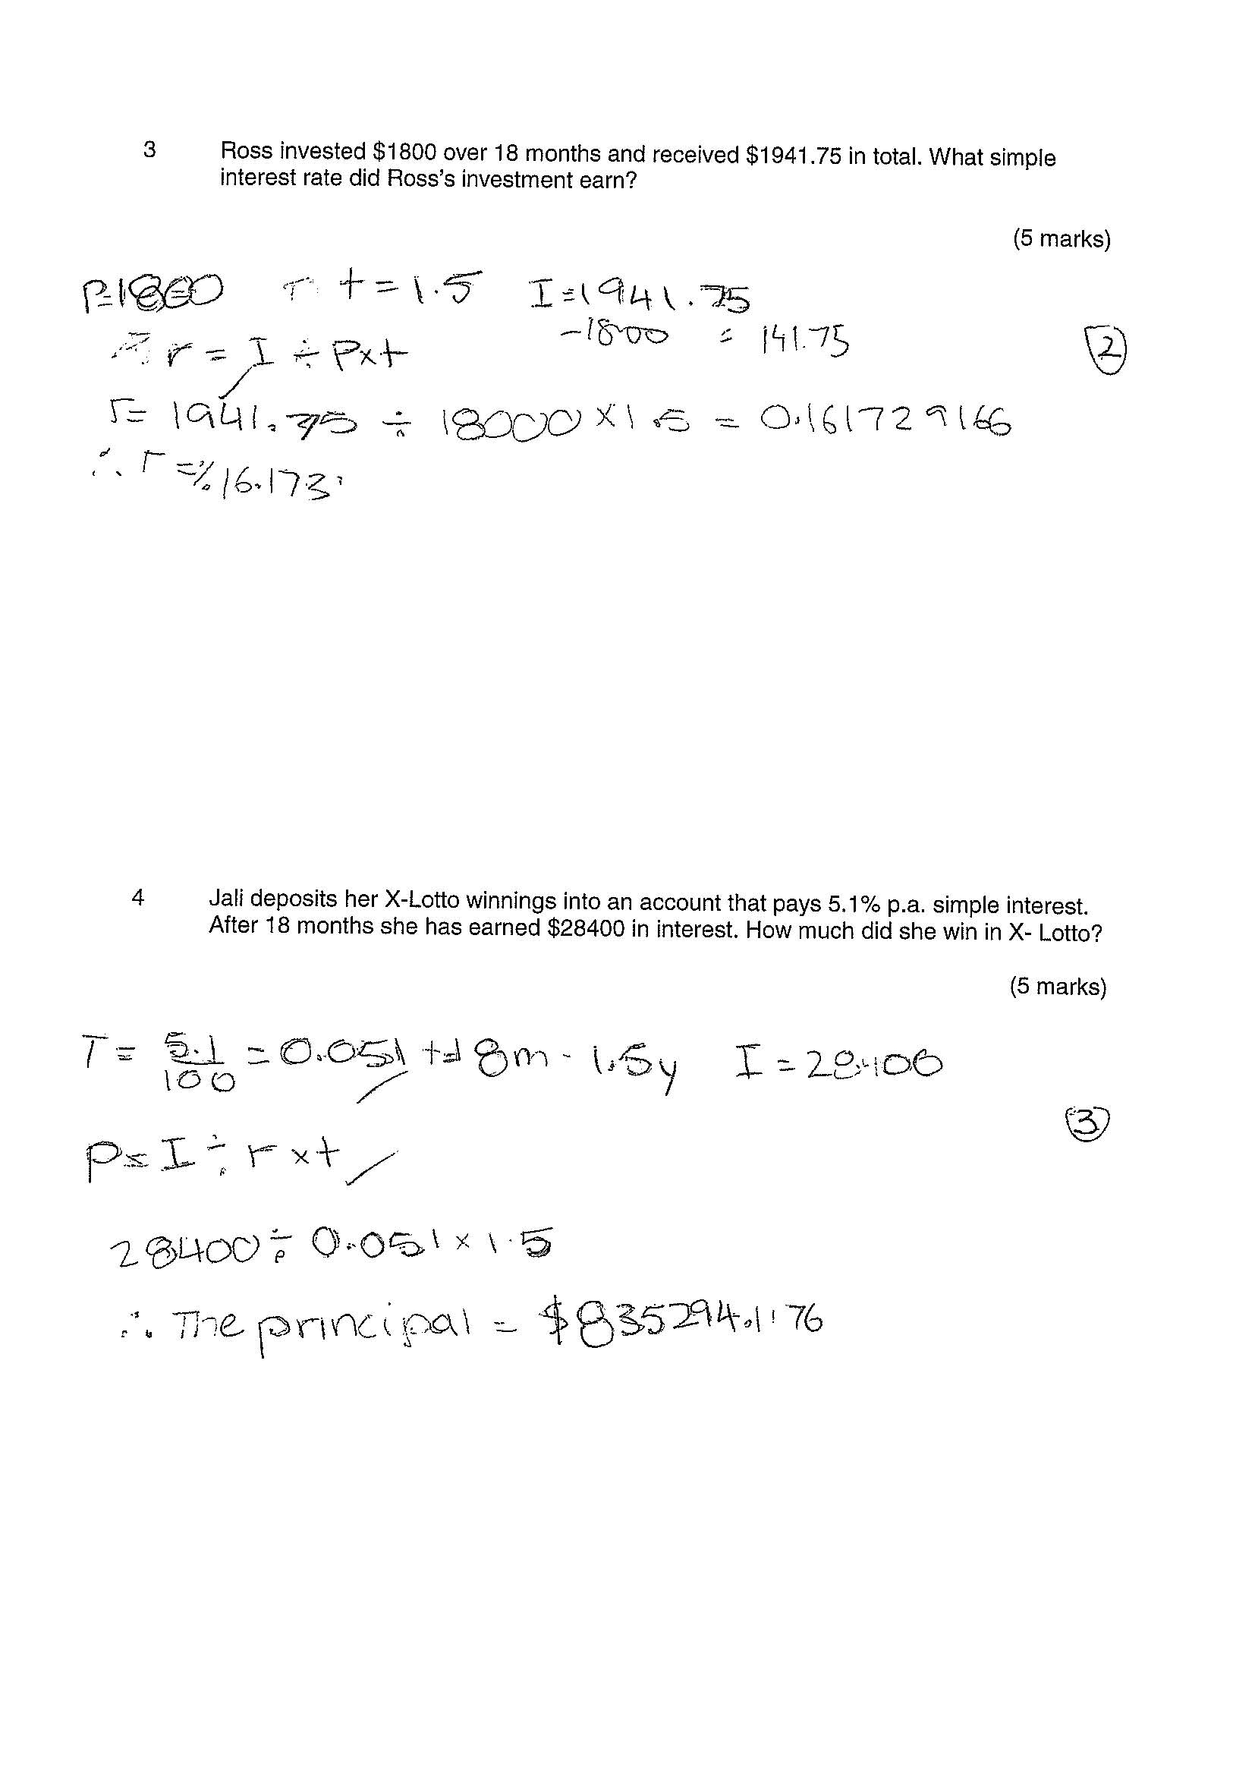
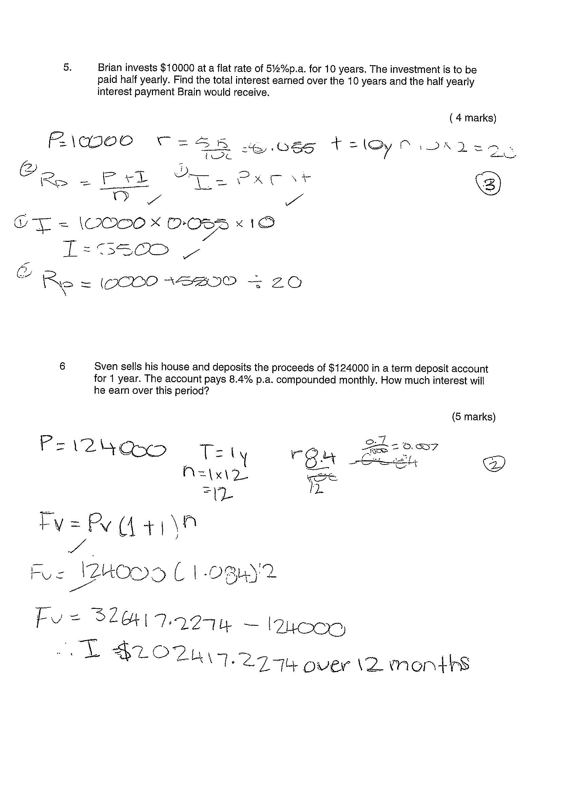
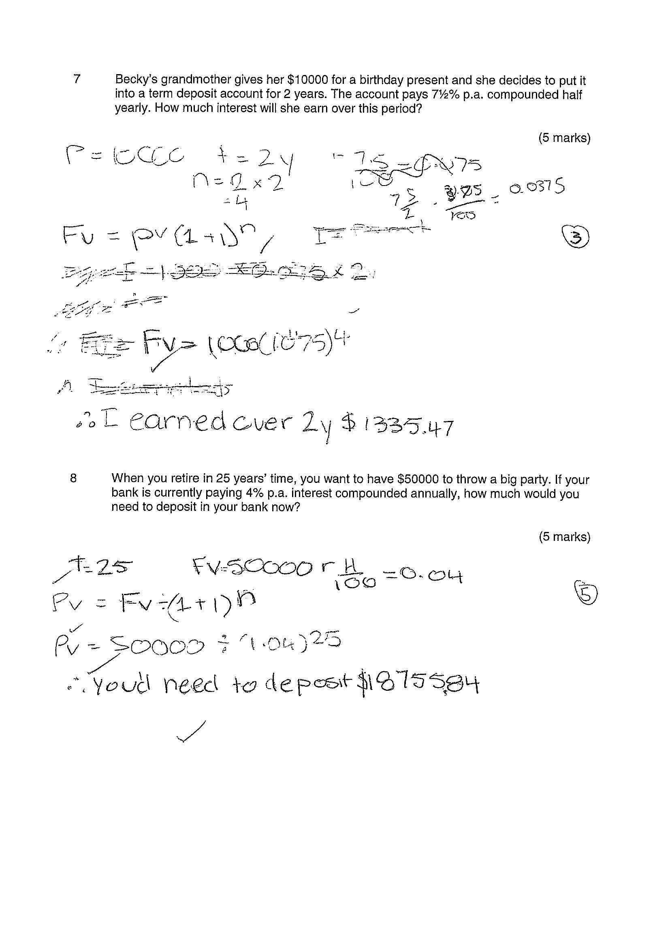
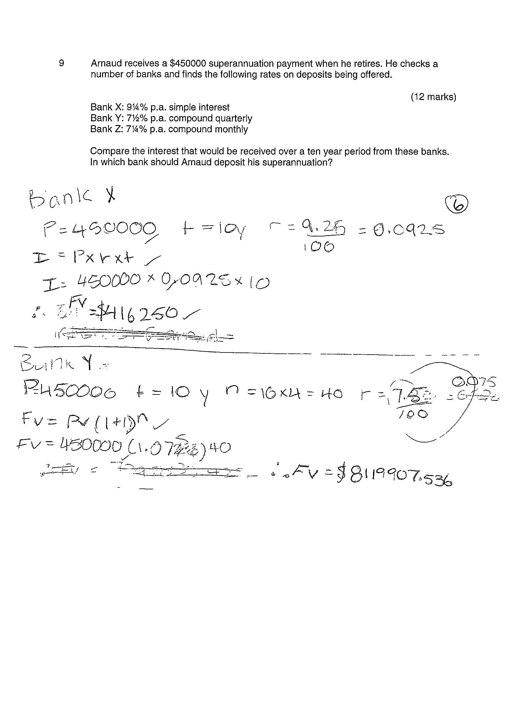
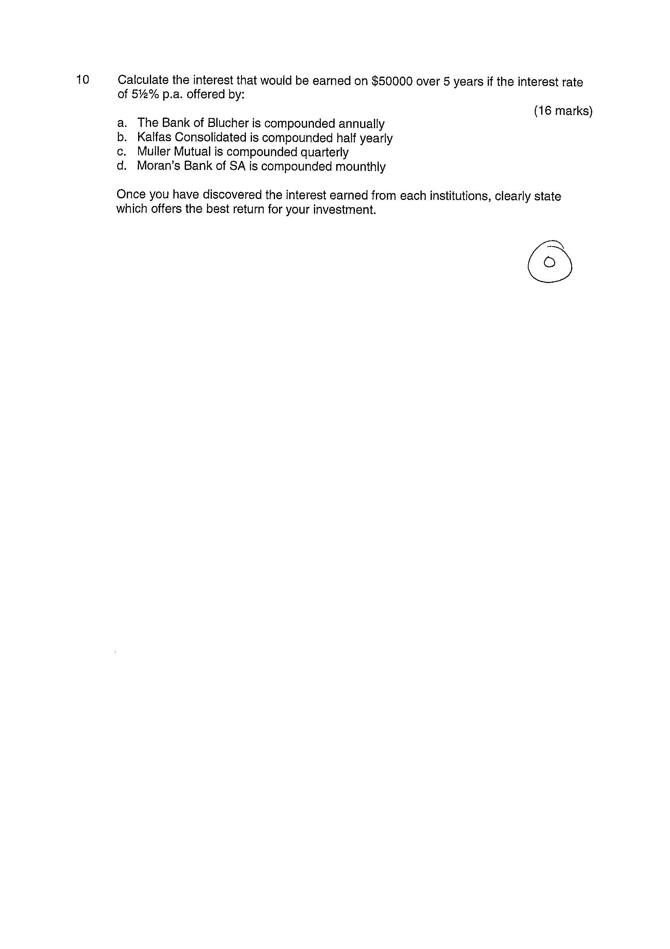
- | Concepts and Techniques | Reasoning and Communication
B | Some depth of knowledge and understanding of concepts and relationships.  Mostly effective selection and application of mathematical techniques and algorithms to find mostly accurate solutions to routine and some complex problems in a variety of contexts.  Attempted development and successful application of mathematical models to find mostly accurate solutions.  Mostly appropriate and effective use of electronic technology to find mostly accurate solutions to routine and some complex problems. | Mostly appropriate interpretation of mathematical results in the context of the problem.  Drawing mostly logical conclusions from mathematical results, with some depth of understanding of their reasonableness and limitations.  Mostly accurate use of appropriate mathematical notation, representations, and terminology.  Mostly effective communication of mathematical ideas and reasoning to develop mostly logical arguments.  Formation and testing of mostly appropriate predictions, using some mathematical evidence.
C | Generally competent knowledge and understanding of concepts and relationships.  Generally effective selection and application of mathematical techniques and algorithms to find mostly accurate solutions to routine problems in different contexts.  Application of mathematical models to find generally accurate solutions.  Generally appropriate and effective use of electronic technology to find mostly accurate solutions to routine problems. | Generally appropriate interpretation of mathematical results in the context of the problem.  Drawing some logical conclusions from mathematical results, with some understanding of their reasonableness and limitations.  Generally appropriate use of mathematical notation, representations, and terminology, with reasonable accuracy.  Generally effective communication of mathematical ideas and reasoning to develop some logical arguments.  Formation of an appropriate prediction and some attempt to test it using mathematical evidence.
D | Basic knowledge and some understanding of concepts and relationships.  Some selection and application of mathematical techniques and algorithms to find some accurate solutions to routine problems in context.  Some application of mathematical models to find some accurate or partially accurate solutions.  Some appropriate use of electronic technology to find some accurate solutions to routine problems. | Some interpretation of mathematical results.  Drawing some conclusions from mathematical results, with some awareness of their reasonableness.  Some appropriate use of mathematical notation, representations, and terminology, with some accuracy.  Some communication of mathematical ideas, with attempted reasoning and/or arguments.  Attempted formation of a prediction with limited attempt to test it using mathematical evidence.

Benchmark decision = C

Concepts and Techniques
In the Investing and Borrowing task, generally effective selection and application of mathematical techniques and algorithms to find solutions to problems in a variety of contexts, was identified. This was evident in the early questions where the student completed routine calculations and used formulas appropriately. In questions 3 to 5 the student demonstrated generally competent knowledge and understanding of concepts and relationships however the student did not carry out calculations with brackets therefore the final answer was incorrect. In questions 6 to 9 routine interpretations were required. Here the student did not always transfer data correctly in the formula, or in some compound interest calculations, the rates were not divided. Questions 9 and 10 focused on the application of mathematical models with only partially accurate solutions evident.

Reasoning and Communication
Throughout the Investing and Borrowing task, generally effective communication of mathematical ideas and reasoning to develop arguments was evident. For example, in question 8 the student clearly and correctly identified the variables to be used, selected the correct formula, completed the calculations, and answered the question in an appropriate written response. The student also used mostly accurate mathematical notation, representation and terminology. Issues identified were the appropriate use of decimal places in $ figures at times.

