
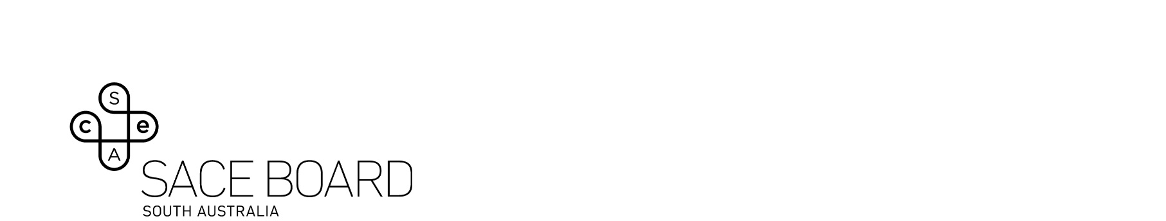
2025 Politics, Power and People Subject Assessment Advice

Overview
This subject assessment advice, based on the 2025 assessment cycle, gives an overview of how students performed in their school and external assessments in relation to the learning requirements, assessment design criteria, and performance standards set out in the relevant subject outline. It provides information and advice regarding the assessment types, the application of the performance standards in school and external assessments, and the quality of student performance.
The Subject Renewal program has introduced changes for many subjects in 2025; these changes are detailed in the change log at the front of each subject outline.

School Assessment
Teachers can improve the moderation process and the online process by:
- thoroughly checking that all grades entered in school online are correct
- ensuring the uploaded tasks are legible, all facing up (and all the same way), and remove blank pages, student notes and formula pages
- ensuring the uploaded responses have pages the same size and in colour so teacher marking, and comments are clear.

Assessment Type 1: Folio
Students undertake at least three folio assessments. This assessment type provides the opportunity to work in the following assessment design criteria areas: Critical and Creative Thinking; Communication and Collaboration; Understanding and Ethical Reasoning and Research and Analysis as defined in the subject outline.
Teachers can elicit more successful responses by:
- including a mixture of tasks with different levels of complexity
- providing or encouraging opportunities to show an argumentative style
- ensuring that a range of interpretations are promoted.
The more successful responses commonly:
- were highly organised and demonstrated critical analysis in their research
- supported judgements about politicians and topics with clear evidence
- demonstrated where collaboration occurred and to what extent it occurred
- drew on political theory where applicable to support the analysis of political concepts
- analysed and explored political issues in-depth
- showed clear understanding of grass roots politics
- demonstrated an impressive coverage of the current Australian political scene
- used a wide range of political sources and not only websites
- demonstrated exemplary research and referencing.

The less successful responses commonly:
- provided statistics with minimal analysis of the source/s
- made judgements about politicians without supporting evidence
- were too general in their coverage and/or overused dot points
- described issues without offering balanced judgements
- did not develop challenging questions
- provided descriptive rather than analytical responses.

Assessment Type 2: Source Analysis
Students undertake at least two source analysis assessments. This assessment type provides the opportunity to work in the following assessment design criteria areas: Critical and Creative Thinking; Communication and Collaboration; Understanding and Ethical Reasoning as defined in the subject outline.
Teachers can elicit more successful responses by:
- encouraging students to use more recent source material
- looking to use a diversity of source material
- making it clear how much is required in each sub part of the question(s).
The more successful responses commonly:
- critically evaluated the sources and considered their individual usefulness
- closely adhered to the word count guidelines
- did not attempt too many skills in any one question
- used sources that had a clear political perspective
- were able to unpack the political bias in the source(s)
- often used multimedia frameworks to enhance the response(s)
- used comparatively recent source materials
- did not vilify a specific person in the source itself
- used clear references to the specific parts of the source under examination
- seamlessly integrated the evidence.
The less successful responses commonly:
- provided only a brief descriptive cover or limited analysis of each source
- provided minimal cover of the significant players involved and their impacts on the situation at hand
- seemed to assume that editorials were without bias
- relied too heavily on annotated screenshots
- did not annotate the sources
- restated the question rather than analysing or evaluating the question.

External Assessment

Assessment Type 3: Investigation
Students are required to undertake one investigation of a local, national of international political issue that is of personal interest from one of the option themes. This assessment type provides the opportunity to work in the following assessment design criteria areas: Critical and Creative Thinking; Communication and Collaboration; Understanding and Ethical Reasoning and Research and Analysis as defined in the Subject Outline.
The more successful responses commonly:
- had a clear frame of reference and a contestable hypothesis
- clearly addressed the guiding question throughout the discourse
- made extensive use of quotes, graphs, cartoons, and statistics which were clearly annotated
- explicitly acknowledged that their solutions were at least, in part, flawed
- covered a current issue with dynamic communication
- made critical use of selected social media
- constantly referenced the initial question or hypothesis
- offered final solutions that were analysed with insightful consideration
- provided impressive final paragraphs and some level of solution(s).
The less successful responses commonly:
- lacked depth of coverage
- used a vague guiding question or hypothesis
- became story telling rather than analysis
- expressed personal, negative opinions toward specific politicians, sometimes using harsh language
- presented minimal solutions or recommendations
- spent too much time on the historical background of the investigation.

