Stage 1 Physics - Medical Science

Investigations Folio

Sight, Light, Hearing and Sound Design Investigation

You are to investigate an aspect of light or sound that has a real-world application.
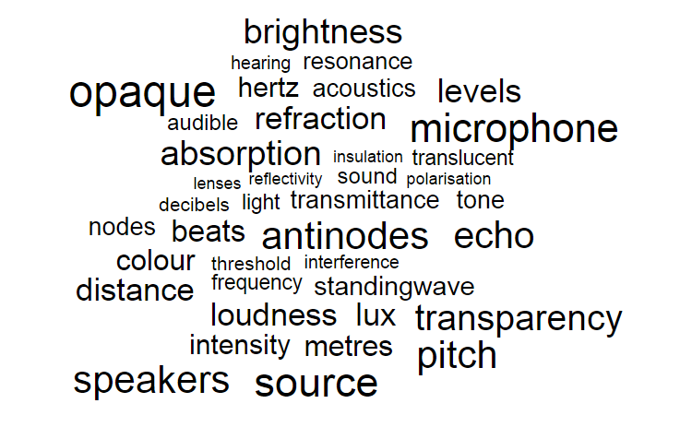
What is a situation/condition/scenario involving light or sound that you are interested in?
What is one aspect of this situation that you can measure?
What are all the things that could affect this aspect?
What will you change? What will you measure? How can you measure your variables?
How will you keep the other aspects constant?

You have access to standard laboratory equipment. Additionally, you may use your smartphone or tablet - they can be tone generators, frequency analysers, audio frequency counters, dB meters, lux meters, colour temperature meters and a light source. Your computer may also be able to perform some of these functions.

An example of a student question: How does the speed of a car influence the noise level in the cabin? Justification: Noise level can affect human health.
Lesson 1 – Deconstructing the problem and designing your Investigation (in class under test conditions)
Come up with a question and refine that to a hypothesis. State your independent and dependent variables. State any other variables that may impact your dependent variable. Investigate (and possibly try out) possible ways to test your hypothesis. Determine how you can keep appropriate variables constant. List equipment and describe a step by step procedure. Use annotations to justify the decisions you make about variables, measurements, etc in your design.
This will be handed up on ____________________.

Lesson 2 - Performing the investigation
When you have received feedback and approval for your design, you will undertake the investigation.
You will have a double lesson to undertake the investigation, however if you are investigating real world phenomena outside of the classroom you may get permission to collect your data ahead of the lesson.

Prepare a report on the investigation you undertake.

The Design
Deconstruction
Summarise the way you have broken down the problem.
Purpose
State the purpose of the investigation clearly. State your rationale of investigation to a real world purpose.
Hypothesis
Write the question you investigated.
Identify the independent and dependent variables in your investigation.
Describe how you kept plan to keep other factors constant, why and how you will keep them constant.
Equipment
List the equipment or measuring instruments used.
Procedure
Describe the steps involved in your investigation. You are encouraged to use labelled diagrams.
Include a blank data table to show how you would record the results.

Annotate your deconstruction and design to justify the decisions you have made about such things as the weed you have chosen, the independent and dependent variables, how and why you will control other variables, number of trials, measurements.
Evidence of deconstruction, the method/procedure chosen as most appropriate, and a justification of the plan of action must be a maximum of 4 sides of an A4 page.
The Report Checklist
Introduction:
State hypothesis, variables
Materials and Method:
Materials used in the actual investigation
Steps in the investigation that you actually performed.
Data Representation
Record data and observations in table(s) using correct significant figures.
Plot a graph of your results - a line graph for continuous data, a column graph is discontinuous data.
Analysis and Interpretation
Describe the pattern of your results.
Include calculations you have made.
Explain your results using physics concepts.
Evaluation
Identify any anomalous results and suggest a reason(s) for them.
Discuss possible sources of random errors and the effect upon precision.
Discuss possible sources of systematic errors.
Place errors in order of impact.
Discuss the precision of your results.
Describe any further areas of investigation.
Conclusion
Write a conclusion with a justification that is based on the results of your investigation.
Relate your conclusion to the hypothesis and the purpose of your investigation.
Evidence of deconstruction must be attached to the practical report.

Stage 1 Physics - Medical Science Student Name:

Sight, Light, Hearing and Sound Design Investigation

Performance Standards for Stage 1 Physics
- | Investigation, Analysis and Evaluation | Knowledge and Application
A | Critically deconstructs a problem and designs a logical and coherent physics investigation with detailed justification.  Obtains, records, and represents data, using appropriate conventions and formats accurately and highly effectively.  Systematically analyses and interprets data and evidence to formulate logical conclusions with detailed justification.  Critically and logically evaluates procedures and their effect on data. | Demonstrates deep and broad knowledge and understanding of a range of physics concepts.  Applies physics concepts highly effectively in new and familiar contexts.  Critically explores and understands in depth the interaction between science and society.  Communicates knowledge and understanding of physics coherently, with highly effective use of appropriate terms, conventions, and representations.
B | Logically deconstructs a problem and designs a well-considered and clear physics investigation with reasonable justification.  Obtains, records, and represents data, using appropriate conventions and formats mostly accurately and effectively.  Logically analyses and interprets data and evidence to formulate suitable conclusions with reasonable justification.  Logically evaluates procedures and their effect on data. | Demonstrates some depth and breadth of knowledge and understanding of a range of physics concepts.  Applies physics concepts mostly effectively in new and familiar contexts.  Logically explores and understands in some depth the interaction between science and society.  Communicates knowledge and understanding of physics mostly coherently, with effective use of appropriate terms, conventions, and representations.
C | Deconstructs a problem and designs a considered and generally clear physics investigation with some justification.  Obtains, records, and represents data, using generally appropriate conventions and formats, with some errors but generally accurately and effectively.  Undertakes some analysis and interpretation of data and evidence to formulate generally appropriate conclusions with some justification.  Evaluates procedures and some of their effect on data. | Demonstrates knowledge and understanding of a general range of physics concepts.  Applies physics concepts generally effectively in new or familiar contexts.  Explores and understands aspects of the interaction between science and society.  Communicates knowledge and understanding of physics generally effectively, using some appropriate terms, conventions, and representations.
D | Prepares a basic deconstruction of a problem and an outline of a physics investigation.  Obtains, records, and represents data, using conventions and formats inconsistently, with occasional accuracy and effectiveness.  Describes data and undertakes some basic interpretation to formulate a basic conclusion.  Attempts to evaluate procedures or suggest an effect on data. | Demonstrates some basic knowledge and partial understanding of physics concepts.  Applies some physics concepts in familiar contexts.  Partially explores and recognises aspects of the interaction between science and society.  Communicates basic physics information, using some appropriate terms, conventions, and/or representations.
E | Attempts a simple deconstruction of a problem and a procedure for a physics investigation.  Attempts to record and represent some data, with limited accuracy or effectiveness.  Attempts to describe results and/or interpret data to formulate a basic conclusion.  Acknowledges that procedures affect data. | Demonstrates limited recognition and awareness of physics concepts.  Attempts to apply physics concepts in familiar contexts.  Attempts to explore and identify an aspect of the interaction between science and society.  Attempts to communicate information about physics.

