AT3 – Exploration of Connections with the Natural Environment:
https://www.youtube.com/watch?v=OZpIEgoI8iQ
*SCRIPT FOR MY VIDEO*
Introduction
Slide 1 –
As stated in the Australian Journal of Outdoor Education, “Outdoor education and bush adventure therapy programs assist in reconnecting urban-based individuals with nature. Whilst educational and therapeutic outcomes may be the priority, these programs also assist participants towards improved physical, mental, social, community and environmental health and wellbeing.”
Slide 2
From year 10 to 12, my school provided me with the opportunity to participate in 3 different activities during the Outdoor Education course, such as bushwalking, kayaking and rock climbing, During these programs, my enthusiasm and connection towards the natural environment and the specific activities increased, as well as the personal and social benefits that accompanied these experiences. Through in-school learning, excursions, and camping experiences, it has enabled me to become more aware of, set personal goals and develop many new personal and interpersonal skills. Through these experiences, I have seen personal development in each of these areas, which has assisted me in dealing with other challenges in other subject areas and everyday life.
Slide 3
Through Outdoor activities, my understanding of the Natural environment has improved:
Outdoor Education offered diverse experiences in the natural environment, including the freshwater Murray region and the marine St Kilda Mangrove Forest. On land, we engaged in rock climbing within the Arapiles and the Bluff and hiking in the Flinders Ranges Conservation Park. Before each experience, we conducted careful preparation and research, increasing our awareness of human impact and the steps that can be made to reduce or even reverse these effects.

Protecting wildlife:
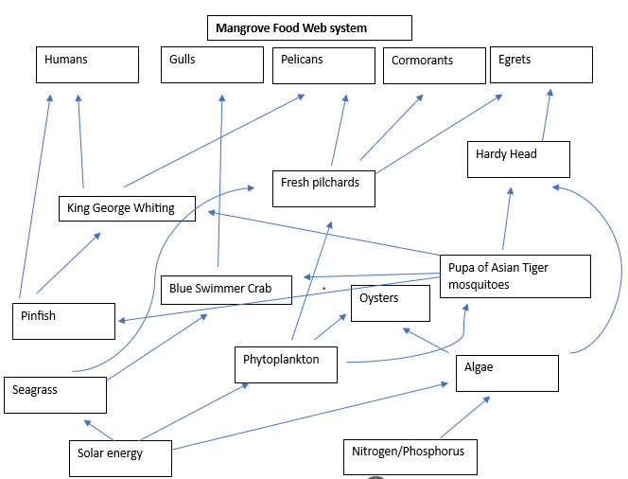
slide 4
Whilst spending time within the Port River and the St Kilda Mangrove forest, I was made aware of the water movement and pollution from industry and the suburban runoff. Stormwater is derived from rainwater as it flows from the land and picks up pollutants from impervious surfaces from urban areas and factories. The resulting nutrient buildup harms flora, particularly mangroves, due to excessive algal blooms. Excessive algal blooms harm seagrass and mangroves by smothering them, resulting in a decline of ‘habitat[s] for fish, shelter and nesting for shorebirds and waterbirds.’ (Shorebird Management and Conservation, 2009) Hence, the destruction of this species has led to a decline in biodiversity. While practising my kayaking skills at Garden Island I observed the way the ecosystem worked together, revealing the importance of the Mangroves. The Mangroves serve as a refuge for fish, waterbirds, and terrestrial birds, and a key producer of the Port River ecosystem. Additionally, the mangroves are a fundamental aspect of the ecosystem whilst supporting the seagrass by ‘filter[ing] pollutants, absorb[ing] excess nutrients from runoff, and trap[ing] sediments, helping to increase the clarity and quality of water.’ (Florida Keys National Marine Sanctuary, No date available).

Slide 5

During these kayaking sessions, I also observed how tides influence the balance of the ecosystem, nurturing the growth of the mangroves and replenishing the fish population. During this journey iencountered the Wilderness Escape tour group. By educating participants on how to minimise their impacts on the environment, tour operators can inspire more people to engage and appreciate outdoor activities while simultaneously preserving the environment. Furthermore, such tours can promote awareness of the significance of the mangrove forest and its diverse wildlife.

Slide 6
Minimising my environmental impact was further aided by adhering to designated campsites and tracks. Department of Environment and Water states that “off-track use has the potential to cause erosion and can spread weeds and soil-borne pathogens such as phytophthora. In addition, some of the illegally constructed trails in these parks are unsustainable in the long term due to the incorrect siting or inadequate construction.” (Parks Management Plan Amendment, 2017, Page 22)
Slide7
Due to the passion developed through the opportunities presented by my Outdoor Ed course, I was highly motivated to share this exploration with my sister. Through providing her with the opportunity of bushwalking, I’ve had the chance to educate her on how he too can have less of an impact while engaging in Outdoor activities. I organised for every Saturday morning during month of August to spend time walking throughout Cobbler Creek Recreation Park to collect litter and rubbish. We took care of litter by collecting it and responsibly disposing of it at home in either the recycling, rubbish or compost. Initially, I intended to utilise shovels and rakes to clear the excess debris from trails and remove any bushes and foliage that were obstructing the paths. However, through research prior to completing this, it revealed to me that I am only allowed to take rubbish out.

Slide (8)
Cobbler Creek Friends, a volunteer group collaborating with the Department of Environment and Water, protects and restores the Recreational Park’s natural environment. they conduct educational meetings and sessions to maintain the balance of the ecosystems, emphasising the education of destructive and vital plant species in consideration of the habitat.
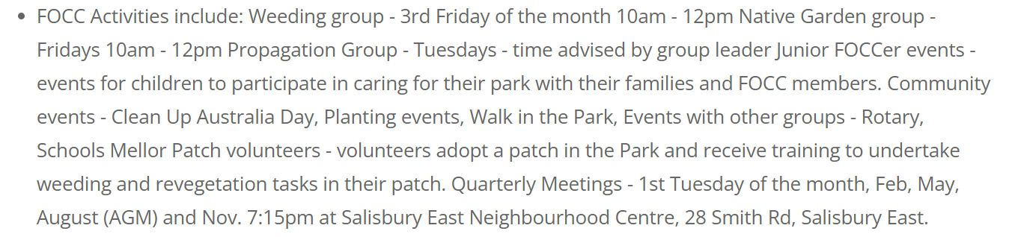

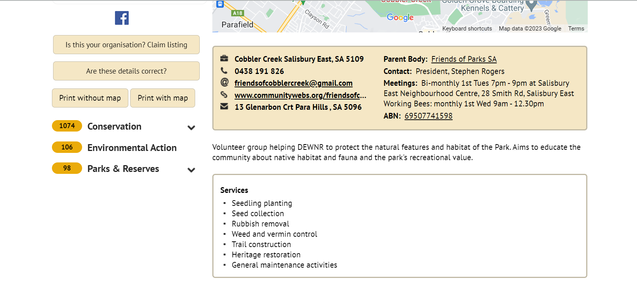

Slide 8 (9)
Our contribution to the maintenance and care of the trails was by respectfully treating the wildlife that we encountered. For instance, on the final Saturday of walking through the Cobler Creek walking tracks, we encountered a mother snake on the side of the pathway. To prevent scaring the snake or imposing any harm to either the snake or my sister and I, we stopped, made minimal sound and movement, stopped walking within a safe distance, and let it venture back into the bush. This experience enabled me to also educate my sister on how to act in response safely and respectfully to encountering a snake.

Slide 10
Flora is essential for parks and walking tracks to provide benefits for humans in the natural environment. Weed invasion is the single most significant threats to the biodiversity of the Adelaide hills. Majority of Australia’s native vegetation has been invaded in due course since European settlement or is susceptible to invasion by exotic species. “Nationally, invasive plants account for approximately 15% of all flora, and about one-quarter of these are either serious environmental weeds or have the potential to be serious weeds.” (Adeliade hills Council, 2023) The AHC also states that “Some weeds are prolific invaders of pastures whilst others thrive in bushland communities, out-competing and smothering native plants, and threatening the survival of local native plants and animals.” The Friends of Park SA, states that a major problem within Cobler Creek are weeds, specifically coolatai. “Coolatai grass was introduced into the Salisbury area during the 1980’s as a landscaping plant, to quickly escape and become an environmental weed.” My research heightened my awareness of this invasive weed, further fueling my desire to protect the natural environment.
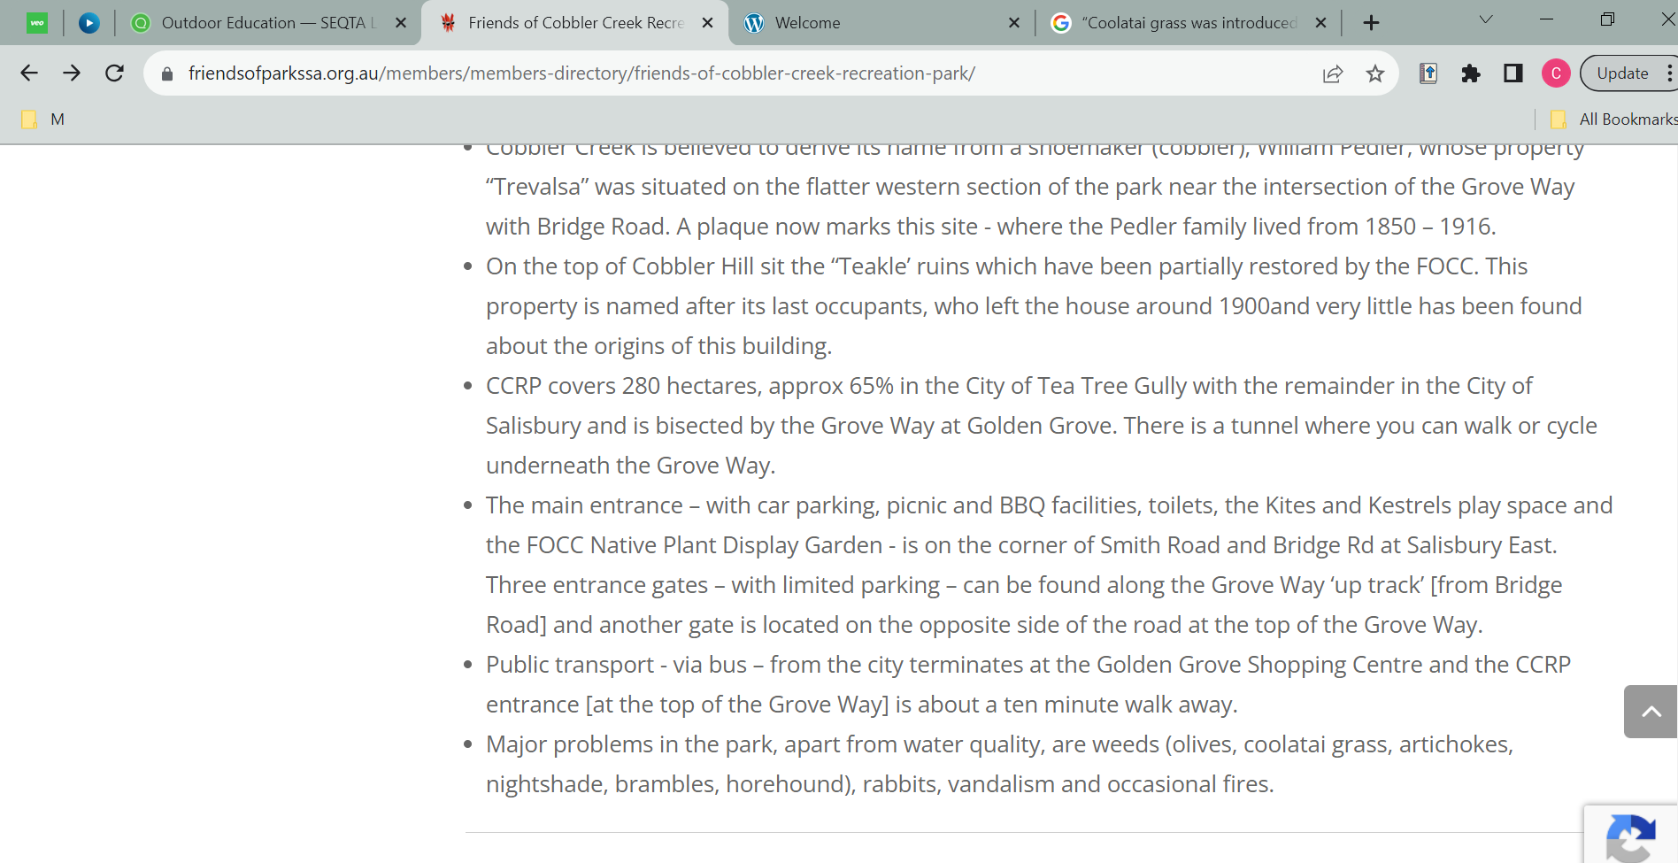

Personal benefits
Slide 12
While hiking and camping, I detached from the typical noisy, technology-bombarded everyday life. I slow down, breathe deeper, and become more aware of my surroundings. This change in pace heightened my awareness of fundamentals such as food, water, temperature, shelter, and comfortable bedding. It is a great ‘breaker’ from our busy world, reminding me to take time to pause and reassess my priorities. These outdoor experiences enhanced both my physical and mental well-being. Physical activity has always been an important part of my life, serving as an escape during challenging times.
Slide (13)
An injury prevented by from playing sports for two years, significantly impacting my mental well-being. Concerns about my performance made me consider changing subjects. However, my course experience presented to me that challenges could be overcome. By making adjustments, such as managing my rucksack’s weight and calibrating my abilities, I set new objectives and achieved them successfully. This experience revealed that success can come in different forms, from reaching a great summit to completing a day walk.
Slide 13 (14)
Bushwalking has enriched my physical and mental well-being, which I've missed due to my injury. Unable to play basketball, I constantly struggled with depressive emotions. “Compared incidence of depression in three treatment groups, where indoor aerobic exercise, antidepressants, or a combination of both were prescribed. After four months the clinical symptoms of approximately 65% of patients in all groups had reduced so significantly that they were no longer classified as clinically depressed.” State within the Ausstrlian Founral of Outdoor education, 2005. This study is something I can personally relate to, as through my experience of exercising outdoors, I have noticed I’ve felt more optimistic throughout each day.
Slide 14 (15)
Additionally, my confidence has also developed accordingly due to feeling accomplished with the progress I have made from the first walks I completed. I recognised from this activity, I felt an increased connection to nature which has permitted me to recharge and find peace amidst the busyness of daily life. Bushwalking has improved my ankle stability, balance, cardiovascular endurance, and strength in my lower body, hence promoting a dramatic increase in my recovery.
Slide 16
A month of consistent bushwalking significantly improved my mental well-being, reducing stress and strengthening my relationship with my sister. The Journal of Global Health conducted research in 2022 that reveals the Health outcomes from nature-based activities. (Graph 1)
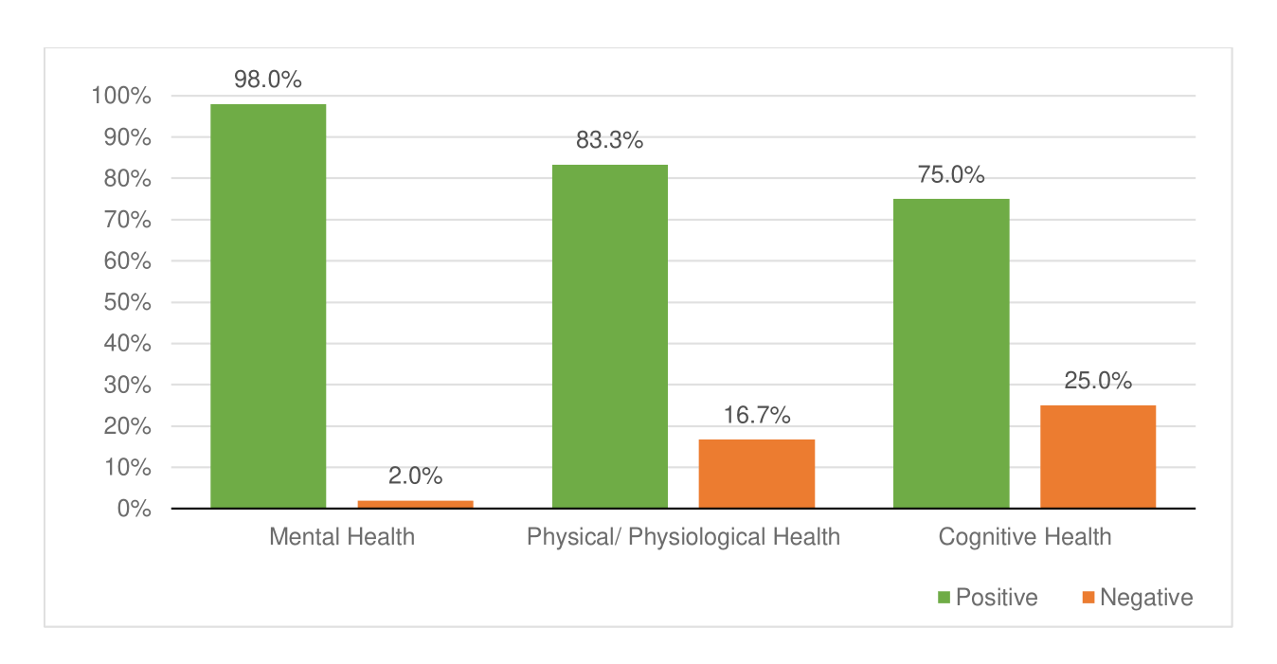
Graph 1: The Jounral of Global Health 2022, produced a study revealing the effects of outdoor interventions and effects on mental health

Slide (17)
Over August, I also challenged 10 peers of my age to join us, surveying the impact on their well-being. The results in the graph show that 77.7% of participants experienced significant improvements in their mental and physical well-being. Many appreciated the social aspects of the activity, preferring to walk with friends or family. Participants also reported achieving a sense of accomplishment and improved sleep quality, providing them with additional energy for the following day.

Graph 2: conducted in 2023, survey revealing the effect outdoor hiking has on mentall wellbing being
Slide 18
Through this experience, I have formed health-giving habits that have improved my mental well-being and physical state. These habits have resulted in me going on outdoor walks consistently with friends and family. After viewing the comments from those who completed the Saturday walking, I have also noticed a positive change in my sleep. I usually sleep with a Heart Rate monitor on my wrist, which has revealed an accurate reading of an increase in my sleep time, and time spent within REM, impacting my mental and physical wellbeing. After acknowledging the numerous benefits I have transferred some of my appreciation of the environment to my everyday life. I also began encouraging my family to become more active, and more aware of environmental issues by sharing information, researching and asking questions. Furthermore, through this I am more motivated to be more observant of the environment while going on walks, for instance, picking up litter whenever I see it.
Social Benefits
Outdoor Education has increased my enthusiasm towards engaging in outdoor activities. This has been beneficial both socially, with family and friends, and as a personal way to improve my mental health. As a result of my experiences, I have become a more knowledgeable and mindful participant, more aware of the impact my actions have on the environment. I now understand the importance of entering and engaging with a zero-impact mindset and valuing the need to further educate on issues related to sustaining for the future. Whilst in Cobler Creek, it was evident that invasive species, such as weeds, were reasonably controlled, due to the efforts of the Friends of Cobler Creek. However, ongoing maintenance is necessary to control these aggressive species. Through this positive experience, I have gained a great admiration for preserving this environment and ensuring its long-term conservation. Additionally, this increased desire has motivated me to participate in voluntary work with the Friends of Cobbler weekly. Through my increased awareness, I am now more conscious of not only my actions but of others. For example, during walks with my sister, I noticed she would walk through terrain rather than sticking to the designated walking path. I then educated her on the environmental damage that these types of actions can cause.
Slide 20
Whilst undertaking walking as a consistent activity, there have been multiple social benefits associated. Despite the busy lives my family and I have, hiking has promoted a deeper connection with my family members within the natural environment. Additionally, I have been able to build upon or begin relationships with those I do not usually speak to who were able to participate in the Saturday hiking session.
I have been able to reveal a new perspective to my sisters and mum whilst I reveal to them the benefits I obtained through this experience. This motivated them to also encourage me to spend more time with them whilst hiking allowing us to create fun and healthy memories. Through the stresses of life and school, they are now able to keep me accountable to spend time in the natural environment but also pay attention to my mental well-being, when usually I would neglect this when I get overwhelmed by things like schoolwork.

Slide 21
Conclusion
My time in nature has changed my perception, making me more connected and considerate towards the environment. I’ve grown physically and mentally and shared these experiences with others. While voluntarily contributing to the maintenance of Cobbler Creek, I have learned the importance of my actions and behaviours, and I am motivated to continue to support the sustainability of various natural environments. Through my research, I discovered the numerous positive effects on the well-being of spending time in nature and engaging in outdoor activities. I trust that everyone will reap the benefits that it offers while connecting with the natural world.
Bibliography:
Morialta and Black Hill Conservation Parks Management Plan Amendment 2017.

Getzzg. “What Is the Impact of Nature on Human Health? A Scoping Review of the Literature — JOGH.” JOGH, 16 Dec. 2022, jogh.org/2022/jogh-12-04099#S1. Accessed 14 Sept. 2023.
‌ https://www.ahc.sa.gov.au/environment/biodiversity-in-the-hills/threats-to-biodiversity
Milner, Jos M, et al. “To Feed or Not to Feed? Evidence of the Intended and Unintended Effects of Feeding Wild Ungulates.” ResearchGate, Wiley, Nov. 2014, www.researchgate.net/publication/267103393_To_Feed_or_not_to_Feed_Evidence_of_the_Intended_and_Unintended_Effects_of_Feeding_Wild_Ungulates. Accessed 17 Sept. 2023.
‌
Pryor, Anita, et al. “Outdoor Education and Bush Adventure Therapy: A Socio-Ecological Approach to Health and Wellbeing.” Australian Journal of Outdoor Education, vol. 9, no. 1, 2023, pp. 3–13, eric.ed.gov/?id=EJ1070755. Accessed 12 Oct. 2023.
‌
Port Waterways Water Quality Improvement Plan.
“Friends of Cobbler Creek Recreation Park - Friends of Parks South Australia.” Friends of Parks South Australia, 17 Jan. 2023, friendsofparkssa.org.au/members/members-directory/friends-of-cobbler-creek-recreation-park/. Accessed 13 Oct. 2023.

‌Rutherford, Henry, and Tracey Hardwick. Cobbler Creek Recreation Park “Proof of Concept” Hyparrhenia Hirta (L.) Stapf (Coolatai Grass) Control Demonstration Site Acknowledgement of Traditional Owners.

‌Guide, Safety. “Discover Deadly.” Discover Deadly, 2013, www.discoverdeadly.com.au/snakesafetyguide. Accessed 15 Oct. 2023.

Stage 2 Outdoor Education – Performance Standards
- | Planning and Application | Evaluation and Reflective Practice | Exploration, Understanding, and Analysis
A | Highly effective planning and application of responsibilities, leadership, and risk-management strategies to participate in safe and sustainable outdoor activities and journeys. | Astute evaluation and critically reflective practice of planning, leadership, and collaborative skills in natural environments.  Astute evaluation and critically reflective practice of the development and application of practical outdoor skills.  Comprehensive evaluation and discerning reflection of personal experiences and connections in natural environments. | Insightful and thoughtful exploration and understanding of the interaction of humans and natural environments, considering a range of perspectives.  Comprehensive and critical analysis of environmental systems and issues, and the sustainability of natural environments.  Detailed and thorough exploration of personal connections with natural environments that enhance personal development and/or strategies for environmental sustainability.
B | Mostly effective planning and application of responsibilities, leadership, and risk-management strategies to participate in safe and sustainable outdoor activities and journeys. | Well-considered evaluation and mostly critically reflective practice of planning, leadership, and collaborative skills in natural environments.  Well-considered evaluation and mostly critically reflective practice of the development and application of practical outdoor skills.  Detailed evaluation and considered reflection of personal experiences and connections in natural environments. | Mostly insightful exploration and well-considered understanding of the interaction of humans and natural environments, considering a range of perspectives.  Mostly detailed and critical analysis of environmental systems and issues, and the sustainability of natural environments.  Mostly detailed exploration of personal connections with natural environments that enhance personal development and/or strategies for environmental sustainability.
C | Competent planning and application of responsibilities, leadership, and risk-management strategies to participate in safe and sustainable outdoor activities and journeys. | Considered evaluation and reflective practice of planning, leadership, and collaborative skills in natural environments.  Considered evaluation and reflective practice of the development and application of practical outdoor skills.  Competent evaluation and mostly considered reflection of personal experiences and connections in natural environments. | Competent exploration and considered understanding of the interaction of humans and natural environments, considering a range of perspectives.  Considered analysis of environmental systems and issues, and the sustainability of natural environments.  Informed exploration of personal connections with natural environments that enhance personal development and/or strategies for environmental sustainability.
D | Basic planning and application of responsibilities, and some leadership and risk-management strategies to participate in safe and sustainable outdoor activities and journeys. | Some description of reflective practice of planning, and/or leadership, and/or collaborative skills in natural environments.  Basic description of reflective practice of the development and application of practical outdoor skills.  Some reflection of personal experiences and/or connections in natural environments. | Some exploration and some understanding of the interaction of humans and natural environments, considering some perspectives.  Basic identification of some environmental systems and issues, and the sustainability of natural environments.  Basic exploration of personal connections with natural environments that enhance personal development and/or strategies for environmental sustainability.
E | Attempted planning and some application of responsibilities to participate in safe and sustainable outdoor activities and journeys | Attempted description of reflective practice of some of the skills of planning, leadership, and collaboration in natural environments.  Attempted description of reflective practice of the development and application of some practical outdoor skills.  Limited reflection of personal experiences or connections in natural environments. | Limited exploration and some attempt to understand the interaction of humans and natural environments.  Attempted description of environmental systems and/or issues, and/or the sustainability of natural environments.  Superficial exploration of personal connections with natural environments.

